Assignment 4: SDN
1. Update Ubuntu
sudo apt update && sudo apt upgrade -y
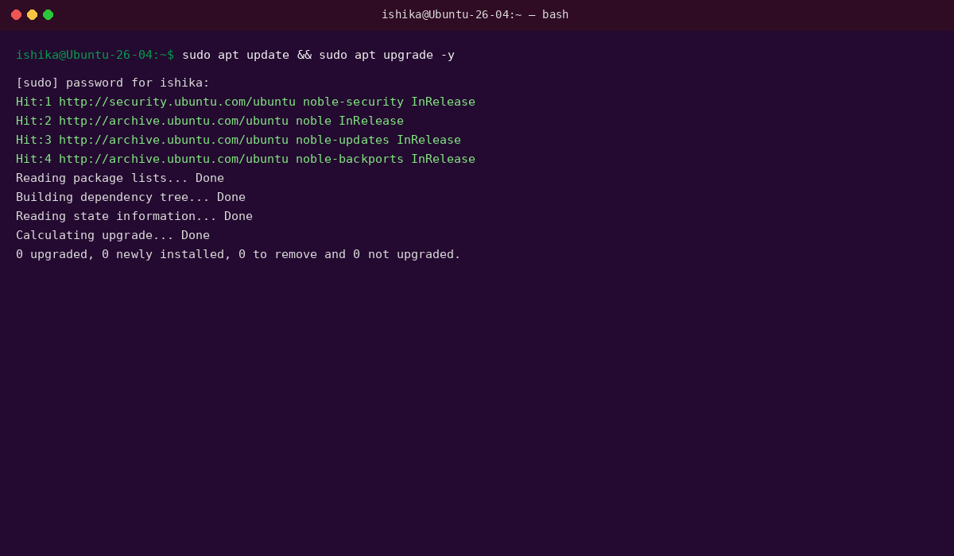
Updates the Ubuntu system.
2.Check Mininet installation
mn --version
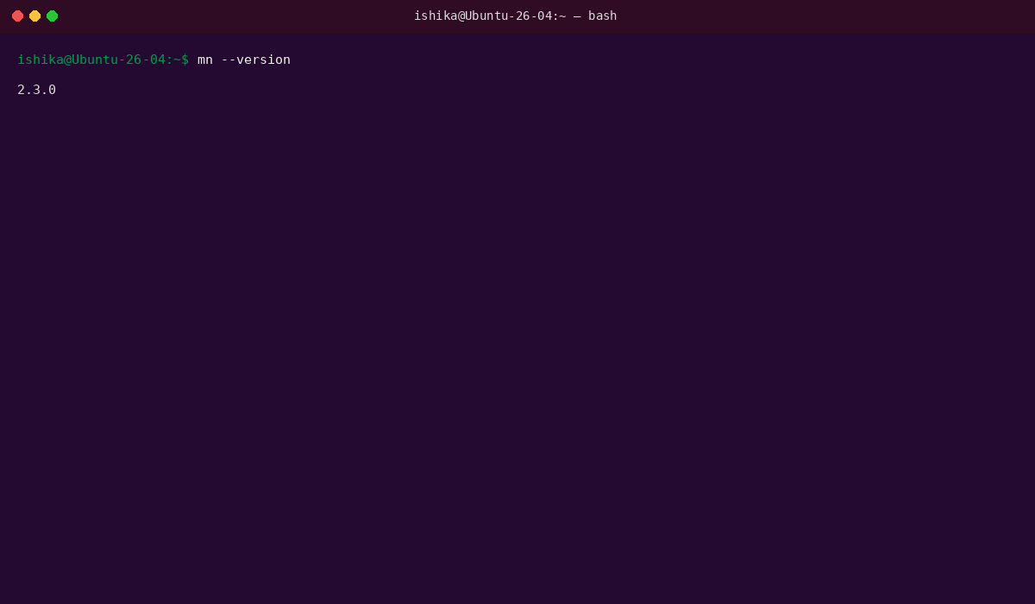
Checks Mininet for creating virtual networks.
3. Install Open vSwitch
sudo apt install openvswitch-switch -y
Installs the software-based SDN switch.
4. Check Open vSwitch
sudo systemctl status openvswitch-switch
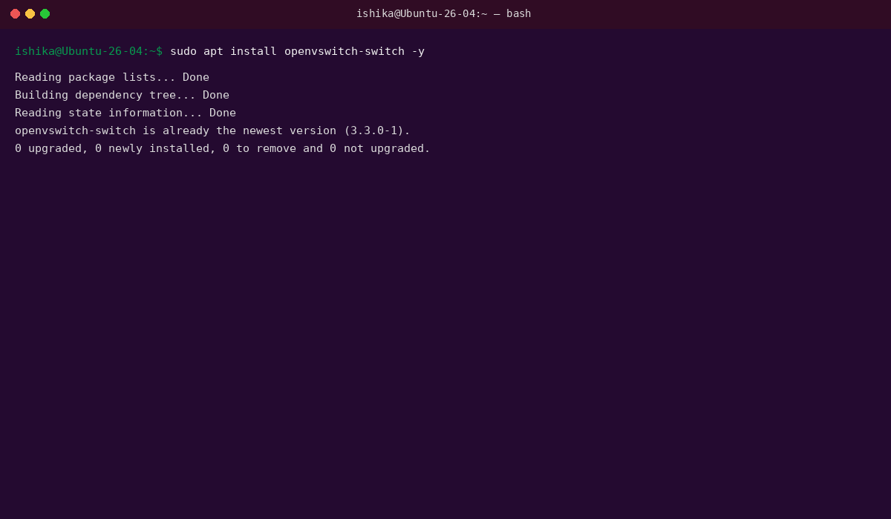
Checks whether Open vSwitch is running.
5. Test Mininet
sudo mn
Starts a basic Mininet network.
mininet> nodes
Displays the available virtual hosts and switch.
mininet> pingall
Tests connectivity between the virtual hosts.
mininet> exit
Exits Mininet.
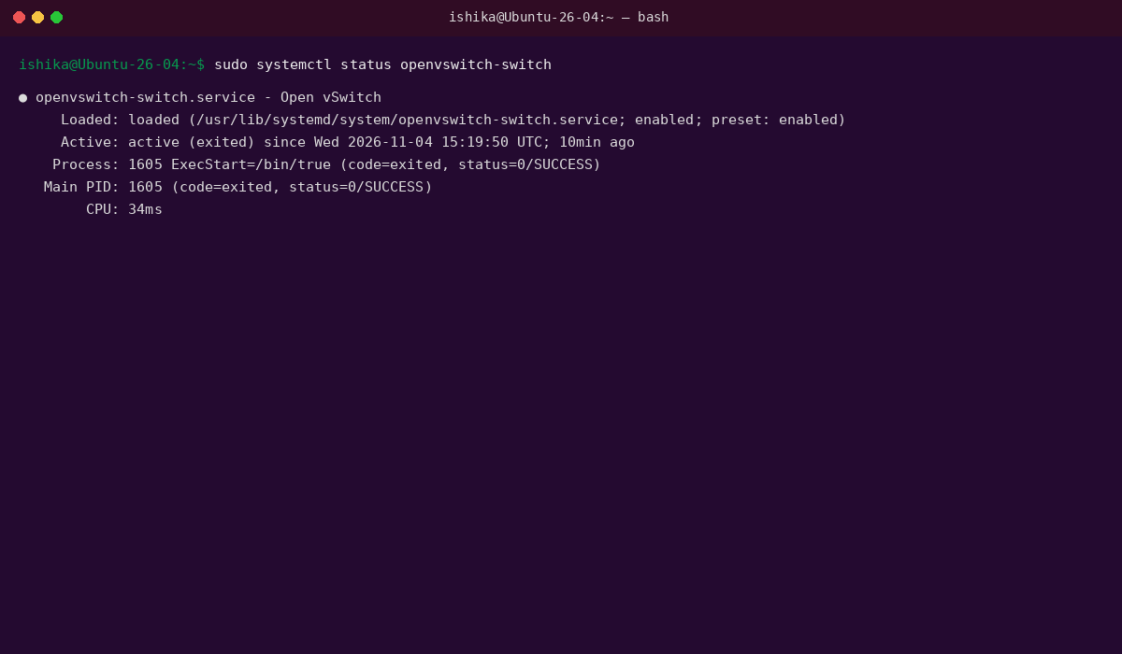
6. Install Python and Virtual Environment
sudo apt install python3-pip python3-venv -y
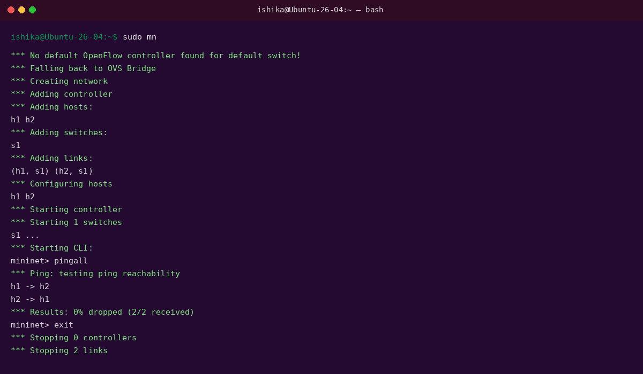
Installs Python package and virtual-environment support.
7. Create Ryu Environment
python3 -m venv ryu-env
source ryu-env/bin/activate
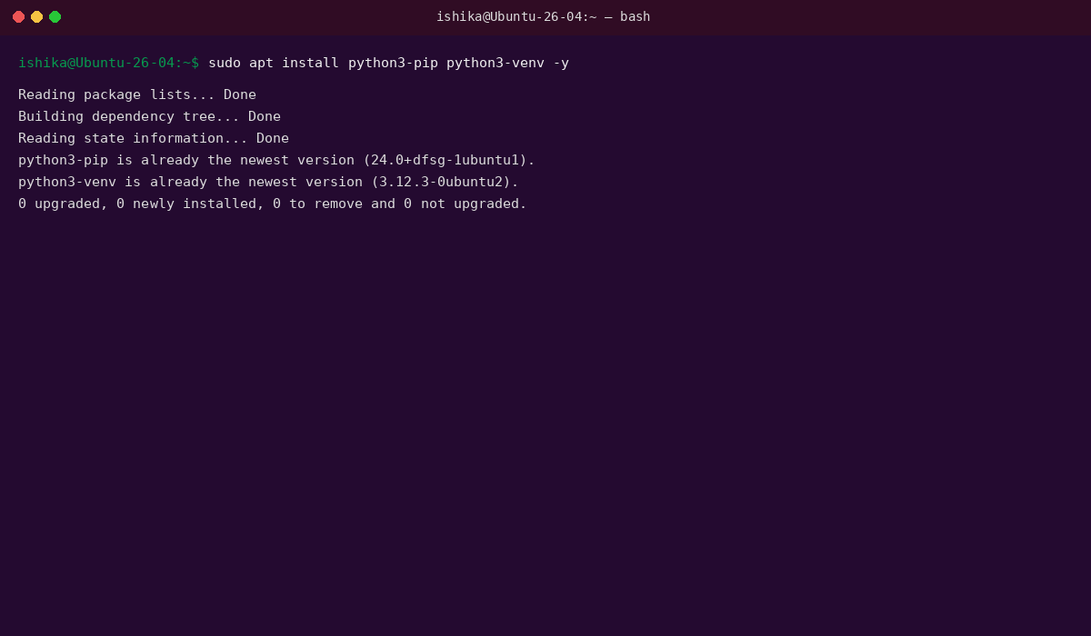
Creates and activates a Python environment for Ryu.
8. Install Ryu
pip install ryu
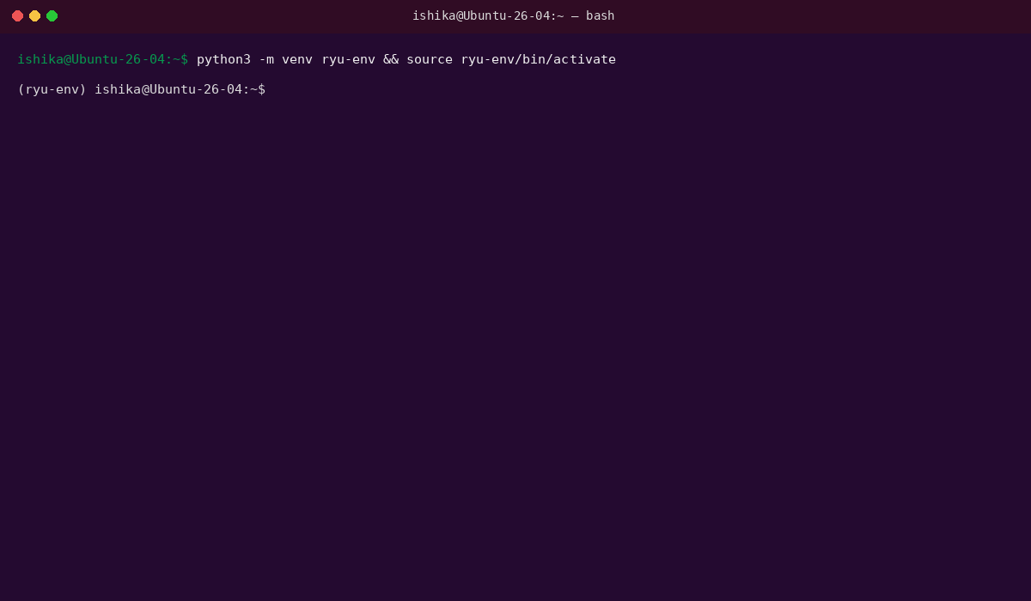
Installs the Ryu SDN controller.
9. Test Ryu Installation
ryu-manager –version
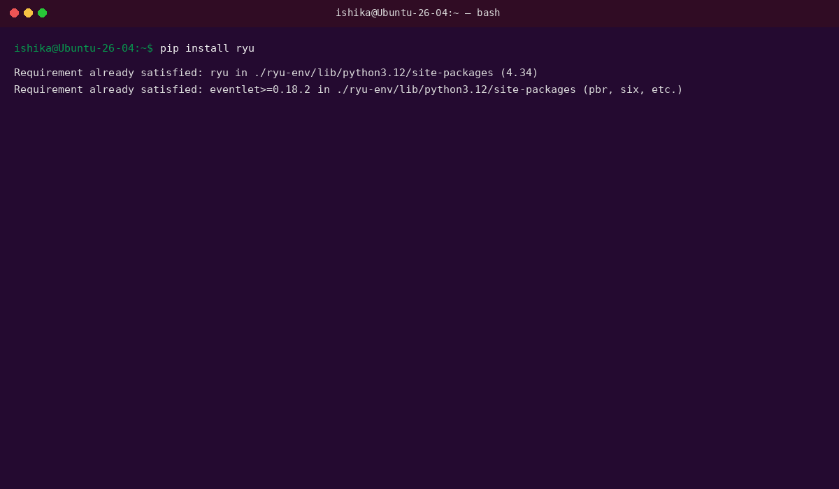
Displays the installed Ryu version.
10. Start Ryu Controller
ryu-manager ryu.app.simple_switch_13
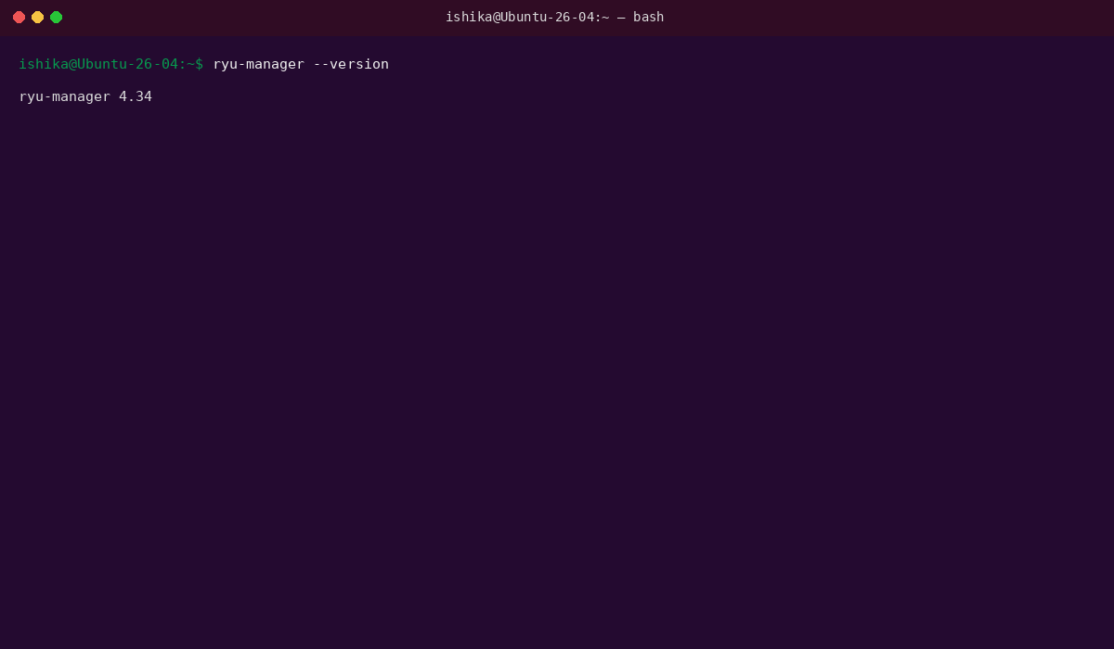
Starts Ryu with a basic OpenFlow switching application.
Keep this terminal open.
11. Create Mininet SDN Topology
Open a new terminal:
sudo mn --topo single,3 --controller=remote --switch ovsk
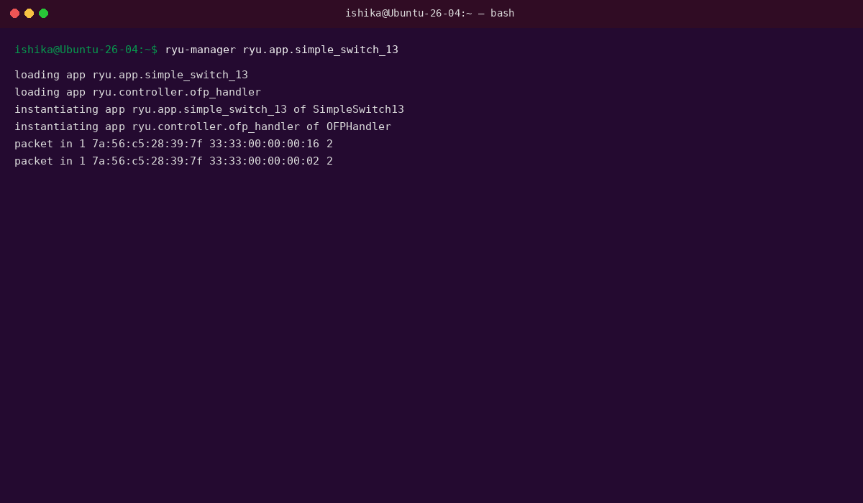
Creates 3 virtual hosts connected to an Open vSwitch and remote Ryu controller.
12. Check Nodes
mininet> nodes
Displays H1, H2, H3 and S1.
13. Check Connections
mininet> net
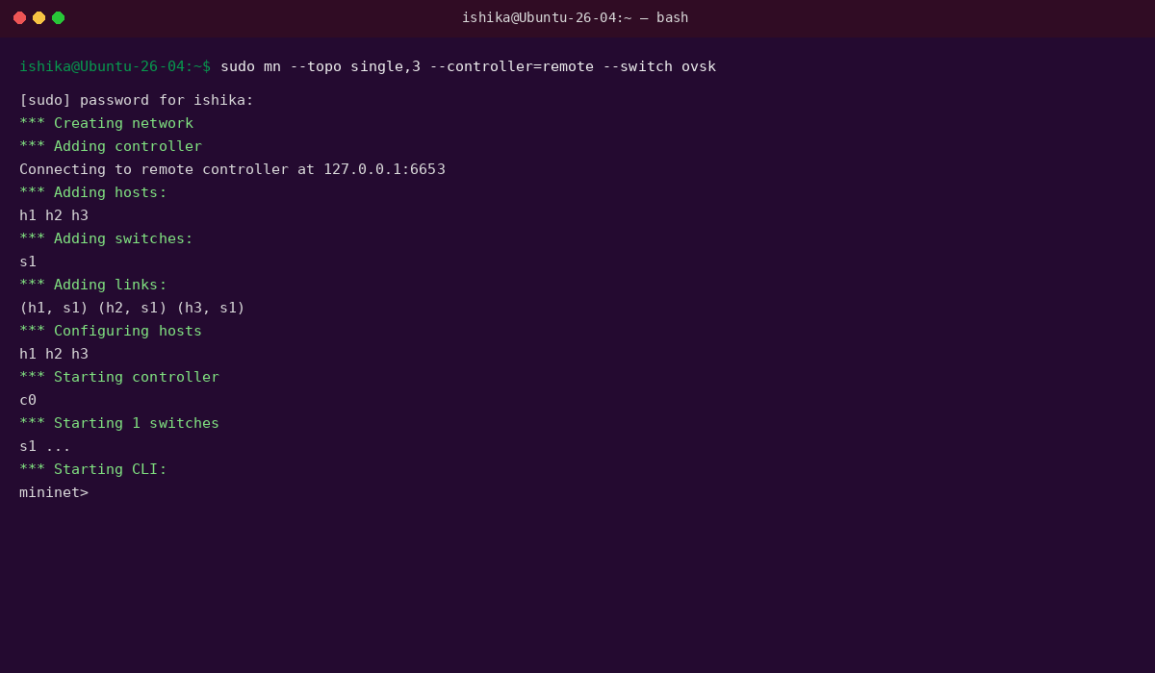
Displays the connections between hosts and the switch.
14. Test Connectivity
mininet> pingall
Verifies communication between all virtual hosts.
mininet> h1 ping h2
Tests connectivity between H1 and H2.
15. View Flow Rules
Open another terminal:
sudo ovs-ofctl -O OpenFlow13 dump-flows s1
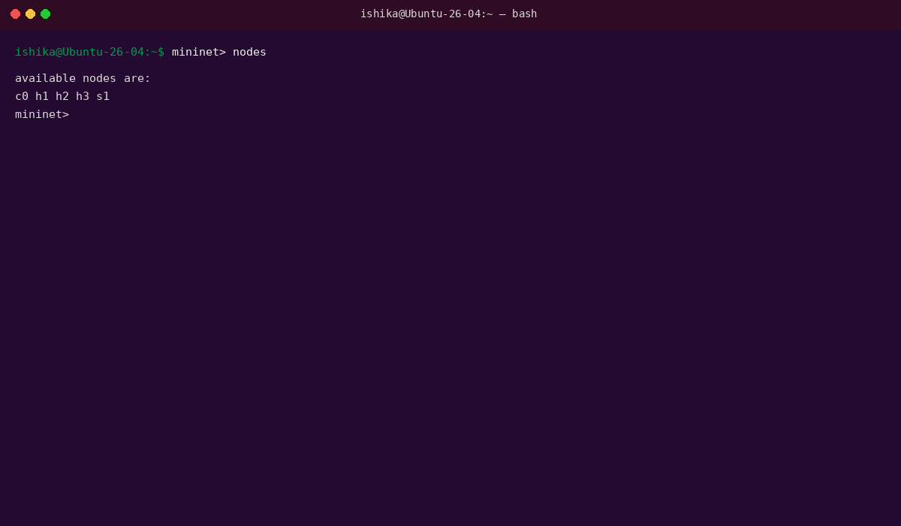
Displays the flow rules installed in the Open vSwitch.
16. Add a Simple Filtering Rule
sudo ovs-ofctl -O OpenFlow13 add-flow s1 "priority=100,in_port=1,actions=drop"
Drops packets entering S1 through port 1.
17. Test the Filtering Rule
mininet> h1 ping h2
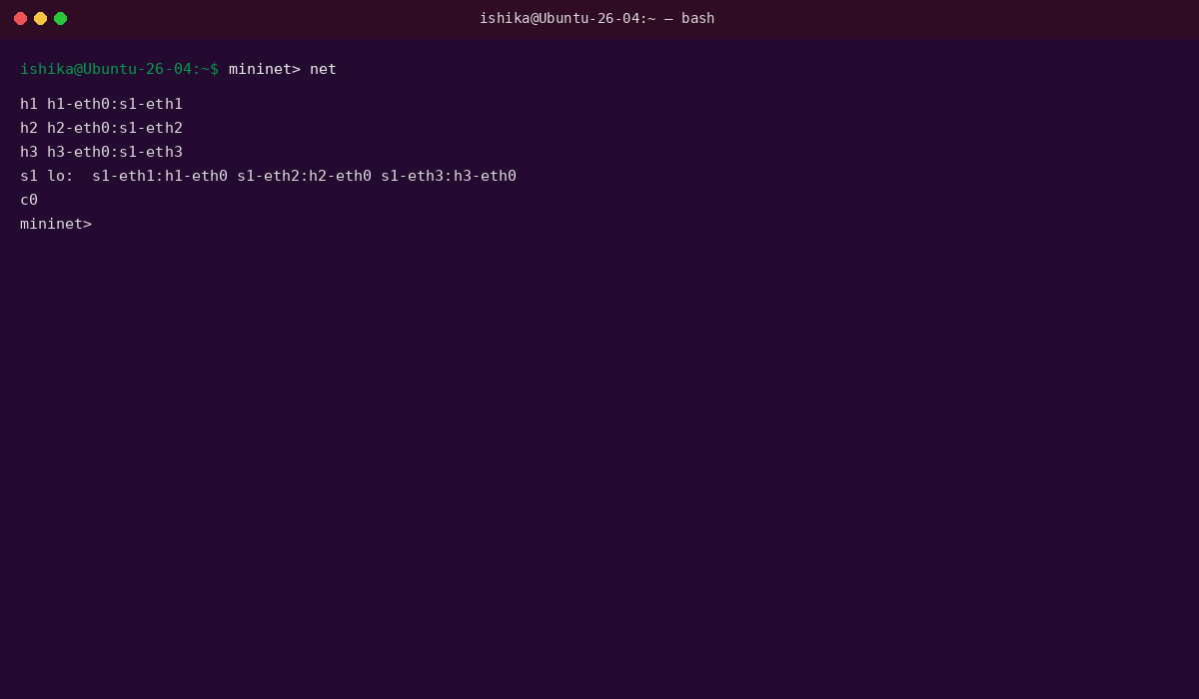
Checks the effect of the filtering rule on H1's traffic.
18. Remove Flow Rules
sudo ovs-ofctl -O OpenFlow13 del-flows s1
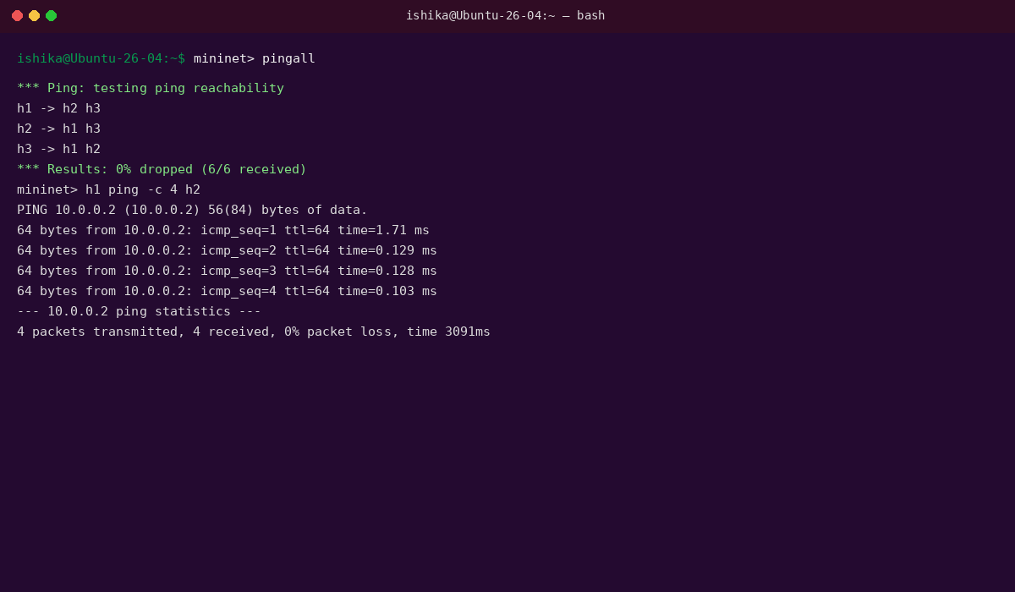
Removes the manually added flow rules.
19. Clean Mininet
sudo mn -c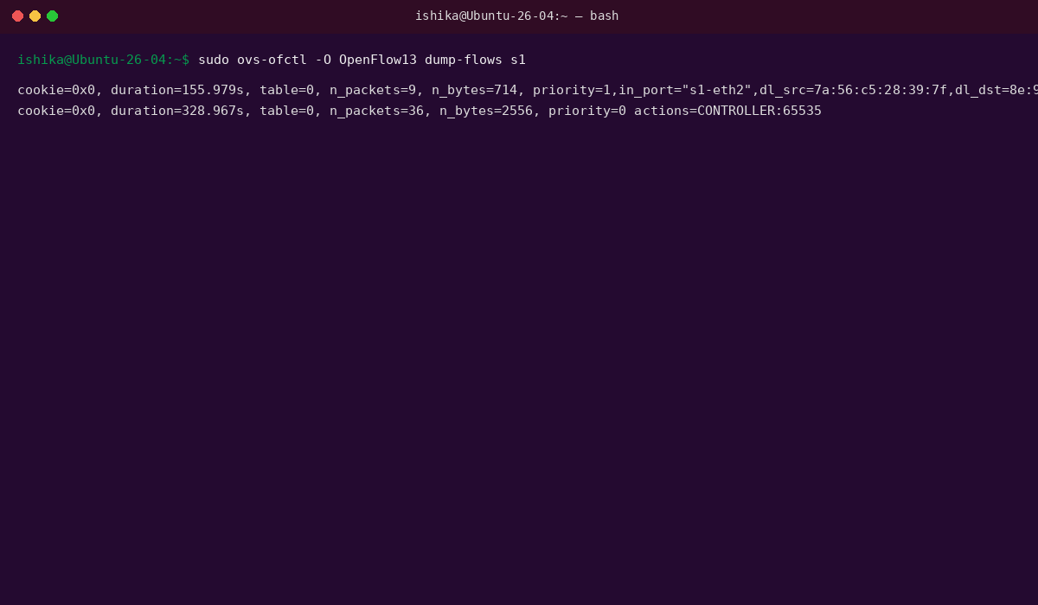
Cleans up Mininet interfaces and processes.

Result: The SDN environment was successfully created using Mininet, Open vSwitch, and the Ryu Controller, and basic forwarding and filtering of network traffic was demonstrated

