EXPERIMENT 5
Implementation of Various Scheduling Mechanisms Using
an Open-Source Cloud Simulator
1 Update Ubuntu
sudo apt update
sudo apt upgrade -y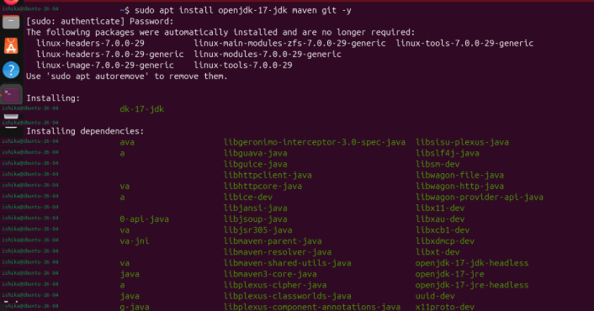
2 Install Java, Maven and Git
sudo apt install openjdk-17-jdk maven git -y
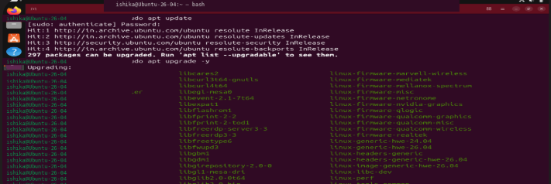
Why: Installs the Java compiler/runtime, Maven build tool and Git version-control utility.
java -version
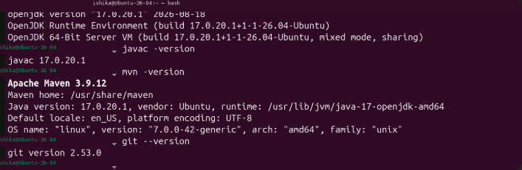
Why: Checks the installed Java runtime version.
javac -version
Why: Checks that the Java compiler is available.
mvn -version
Why: Confirms Maven installation and displays the Java version Maven uses.
git –version
Why: Confirms Git installation.
Expected check: Java and javac should report version 17.x. Maven should display a version and show that it is using Java 17.
Resolve any Java-version mismatch before proceeding.
3. Create the CloudSim Plus Maven project
3.1 Create folders
mkdir -p ~/CloudSchedulingLab/src/main/java/lab
Why: Creates the project directory and standard Maven Java source directory. -p creates missing parent directories too.
cd ~/CloudSchedulingLab
Why: Changes the terminal’s current directory to the project root.
3.2 Create pom.xml
nano pom.xml
Why: Opens the nano text editor to create the Maven configuration file.

4. Implement the experiment
nano src/main/java/lab/SchedulingExperiment.java
Why: Creates the Java source file containing the simulation setup, scheduler configurations and output code.
<project xmlns="http://maven.apache.org/POM/4.0.0"
xmlns:xsi="http://www.w3.org/2001/XMLSchema-instance"
xsi:schemaLocation="http://maven.apache.org/POM/4.0.0
https://maven.apache.org/xsd/maven-4.0.0.xsd">

<modelVersion>4.0.0</modelVersion>

<groupId>lab</groupId>
<artifactId>cloud-scheduling-lab</artifactId>
<version>1.0-SNAPSHOT</version>

<properties>
<maven.compiler.release>17</maven.compiler.release>
<project.build.sourceEncoding>UTF-8</project.build.sourceEncoding>
</properties>

<dependencies>
<dependency>
<groupId>org.cloudsimplus</groupId>
<artifactId>cloudsimplus</artifactId>
<version>8.5.5</version>
</dependency>
</dependencies>

</project>
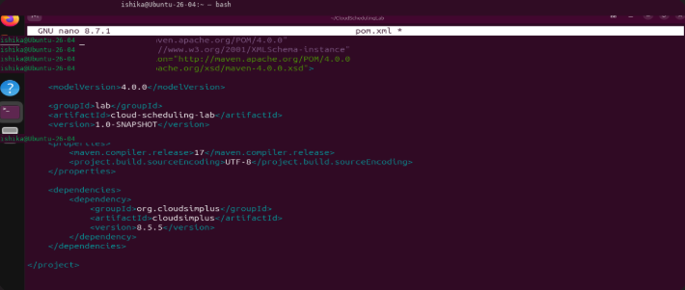
Save in nano: Ctrl+O, press Enter, then Ctrl+X.
Why this file is required: It defines the Maven project, sets Java 17 as the target and declares CloudSim Plus as a dependency. Maven downloads the required library files automatically.
3.3 Resolve dependencies
mvn dependency:resolve
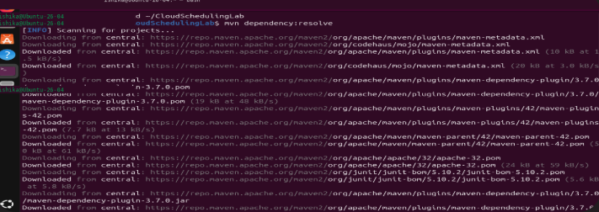
Why: Downloads the declared CloudSim Plus library and supporting dependencies into Maven’s local repository.
mvn clean
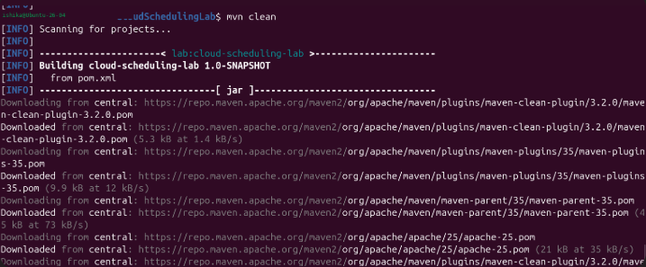
Why: Removes old build output (the target directory), ensuring the next build starts cleanly.
4. Implement the experiment
nano src/main/java/lab/SchedulingExperiment.java
Why: Creates the Java source file containing the simulation setup, scheduler configurations and output code.
package lab;

import java.util.ArrayList;
import java.util.List;

import org.cloudsimplus.core.CloudSimPlus;
import org.cloudsimplus.datacenters.Datacenter;
import org.cloudsimplus.datacenters.DatacenterSimple;
import org.cloudsimplus.brokers.DatacenterBroker;
import org.cloudsimplus.brokers.DatacenterBrokerSimple;
import org.cloudsimplus.cloudlets.Cloudlet;
import org.cloudsimplus.cloudlets.CloudletSimple;
import org.cloudsimplus.hosts.Host;
import org.cloudsimplus.hosts.HostSimple;
import org.cloudsimplus.resources.Pe;
import org.cloudsimplus.resources.PeSimple;
import org.cloudsimplus.schedulers.cloudlet.CloudletScheduler;
import org.cloudsimplus.schedulers.cloudlet.CloudletSchedulerSpaceShared;
import org.cloudsimplus.schedulers.cloudlet.CloudletSchedulerTimeShared;
import org.cloudsimplus.schedulers.vm.VmScheduler;
import org.cloudsimplus.schedulers.vm.VmSchedulerSpaceShared;
import org.cloudsimplus.schedulers.vm.VmSchedulerTimeShared;
import org.cloudsimplus.utilizationmodels.UtilizationModel;
import org.cloudsimplus.utilizationmodels.UtilizationModelFull;
import org.cloudsimplus.vms.Vm;
import org.cloudsimplus.vms.VmSimple;
import org.cloudsimplus.provisioners.ResourceProvisionerSimple;
import org.cloudsimplus.allocationpolicies.VmAllocationPolicySimple;

public class SchedulingExperiment {

private static final int HOST_PES = 4;
private static final int VM_COUNT = 2;
private static final int CLOUDLET_COUNT = 4;

private static final long MIPS = 1000;
private static final long CLOUDLET_LENGTH = 20000;

public static void main(String[] args) {

// Scenario A
runScenario(
"A: VM SpaceShared + Cloudlet SpaceShared",
new VmSchedulerSpaceShared(),
new CloudletSchedulerSpaceShared()
);

// Scenario B
runScenario(
"B: VM SpaceShared + Cloudlet TimeShared",
new VmSchedulerSpaceShared(),
new CloudletSchedulerTimeShared()
);

// Scenario C
runScenario(
"C: VM TimeShared + Cloudlet SpaceShared",
new VmSchedulerTimeShared(),
new CloudletSchedulerSpaceShared()
);

// Scenario D
runScenario(
"D: VM TimeShared + Cloudlet TimeShared",
new VmSchedulerTimeShared(),
new CloudletSchedulerTimeShared()
);
}

// Execute individual scheduling scenario
private static void runScenario(
String title,
VmScheduler vmScheduler,
CloudletScheduler cloudletScheduler) {

System.out.println("\n==============================================");
System.out.println(title);
System.out.println("==============================================");

CloudSimPlus simulation = new CloudSimPlus();

createDatacenter(simulation, vmScheduler);

DatacenterBroker broker =
new DatacenterBrokerSimple(simulation);

List<Vm> vmList = createVms(cloudletScheduler);

List<Cloudlet> cloudletList = createCloudlets();

broker.submitVmList(vmList);

broker.submitCloudletList(cloudletList);

simulation.start();

List<Cloudlet> finished =
broker.getCloudletFinishedList();

System.out.printf(
"%-10s %-10s %-12s %-12s %-12s%n",
"Cloudlet", "VM", "Status", "Start", "Finish"
);

for (Cloudlet cloudlet : finished) {

System.out.printf(
"%-10d %-10d %-12s %-12.2f %-12.2f%n",
cloudlet.getId(),
cloudlet.getVm().getId(),
cloudlet.getStatus(),
cloudlet.getStartTime(),
cloudlet.getFinishTime()
);
}

System.out.println(
"Completed Cloudlets: "
+ finished.size() + " / " + CLOUDLET_COUNT
);
}

// Create Datacenter and Host
private static Datacenter createDatacenter(
CloudSimPlus simulation,
VmScheduler vmScheduler) {

List<Pe> peList = new ArrayList<>();

for (int i = 0; i < HOST_PES; i++) {

peList.add(new PeSimple(MIPS));
}

Host host = new HostSimple(
8192,
100000,
1000000,
peList
);

host.setRamProvisioner(
new ResourceProvisionerSimple()
);

host.setBwProvisioner(
new ResourceProvisionerSimple()
);

host.setVmScheduler(vmScheduler);

List<Host> hostList = new ArrayList<>();

hostList.add(host);

return new DatacenterSimple(
simulation,
hostList,
new VmAllocationPolicySimple()
);
}

// Create Virtual Machines
private static List<Vm> createVms(
CloudletScheduler scheduler) {

List<Vm> vmList = new ArrayList<>();

for (int i = 0; i < VM_COUNT; i++) {

Vm vm = new VmSimple(i, MIPS, 2);

vm.setRam(2048)
.setBw(10000)
.setSize(10000);

// Each VM must have its own scheduler instance
CloudletScheduler vmScheduler;

if (scheduler instanceof CloudletSchedulerSpaceShared) {

vmScheduler =
new CloudletSchedulerSpaceShared();

} else {

vmScheduler =
new CloudletSchedulerTimeShared();
}

vm.setCloudletScheduler(vmScheduler);

vmList.add(vm);
}

return vmList;
}

// Create Cloudlets
private static List<Cloudlet> createCloudlets() {

List<Cloudlet> cloudletList = new ArrayList<>();

UtilizationModel utilization =
new UtilizationModelFull();

for (int i = 0; i < CLOUDLET_COUNT; i++) {

Cloudlet cloudlet = new CloudletSimple(
CLOUDLET_LENGTH,
1,
utilization
);

cloudlet.setSizes(300);

cloudletList.add(cloudlet);
}

return cloudletList;
}
}

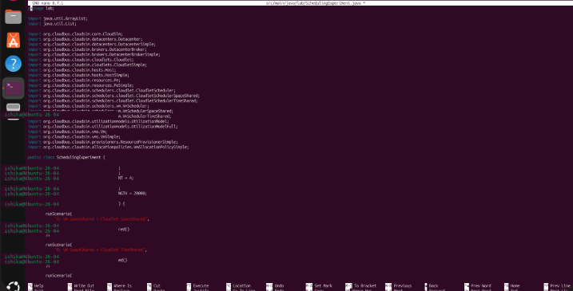
5. Compile and execute
5.1 Compile
mvn clean compile
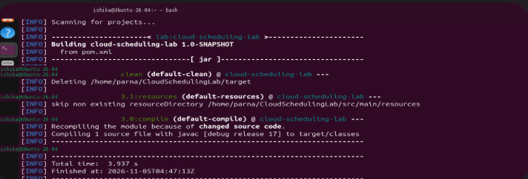
Why: Compiles the Java source code and reports syntax or API errors before running the simulation.

5.2 Run
mvn exec:java -Dexec.mainClass="lab.SchedulingExperiment" -Dexec.classpathScope=compile
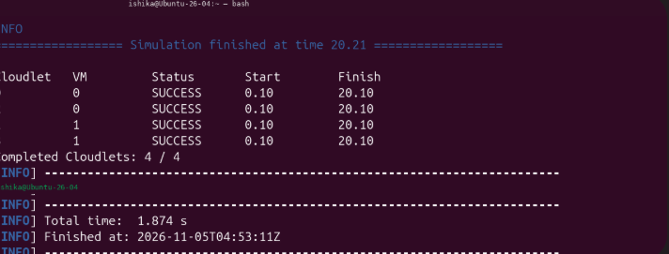

Why: Executes the main() method with Maven and the project dependency classpath.

