UML Lab – Pictorial Diagrams Submission

As-Is Swimlane Diagram
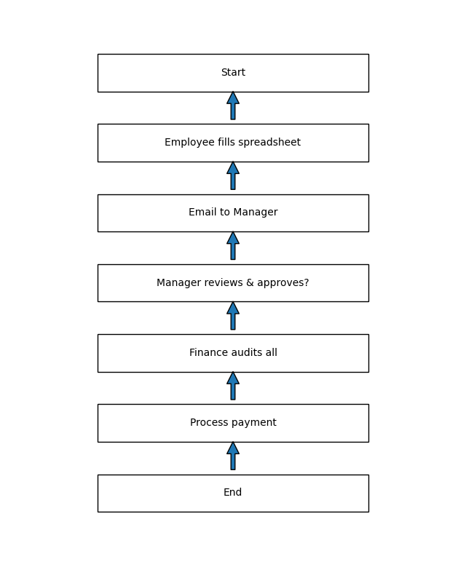

To-Be Swimlane Diagram
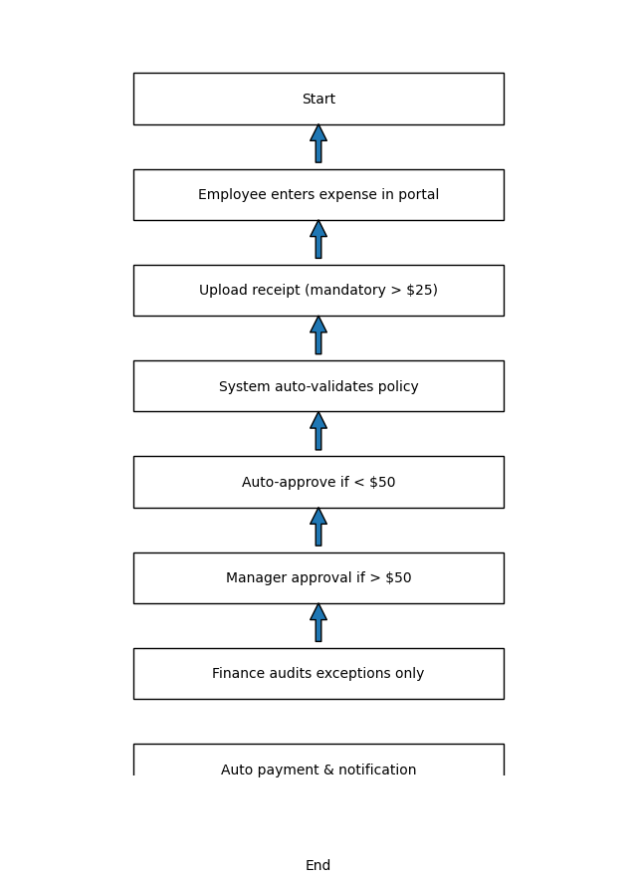

UML Use Case Diagram
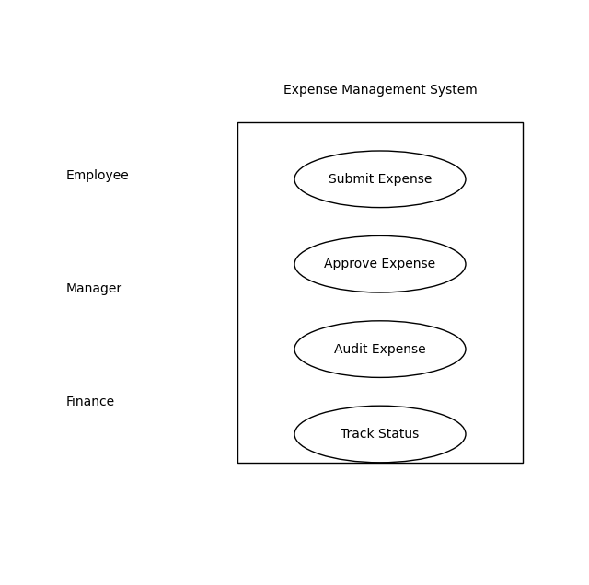

UML Activity Diagram
