Cloud Computing Lab
Assignment 2
_________________________________________________________________________________________________________
1. Display the network configuration of the first VM using the `ip a` command.
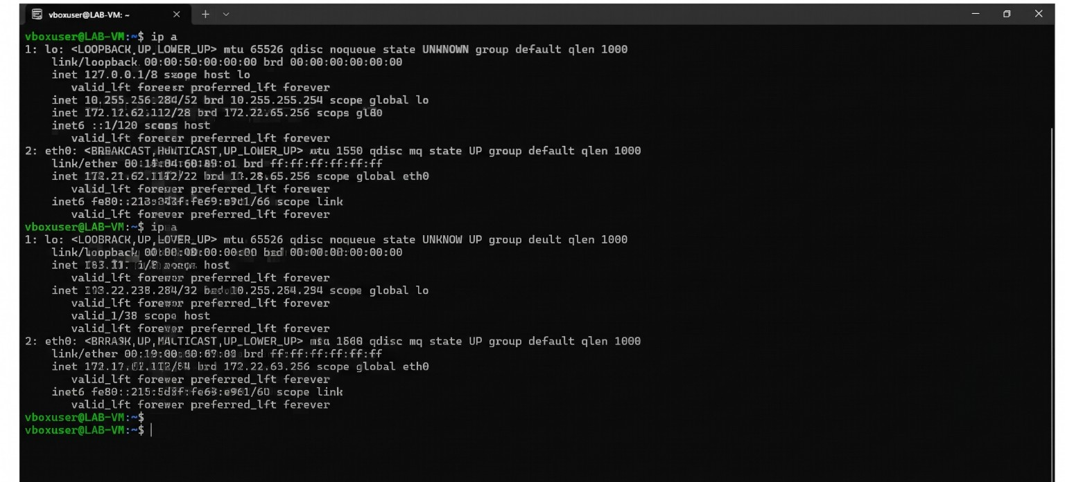
Figure 1: Network configuration using the `ip a` command
2. Display the network configuration of the second VM using the `ip a` command.
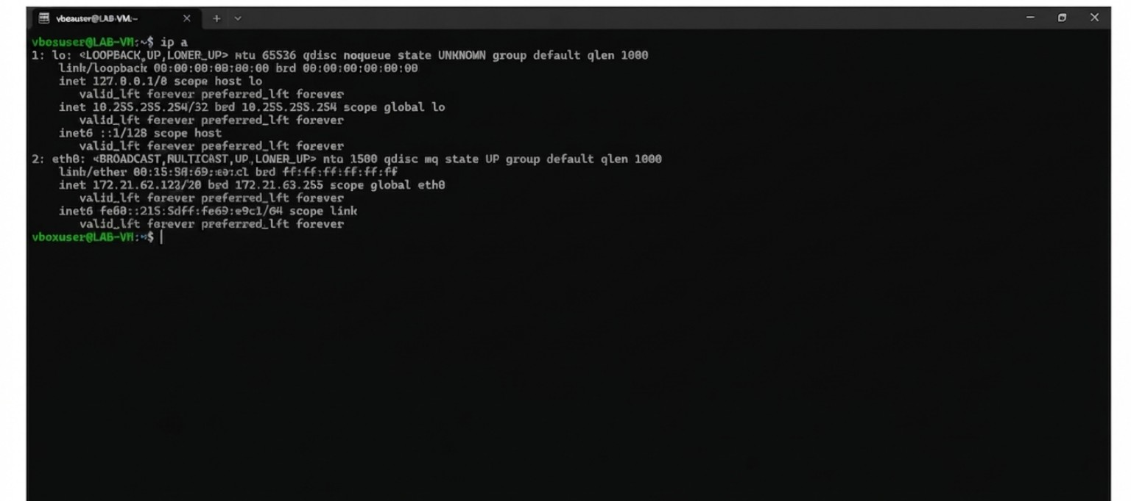
Figure 2: Network configuration using the `ip a` command
3. Create a customized NAT Network in VirtualBox.
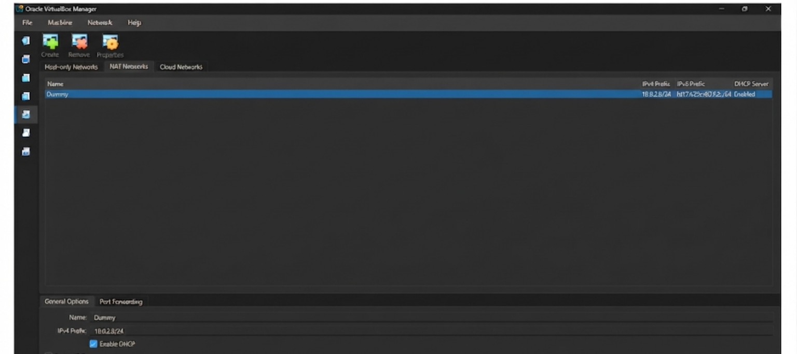
Figure 3: Customized NAT Network in VirtualBox
4. Open and view the NAT Networks tab in VirtualBox.
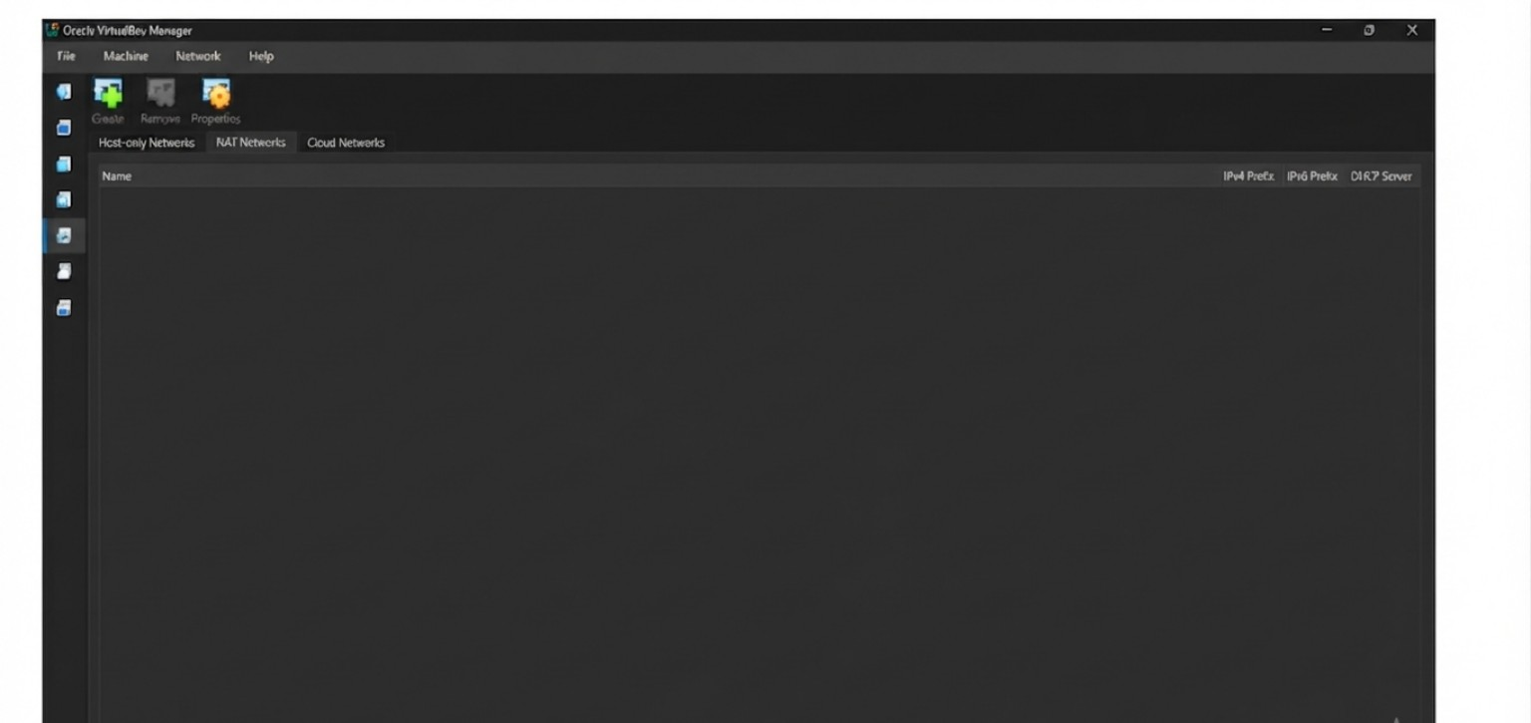
Figure 4: NAT Networks tab in VirtualBox
5. Attach the VM to the created NAT Network.
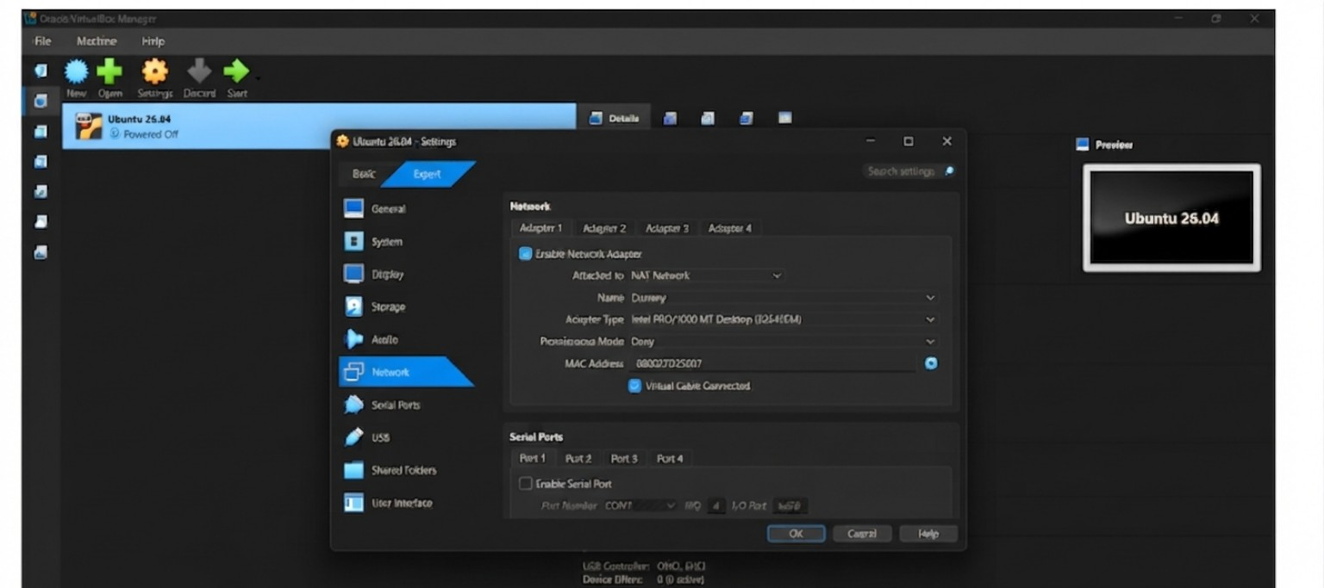
Figure 5: VM Network Settings attached to the NAT Network

