CLOUD LAB ASSIGNMENT – 2
VirtualBox Networking – NAT Network Configuration
1. Check Network Configuration using `ip a`
Open the Ubuntu terminal and execute the command `ip a` to view the network interfaces and IP configuration.
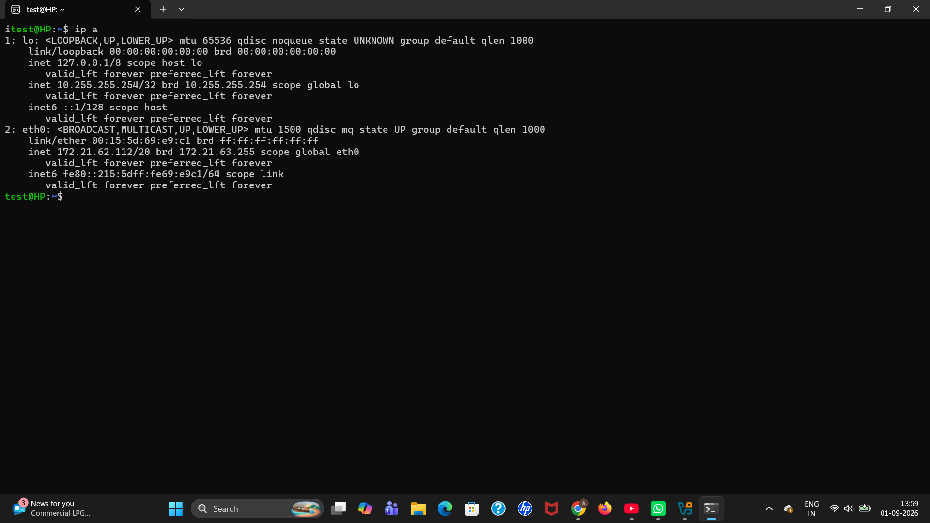
Figure 1
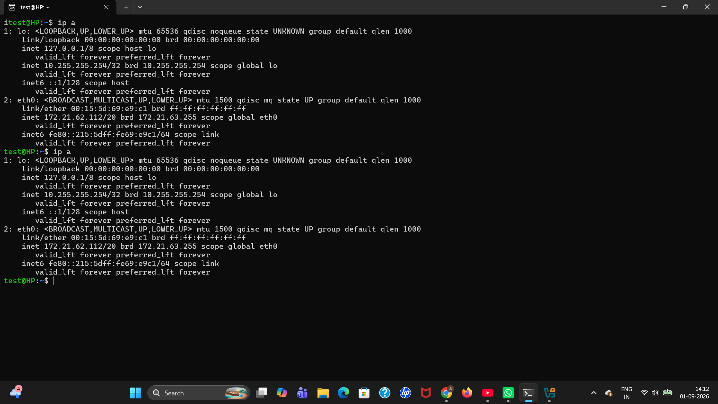
Figure 1 – VM 2

2. Create Customized NAT Network in VirtualBox
Open VirtualBox and go to Files → Tools → Network. Create a customized NAT Network.
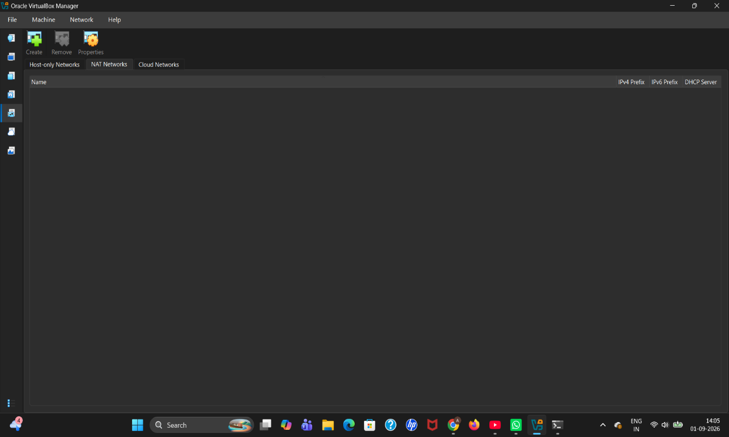
Figure 2

3. Attach the Virtual Machines to the NAT Network
For the required virtual machine, open Machine → Settings → Expert → Network. Enable the network adapter and select Attached to “NAT Network”, then select the configured network.
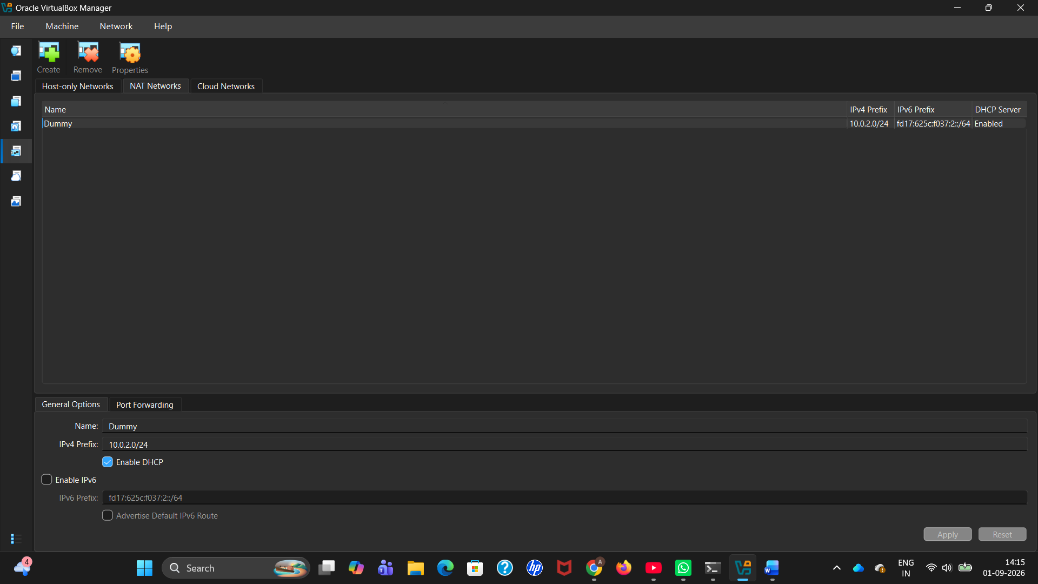
Figure 3

4. Verify the Network Configuration
Start the virtual machine and use `ip a` again to verify the network interface and IP address.
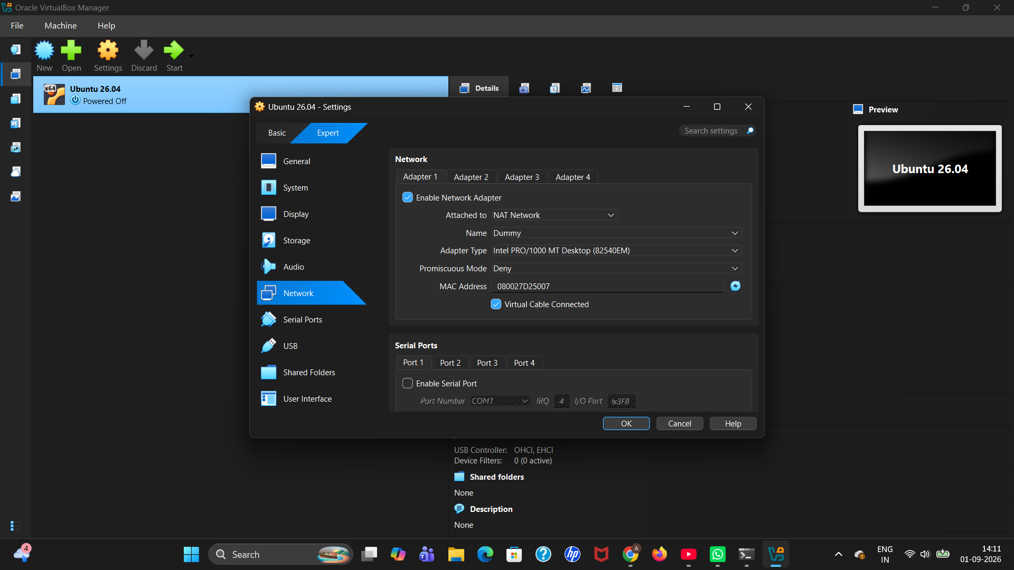
Figure 4

