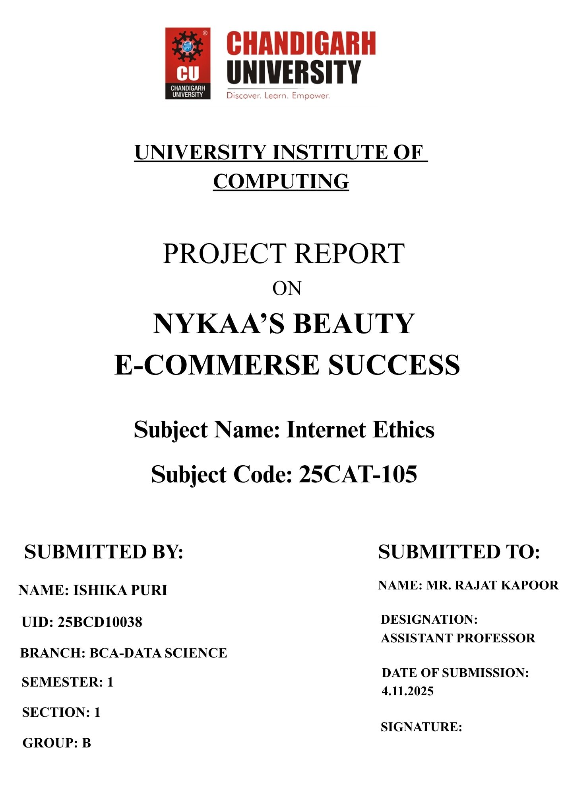

TITLE

Decoding Nykaa's Beauty E-Commerce Success: An Analysis of its Hybrid Business Model and Digital-First Marketing Strategy

AIM/ INTRODUCTION OF THE PROJECT

This project aims to dissect the phenomenal success of Nykaa, India's leading beauty e-commerce platform. The objective is to explore and understand the key pillars of its business model and its highly effective, digitally-native marketing approach. In a highly competitive market, Nykaa has not only survived but thrived by creating a trusted brand and a unique ecosystem for beauty consumers. This report will analyze how its hybrid inventory model, strategic use of influencers, and mastery of digital channels have been instrumental in building a loyal customer base and achieving profitability.

OBJECTIVE

- To analyze Nykaa's unique hybrid (Marketplace + Inventory) e-commerce business model.
- To understand the role of Nykaa's owned brands (like Nykaa Cosmetics) in its profitability.
- To explore Nykaa's multi-channel marketing strategy, with a deep dive into influencer and content marketing.
- To examine the use of digital platforms (Instagram, YouTube, own platform) for customer engagement and conversion.
- To identify the challenges and future growth avenues for Nykaa in the evolving beauty landscape.

OVERVIEW OF E-COMMERSE CONCEPT USED

Nykaa employs a Hybrid E-Commerce Model, which is a powerful combination of two primary models:
- Inventory-led Marketplace Model: Nykaa purchases inventory in bulk directly from brands (both domestic and international) and stores it in its own warehouses. This allows for:
  - Quality Control & Authenticity Guarantee: Building immense consumer trust.
  - Efficient Logistics: Control over packaging and faster delivery through its own fulfillment centers.
  - Running Promotions: Ability to offer site-wide sales and discounts.
- Managed Marketplace Model: Nykaa also allows other sellers to list their products on its platform. However, it maintains strict control over the seller onboarding process, inventory, and customer experience, ensuring a consistent brand promise.
This is complemented by a Vertical E-Commerce focus, specializing exclusively in the beauty and personal care segment, and a Private Label strategy with its highly successful owned brands.

WORKING MODEL/PROCESS FLOW

- Sourcing & Curation: Nykaa's buying team curates a wide selection of brands, from luxury (Dior, Huda Beauty) to mass (Maybelline) and indie brands. It also manufactures its own Nykaa Cosmetics and other private labels.
- Inventory Management: Purchased inventory is stored in centralized warehouses. The marketplace seller inventory is also managed as per Nykaa's standards.
- Customer's Journey:
  - Discovery: Customer discovers products via Nykaa's app/website, influencer reviews on YouTube/Instagram, or blog articles.
  - Consideration: Reads detailed product descriptions, views user-generated content (UGC), and watches video tutorials on the platform.
  - Purchase: Adds product to cart and checks out. Nykaa handles payment processing and logistics.
  - Fulfillment: Order is packed at a Nykaa fulfillment center (for its inventory) and shipped via logistics partners.
  - Post-Purchase: Customer receives the order, may create UGC, and joins the loyalty program ("Nykaa Prive Platinum").
- Content & Community Loop: The customer's experience fuels UGC, which in turn becomes content for new customers, creating a self-sustaining marketing loop.

BENEFITS AND LIMITATIONS

Benefits:
- Trust and Authenticity: The inventory model guarantees genuine products, a critical factor in the beauty category.
- Wide Selection & Curation: Offers a vast "assortment depth" across categories and price points, acting as a one-stop-shop.
- High-Margin Revenue Stream: Owned brands (Nykaa Cosmetics, Kay Beauty) provide significantly higher margins than reselling other brands.
- Content-Commerce Synergy: Integrated content (blogs, videos) drives higher engagement and reduces the need for external research, increasing conversion rates.
- Data-Driven Decisions: Owns valuable first-party data on customer preferences, which informs inventory planning and product development for its private labels.

Limitations:

- High Operational Costs: Maintaining inventory, warehouses, and a large workforce is capital-intensive.
- Inventory Risk: Risk of unsold inventory, especially for perishable or trend-driven products.
- Intense Competition: Faces competition from horizontal players (Amazon, Flipkart), vertical rivals (Purplle), and Direct-to-Consumer (D2C) brands.
- Seller Relationships: The dual role of a retailer and a competitor (via its own brands) can sometimes create friction with third-party brands on its marketplace.

TECHNOLOGY AND PAYMENT USED

Technology:
- Platform: A robust, mobile-first e-commerce website and application.
- Data Analytics & AI: Uses AI for personalized product recommendations on the app and website. Analyzes customer data to predict trends for its private labels.
- AR Technology: Implemented Augmented Reality (AR) try-on features for lipsticks and makeup, enhancing the online shopping experience.
- CRM & Loyalty Program: A sophisticated system to manage its tiered "Nykaa Prive" loyalty program, offering early access, birthday gifts, and points.
Payment System:
Nykaa offers a full suite of payment options to maximize conversion:
- Card & Net Banking: All major credit/debit cards and net banking.
- Digital Wallets: Paytm, PhonePe, etc.
- UPI: Extremely popular in India.
- Cash on Delivery (COD): A crucial option for many Indian customers.
- EMI Options: For high-value purchases like premium electronic beauty devices.

RISK AND SECURITY MEASURES

Risks:
- Counterfeit Goods (Marketplace Risk): Despite controls, a marketplace seller could list fake products, damaging Nykaa's hard-earned trust.
- Data Security: Risk of data breaches exposing customer personal and financial information.
- Supply Chain Disruptions: Logistics and inventory management challenges.
- Reputation Risk: Negative reviews from influencers or customers can spread rapidly on social media.
Security Measures:
- Seller Vetting: Rigorous checks and quality control for marketplace sellers.
- Secure Sockets Layer (SSL) Encryption: Protects data during transmission.
- PCI-DSS Compliance: For secure handling of credit card information.
- Secure Authentication: Options for OTP-based login and transactions.
- Transparent Review System: A robust user review and rating system helps in self-policing and building community trust.

FINDINGS/ANALYSIS

- The Trust Factor is the Moats: Nykaa's biggest competitive advantage is the trust it has built by guaranteeing authentic products. This is a significant barrier for new entrants.
- Content is not just Marketing, it's the Product: Nykaa successfully merged a beauty magazine (content) with a supermarket (commerce). The tutorials, reviews, and blogs reduce purchase anxiety and create a sticky platform.
- The Power of the Owned Brand: Nykaa Cosmetics and its other labels are not just revenue drivers; they are strategic tools. They allow Nykaa to control margins, gather unparalleled consumer insights, and build a distinct brand identity.
- Influencers as a Sales Force: Nykaa didn't just use influencers for branding; it integrated them into its business model. "Get Ready With Me" videos and review codes directly track sales, making influencer marketing highly ROI-positive.
- Omnichannel as a Natural Evolution: The launch of physical stores was a masterstroke. It allowed customers to experience products, provided a touch-and-feel element, and served as marketing hubs, creating a seamless online-to-offline (O2O) journey.

CONCLUSION

Nykaa's success is not an accident but a result of a meticulously crafted strategy that perfectly understood the gaps in the Indian beauty market. It built a trust-first platform through its hybrid model, educated and engaged consumers through high-quality, integrated content, and leveraged digital influencers as a core distribution channel. The strategic introduction of high-margin private labels and an omnichannel presence solidified its market leadership. Nykaa demonstrates that in niche e-commerce, deep domain expertise, community building, and controlling the entire value chain from content to commerce are the keys to building a sustainable and profitable business.

LEARNING OUTCOMES

Understanding the strategic advantage of a in Hybrid E-Commerce Model in building trust and controlling customer experience.
- Recognizing Content and Community as critical pillars for engagement and conversion in vertical e-commerce.
- Learning how to effectively leverage Influencer Marketing not just for awareness but for direct sales and credibility.
- Appreciating the strategic importance of Private Labels in improving profitability and owning customer data.
- Analyzing the role of an Omnichannel Strategy in enhancing brand presence and bridging the gap between online and offline retail.

REFERENCES

- Falguni Nayar. (2021). Nykaa's IPO Prospectus. Securities and Exchange Board of India.
- Business Today. (2021). How Nykaa became a profitable unicorn.
- Forbes India. (2022). The Nykaa Phenomenon: Building a Beauty Empire.
- Social Media Platforms: Official Nykaa Instagram (@nykaa) and YouTube channels.
- Case Study: Nykaa: Building a Beauty E-commerce Ecosystem. Ivey Publishing.

