
Mini Project Report

on

Smart Traffic Management System

BACHELOR OF TECHNOLOGY COMPUTER SCIENCE AND ENGINEERING

Submitted by:

Ishika Ishwar Geed - VI-A (23070521060)

UNDER THE GUIDANCE OF

Dr. Piyush Chauhan

Assistant Professor

DEPARTMENT OF COMPUTER SCIENCE AND ENGINEERING
AY 2025-26

1. Introduction
Traffic congestion is one of the most critical challenges faced by urban populations worldwide. With the exponential growth in the number of vehicles on roads, especially in developing countries like India, managing and monitoring road traffic has become a necessity rather than a luxury. The lack of real-time traffic information often leads to longer commute times, increased fuel consumption, higher carbon emissions, and a deterioration in the overall quality of urban life.
Modern mobile technology, particularly Android-based applications, has opened up new avenues for addressing these challenges. Smartphones are now capable of gathering, processing, and displaying real-time data in a user-friendly manner, making them an ideal platform for a smart traffic monitoring solution.
The Smart Traffic System is an Android application developed as a mini project for the subject of Android Programming. The application is designed to provide users with a real-time overview of traffic conditions at multiple road locations. It displays traffic density levels and corresponding status indicators, enabling users to make informed decisions about their travel routes and timing. Additionally, the application features an image upload module that allows users to contribute road imagery, which can be used for automated traffic density analysis in future iterations.
This project is built using Java as the primary programming language and follows the MVVM (Model-View-ViewModel) architectural pattern, which is the industry-recommended approach for developing scalable and maintainable Android applications. The UI leverages the latest Material Design 3 component library to deliver a modern, intuitive, and visually consistent user experience.
The report that follows provides a comprehensive account of the project — covering its objectives, system design, technical architecture, implementation details, source code description, screenshots, and future enhancement possibilities.

2. Problem Statement
Commuters in urban areas routinely face the problem of not having access to accurate and up-to-date traffic information before and during their journey. Existing traffic information systems are often fragmented, platform-specific, or require expensive hardware infrastructure. The absence of a simple, lightweight, and accessible mobile application that consolidates traffic data from multiple road locations leads to the following issues:
- Drivers spend excessive time in congested areas due to lack of route awareness.
- Emergency vehicles are delayed because of unpredictable traffic bottlenecks.
- Urban traffic management authorities lack an easy way to crowdsource road condition reports.
- Commuters cannot plan trips in advance based on current or expected traffic density.

The Smart Traffic System addresses these problems by providing a centralized, mobile-first dashboard that aggregates traffic data for multiple locations, presents it with clear visual indicators, and allows users to actively participate in data collection through image uploads.

3. Objectives
The primary and secondary objectives of this project are outlined below:

3.1 Primary Objectives
- To design and develop an Android application that displays real-time traffic status for multiple road locations on a centralized dashboard.
- To implement a live search and filter functionality that allows users to quickly find specific locations within the traffic list.
- To develop an image upload module where users can select a road image from their device gallery and submit it for traffic density processing.
- To apply the MVVM architectural pattern for clean separation of UI, business logic, and data concerns.

3.2 Secondary Objectives
- To implement Material Design 3 UI components for a polished, modern, and consistent user experience.
- To use Android Jetpack components including ViewBinding, LiveData, and ViewModel for robust and lifecycle-aware data handling.
- To resolve Gradle build compatibility issues to ensure a stable and reproducible build environment.
- To lay the groundwork for future integration with a live backend API and machine learning-based traffic density analysis.

4. System Design and Architecture

4.1 Architectural Pattern: MVVM
The application follows the MVVM (Model-View-ViewModel) architectural pattern, which is recommended by Google for Android development. MVVM promotes a clear separation of concerns, making the codebase easier to test, maintain, and scale. The three layers of MVVM are described as follows:

Model
The Model layer represents the data and business logic of the application. In this project, the TrafficData class serves as the data model. It encapsulates information about a single traffic location, including its name, current traffic status (Heavy, Moderate, or Clear), and the density percentage. A TrafficRepository class acts as the single source of truth for data, currently providing mock data for demonstration purposes but designed to support live API integration via Retrofit in future versions.
View
The View layer is responsible for rendering the user interface and responding to user interactions. It consists of two Activity classes: MainActivity, which hosts the traffic dashboard and search functionality, and UploadActivity, which handles the image selection and processing workflow. A custom RecyclerView adapter, TrafficAdapter, is also part of the View layer and is responsible for binding individual TrafficData objects to the item_traffic.xml layout for display in the list.
ViewModel
The ViewModel layer serves as an intermediary between the Model and the View. The TrafficViewModel class fetches data from the TrafficRepository and exposes it to the View through LiveData — a lifecycle-aware observable data holder. Because ViewModel instances survive configuration changes such as screen rotations, the data is not re-fetched unnecessarily, improving performance and user experience.

4.2 Application Flow
The application flow is straightforward and user-friendly. Upon launch, the user is presented with the Smart Traffic Dashboard (MainActivity), which automatically populates the RecyclerView with traffic data sourced from the ViewModel. The user can type in the search bar to filter locations by name. To report or analyze a new road condition, the user taps the Floating Action Button (FAB) in the bottom-right corner, which navigates them to UploadActivity. There, the user selects an image from their gallery, previews it, and triggers the density processing pipeline.

4.3 Data Flow Diagram
The data flows through the application as follows:

TrafficRepository → TrafficViewModel (LiveData) → MainActivity → TrafficAdapter → RecyclerView (UI)

5. Key Features Implemented

5.1 Real-Time Traffic Dashboard
The main screen of the application presents a scrollable, card-based list of traffic locations. Each card displays the location name, current traffic status, and density percentage. The dashboard is powered by a RecyclerView combined with a custom adapter and a ViewModel that holds the data in a LiveData object. The UI automatically updates whenever the underlying data changes, without requiring any manual refresh action from the user.

5.2 Visual Traffic Status Indicators (Color-Coding)
One of the most important features of the application is its ability to communicate traffic severity at a glance through color-coded visual indicators. The application defines three distinct traffic categories based on vehicle density:

Status | Density Threshold | Description
Heavy (Red) | Density >= 80% | Severe congestion; travel strongly discouraged
Moderate (Orange) | 40% <= Density < 80% | Moderate flow; some delay expected
Clear (Green) | Density < 40% | Free-flowing traffic; no significant delay

Table 1: Traffic Status Classification by Density

5.3 Live Search and Filtering
A search bar implemented using TextInputLayout (Material3 outlined style) is positioned at the top of the dashboard. A TextWatcher is registered on the inner TextInputEditText field, so every keystroke triggers the adapter's filter() method in real time. This means the RecyclerView list is immediately narrowed down to locations whose names match the user's query, providing a fast and responsive search experience without any additional button press.

5.4 Image Upload and Preview
The upload functionality is implemented in UploadActivity. The user initiates the selection by tapping the 'Select Image from Gallery' button, which launches an image picker via Android's ActivityResultLauncher API using the ActivityResultContracts.StartActivityForResult contract. This is the modern replacement for the deprecated startActivityForResult() + onActivityResult() pattern, providing cleaner code and better lifecycle management.
Once an image is selected, its URI is stored in a local variable and displayed in the preview ImageView contained within a MaterialCardView. The user can then press 'Process Traffic Density' to submit the image. In this version, a toast message confirms the action; the full ML-based density processing pipeline is identified as a future enhancement.

5.5 Modern Material Design 3 Interface
The application uses the Material Components for Android (Material3) library throughout its UI. Key components used include: MaterialToolbar for the top app bar, MaterialCardView for traffic list items and image preview, TextInputLayout with outlined style for the search bar, MaterialButton and tonal MaterialButton for actions, and FloatingActionButton (FAB) for primary navigation. The dark-themed color scheme with a lavender-purple primary color provides a sleek, contemporary aesthetic that is consistent across both screens.

6. Implementation Details

6.1 MainActivity.java
MainActivity is the launcher activity and serves as the primary user interface. In the onCreate() method, it inflates the layout using ViewBinding (ActivityMainBinding), sets up the RecyclerView, initializes the ViewModel, and registers event listeners. The four private setup methods each handle a distinct responsibility:
- setupRecyclerView(): Creates and assigns a LinearLayoutManager and a TrafficAdapter instance to the RecyclerView.
- setupViewModel(): Obtains a TrafficViewModel instance via ViewModelProvider and begins observing the LiveData<List<TrafficData>> stream. When data updates are posted, the adapter's dataset is refreshed accordingly.
- setupListeners(): Attaches an OnClickListener to the FloatingActionButton (fabUpload) that starts UploadActivity via an explicit Intent.
- setupSearch(): Registers a TextWatcher that calls adapter.filter(query) on every text change in the search field, enabling real-time filtering.

6.2 UploadActivity.java
UploadActivity manages the road image upload workflow. It uses ViewBinding (ActivityUploadBinding) for safe view access. An ActivityResultLauncher is registered at the class level using registerForActivityResult(), which receives the selected image URI via the result callback. The URI is stored in a selectedImageUri field and the preview ImageView is updated. The process button checks whether an image has been selected before proceeding, showing an appropriate toast message in either case.
Crucially, the activity uses getSupportActionBar() to configure an Up (back) button in the toolbar, and onSupportNavigateUp() calls onBackPressed() to handle it, providing a standard navigation experience consistent with Android design guidelines.

6.3 XML Layout Files
Three XML layout files define the visual structure of the application's screens:

activity_main.xml
This layout uses a CoordinatorLayout as the root, which enables scroll-aware behavior. Inside it, an AppBarLayout hosts a MaterialToolbar with the application title 'Smart Traffic Dashboard'. A ConstraintLayout acts as the content area, containing a TextInputLayout (search bar at the top) and a RecyclerView below it. A FloatingActionButton is positioned at the bottom-right using layout_gravity.
activity_upload.xml
This layout uses a vertical LinearLayout centered both horizontally and vertically, with 24dp padding. It contains a large headline TextView, a MaterialCardView (300dp tall, 16dp corner radius) housing the image preview ImageView, and two MaterialButtons — one primary (Select Image) and one tonal (Process Traffic Density).
item_traffic.xml
This is the layout for each row in the RecyclerView. A MaterialCardView with a 12dp corner radius and 4dp elevation wraps a vertical LinearLayout. Inside it, a primary-colored TextView shows the location name (TitleMedium style), a horizontal LinearLayout shows 'Status: ' followed by a bold, dynamically colored status label, and a BodySmall TextView shows the density percentage.

6.4 Build Configuration and Gradle Compatibility
A critical build issue was encountered during development related to Gradle version compatibility. The error 'Cannot mutate dependencies after configuration' arose due to a mismatch between the Gradle Wrapper version and the Android Gradle Plugin (AGP) version. This was resolved by aligning the Gradle Wrapper to version 8.7 with AGP version 8.2.2. Proper version alignment is essential in Android projects to ensure stable, reproducible builds and to leverage the latest compilation optimizations.

7. Application Screenshots
The following screenshots were captured from the working application running on a physical Android device. They demonstrate the complete user interface as implemented.

7.1 Smart Traffic Dashboard
Figure 1 shows the main dashboard screen. Four road locations are displayed — Downtown Crossing (Heavy, 85%), North Station (Moderate, 45%), Airport Road (Clear, 10%), and West End (Heavy, 90%). The color-coded status labels (red, orange, and green) and status icons are clearly visible alongside each card. The search bar is at the top, and the purple FAB appears at the bottom right.

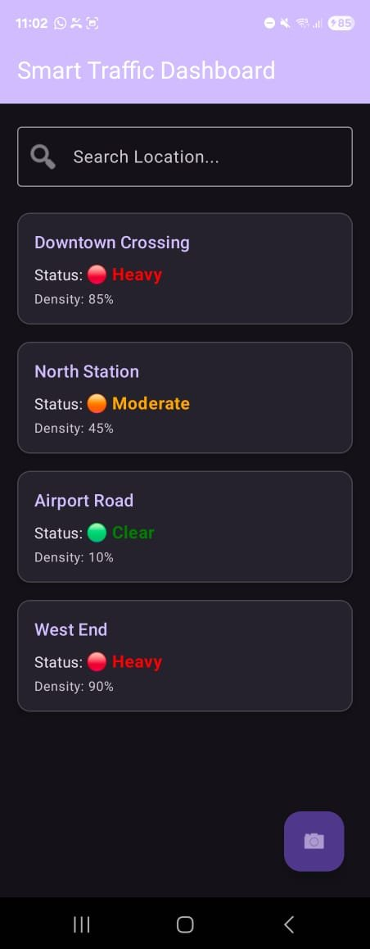
Figure 1: Smart Traffic Dashboard — Main Screen with Real-Time Traffic Status Cards

7.2 Upload Screen — Empty State
Figure 2 shows the Upload Road Image screen in its initial empty state. The image preview card displays a placeholder gallery icon. Both action buttons ('Select Image from Gallery' and 'Process Traffic Density') are displayed below the card, and the purple-themed toolbar indicates navigation context.

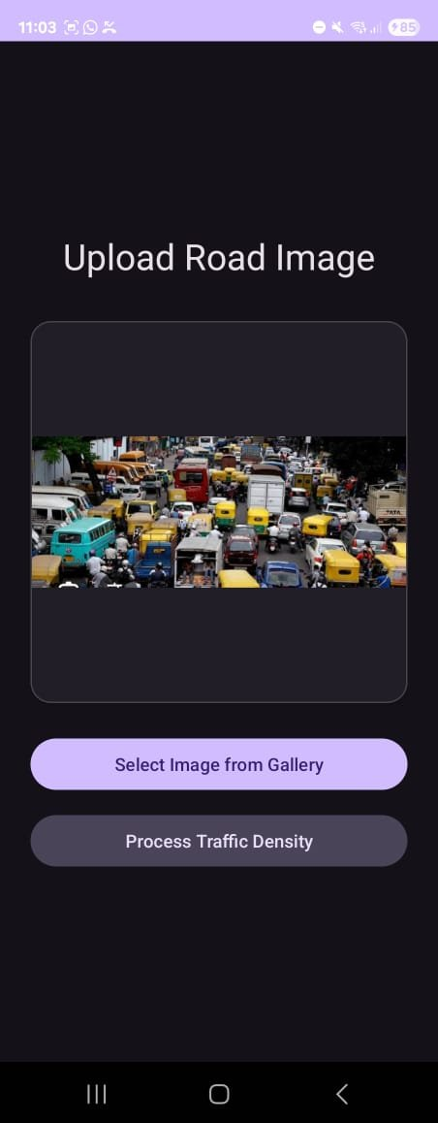
Figure 2: Upload Road Image Screen — Initial Empty State Before Image Selection

7.3 Upload Screen — Image Loaded
Figure 3 demonstrates the upload screen after the user has selected a road image from the device gallery. The image — depicting a heavily congested Indian road intersection with numerous vehicles — is rendered inside the preview card. This confirms that the ActivityResultLauncher correctly captures the selected URI and binds it to the ImageView.

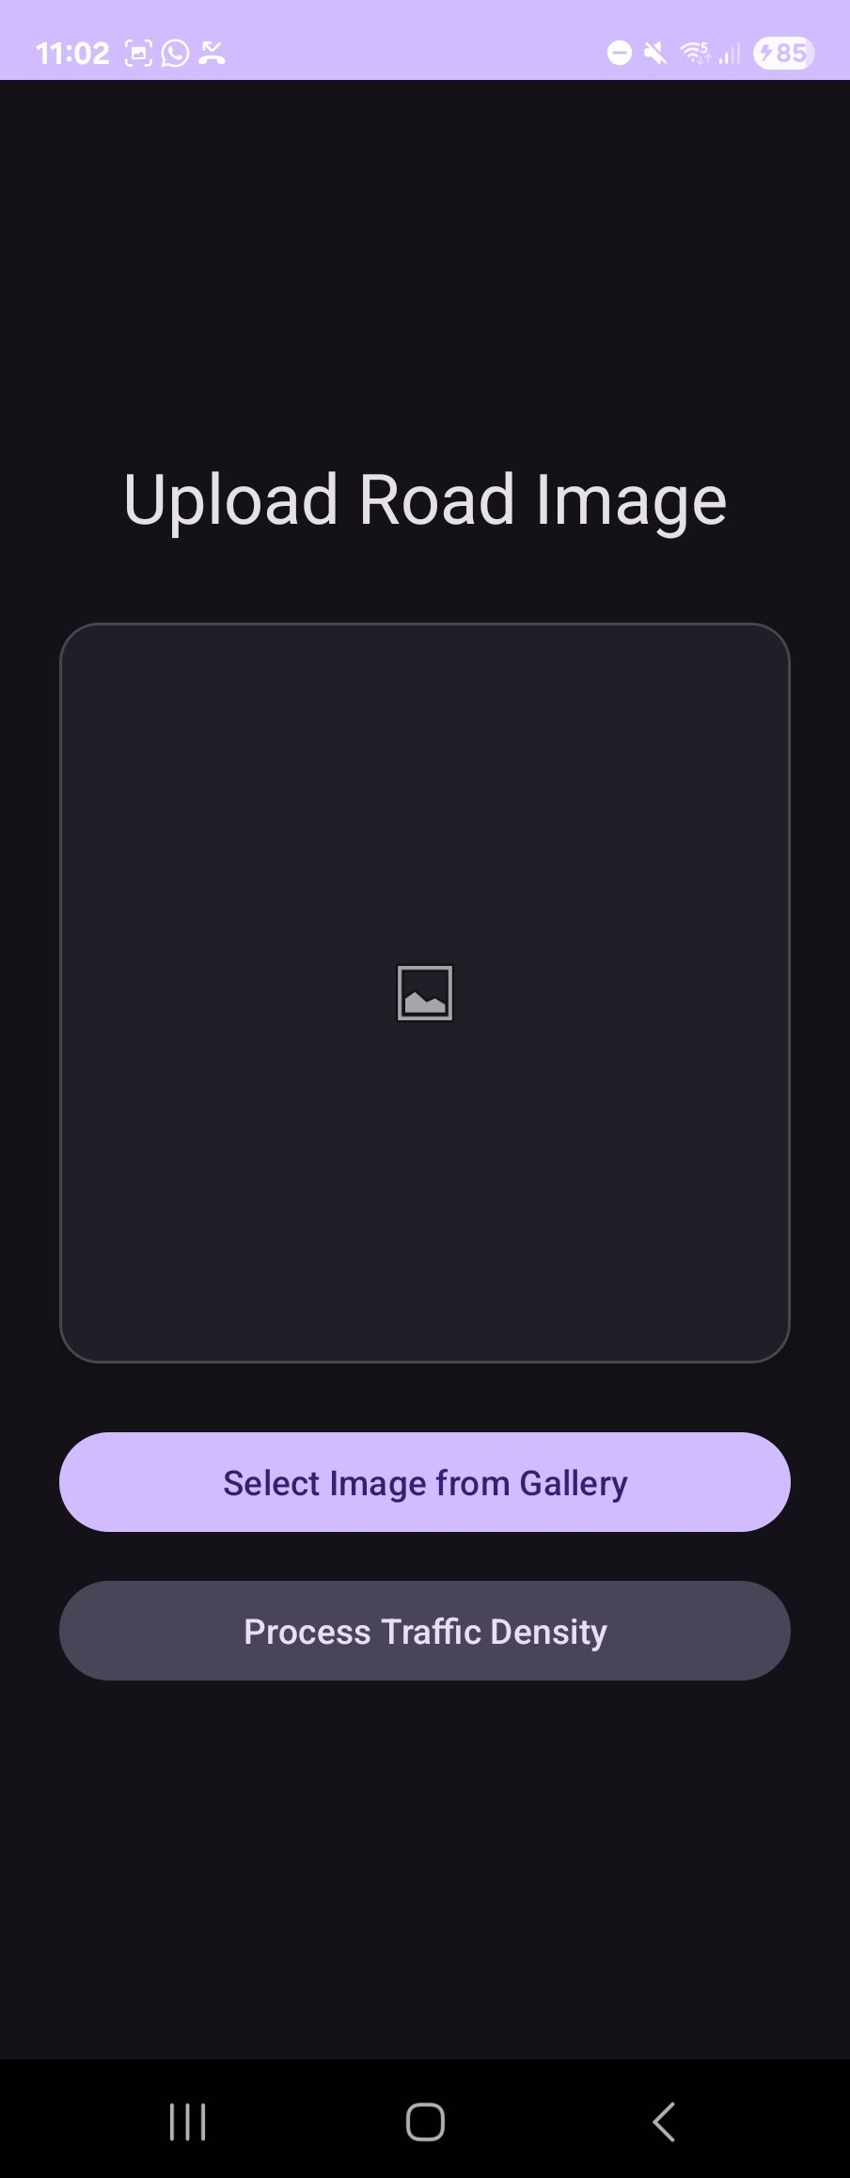
Figure 3: Upload Road Image Screen — Road Image Selected and Ready for Processing

8. Technology Stack
The following table summarizes all technologies, libraries, and tools used in the development of the Smart Traffic System application:

Category | Technology / Detail
Platform | Android (Minimum SDK: API 21, Target: Latest)
Language | Java
Architecture | MVVM (Model-View-ViewModel)
UI Library | Material Components for Android (Material Design 3)
Layout | ConstraintLayout, LinearLayout, CoordinatorLayout
View Access | ViewBinding (ActivityMainBinding, ActivityUploadBinding)
Data Observability | LiveData + ViewModel (Android Jetpack)
List Rendering | RecyclerView with LinearLayoutManager
Image Handling | ActivityResultLauncher (ActivityResultContracts)
Networking (Ready) | Retrofit 2 + Gson Converter (prepared for API)
Build System | Gradle 8.7 with Android Gradle Plugin 8.2.2
IDE | Android Studio

Table 2: Complete Technology Stack

9. Challenges Faced and Solutions

9.1 Gradle Version Compatibility
One of the most significant technical challenges encountered during the project was a Gradle build failure. The error message 'Cannot mutate dependencies after configuration has been resolved' was thrown during the build process. After investigation, this was traced to a version mismatch between the Gradle Wrapper (which was at a lower version) and the Android Gradle Plugin (AGP) being used. The solution was to explicitly update the Gradle Wrapper to version 8.7 and align the AGP to version 8.2.2 in the project-level build.gradle file. This resolved the conflict and restored build stability.

9.2 Layout Optimization with ConstraintLayout
Early versions of the main dashboard used a basic LinearLayout, which caused performance issues when the RecyclerView and search bar were nested together. Replacing the outer container with a ConstraintLayout allowed the search bar and the RecyclerView to be constrained relative to each other without nesting, resulting in a flatter view hierarchy and more responsive rendering on lower-end devices.

9.3 Resource Linking Errors
During development, several XML resource linking errors were encountered due to referencing drawables and styles that were either misspelled or not correctly defined in the resource files. These were systematically resolved by verifying resource IDs in the res/values/ and res/drawable/ directories and correcting the references in the layout files. This exercise reinforced the importance of consistent resource naming conventions in Android projects.

9.4 Deprecated API Migration
The original prototype used the deprecated startActivityForResult() method for launching the image picker. As part of aligning the project with modern Android development standards, this was migrated to the ActivityResultLauncher pattern using ActivityResultContracts.StartActivityForResult. This not only eliminated the deprecation warning but also made the code cleaner and more modular.

10. Future Scope and Enhancements
The Smart Traffic System in its current form is a functional prototype that demonstrates core Android programming concepts. However, there are numerous avenues for enhancement that would transform it into a production-ready smart city solution:

10.1 Machine Learning Integration
The most impactful enhancement would be the integration of an on-device or cloud-based machine learning model for automated traffic density analysis. A YOLO (You Only Look Once) object detection model or a TensorFlow Lite model could be deployed to count vehicles in uploaded road images and compute a precise density percentage. This would make the 'Process Traffic Density' button fully functional and provide real value to traffic management authorities.

10.2 Google Maps API Integration
Integrating the Google Maps Android API would allow the application to display traffic status visually on an interactive map. Road segments could be color-coded (red, orange, green) based on their current density, providing a geographic and spatial understanding of traffic conditions that is far more intuitive than a text-based list.

10.3 Live Backend API Integration
The application is already architecturally prepared for live API integration through its Repository pattern and Retrofit/Gson setup. Connecting to a live REST API would allow the traffic data to be sourced from a real database, updated continuously, and shared across multiple users. Firebase Realtime Database or a custom Node.js/Django backend could serve as the data source.

10.4 Push Notifications
Using Firebase Cloud Messaging (FCM), the application could be enhanced to send push notifications to users when the traffic status in their saved or frequently visited locations escalates to 'Heavy'. This would provide proactive, time-sensitive alerts without the user needing to open the app.

10.5 Weather API Integration
Traffic density is often heavily influenced by weather conditions. Integrating a Weather API (such as OpenWeatherMap) would allow the application to display current weather conditions alongside traffic status, giving users a fuller picture of road conditions. For example, heavy rain or fog could be flagged as additional risk factors even when vehicle density is moderate.

10.6 User Authentication and Personalization
Adding user authentication via Firebase Authentication would enable personalized features such as saving favorite locations, viewing personal traffic history, and receiving tailored notifications. Users could also contribute verified road reports, and a rating system could be implemented to ensure data quality.

11. Conclusion
The Smart Traffic System Android application represents a comprehensive practical exercise in modern Android application development. Over the course of this mini project, a fully functional Android application was designed, architected, and implemented using industry-standard tools and design patterns.
The project successfully demonstrates the application of the MVVM architectural pattern, which enforces a clean separation between the user interface, data logic, and business rules. The use of Android Jetpack components — particularly LiveData and ViewModel — ensures that the application is lifecycle-aware, efficient, and resilient to common issues such as data loss on screen rotation. ViewBinding provides safe and concise access to layout views, eliminating the risk of NullPointerExceptions from manual view lookups.
The user interface, built with Material Design 3 components, delivers a modern, professional, and accessible experience. The color-coded traffic status indicators (red for Heavy, orange for Moderate, and green for Clear) make traffic data immediately comprehensible at a glance, even for users with no technical background.
The image upload module, powered by the modern ActivityResultLauncher API, demonstrates the correct approach to media selection in contemporary Android development. The overall application architecture is designed with extensibility in mind — Retrofit and the Repository pattern are already in place to support seamless integration with a live backend API.
Several real-world engineering challenges were encountered and resolved during development, including Gradle version compatibility issues, layout hierarchy optimization, and migration from deprecated APIs. These experiences provide valuable practical insight into professional Android development workflows.
In conclusion, the Smart Traffic System not only meets the requirements of the Android Programming course but also serves as a solid foundation for a production-grade smart city mobility application. With the proposed future enhancements — including ML-based density analysis, Google Maps integration, and push notifications — this application has the potential to make a meaningful contribution to urban traffic management and commuter convenience.

References
- Android Developers Official Documentation. (2024). Guide to App Architecture. Google. https://developer.android.com/topic/architecture
- Android Developers. (2024). ViewModel Overview. Android Jetpack. https://developer.android.com/topic/libraries/architecture/viewmodel
- Android Developers. (2024). LiveData Overview. Android Jetpack. https://developer.android.com/topic/libraries/architecture/livedata
- Android Developers. (2024). RecyclerView. https://developer.android.com/guide/topics/ui/layout/recyclerview
- Material Design. (2024). Material Design 3 for Android. Google. https://m3.material.io/develop/android
- Android Developers. (2024). View Binding. https://developer.android.com/topic/libraries/view-binding
- Square Inc. (2024). Retrofit — A type-safe HTTP client for Android and Java. https://square.github.io/retrofit/
- Android Developers. (2024). Getting a result from an Activity. https://developer.android.com/training/basics/intents/result

