AI-ML PROJECT
1.)SPEAK-YO-FOOD
I built Chalk & Cart, a voice-driven grocery shopping assistant — a web app where you speak commands like 'add two apples' or ask it to walk you through a recipe's ingredients, and it builds your shopping cart in real time, with brand and price comparison built in. It's entirely client-side — no backend server , using the browser's native speech APIs plus a custom command-parsing layer I wrote.
How it works, step by step
- Voice input — the browser's built-in SpeechRecognition API (Web Speech API) converts spoken audio into text, free and with zero setup — no external API key needed.
- Command parsing — that transcript goes through a rule-based NLP layer I wrote: it extracts the intent (add/remove/search), the item, and the quantity from flexible phrasing ("I need milk" vs "add milk" both resolve the same way).
- Catalog matching — the parsed item is matched against a 72-item product catalog (organized by category, each with multiple brand options and prices), and a confirmation card appears with brand/quantity selection.
- State update — confirming adds it to an in-memory cart, which renders as a running receipt with a live total.
- Smart suggestions layer — three separate heuristics stacked on top: seasonal picks, substitute suggestions, and a purchase-history tracker that resurfaces "you're running low on X" once you've bought something twice.
- There's also a guided conversational mode — it asks what recipe you're making, looks it up in a small recipe dataset, and walks you through each ingredient one at a time using text-to-speech (SpeechSynthesis), pausing to let you pick a brand when there's more than one option.

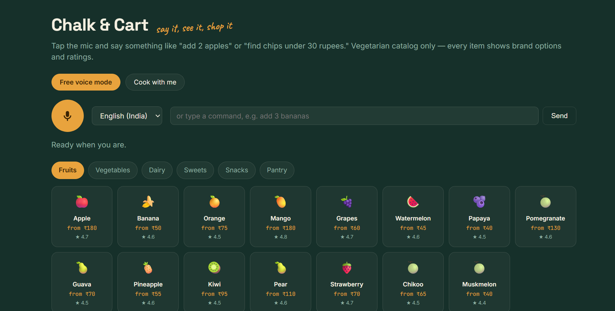
1.) SPEAK ABOUT INGREDIENTS
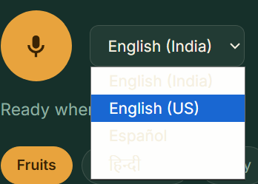
2.)MULTI LANGUAGE FLEXIBILITY
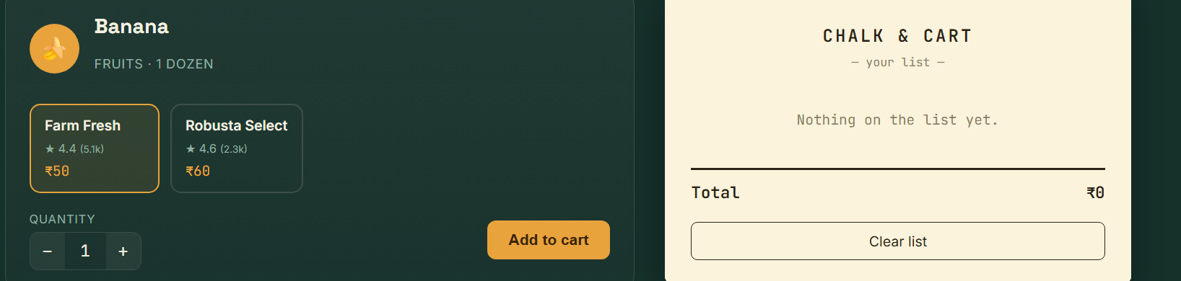
3.)VARIETY OF BRANDS

4.)RECOMMENDATION SYSTEM
also we have speaking ai bot ,u can talk to it and tell it u want to make specific recipe and it would give us all ingredients
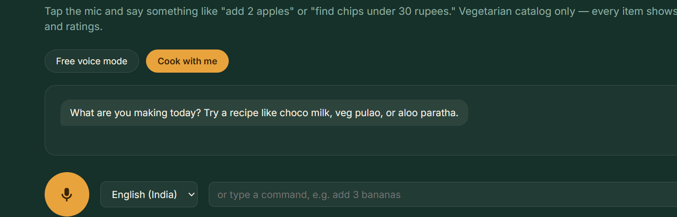
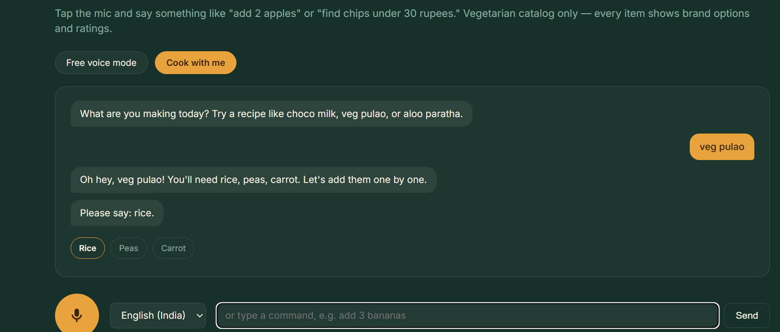
It automatically adds items to the cart
THANK YOU!

