EXPLORATORY DATA ANALYSIS
E-Commerce Order Dataset — Diagnostic Report
Project 2 · Data Analytics Internship Kit
Prepared by: Ishika Prajapati - Data Analyst Intern | Batch 2026 | DecodeLabs
Dataset: Dataset_for_Data_Analytics.xlsx (1,200 orders × 14 fields
Github: https://github.com/IshikaPrajapati/DecodeLabs-Internship

1. Executive Summary
This report presents an exploratory data analysis (EDA) of DecodeLabs' e-commerce order dataset, covering 1,200 transactions recorded between January 2023 and June 2025. The objective was to move beyond a static table of numbers and uncover the patterns, trends, and anomalies that describe how customers order, what they spend, and where operational risk sits in the fulfillment pipeline.
The dataset is clean and internally consistent: there are no duplicate orders, and Total Price reconciles exactly with Quantity × Unit Price for all 1,200 records. The only incompleteness is in the Coupon Code field, where 309 orders (25.8%) legitimately carry no code because no coupon was applied. Overall data completeness is effectively 100% once this is accounted for.

Key Findings
- Average order value is $1,053.97, but the median ($823.62) sits well below it — order value is right-skewed, driven by a small cluster of high-quantity, high-price orders.
- 8 orders (0.7%) qualify as statistical outliers on Total Price using the IQR method, all representing maximum-quantity (5-unit) purchases of premium-priced items — these are legitimate bulk orders, not data errors.
- 41.4% of all orders end in Cancelled or Returned status, the single largest revenue-at-risk signal in the dataset.
- Unit Price and Quantity together explain order value, with Unit Price the stronger driver (r = 0.72) — high-ticket items, not bulk buying, is what pushes revenue per order.
- Order volume is stable year-over-year (~39–43 orders/month) and shows no strong seasonality once the partial 2025 data window is corrected for.

2. Methodology
The analysis followed the standard IPO (Input → Process → Output) framework taught in this module:
- Input: Raw dataset audited for missing values, duplicates, and referential consistency (e.g., Total Price = Quantity × Unit Price).
- Process: Descriptive statistics (mean, median, quartiles) computed for all numeric fields; distribution shape assessed via histograms; outliers flagged using the IQR method (1.5× IQR fences); relationships explored using Pearson correlation.
- Output: Findings translated into business-relevant observations and prioritized recommendations, avoiding raw statistical jargon in favor of actionable framing.
Tools used: Python (pandas for statistics and aggregation, matplotlib for visualization).

3. Data Overview & Quality Audit
The dataset contains 1,200 order-level records across 14 fields spanning three data types: identifiers (OrderID, CustomerID, TrackingNumber), categorical attributes (Product, PaymentMethod, OrderStatus, CouponCode, ReferralSource, ShippingAddress), and numeric measures (Quantity, UnitPrice, ItemsInCart, TotalPrice), plus an order Date.
1,200  Total Orders | 14  Fields | Jan '23–Jun '25  Date Range | 100%  Data Completeness

Data Quality Notes
- Duplicates: none found.
- Missing values: only CouponCode (309 nulls / 25.8%) — confirmed to represent 'no coupon applied' rather than a data entry gap.
- Referential integrity: Total Price validated as an exact product of Quantity and Unit Price across all 1,200 rows — no calculation errors in the source system.
- Every OrderID and TrackingNumber is unique; CustomerID has 1,189 unique values across 1,200 orders, indicating a small number of repeat customers.

4. Univariate Analysis — Central Tendency & Spread
The table below summarizes the core descriptive statistics for each numeric field.
Metric | Quantity | Unit Price ($) | Items in Cart | Total Price ($)
Count | 1,200 | 1,200 | 1,200 | 1,200
Mean | 2.95 | 356.41 | 5.49 | 1,053.97
Median | 3.00 | 364.21 | 5.00 | 823.62
Std. Dev. | 1.41 | 197.18 | 2.28 | 819.86
Min | 1 | 11.39 | 1 | 11.39
Max | 5 | 699.93 | 10 | 3,456.40
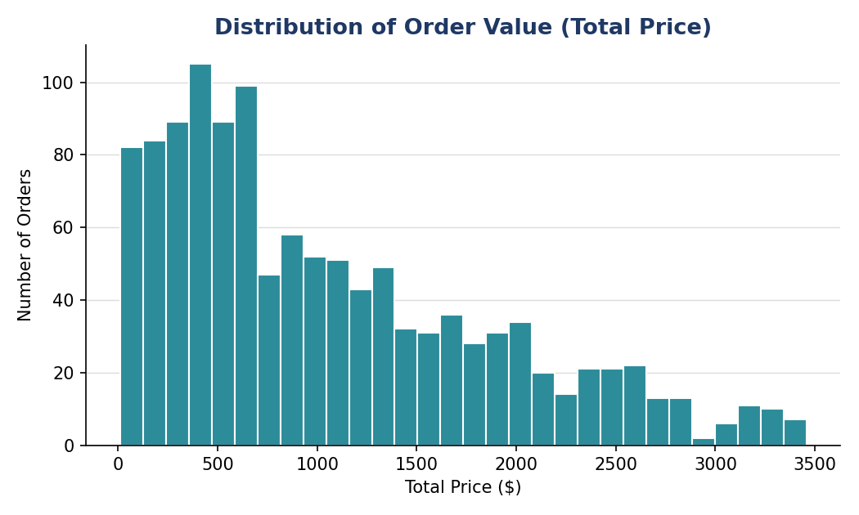
Figure 1: Distribution of Total Price — right-skewed, so the median ($823.62) is the more reliable 'typical order' figure than the mean.
Because Total Price is right-skewed (mean > median), the mean is pulled upward by a subset of large orders. This is the classic 'Elon Musk in the room' effect described in the training material: for reporting a 'typical' order value to stakeholders, the median is the more honest metric, while the mean remains useful for revenue-forecasting purposes where the total dollar impact matters.

5. Outlier Analysis
Outliers were flagged using the IQR method (values beyond Q1 − 1.5×IQR or Q3 + 1.5×IQR). Quantity, Unit Price, and Items in Cart produced zero outliers — all values fall within expected operational bounds. Total Price produced 8 outliers (0.67% of orders), all above the upper fence of $3,330.41.
Order ID | Product | Qty | Unit Price ($) | Total Price ($) | Status
ORD200789 | Tablet | 5 | 691.28 | 3,456.40 | Delivered
ORD201122 | Monitor | 5 | 678.19 | 3,390.95 | Returned
ORD200632 | Laptop | 5 | 678.16 | 3,390.80 | Delivered
ORD200469 | Chair | 5 | 676.98 | 3,384.90 | Cancelled
ORD200328 | Tablet | 5 | 674.04 | 3,370.20 | Cancelled
ORD200107 | Printer | 5 | 670.75 | 3,353.75 | Shipped
ORD200326 | Laptop | 5 | 670.48 | 3,352.40 | Returned
ORD201065 | Printer | 5 | 666.80 | 3,334.00 | Delivered
Diagnosis — Signal, not Noise: every outlier is a maximum-quantity (5-unit) order of a premium-priced item. This is a coherent, explainable pattern rather than a data-entry error, so these records should be retained rather than removed. They represent DecodeLabs' highest-value transactions and are worth flagging for VIP/bulk-buyer treatment rather than being treated as noise to clean out.
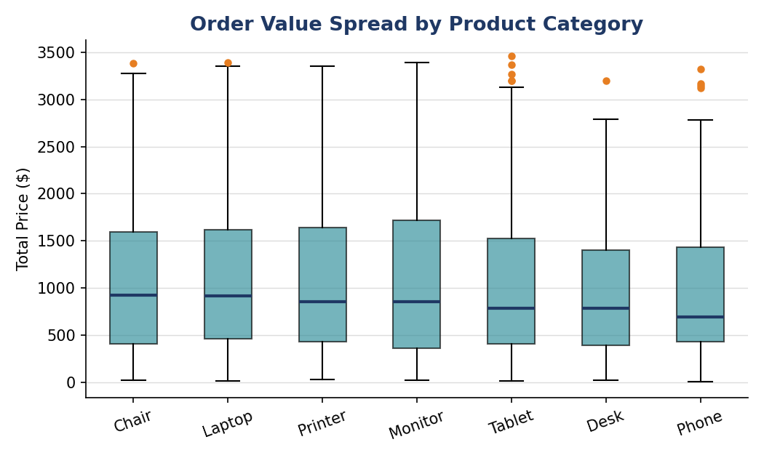
Figure 2: Order value spread by product — boxes show the interquartile range; dots mark the 8 high-value outliers, concentrated among Tablet, Laptop, and Printer purchases.

6. Relationships Between Variables
A Pearson correlation matrix was computed across the four numeric fields to identify what drives order value.
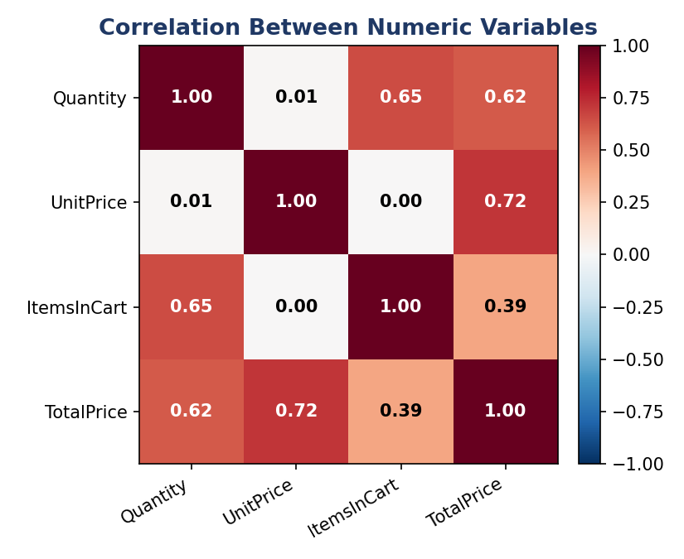
Figure 3: Correlation matrix — Unit Price (r = 0.72) is the strongest driver of Total Price, followed by Quantity (r = 0.62).
- Unit Price → Total Price: r = 0.72 (strong positive) — the price of the item, not how many units are bought, is the primary revenue driver.
- Quantity → Total Price: r = 0.62 (moderate-strong positive) — bulk buying still matters, but secondarily.
- Quantity → Items in Cart: r = 0.65 — customers who order more units per line also tend to have fuller carts, as expected.
- Unit Price → Quantity: r = 0.02 (negligible) — customers do not appear to buy fewer units when the item is more expensive, at least within this catalog's price range.
Golden Rule reminder: these are correlations, not causal proof. For example, high Unit Price and high Total Price move together almost by construction (Total Price is a direct function of Unit Price), so this relationship confirms the calculation logic more than it reveals new customer behavior. The more actionable relationship is Quantity vs. Items in Cart, which suggests genuine bulk-purchase behavior worth targeting with cart-based promotions.

7. Categorical & Trend Analysis

7.1 Revenue by Product Category
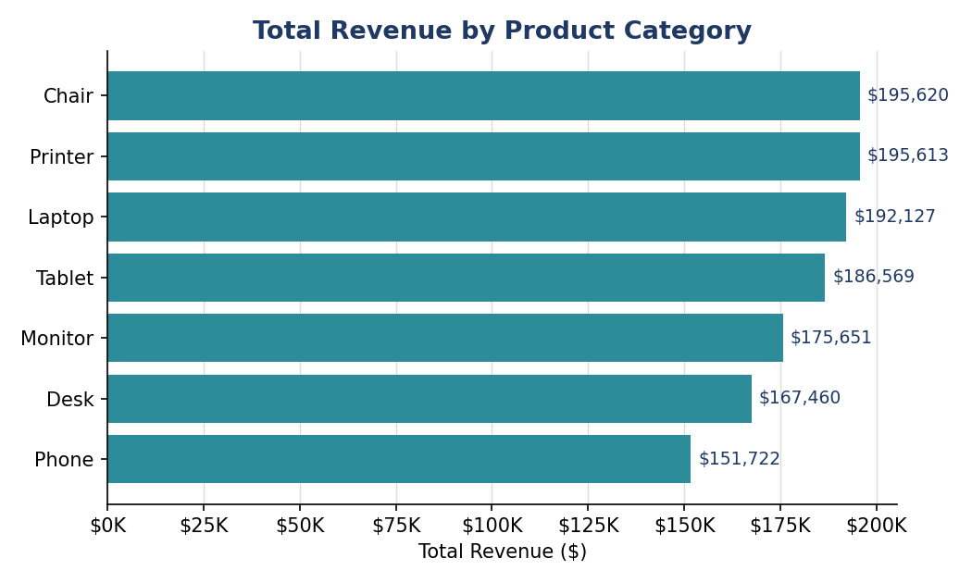
Figure 4: Chairs, Printers, and Laptops are the top three revenue-generating categories; Phones generate the least, both in volume and average order value.
Product | Orders | Revenue ($) | Avg. Order Value ($)
Chair | 178 | 195,620.11 | 1,098.99
Printer | 181 | 195,612.61 | 1,080.73
Laptop | 173 | 192,126.56 | 1,110.56
Tablet | 179 | 186,568.95 | 1,042.28
Monitor | 163 | 175,651.41 | 1,077.62
Desk | 170 | 167,459.93 | 985.06
Phone | 156 | 151,722.39 | 972.58

7.2 Order Fulfillment Health
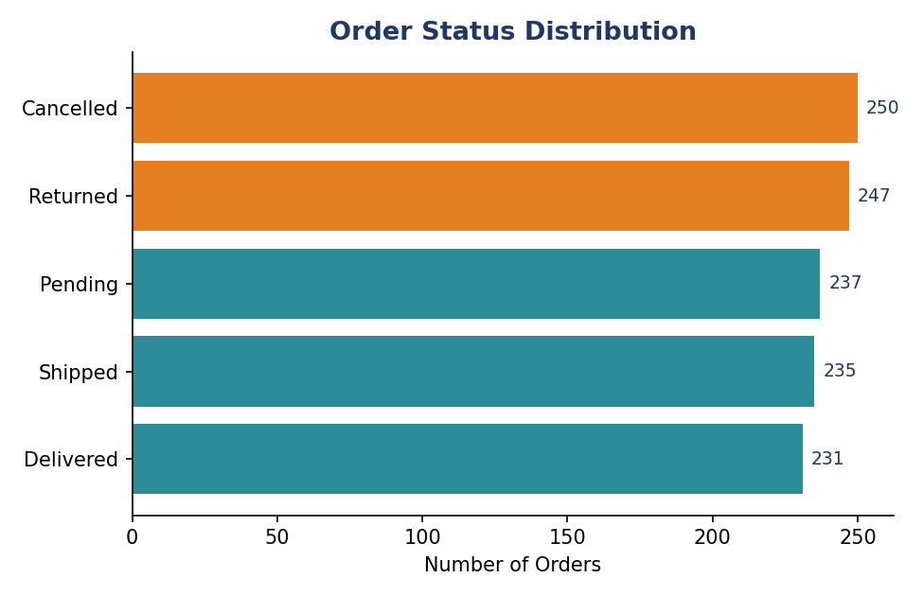
Figure 5: Order status distribution — Cancelled and Returned orders combined represent 41.4% of all orders (highlighted).
This is the most business-critical finding in the dataset. Nearly 2 in 5 orders never convert into a completed sale. Cancelled orders alone ($276,396) represent more revenue than any single product category generates, making fulfillment reliability a bigger lever for growth than any product-mix change.

7.3 Order Volume Trend
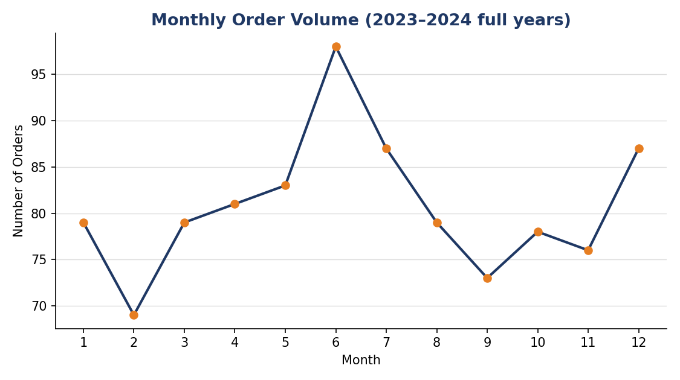
Figure 6: Monthly order volume using complete years only (2023–2024). Volume is broadly stable across the year with a mild dip in September.
Note on methodology: the raw monthly totals (including partial 2025 data through June) initially suggested a sharp peak in June and a decline in the second half of the year. Because 2025 data stops at June 30, those months are overrepresented in a naive combined count. Restricting the trend to complete years (2023–2024) removes this artifact and shows order volume is, in fact, fairly stable year-round — a good example of why raw aggregation without checking for data completeness can mislead.

7.4 Payment Method & Referral Source
Revenue is evenly distributed across all five payment methods (Cash, Credit Card, Debit Card, Gift Card, Online), each contributing 19–21% of total revenue, with Credit Card showing the highest average order value ($1,127.55). Referral source shows a similar even spread, with Instagram (259 orders, $275,285) and Facebook (highest AOV at $1,098.29) as the strongest channels, though the differences are not large enough to indicate one channel dramatically outperforms the others.

7.5 Coupon Usage
Orders with a coupon applied average $1,057.64, essentially identical to the $1,043.37 average for orders without one. Coupons in this dataset do not appear to be driving larger basket sizes — their effect, if any, is on conversion rather than order value, which this dataset cannot directly measure.

8. Business Impact — Translating Findings into Action
What the Data Shows | Business Diagnosis
41.4% of orders are Cancelled or Returned | This is equivalent to $519,674 in at-risk revenue (Cancelled + Returned combined) — larger than the revenue of any single product line. Root-causing cancellation reasons should be the top operational priority.
Total Price is right-skewed (mean $1,053.97 vs. median $823.62) | Standard 'average order value' reporting overstates the typical customer's spend by ~28%. Marketing and inventory planning should reference the median, not the mean.
8 orders are 5-unit, premium-price bulk purchases | These are DecodeLabs' highest-value transactions, not data noise. Consider a VIP/bulk-buyer segment with dedicated account handling.
Unit Price (r = 0.72) outweighs Quantity (r = 0.62) as a revenue driver | Upselling to higher-priced SKUs is likely a more effective revenue lever than promoting larger cart sizes.
Order volume is stable, not seasonal, once corrected for partial-year data | No urgent need for seasonal staffing or inventory swings; resources can be planned on a steady month-to-month basis.

9. Recommendations
- Investigate cancellation and return drivers first — this is the single largest source of revenue leakage identified in this analysis.
- Report order value using the median (or both mean and median side-by-side) to avoid overstating typical customer spend to stakeholders.
- Build a lightweight bulk-order flag for 5-unit, premium-price purchases and route them to a dedicated retention/support track.
- Prioritize upsell campaigns toward higher-priced product tiers (Chairs, Laptops, Printers) rather than cart-size promotions, given the stronger correlation with Unit Price.
- Re-evaluate coupon strategy — current codes are not measurably increasing order value, so their ROI should be assessed against conversion data rather than basket size.

10. Conclusion
This EDA confirms the dataset is clean, internally consistent, and ready for deeper analysis or dashboarding. The core diagnostic finding — a 41.4% cancellation/return rate — outweighs any single product or channel insight and should anchor the next phase of investigation. In line with the project's goal, this report moves beyond simple reporting to uncover the story the data is telling: DecodeLabs' fulfillment reliability, not its product mix or marketing channel, is the primary constraint on realized revenue.

