What is Temporal.io?
- Open-source durable execution platform for building reliable distributed systems
Without Temporal:
- Distributed systems are complex and failure-prone
- Traditional approaches: custom retry logic, state management, error handling
- Without Temporal: lost progress on failures, complex recovery
With Temporal:
- Durable Execution: Workflows can run for days/months without losing progress
- Automatic Reliability: Handles failures, retries, timeouts automatically
- Developer Experience: Write business logic as simple code, not infrastructure
- Observability: Complete execution history and debugging capabilities

Core Components
Component 1: Workflows
Definition: The orchestration logic that defines your business pr
Key Characteristics:
- Deterministic (same input = same output)
- Long-running (can sleep for days/weeks)
- Fault-tolerant (automatically recovers from failures)
- Written in your preferred language (Go, Java, Python, TypeScript, .NET, PHP)

Temporal isn’t a no-code Workflow engine — it is Workflows-as-Code.
Component 2: Activities

Definition: Individual tasks that interact with external systems. Activities are defined as either functions or methods
Key Characteristics:
- Non-deterministic (can make API calls, DB queries)
- Can fail and retry automatically
- Timeout and retry policies configurable
- Heartbeat support for long-running operations

Component 3: Workers

Definition: Processes that execute your workflow and activity code

Key Characteristics:
- Run on YOUR infrastructure (not Temporal Server)
- Poll task queues for work
- Stateless (can scale horizontally)
- Execute workflows and activities

┌─────────────────────────┐
│ Worker Process │
│ │
│ ┌──────────────────┐ │
│ │ Workflow Worker │ │
│ │ (orchestrates) │ │
│ └──────────────────┘ │
│ │
│ ┌──────────────────┐ │
│ │ Activity Worker │ │
│ │ (executes tasks) │ │
│ └──────────────────┘ │
│ │
│ ⬇️ polls │
│ Task Queue │
└─────────────────────────┘

Component 4: Temporal Server
Definition: The orchestration engine that coordinates everything
Components:
1. Frontend Service: API gateway for clients
2. History Service: Maintains workflow execution history
3. Matching Service: Manages task queues
4. Worker Service: Internal system workflows

Client → Frontend → History Service → Task Queue
↓
Workers (poll)
↓
Execute & Report
↓
History Service
Component 5: Task Queues

Definition: Lightweight queues that route tasks to workers
Characteristics:
- Dynamically allocated
- Workers poll queues for tasks
- Multiple workers can poll same queue
- Supports task routing and load balancing

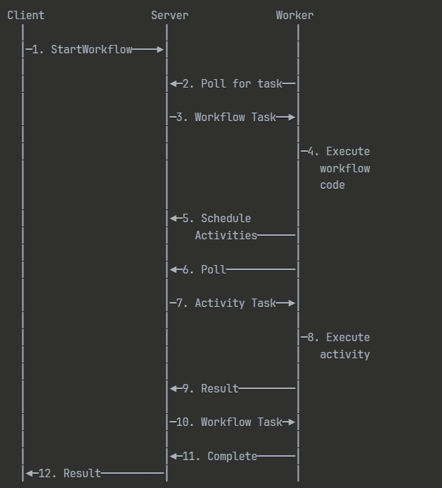

How Temporal Handles Failures Internally

When a workflow or activity fails, Temporal does not crash the system.
Instead, it records the failure in the workflow history and automatically retries based on the retry policy.

🔸 Example Flow:

1. Client starts a workflow.
2. Workflow runs an activity (say `fetchDataFromAPI()`).
3. The API fails or times out.
4. Temporal catches the error, waits for the configured **retry interval**, and reruns the activity.
5. Once it succeeds, the workflow continues.
6. If retries are exhausted, the workflow gets marked as **failed** and you can handle that gracefully.

Temporal’s Core Retry System

A. Activity Retries
- Each activity has a Retry Policy.
- You define it once — Temporal takes care of automatic backoff, delays, and limits.

🧠 Temporal will:
- Automatically retry up to 5 times
- Double the delay each time
- Preserve the workflow’s state while retrying

B. Workflow Retries
Workflows themselves can also fail and be retried — for example, if an entire workflow crashes due to a fatal error.

Temporal replays the workflow history log to restore state and re-execute deterministically until completion.

🔹 4. Determinism: The Secret Behind “Resume Exactly Where It Failed”

Temporal stores every step of the workflow in its event history in the database (PostgreSQL, Cassandra, etc.).
If a crash or power failure happens:
- The worker restarts.
- Temporal replays the workflow from its event history.
- Execution continues _exactly where it left off.
✅ No code reruns.
✅ No double execution.
✅ No lost progress.

