

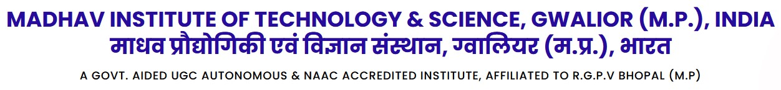

**Assignment of Engineering Physics (Code - 3000001)**

Q.1 Explain in detail about

(a) Density of energy states. (b) Energy band formation.

(c) Direct and indirect band gap. (d) Effective mass.

Q.2 what is Fermi level? Discuss about mobility and carrier concentration in intrinsic semiconductor?

Q.3 Explain in detail about

(a) Photovoltaic cell. (b) Injection Laser diode (ILD).

(c) PN junction diode and its properties. (d) Light emitting diode (LED)

Q.4 Describe about laser action in semiconductors?

Q.5 Explain Radiative and non-radiative recombination mechanism in semiconductors?

Note: This assignment should be submit individually after 15/05/2023 in hand written format with neat and clean diagram. After remark, I will return it back to you.