Question1: Create Database.

Answer1:

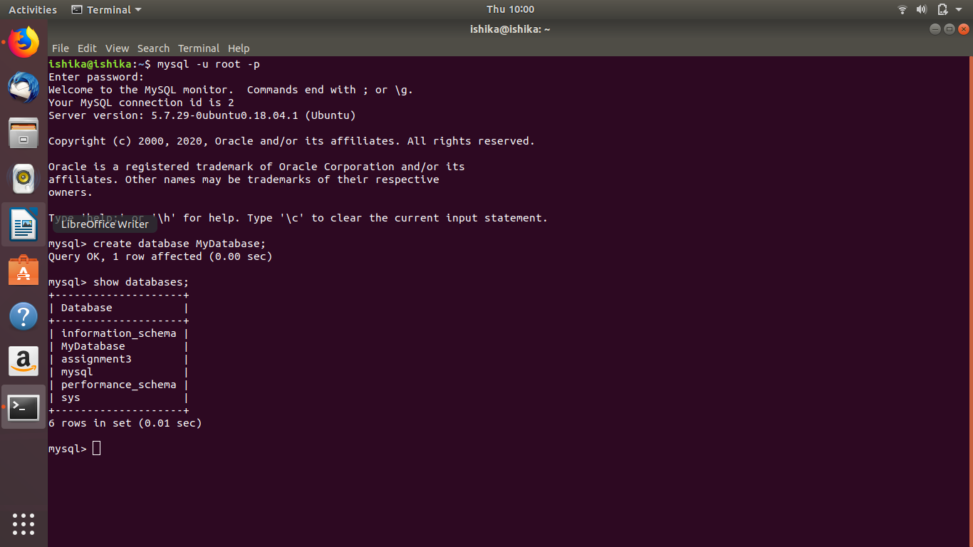

Question 2: Design Schema.

Answer 2:

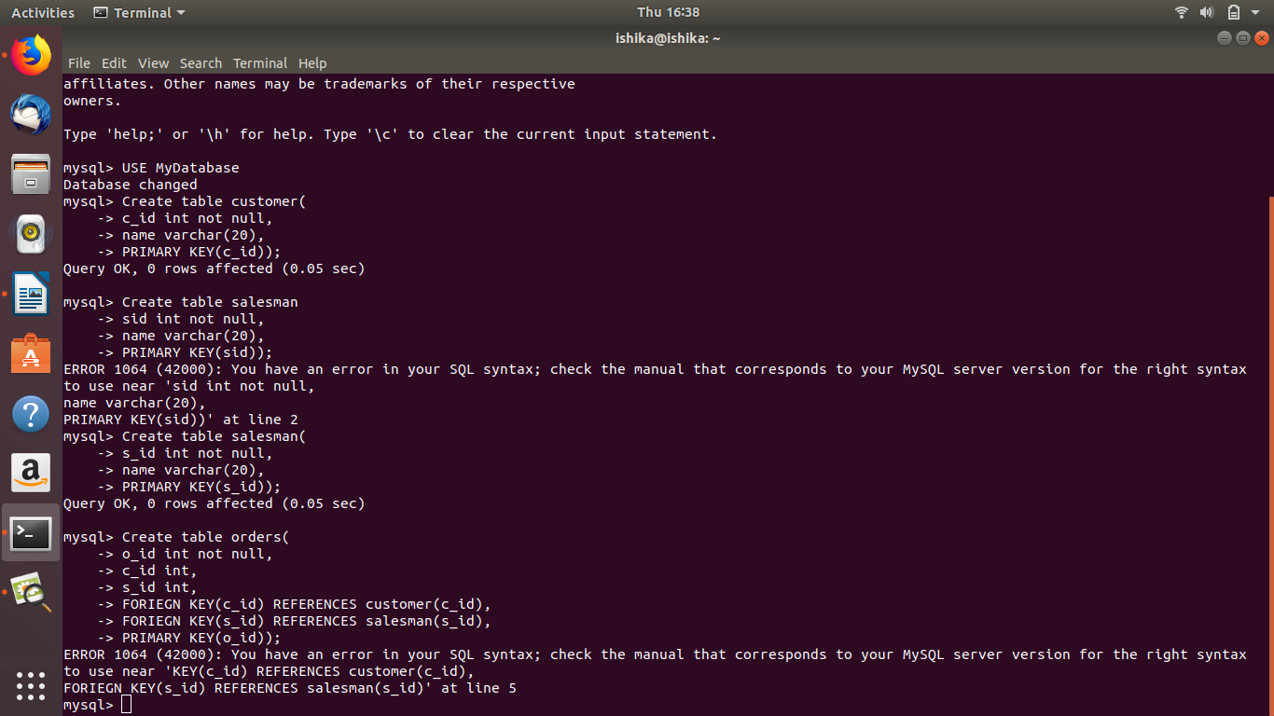

Question 3: Create tables.

Answer3:

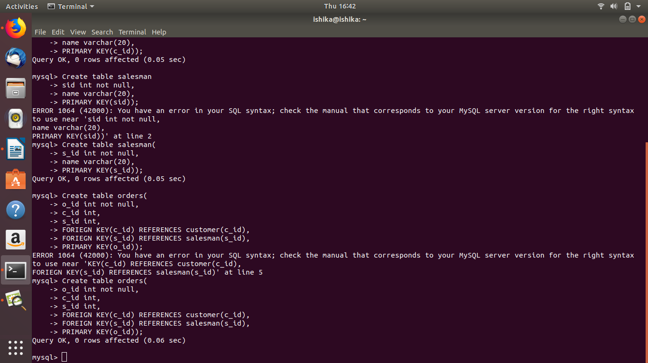



Question 4: Insert sample data

Answer 4:

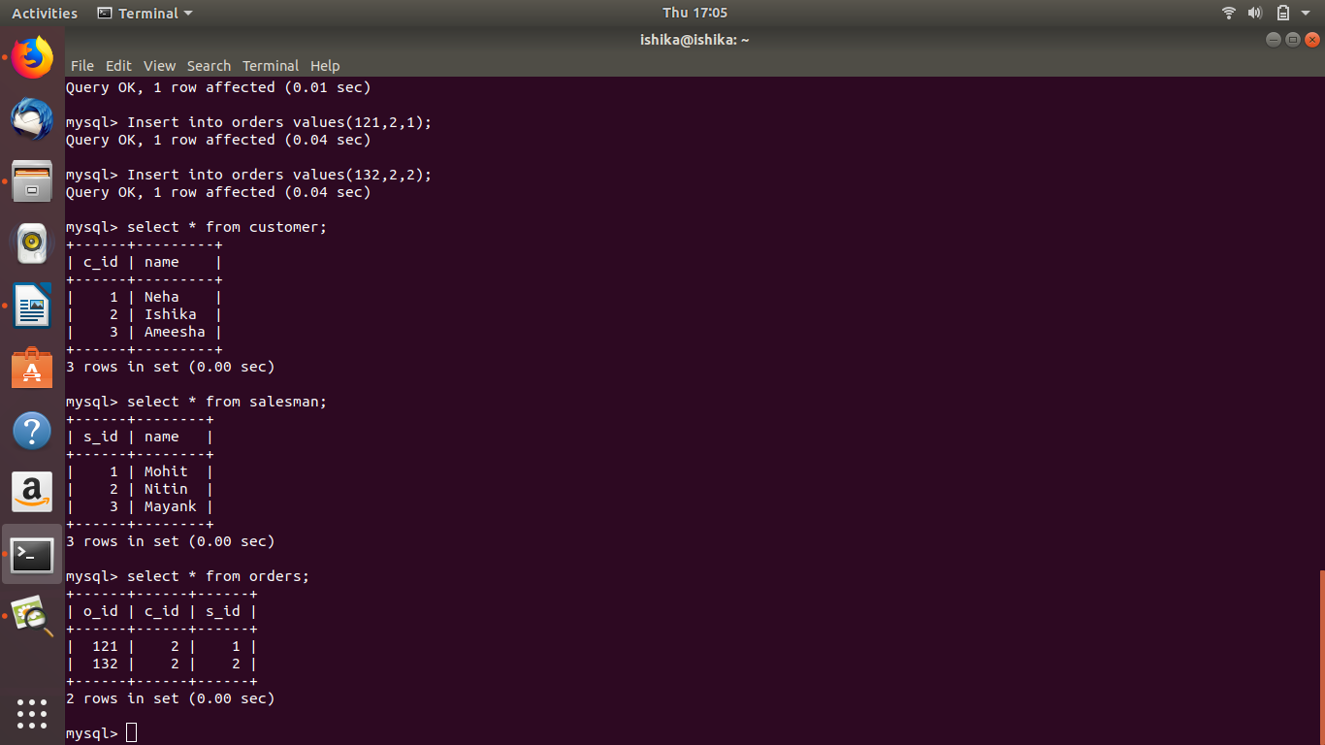

Question 5: Find the sales person have multiple orders.

Answer 5:

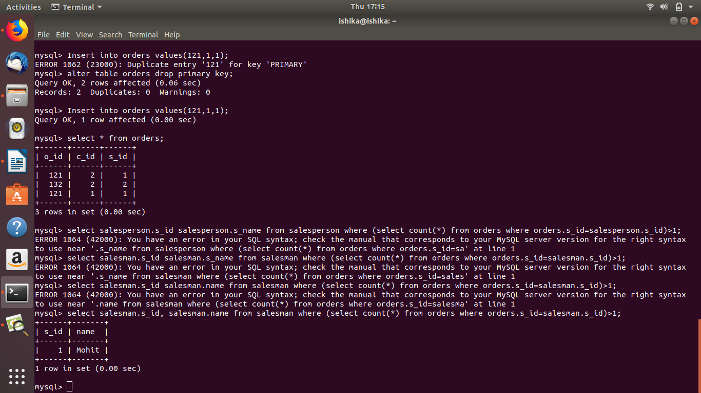

Question 6: Find the all sales person details along with order details

Answer 6:

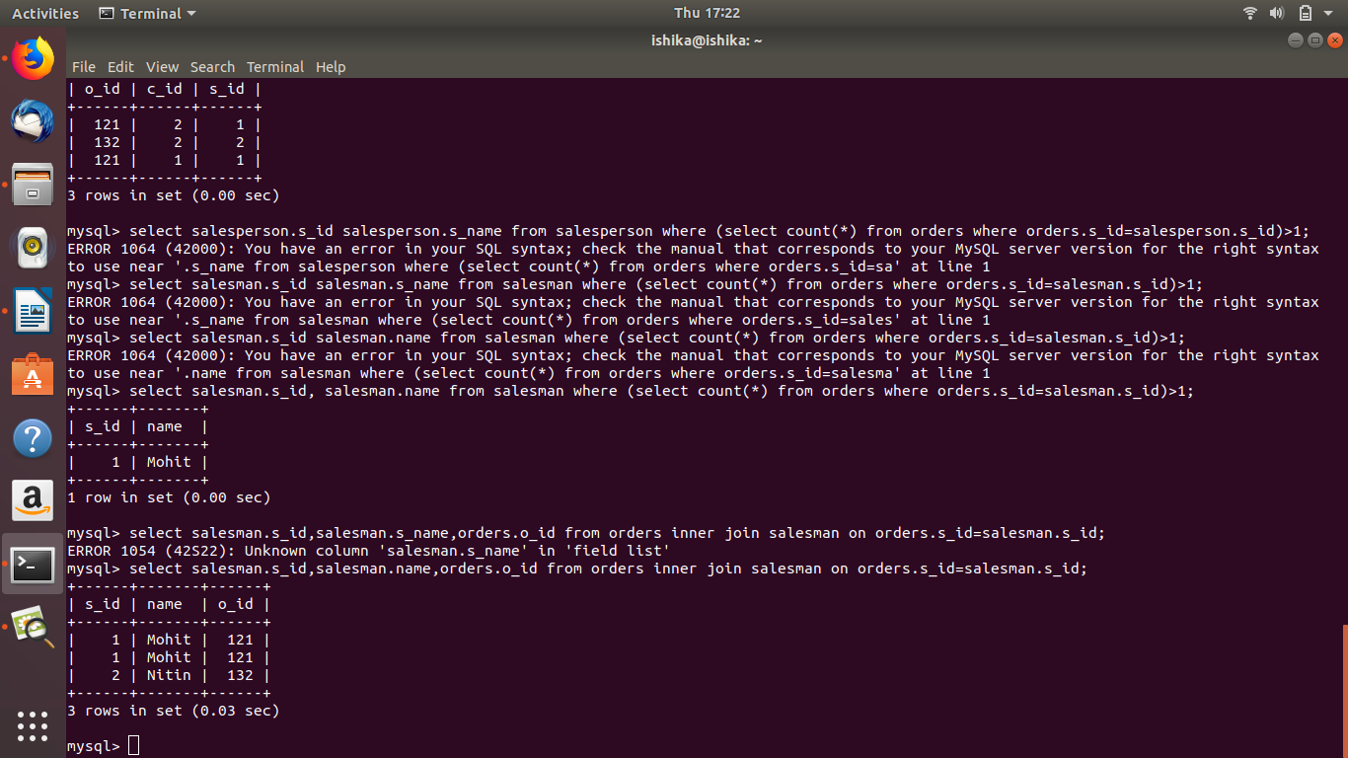

Question 7: Create index.

Answer 7:

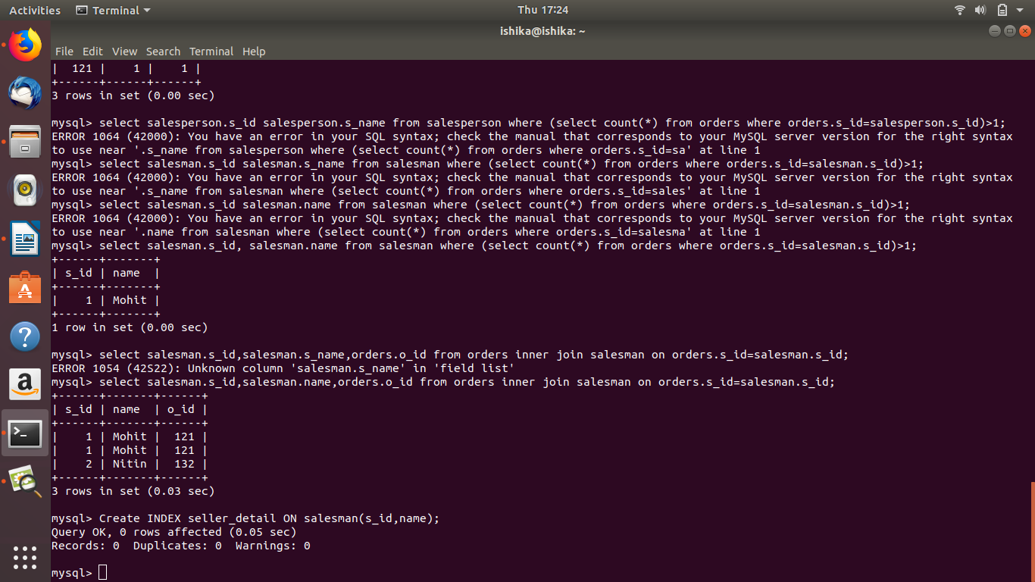

Question 8: How to show index on a table.

Answer 8:

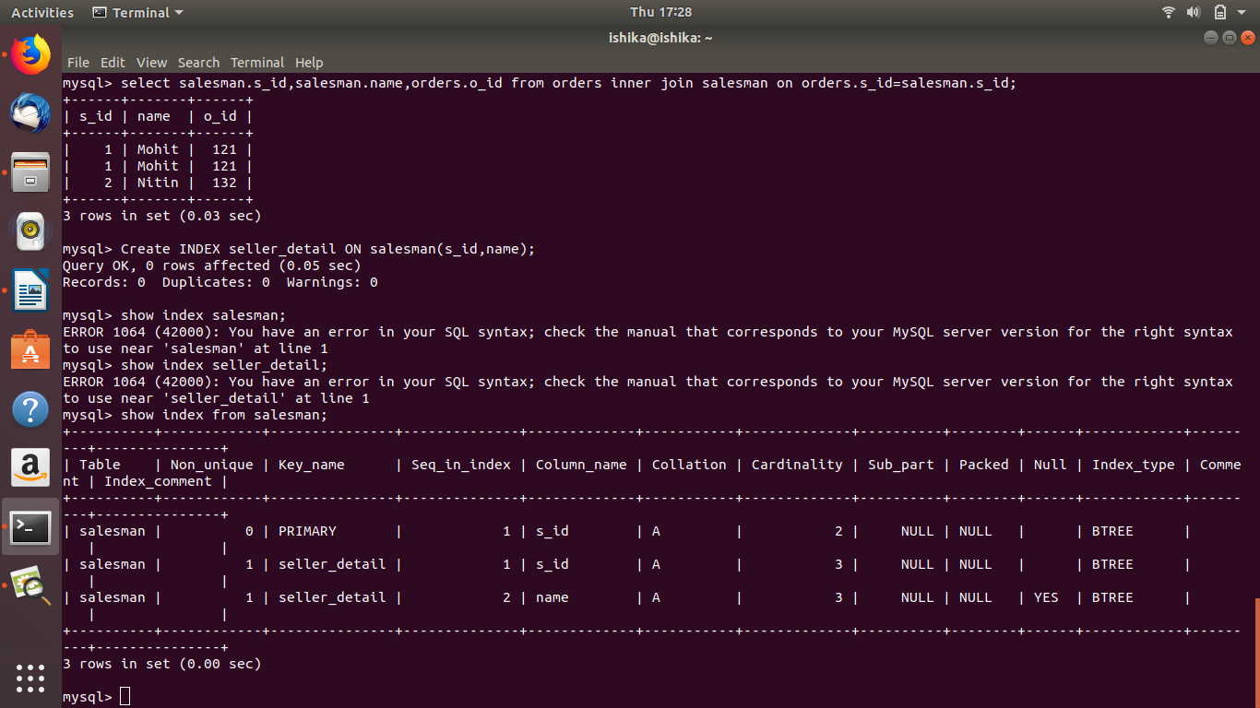

Question 9: Find the order number, sale person name, along with the customer to whom that order belongs to.

Answer 9:

