Assignment 01

Question 01
The Mapping Logic
A piecewise linear transformation was implemented to map input intensities to output intensities using four anchor points: (0,0), (100,50), (150,200), and (255,255). This was achieved using a Lookup Table (LUT) for computational efficiency.
Code Sniipets
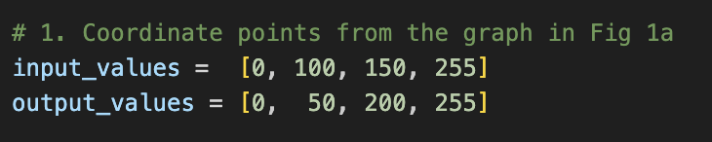
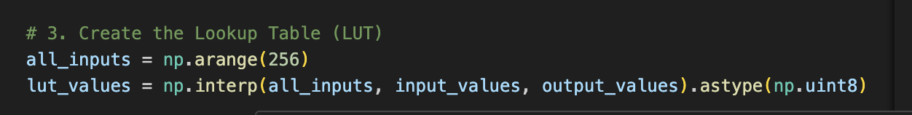
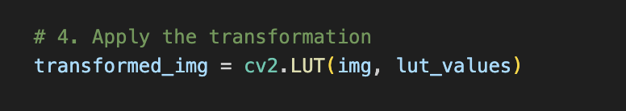
The Visual Evidence
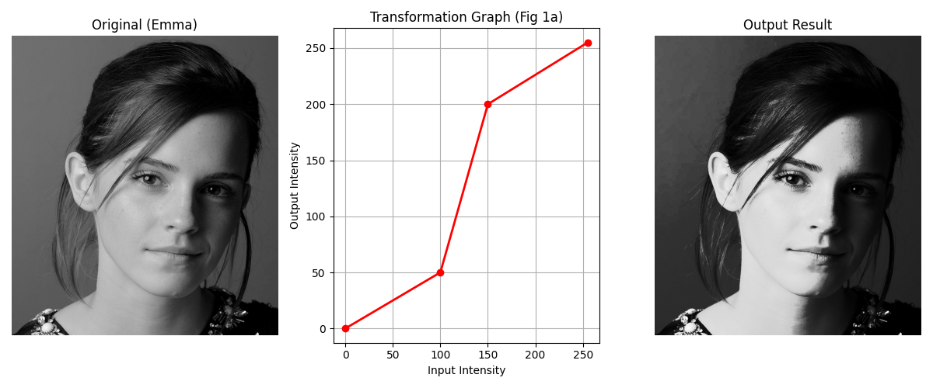

Interpretation of Results
- Piecewise Linear Mapping: The transformation uses three linear segments to re-map the dynamic range.
- Contrast Stretching (Mid-tones): The region between input intensities 100–150 has a very steep slope ($\text{gain} > 1$). This "stretches" the mid-gray pixels across a wider output range (50–200), significantly enhancing visible detail and contrast in the subject.
- Intensity Compression (Shadows & Highlights): * The 0–100 range is compressed into 0–50, making the shadows darker.
  - The 150–255 range is compressed into 200–255, preventing highlight "clipping" while maintaining brightness.
- Visual Impact: The result is an image with much punchier mid-tone details at the cost of some shadow detail, effectively highlighting the primary features of the image.

