Screen Priority

Please carry on the screen development in the following order, which means create the top listed screen first, and the bottom listed screen last. The judging scores would be based 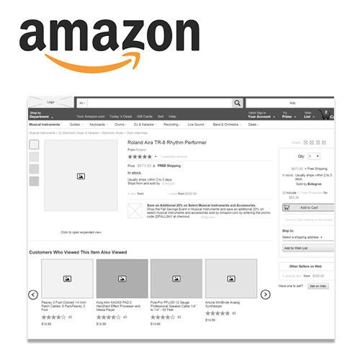on the priority of screens and the number of screens created by the end. Creating all the screens is not compulsory, but would definitely add up to your score!

1. Home

2. Item page

3. Cart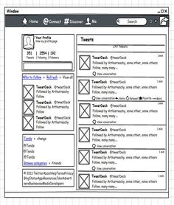

4. Account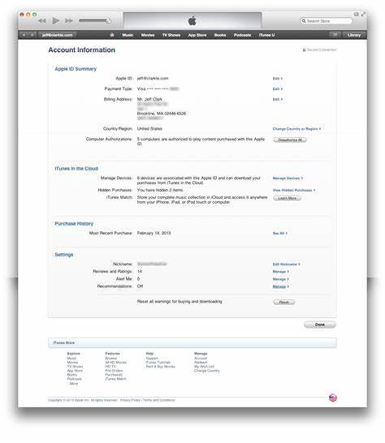

5. Return Orders