

**Programming For Problem Solving Using Python**

**LAB-07**

**SUBMITTED BY:**

**ISHIKA KATARIA**

**2K19CSUN01137**

**CSE (4C)**

**Functions**

1. **Write a program to multiply two numbers using functions.**

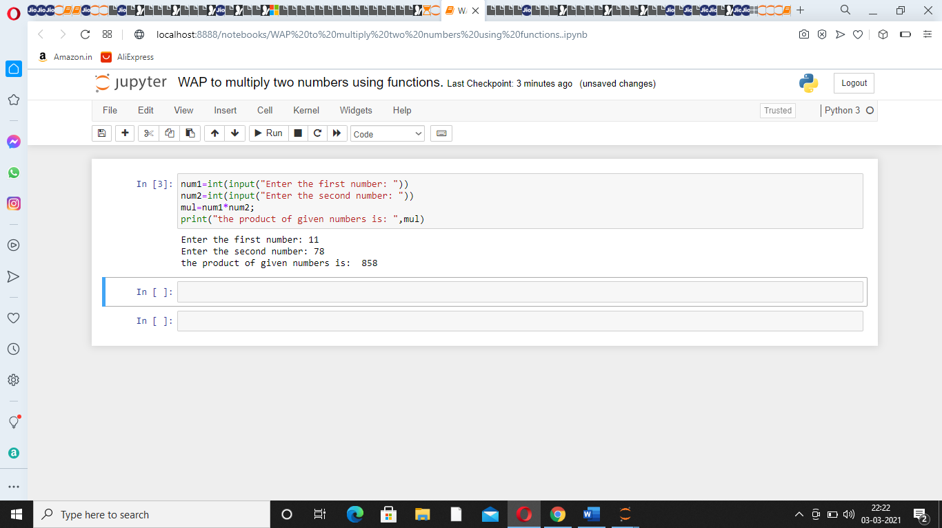

1. **Write a program to add two numbers using functions.**

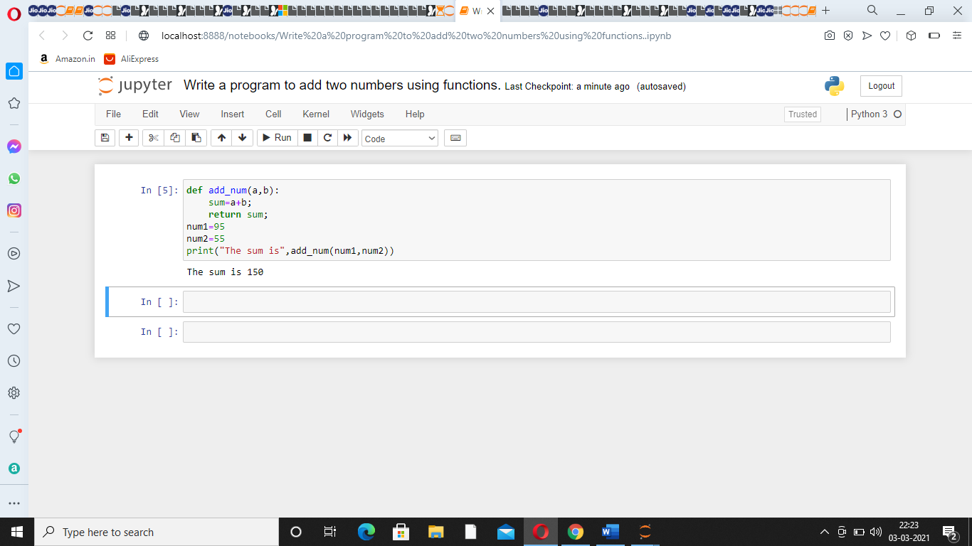

1. **Calculate factorial of a number using function.**

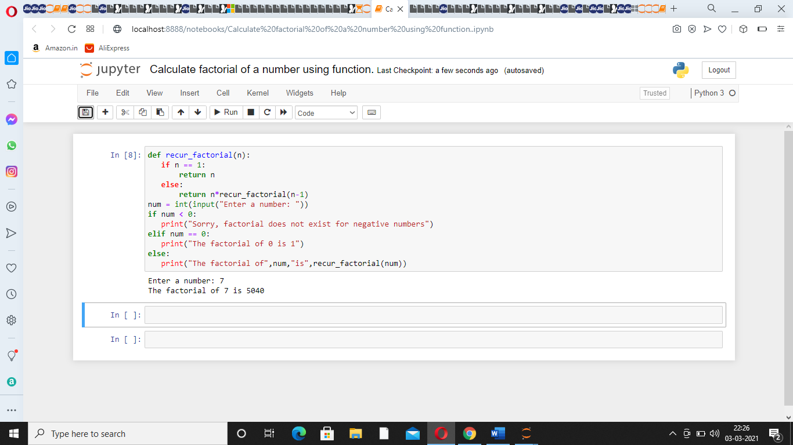

1. **Create sequence of Fibonacci using function.**

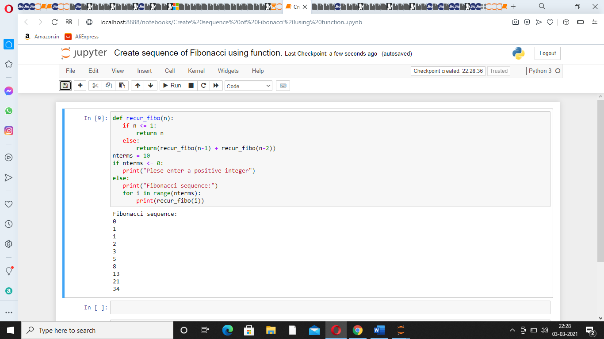

1. **Write a program to swapping of two numbers using functions.**

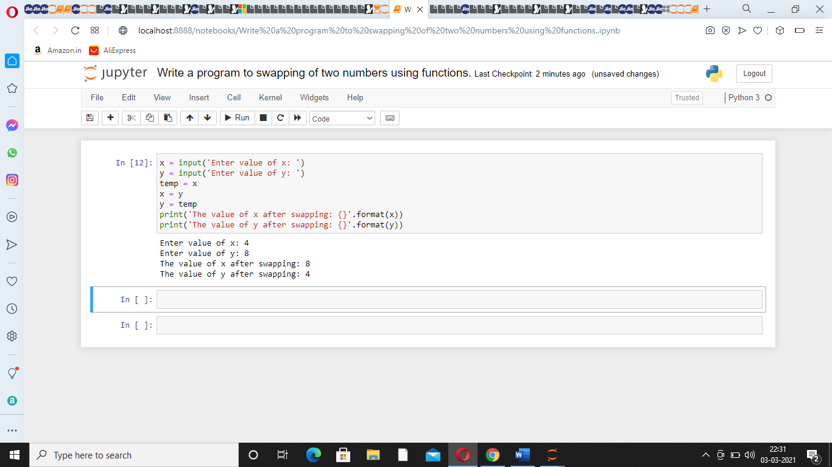

1. **Write a function to find the HCF of some given numbers.**

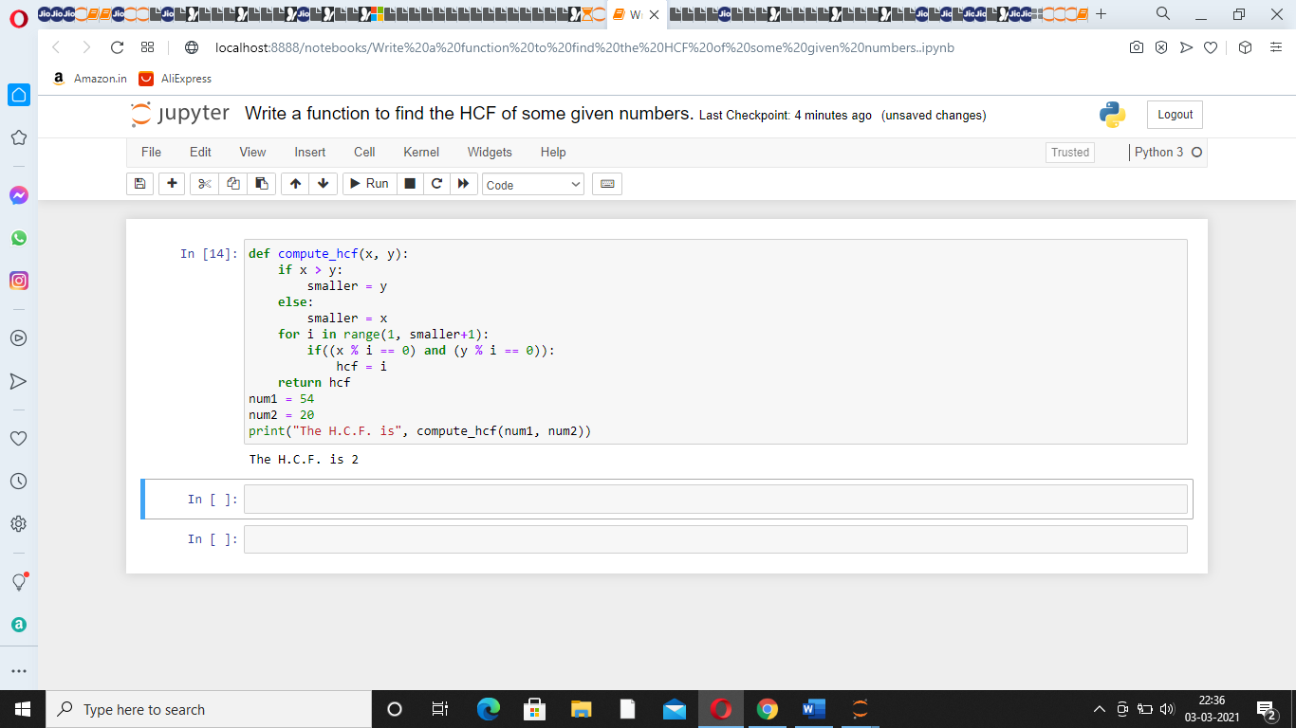

1. **Write a function to find the ASCII value of the character.**

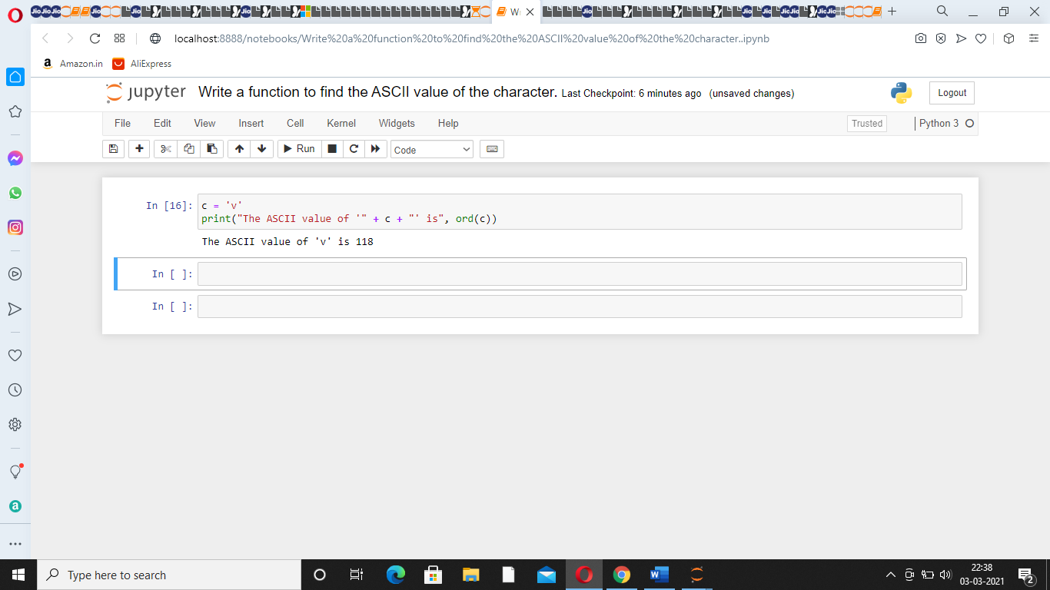

1. **Write a program that demonstrates the (built in function) mathematical functions.**

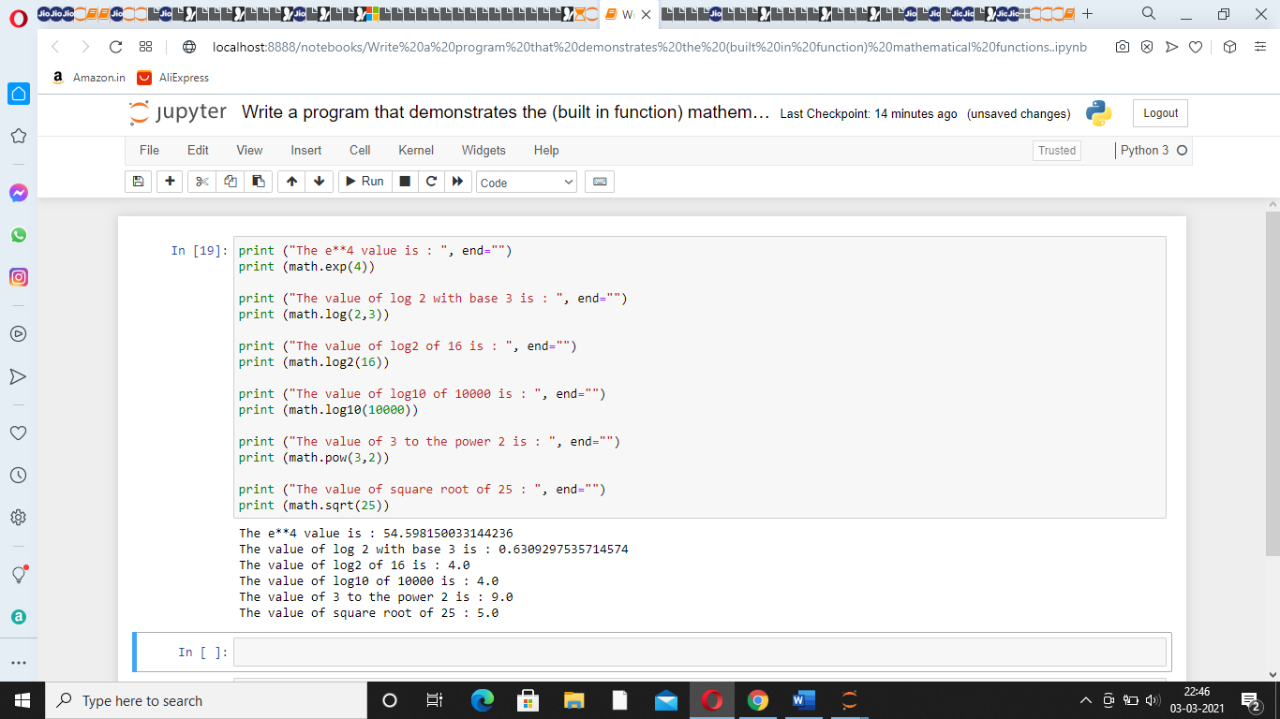

1. **Write a program that demonstrates the (built in function) Date & Time functions.**

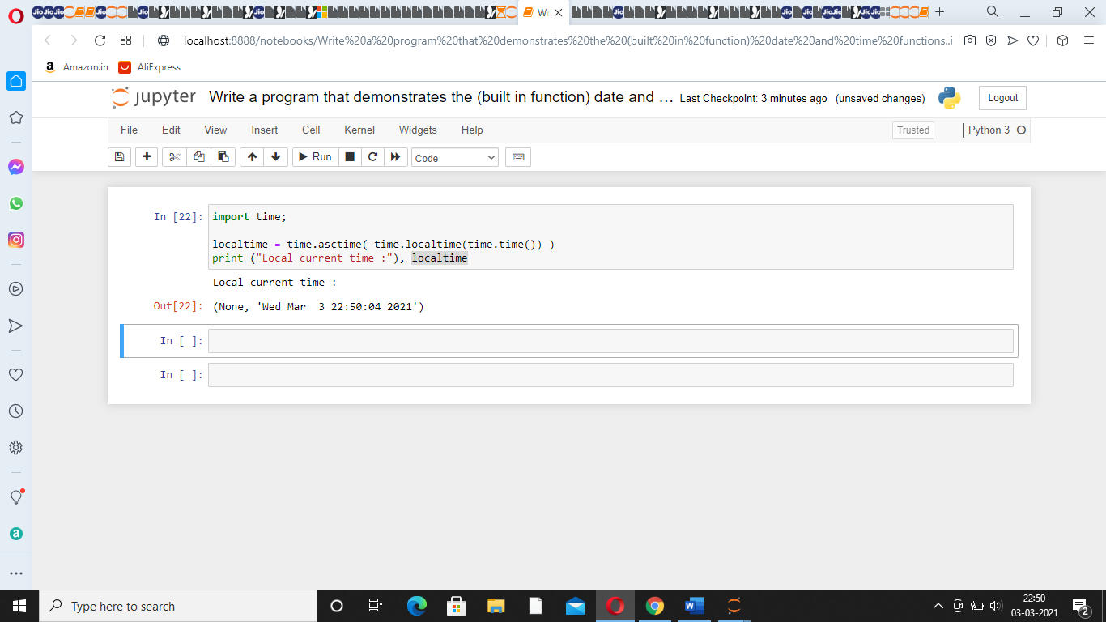

1. **Write a program that demonstrates keyword arguments.**

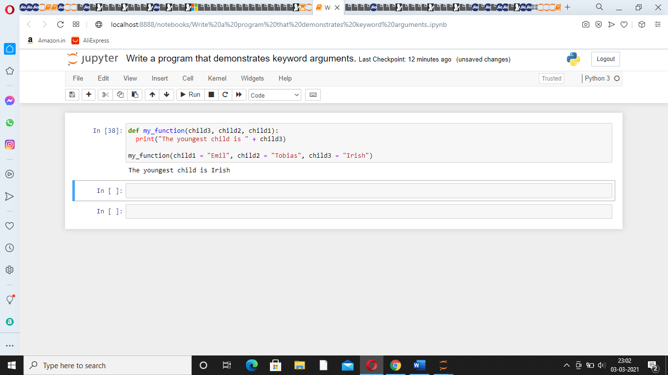

1. **Write a program that demonstrates Default arguments.**

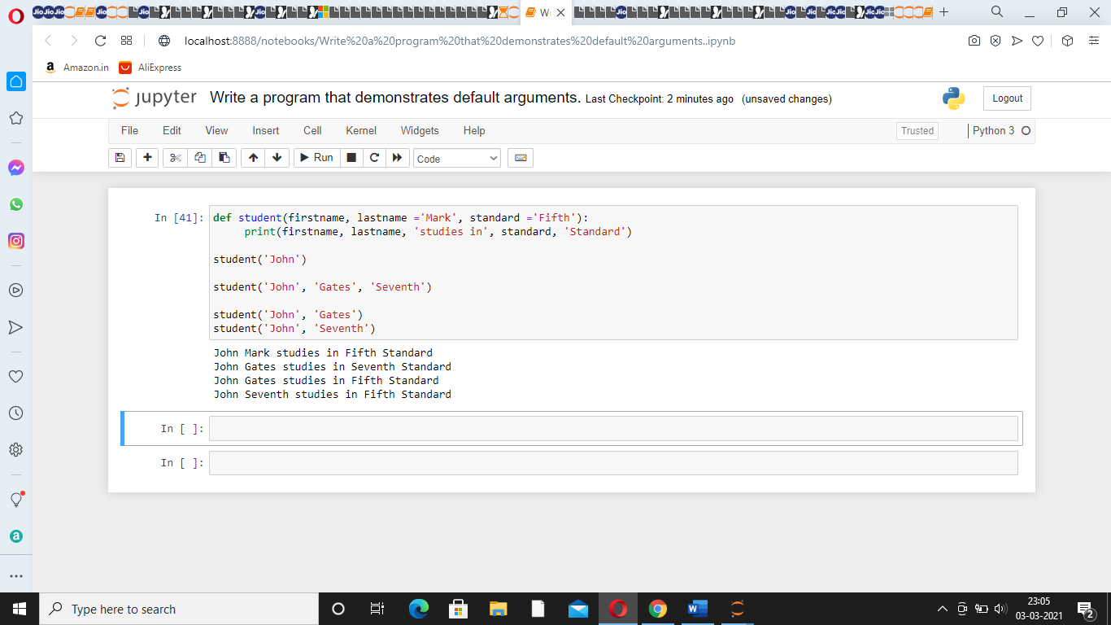

1. **Write a program that demonstrates Variable –length arguments.**

