WORKFLOW AUTOMATION & REMINDER SYSTEM
(Project Report)

College Name: UPES
Course: BTech CSE

Submitted To: Mr. Suvojit Dhara

Subject: Python Programming

Submitted by:
- Ishika Singh
Batch: 67

Date: 22-04-2026

Project Overview

The Workflow Automation & Reminder System is a desktop-based task management application developed using Python. It is designed to help users organize, track, and manage their daily tasks efficiently.
The system provides an interactive graphical user interface (GUI) built with Tkinter, allowing users to:
- Add and manage tasks
- Set deadlines
- Track task status
- Receive automated reminders
The application integrates a SQLite database for persistent storage and uses background threading to monitor tasks and trigger real-time reminders.

Objective

The main objectives of this project are:
- To design a user-friendly task management system.
- To automate reminders for scheduled tasks.
- To implement efficient data storage using a database.
- To provide priority-based task organization.
- To demonstrate integration of GUI, database, and threading.

Concepts Applied

This project applies several important computer science concepts:
1. Graphical User Interface (GUI)
- Developed using Tkinter.
- Includes dashboard, sidebar, forms, and popups.

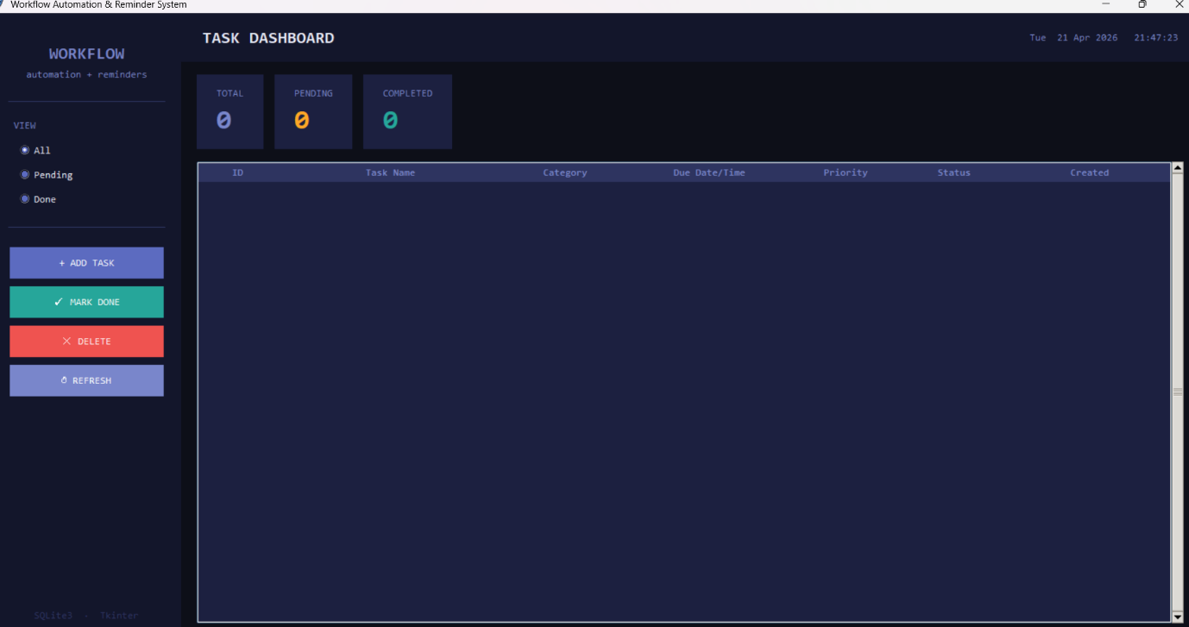

Figure 1: Main Dashboard showing task overview

2. Database Management
- Uses SQLite3.
- Stores task details such as:
  - Name
  - Description
  - Due date
  - Priority
  - Status
3. Multithreading
- Background thread continuously checks for due tasks.
- Ensures UI remains responsive.
4. Event-Driven Programming
- Button clicks, user inputs, and reminders trigger actions.
5. Automation Logic
- Automatically detects due tasks.
- Triggers notification popups and sound alerts.
6. Task Creation Mode
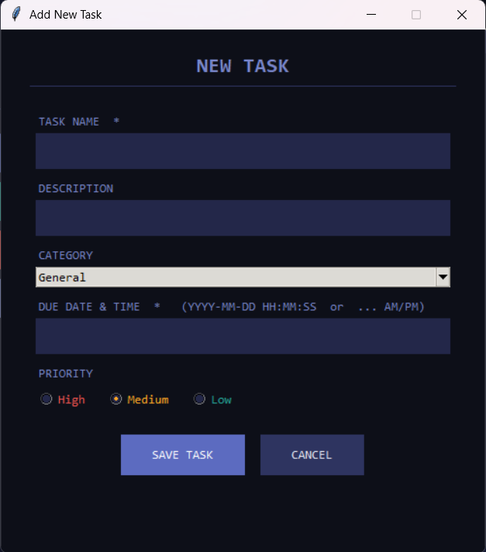

Figure 2: Task Creation Interface

7. Task Details Module
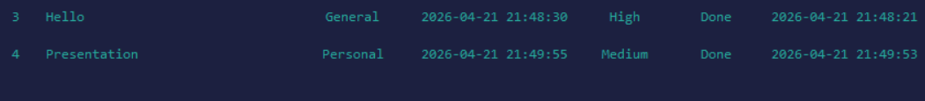

Figure 3: Detailed View of selected task

8. Reminder System
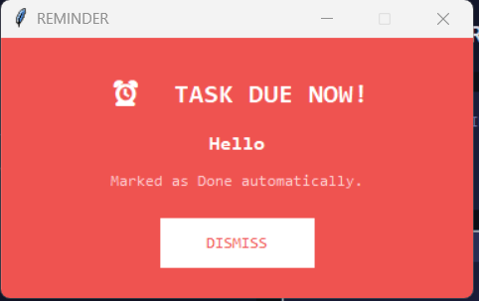

Figure 4: Automated reminder notification

Challenges Faced

1. UI and Logic Integration
Combining a modern UI with backend logic required careful structuring to avoid conflicts.
2. Thread Safety
Handling background threads with Tkinter was tricky because:
- Tkinter is not thread-safe
- Required safe UI updates using .after()
3. Date & Time Handling
Parsing and validating user-entered date-time formats needed:
- Multiple format support
- Error handling
4. Reminder Logic Design
Initially:
- Tasks were auto-marked as done
Improvement:
- Added user-controlled actions like:
  - Mark Done
  - Snooze
5. UI Enhancement
Transforming a basic interface into a modern dashboard-style UI required:
- Colour consistency
- Layout redesign
- Better spacing and alignment

Future Scope

The project can be further enhanced with:
- Cloud integration for syncing across devices
- Mobile application version
- User authentication system
- Analytics dashboard (task completion graphs)
- System-level notifications
- AI-based task prioritization

Conclusion

The Workflow Automation & Reminder System successfully demonstrates the integration of GUI, database management, and background processing in a single application.
It provides:
- Efficient task organization
- Real-time reminders
- User-friendly interaction
This project enhances productivity by automating routine task tracking and serves as a strong foundation for building more advanced productivity applications.

