UNIVERSITY OF LAY ADVENTISTS OF KIGALI (UNILAK)
Faculty of Computing and Information Sciences
E-Commerce and Web Application

CONTINUOUS ASSESSMENT TEST: PRACTICAL GROUP PROJECT
Project report
Topic: African movie selling and streaming platform
Group number: 1
No. | Names | Registration number
1 | ISHIMWE Isaac | 25611/2024
2 | Sidick Zakaria ISSA | 25769/2024
3 | Ahmed Refat NASUR | 25899/2024
Lecturer: ______________________
Kigali, November 2026

1. Introduction

1.1 The business
Mboni is an online platform where people can watch, rent and buy African films. The name means “the pupil of the eye” in Swahili, and it is also used to say “the apple of my eye”: something precious. Our slogan is “See Africa.”
The catalogue has 24 films from 15 African countries (Rwanda, Nigeria, Ghana, Kenya, South Africa, Senegal, Tanzania and others), in local languages with English, Kinyarwanda and French subtitles. Customers can pay in three ways:
- Subscribe to a monthly plan (Mobile 3,000 RWF, Standard 6,000 RWF or Premium 9,000 RWF) and watch everything included;
- Rent a single film for 48 hours (from 800 RWF);
- Buy a film to keep it forever and download it for offline viewing (from 3,500 RWF).
Because a film is a digital product, the shopping cart works like a selection list: a customer can put several films in the cart, choose to rent or buy each one, and pay once. Extra copies of a film become gift codes that can be sent to friends and family, for example to relatives living abroad.

1.2 Target customers
- Students and young workers in Rwanda who use smartphones, buy mobile data in bundles and pay with MTN MoMo or Airtel Money rather than a bank card.
- Families who share one account and need a safe space for children (Kids profiles).
- The African diaspora who want films from home and like to send them as gifts.
- African filmmakers, who earn 60% of every rental and sale, as shown on the admin dashboard.

1.3 The problem the system solves
African films are hard to find legally online. Big international platforms have very few of them, and many local viewers cannot pay because they do not have a Visa or Mastercard. Mobile data is also expensive, so streaming a whole film is costly. As a result, many people watch pirated copies and filmmakers earn nothing.
Mboni solves this by putting African films in one place, accepting mobile money, letting people rent one film cheaply instead of paying for a full subscription, offering a data saver quality (about 180 MB per hour), and allowing offline downloads for bought films.

2. System description

2.1 Main features
The table below shows how Mboni meets each module required by the CAT.
Required module | How Mboni does it
1. Home page & branding | Mboni name and eye logo, menu, featured films in a rotating banner, footer with address, phone, email and opening hours.
2. Catalogue | 24 films with photo, description, director, cast, rent and buy prices in RWF and availability (“Available now” or “Coming soon”). Search by title, actor, country or language, and filters by genre (category), country, language, access type and sort order.
3. Shopping cart | Add films, choose Rent or Buy for each, change the quantity with − / +, remove, save for later, empty the cart. Subtotal and total update straight away without reloading. Guests can also use the cart; it is kept when they sign in.
4. User accounts | Registration, login and logout. Two roles: customer (viewer) and administrator. Customers can also create profiles, including Kids profiles.
5. Checkout & orders | Contact and delivery details (name, email, phone, gift message), order summary, promo code. Orders are saved in the database with the status pending, paid, delivered, cancelled or refunded.
6. Payment | Simulated MTN MoMo, Airtel Money and card payment with a phone approval screen and a confirmation page. No real money is used.
7. Admin dashboard | Sales statistics and charts; add, edit and delete films; view all orders and change their status; read and answer messages; members list; payments list with CSV export.
8. Customer interaction | Contact form, customer reviews with stars, FAQ (help centre), phone and email links.
9. Design & usability | Same layout on every page; works on phones (bottom tab bar) and computers; dark and light theme; three languages.
10. Basic security | Hashed passwords, CSRF protection, input validation on every form, admin pages blocked for customers, customers can only see their own orders.

2.2 Users of the system and how they use it
The customer (viewer). A visitor opens the home page and browses the catalogue. On a film page they can watch the trailer, read reviews and see the prices. They add films to the cart, then sign in or create an account. At checkout they confirm their contact details, choose MTN MoMo, Airtel Money or card, and approve the payment on their phone. The order then becomes paid and delivered: the films appear in their Library, and any gift codes are shown on the order page. From the Library they watch online or download for offline viewing. They can follow all their orders under My orders, review films and contact the team.
The administrator. The admin signs in with an admin account and lands on the dashboard, which shows revenue for the last 30 days, active subscribers, live rentals, money owed to filmmakers, failed payments, orders waiting for delivery and open messages. The admin can add a new film (with a live preview of its poster), edit or delete films, mark a film as “coming soon”, open any order to deliver, cancel or refund it, and mark customer messages as answered.

2.3 Demo accounts and test values
Purpose | Value
Customer account | demo@mboni.rw / demo1234
Administrator account | admin@mboni.rw / admin123
Approved MoMo / Airtel payment | Any number starting 078/079 (MTN) or 072/073 (Airtel)
Declined payment | A phone number ending in 0000, or card 4000 0000 0000 0002
Approved card payment | 4242 4242 4242 4242, any future expiry date, any CVC
Promo codes | STUDENT50 (50%), KWIBOHORA (30%), MBONI10 (10%)

3. Design

3.1 Technology and architecture
Mboni is a web application built with Python 3 and the Flask framework. Pages are generated on the server with Jinja2 templates, styled with our own CSS, and improved with plain JavaScript (for example the cart updates without reloading the page). Data is stored in an SQLite relational database. The code is split into modules (Flask blueprints):
- auth.py: registration, login, logout and roles;
- main.py: home page, catalogue, film pages, player, library, profiles and settings;
- shop.py: cart, checkout, orders and their statuses, gift codes, help and contact form;
- billing.py: plans and the simulated MoMo, Airtel and card payments;
- admin.py: dashboard, films, orders, messages, members and payments;
- db.py: the database structure and the sample data.

3.2 Database structure
The database has 18 tables. The most important ones are listed below, and Figure 1 shows how they are related. Most relationships are one-to-many: for example, one user has many orders, one order has many order items, and one film appears in many order items.
Table | What it stores
users | Customers and admins: name, email, phone, hashed password, role (viewer or admin), language.
profiles | Viewing profiles of one account (e.g. Isaac, Kids). One user has many profiles.
plans / subscriptions | The three monthly plans, and which user is subscribed to which plan until which date.
movies | The catalogue (the “products”): title, description, country, language, genres, prices, access type, availability.
cart_items | What each customer has in the cart: film, rent or buy, quantity (1 to 10).
orders | One row per checkout: order number, contact details, subtotal, discount, total, promo code, status.
order_items | The films inside each order, with the price at the time of purchase.
order_events | The history of each order (placed, paid, delivered, refunded…) with who did it and when.
transactions | Every payment attempt: method (MTN, Airtel, card), masked account, amount, status.
purchases | Films a user can watch because they rented (with an expiry time) or bought them.
gift_codes | Codes created for extra copies; who redeemed them and when.
reviews | Star ratings (1 to 5) and comments from customers.
watchlist / progress / downloads | My List, where each profile stopped in a film, and offline downloads.
promo_codes | Discount codes and their percentage.
messages | Messages sent through the contact form, open or answered.

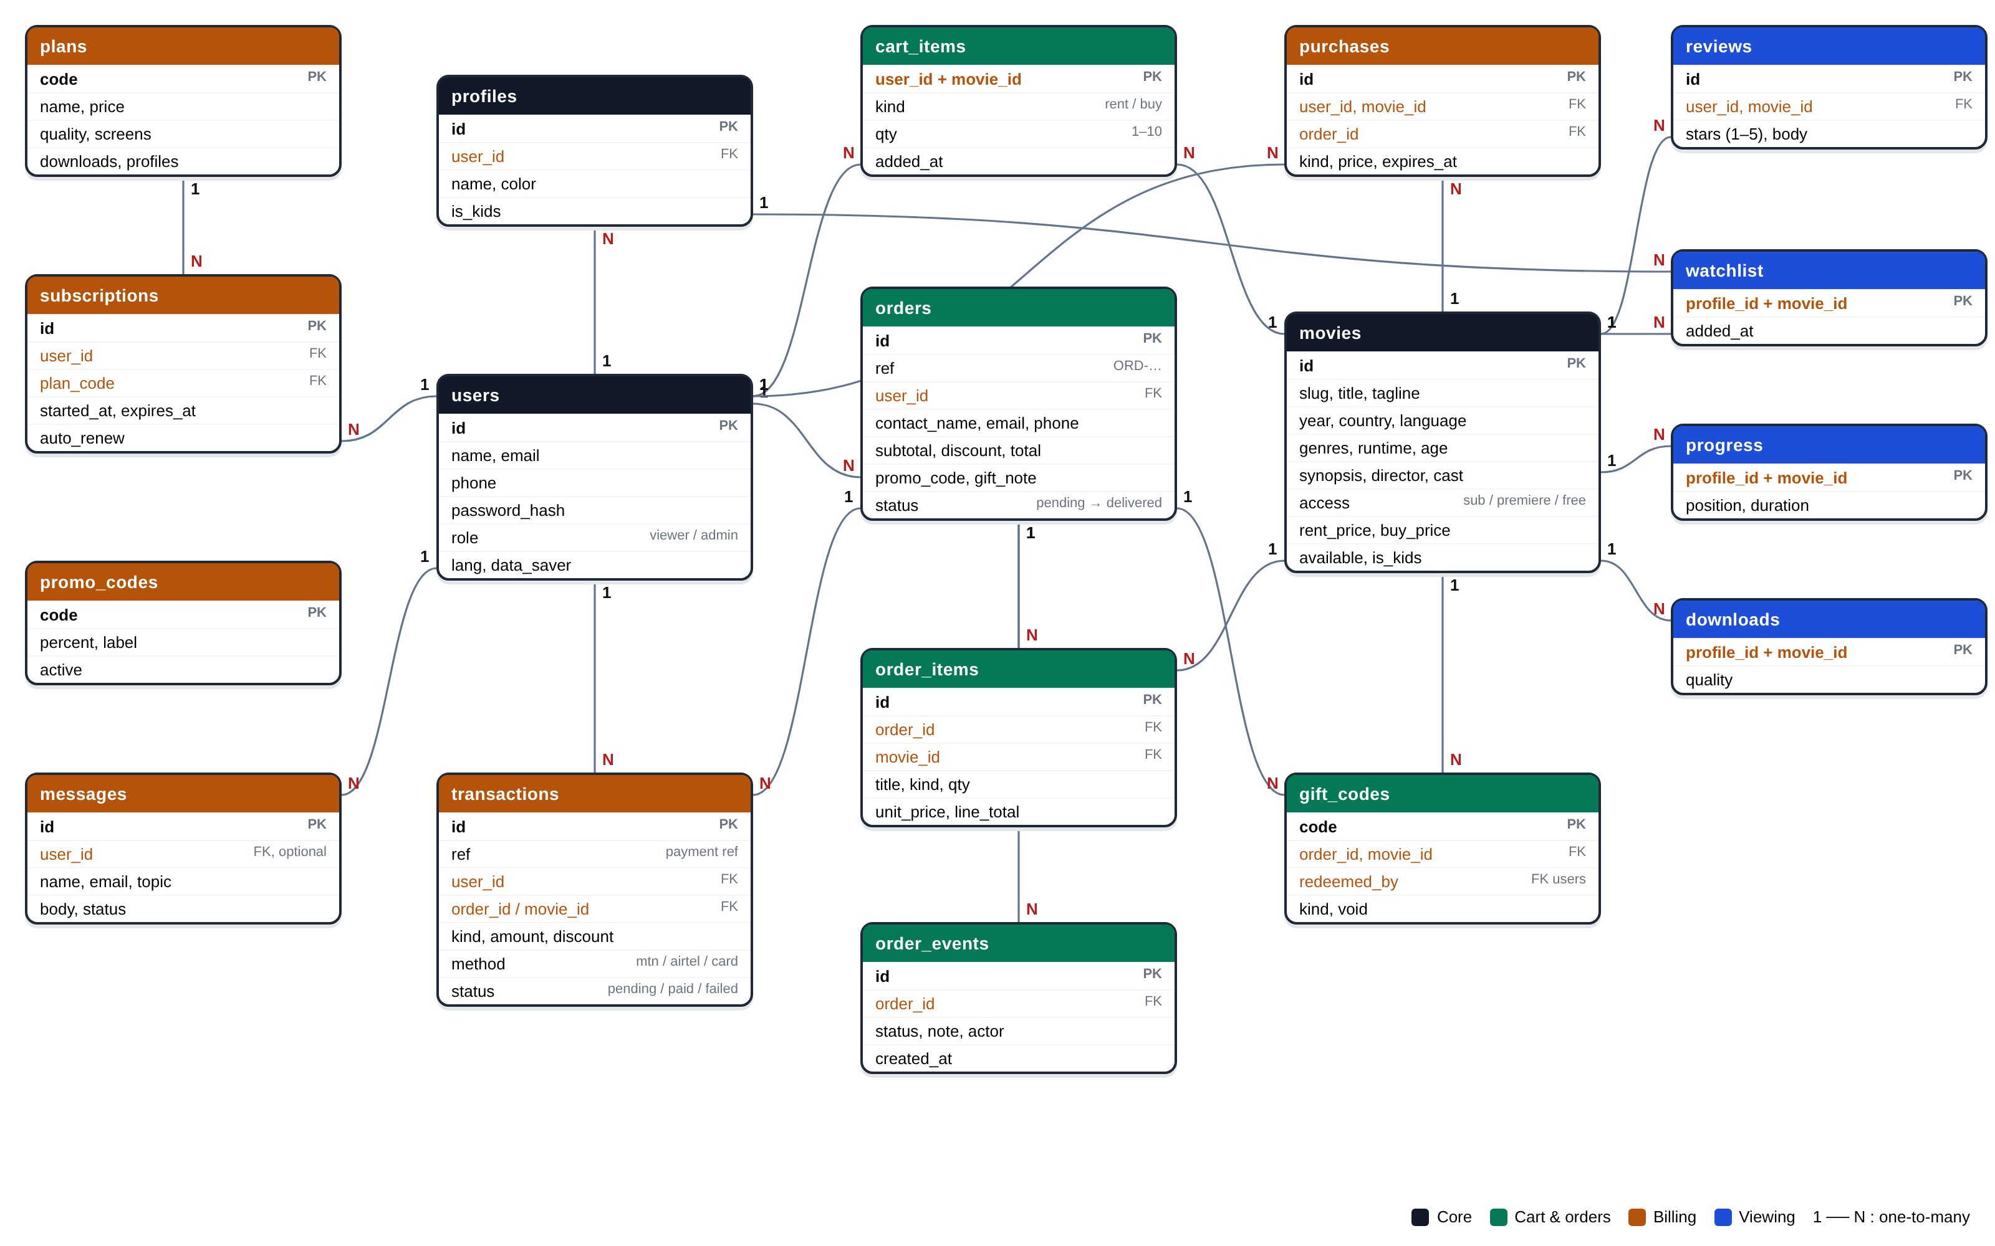
Figure 1: Database tables and their relationships (1 = one, N = many)
Main relationships: users 1–N orders, orders 1–N order_items, movies 1–N order_items, orders 1–N transactions (a customer can try to pay again after a failed payment), orders 1–N gift_codes, users 1–N cart_items, users 1–N profiles and plans 1–N subscriptions.

3.3 How a customer moves from browsing to payment
Figure 2 shows the path of a customer from the moment they open the website until they watch the film they paid for.
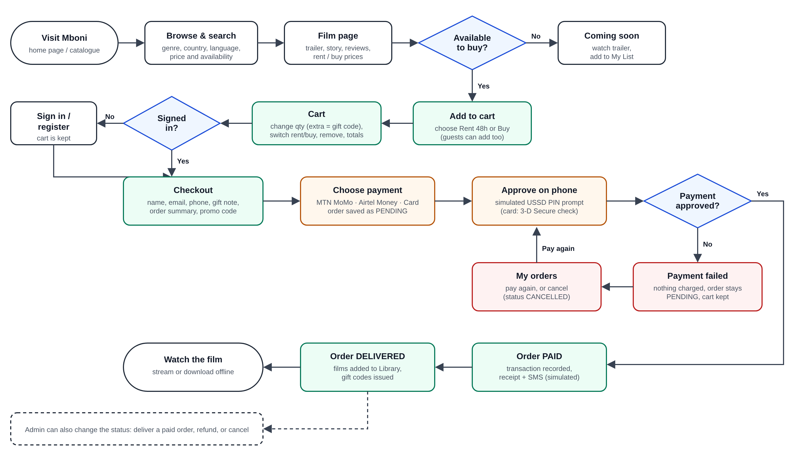
Figure 2: Customer journey from browsing to payment and delivery

3.4 Order status
Every order goes through clear statuses, which the customer sees as a timeline and the admin can update:
Status | Meaning | Who changes it
Pending | The order is saved but not paid yet (or the payment failed). | System, when the order is placed
Paid | The payment was approved. | System, after the MoMo / Airtel / card approval
Delivered | Films are in the customer's Library and gift codes were issued. | System straight after payment, or the admin
Cancelled | The order was stopped before payment. Nothing was charged. | Customer or admin (only from pending)
Refunded | The money was returned, the films were taken back and gift codes cancelled. | Admin (from paid or delivered)

3.5 Security
- Passwords are never stored in plain text: they are hashed with Werkzeug (scrypt).
- Every form has a hidden CSRF token so other websites cannot submit forms on behalf of a user.
- All inputs are checked on the server: email format, Rwandan phone numbers (078/079 for MTN, 072/073 for Airtel), card number with the Luhn check, expiry date, quantities between 1 and 10, message length.
- Admin pages return “403 Forbidden” to customers, and a customer who tries to open someone else's order gets “404 Not found”.
- Only the last four digits of a card are stored. The login page cannot be used to redirect users to another website.

3.6 Usability and responsive design
The design follows Nielsen's usability heuristics. For example, the system always shows its status (cart badge, order timeline, payment progress), error messages explain how to fix the problem (“MTN MoMo numbers start with 078 or 079”), and dangerous actions such as emptying the cart or cancelling an order ask for confirmation. On phones the menu becomes a bottom tab bar within reach of the thumb, and cart lines stack vertically. The site also supports a light theme, high contrast, reduced motion and three languages (English, Kinyarwanda, French).

4. Screenshots
The screenshots below were taken from the running system. They show the main pages for the customer and the administrator.

4.1 Customer pages
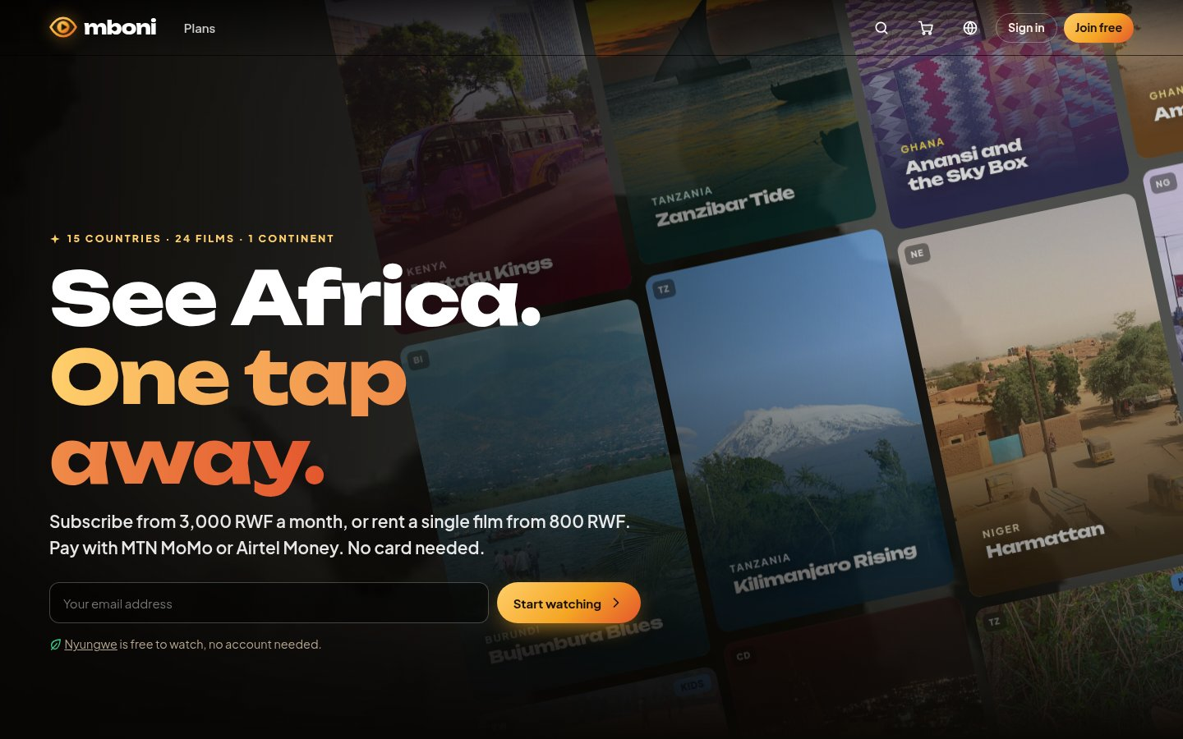
Figure 3: Home page
The first page a visitor sees: the Mboni logo and menu, the slogan, prices, and a moving wall of film posters. Visitors can start watching straight away, and the film Nyungwe is free without an account.
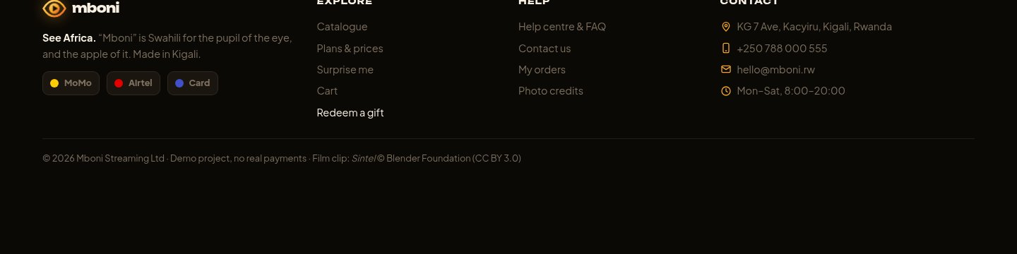
Figure 4: Footer with contact details
Every page ends with the footer: links to the catalogue, cart and help centre, and the company's address, phone number, email and opening hours.
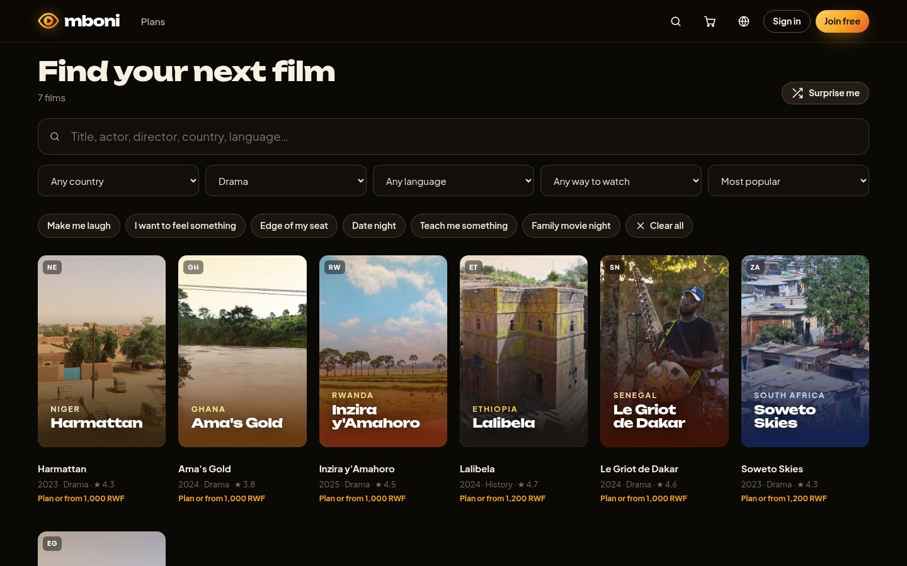
Figure 5: Catalogue with search and filters
Customers can search by title, actor, country or language and filter by country, genre (category), language and access type. Each film card shows its photo, year, genre, rating and starting price.
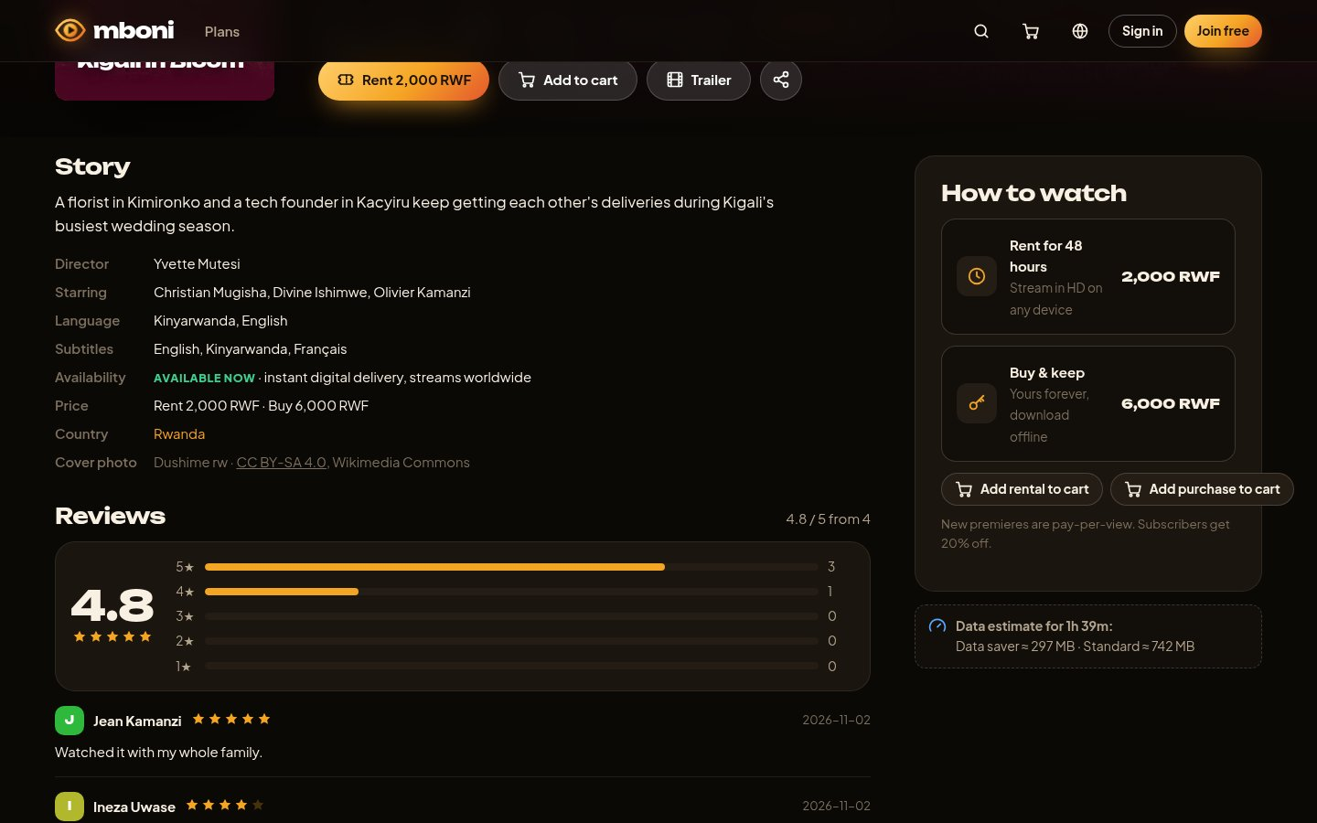
Figure 6: Film page
The film page shows the story, director, cast, language, availability and price, the reviews, and the “How to watch” panel with the options to rent, buy or add to the cart.
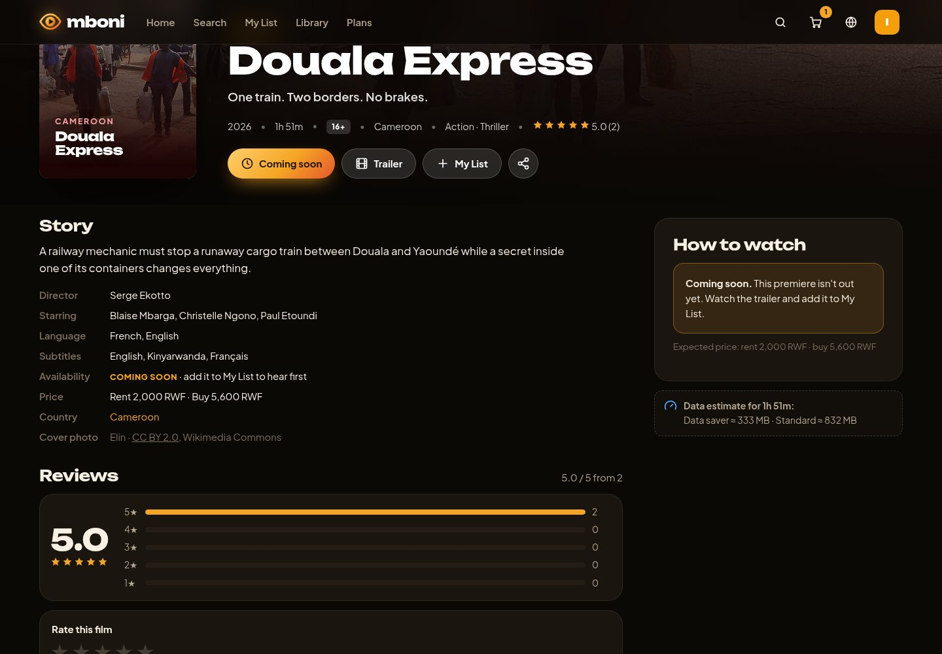
Figure 7: A film that is not available yet
When the admin marks a film as “Coming soon”, it cannot be rented, bought or added to the cart. Customers can still watch the trailer and add it to My List.
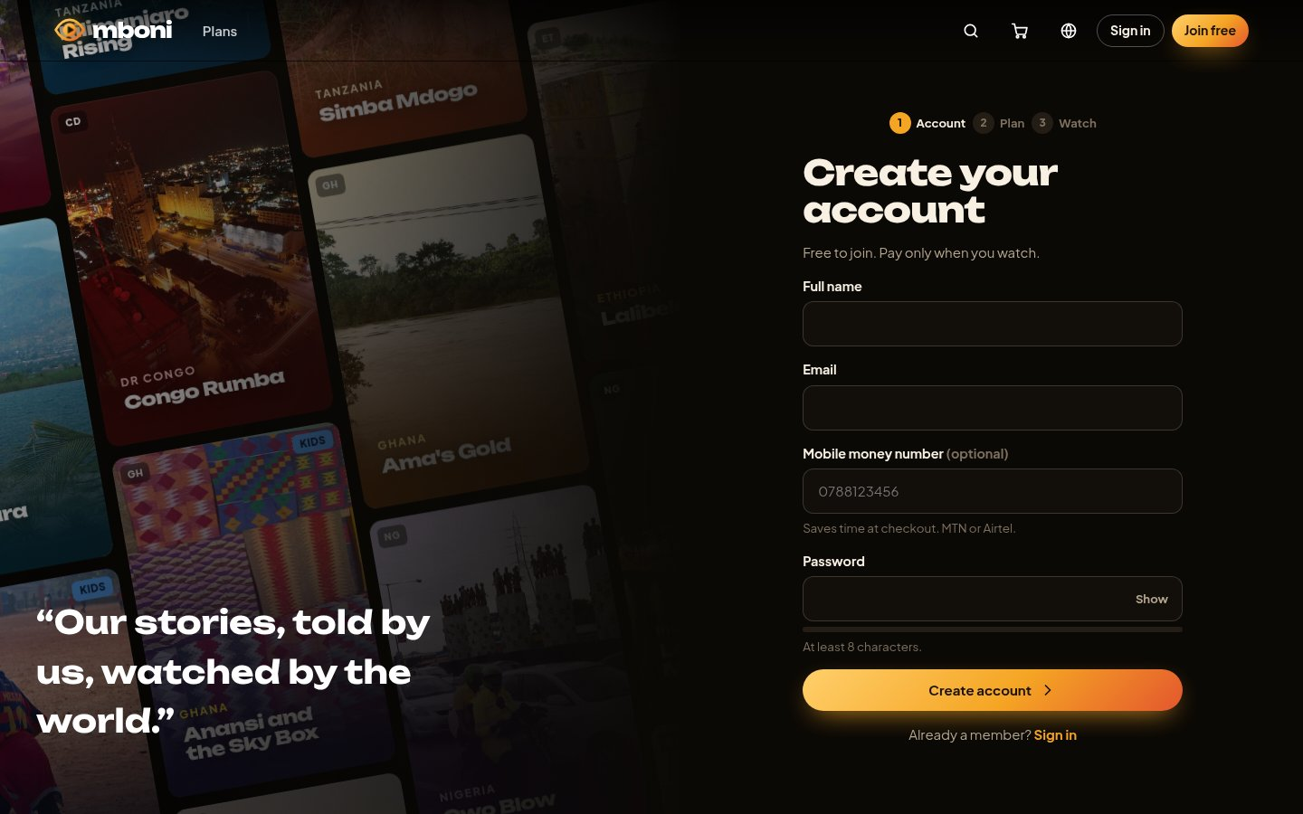
Figure 8: Registration page
New customers create an account with their name, email, optional mobile money number and a password. A meter shows how strong the password is.
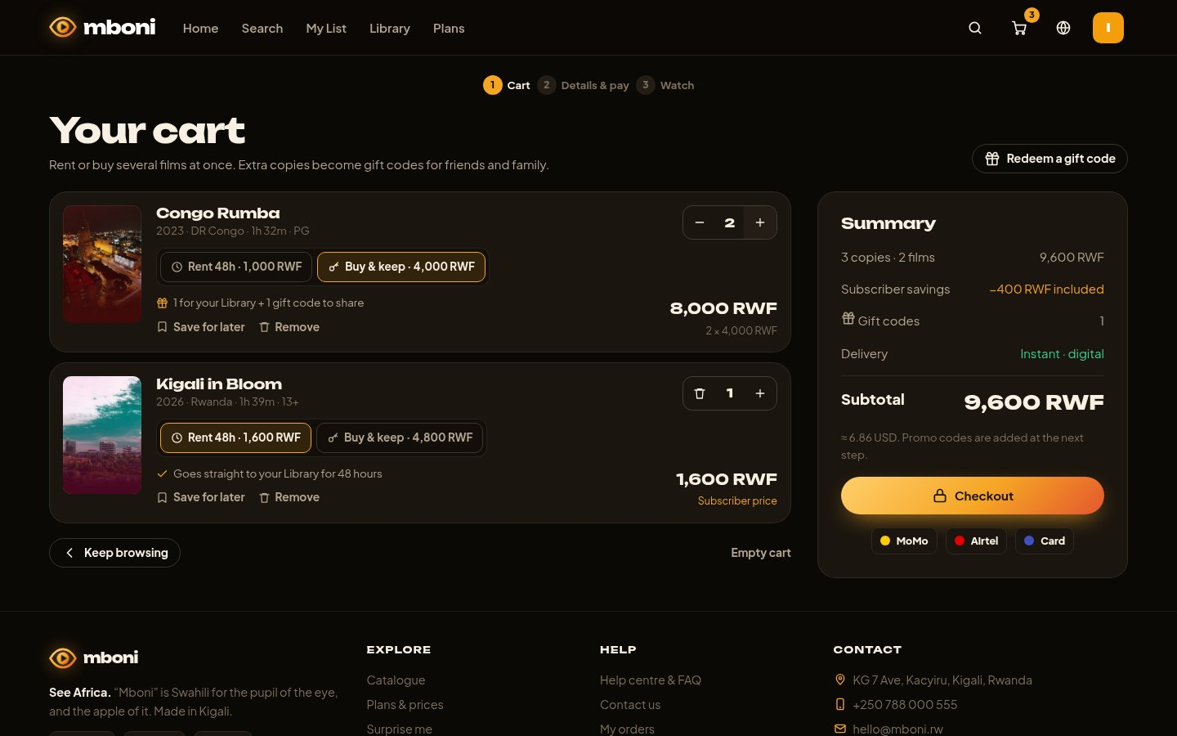
Figure 9: Shopping cart
The cart lists each film with Rent / Buy buttons, a quantity stepper (− / +), “Save for later” and “Remove”. The summary shows the number of copies, subscriber savings, gift codes and the subtotal. Everything updates without reloading the page.
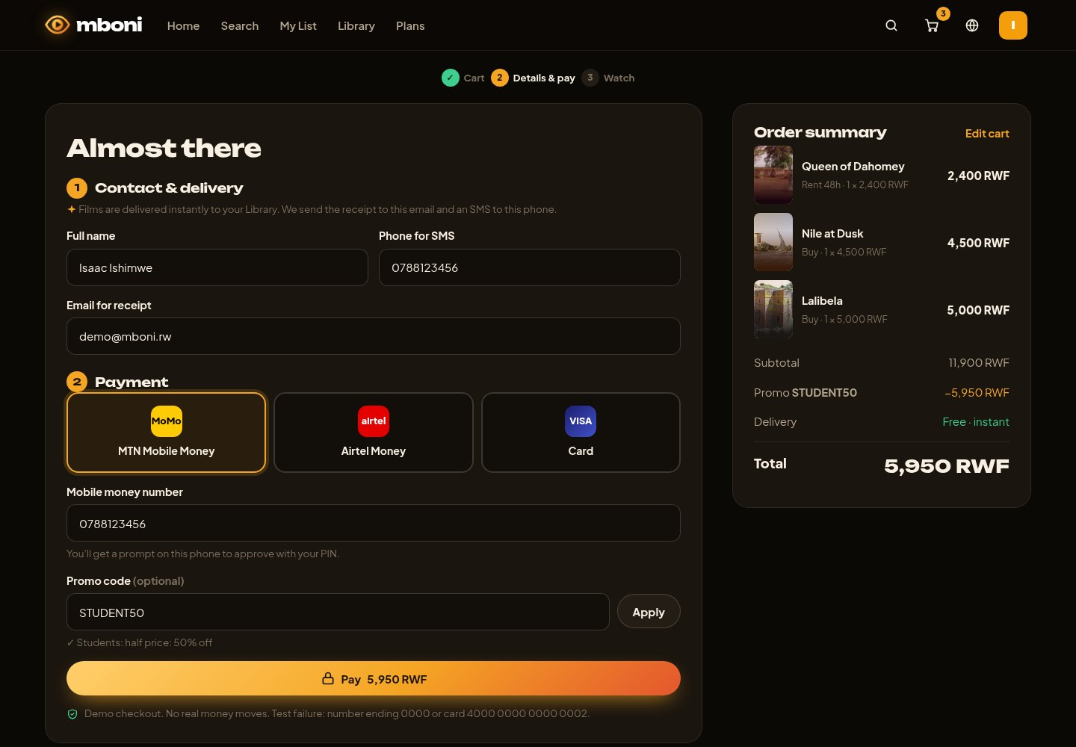
Figure 10: Checkout: contact details and payment
Step 1 collects the contact and delivery details; step 2 lets the customer choose MTN MoMo, Airtel Money or card and apply a promo code. The order summary on the right shows each film and the total (here with 50% off from STUDENT50).
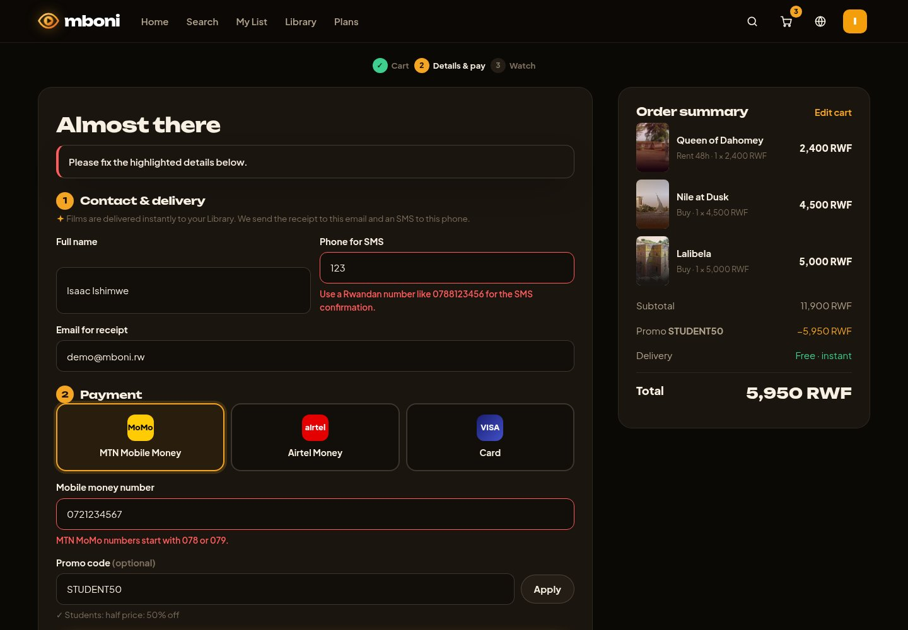
Figure 11: Checkout validation
If a detail is wrong, the form keeps what was typed and explains exactly how to fix each field, for example that an MTN MoMo number must start with 078 or 079.
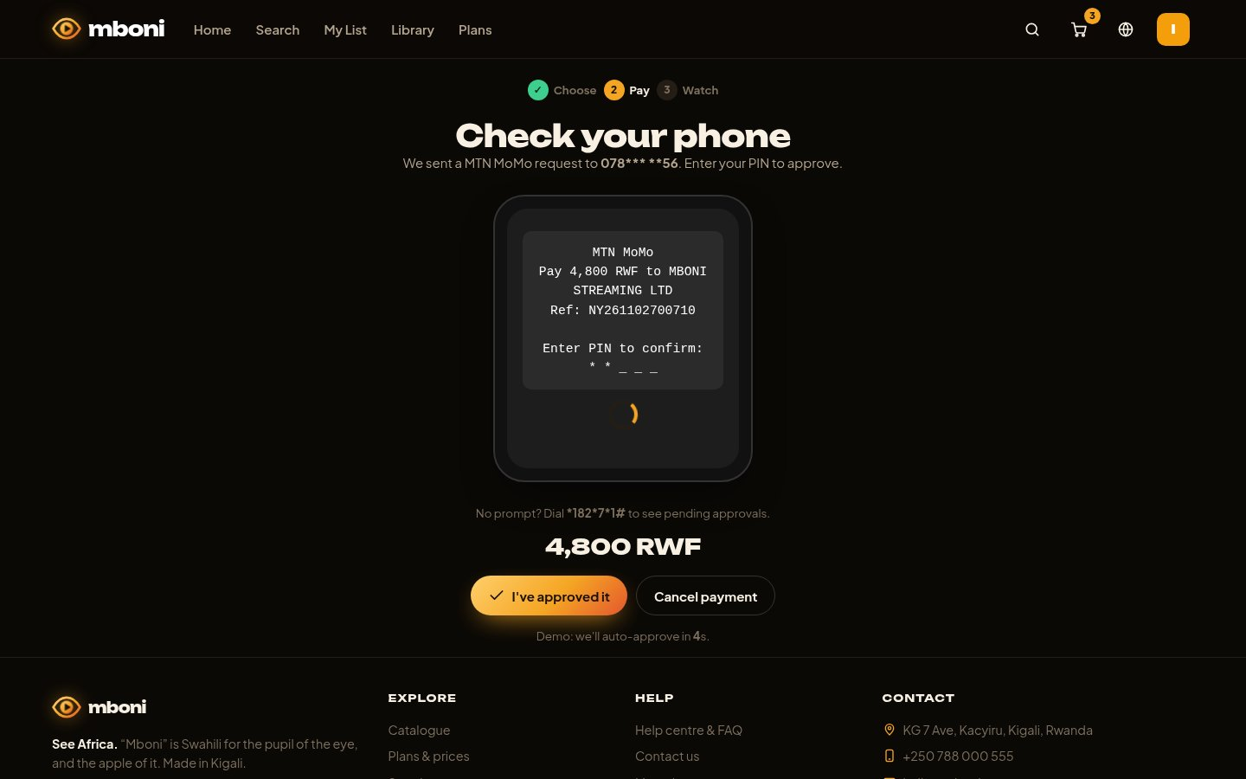
Figure 12: Simulated mobile money approval
After clicking Pay, the customer sees the same kind of USSD message they would get on their phone and approves it. In the demo it approves itself after 6 seconds. No real money moves.
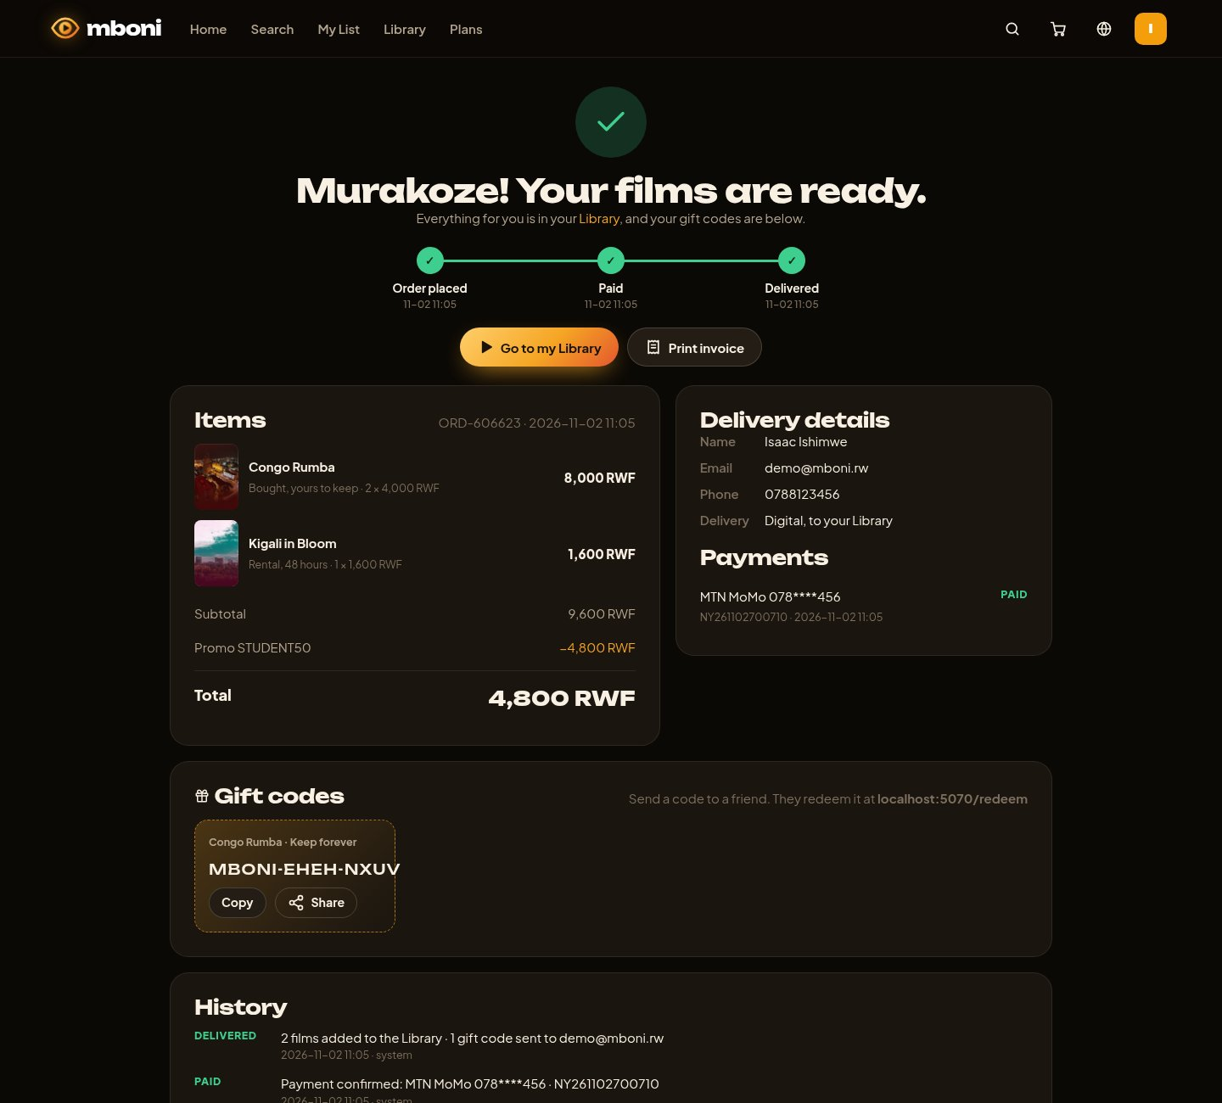
Figure 13: Order confirmation
After payment the order page shows the status timeline (Order placed, Paid, Delivered), the items, the delivery details, the payment, the gift codes to share and the full history of the order.
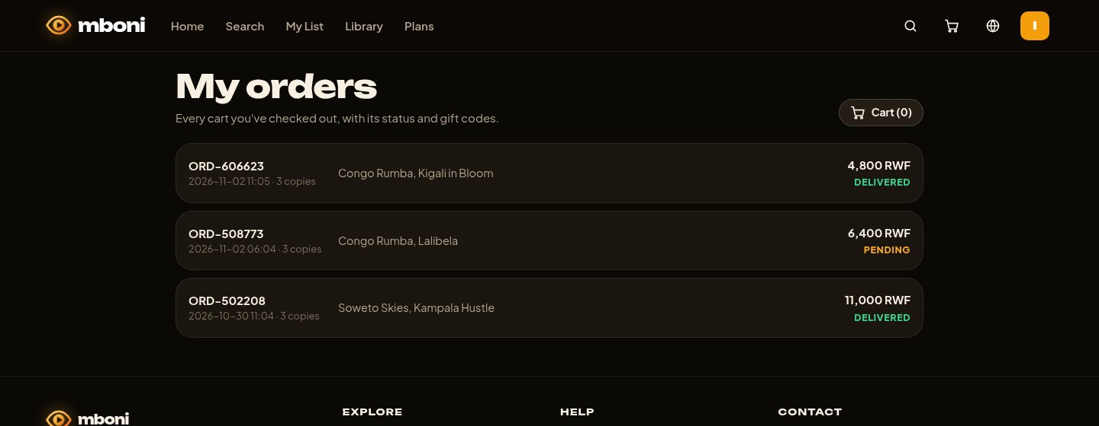
Figure 14: My orders
Customers can see all their orders with the date, films, total and status. A pending order can be paid again or cancelled.
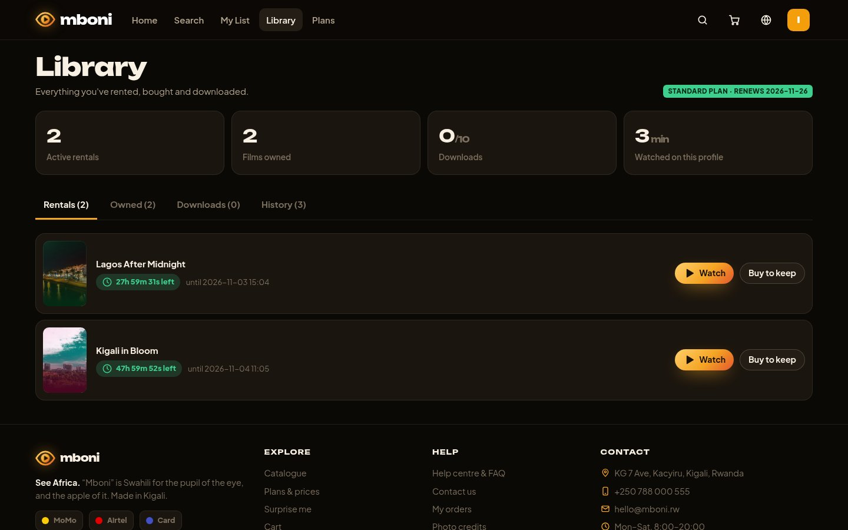
Figure 15: Library
Films the customer rented or bought appear in the Library, with a live countdown for rentals and a button to buy a rented film.
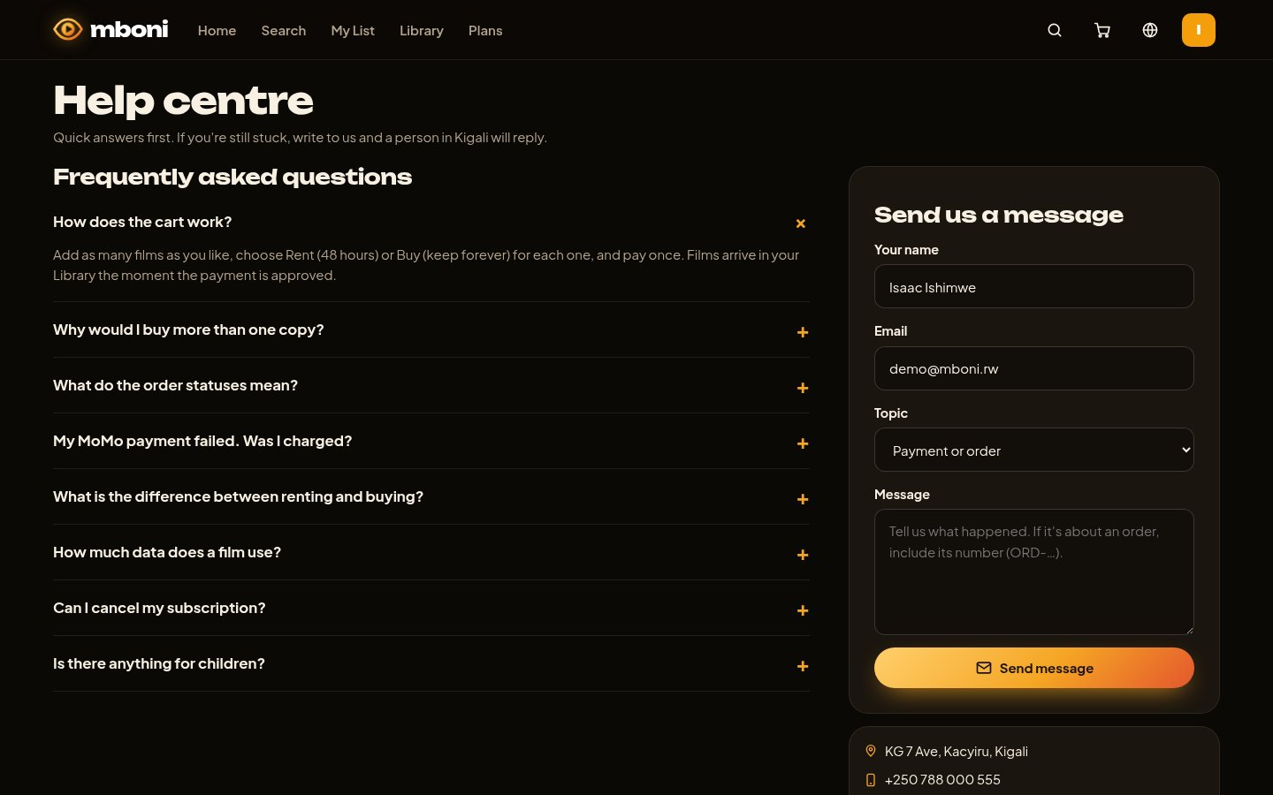
Figure 16: Help centre and contact form
The FAQ answers common questions (cart, gift codes, order statuses, failed MoMo payments). The contact form sends a message to the admin team.

4.2 Administrator pages
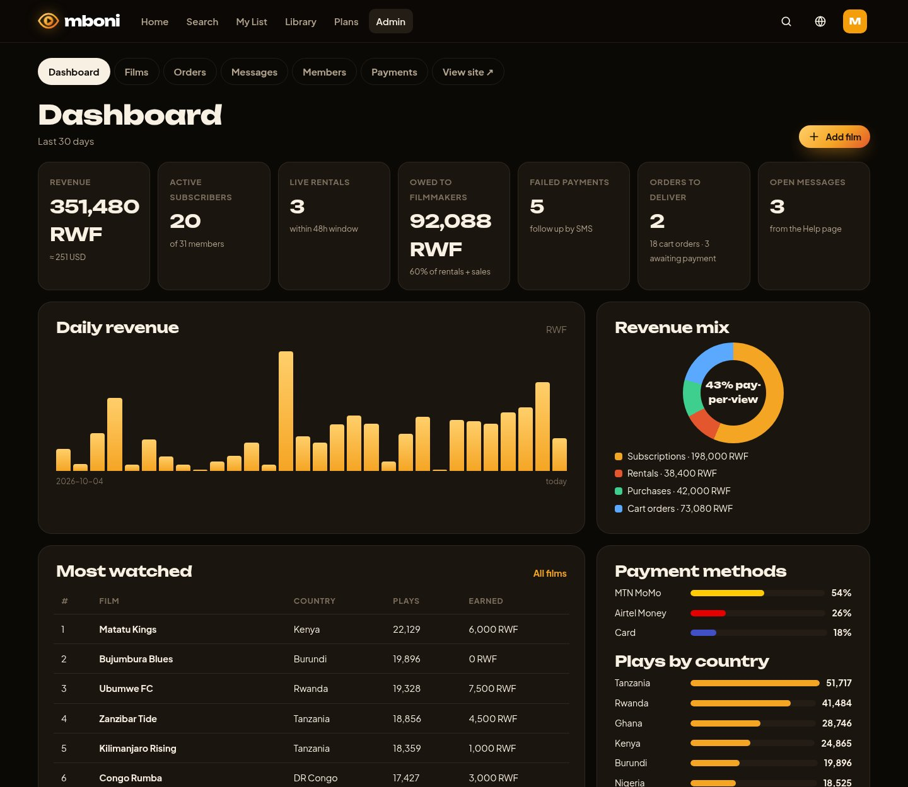
Figure 17: Admin dashboard
The dashboard shows revenue, subscribers, live rentals, money owed to filmmakers, failed payments, orders to deliver and open messages, with a daily revenue chart and the revenue mix by type of sale.
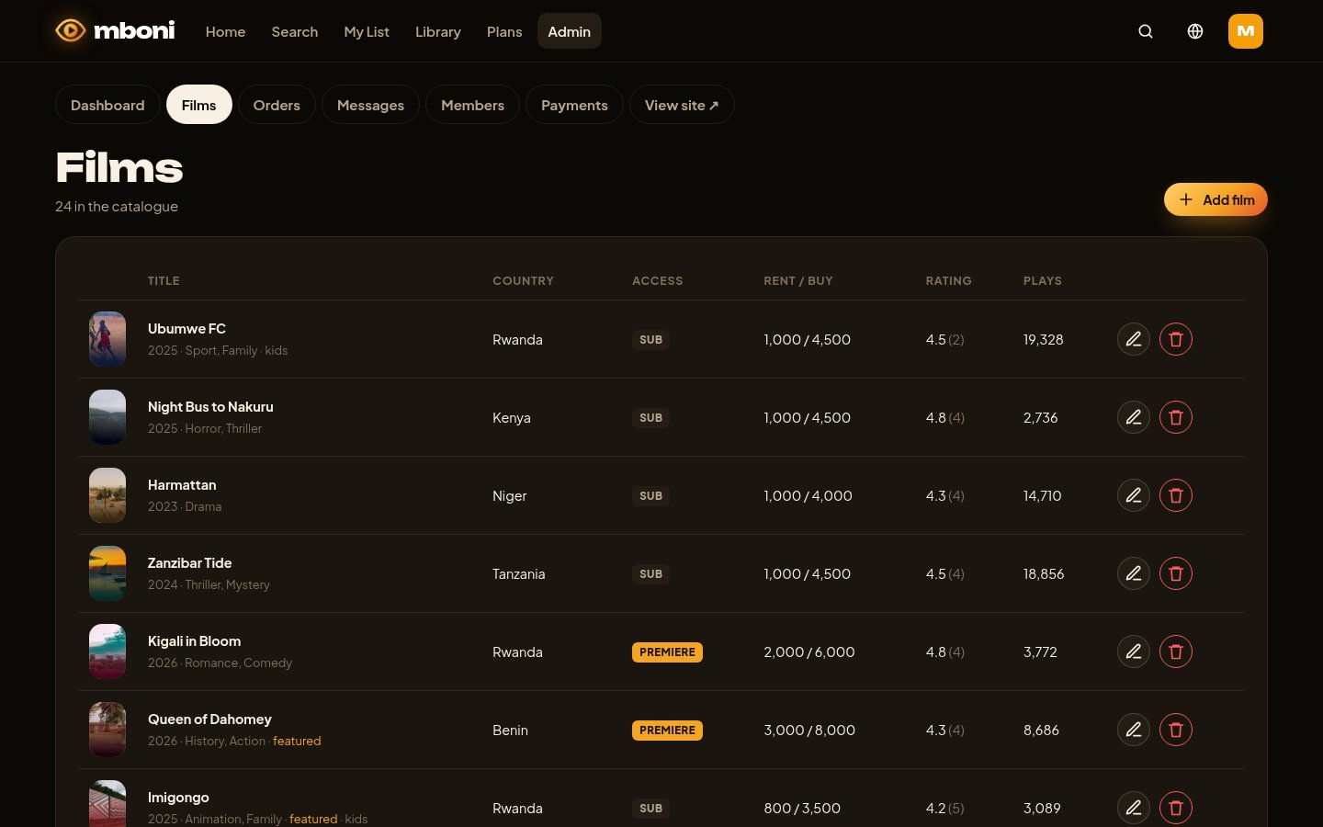
Figure 18: Managing films
The admin sees every film with its country, access type, prices, rating and plays, and can edit or delete it.
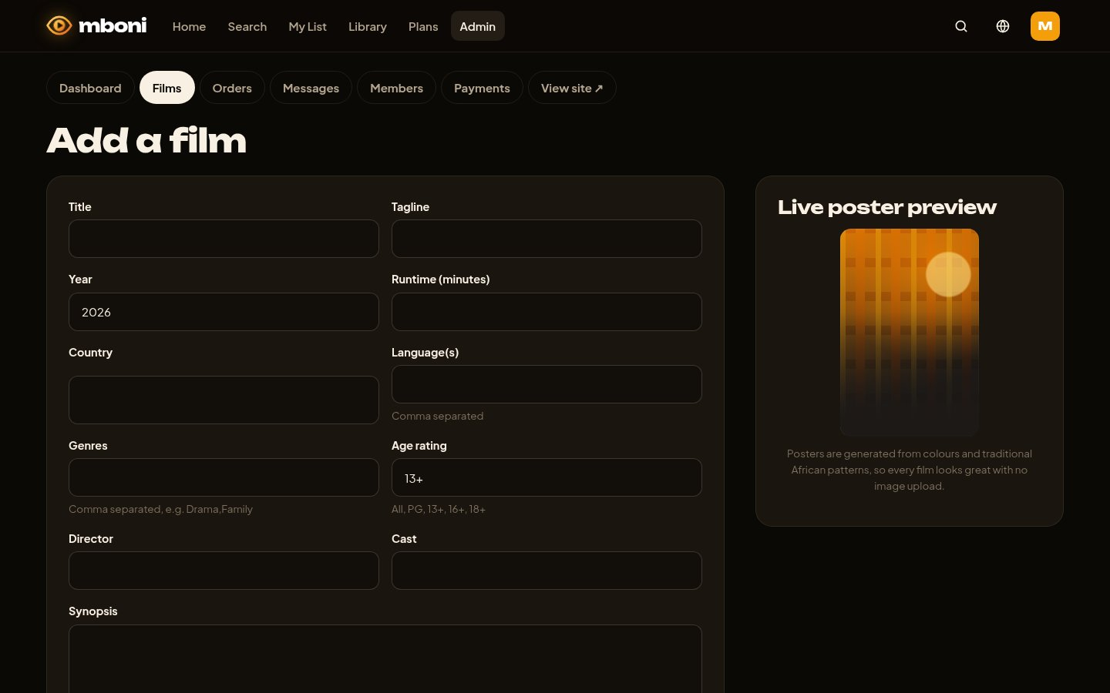
Figure 19: Adding a film
The form to add or edit a film. All fields are validated, and a live preview shows the poster as the admin types.
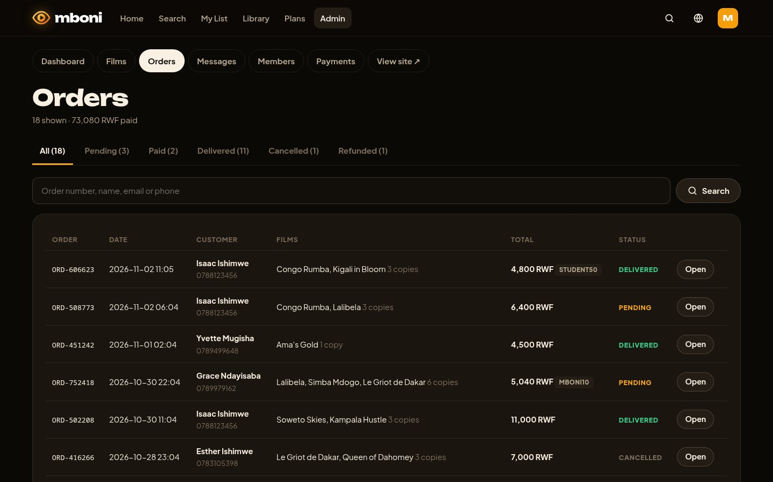
Figure 20: Customer orders
All orders, with tabs to filter by status and a search box for the order number, name, email or phone.
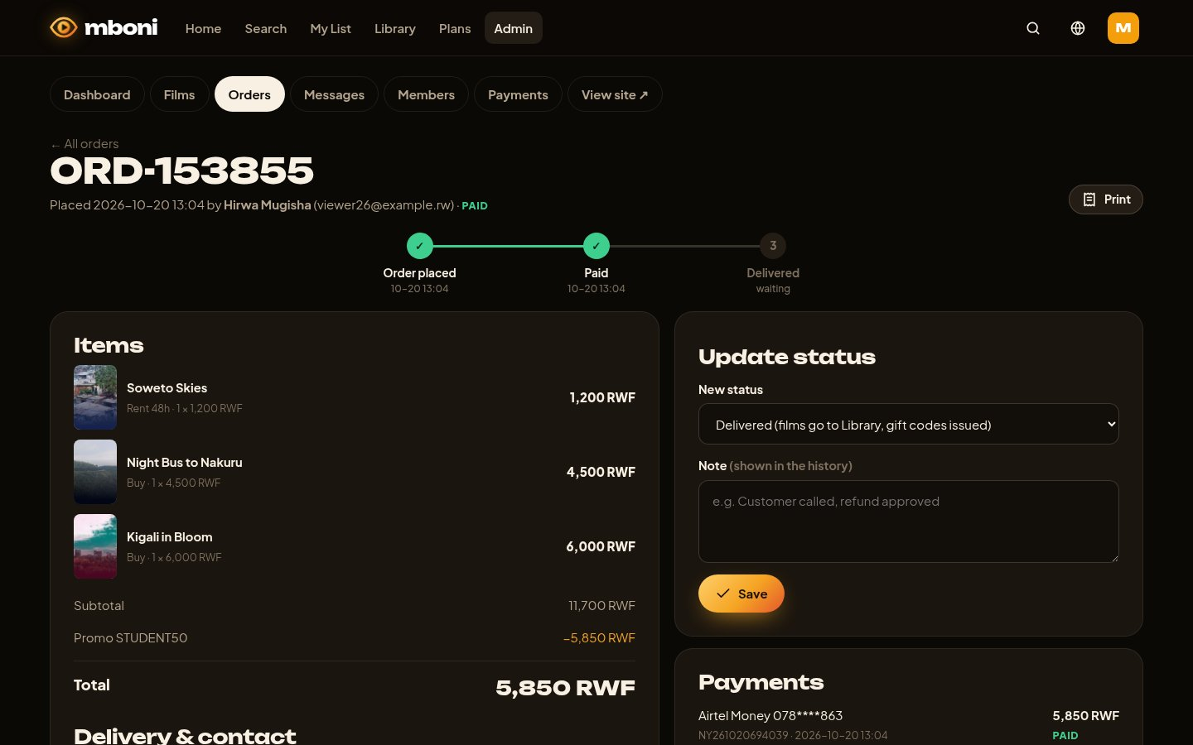
Figure 21: Updating an order
The admin opens an order to see its items, contact details and payments, and changes its status (deliver, cancel or refund) with a note that is saved in the order history.
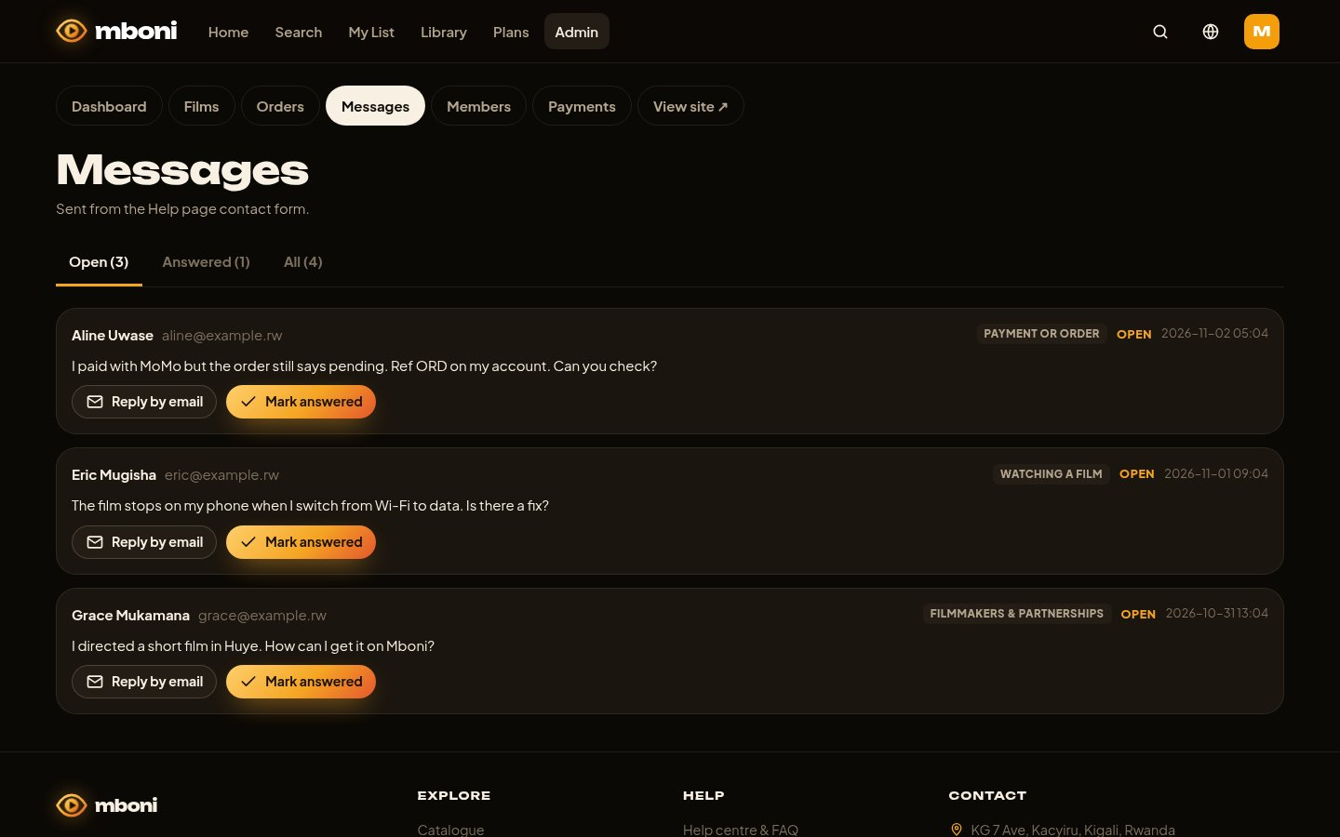
Figure 22: Customer messages
Messages from the contact form. The admin can reply by email and mark each message as answered.

4.3 Mobile view
The same pages adapt to small screens. Figure 23 shows the home page, a film page and the cart on a phone 390 pixels wide.
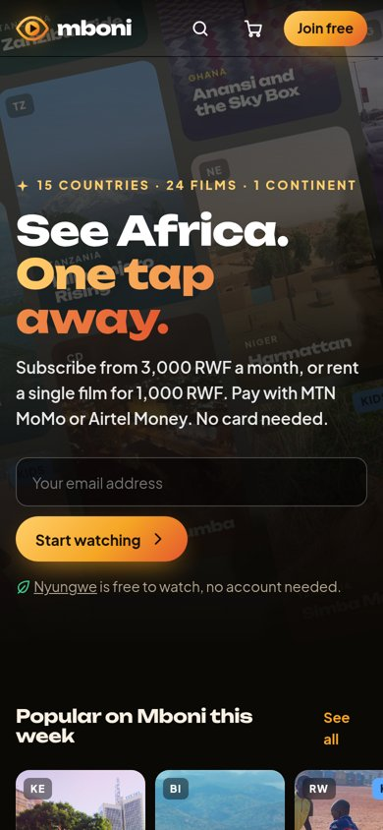 | 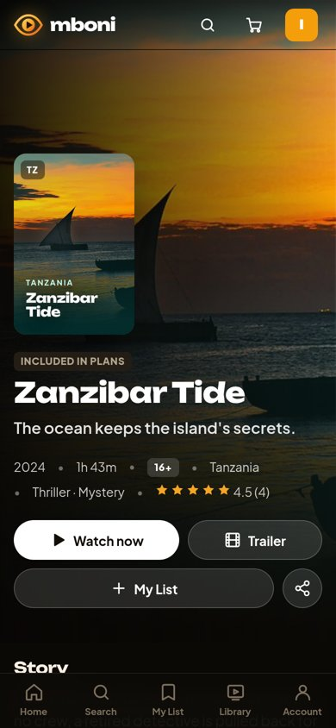 | 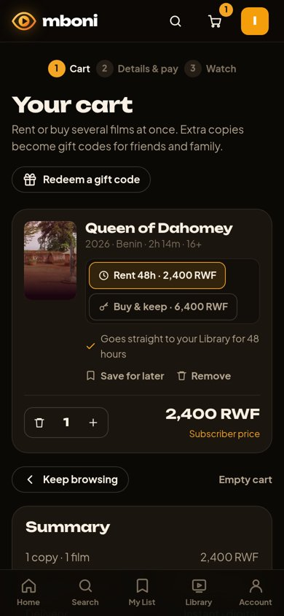
Figure 23: Home page, film page and cart on a phone

5. Testing
We wrote 53 automated tests (Python unittest) that run against a fresh copy of the database. They check, among other things:
- adding films to the cart, changing the quantity, switching between rent and buy, removing items, and that the total is correct;
- that free films and “coming soon” films cannot be added to the cart;
- that a guest's cart is kept after signing in;
- checkout validation (name, email, phone, payment details);
- the full order life cycle: pending → paid → delivered, with the right number of gift codes, and redeeming a gift code from another account;
- that a failed payment keeps the order pending and the cart full, and that paying again works;
- that customers cannot see other people's orders or open admin pages;
- that the admin can deliver and refund orders (a refund removes the films and cancels gift codes);
- the contact form and the admin message inbox, registration, login, CSRF protection and the film management forms.
All 53 tests pass. We also tested the site by hand in Chrome on a computer screen and at a phone width of 390 pixels.

6. Challenges and recommendations

6.1 Challenges we met
- Adapting a cart to digital products. A film is not a physical item, so “quantity” needed a meaning. We decided that the first copy goes to the buyer and extra copies become gift codes. We also had to handle cases where the buyer can already watch the film (for example it is in their plan), so every copy becomes a gift.
- Simulating mobile money. Real MoMo and Airtel payments need a business account and an API. We built a realistic simulation (phone prompt, approval, decline) and made sure a declined payment never loses the customer's order or cart.
- Keeping prices correct. Subscribers get 20% off new premieres and promo codes can be added, so we calculate prices on the server at checkout and save the price in each order item, so old orders do not change when a price changes.
- Kids profiles. A bug let adult films appear in the Kids catalogue when a search used “OR” conditions. Our tests caught it and we fixed the database query.
- Images. We needed attractive cover photos that we are allowed to use. We used free-licence photographs from Wikimedia Commons and credited every photographer (see References).
- Responsive design. Tables and cart lines that look good on a computer were too wide on phones; we redesigned them to stack on small screens.

6.2 Recommendations and future improvements
- Connect the real MTN MoMo and Airtel Money APIs and a card payment gateway, with a business account.
- Send real emails and SMS for receipts and gift codes (for example with an SMS gateway such as Africa's Talking).
- Use adaptive streaming (HLS) so the video quality changes automatically with the network speed, and protect films with DRM.
- Add a filmmaker portal so producers can upload films and follow their earnings.
- Move from SQLite to PostgreSQL and host the system online so it can serve many users at the same time.
- Build Android and iOS apps, and add recommendations based on what each customer watches.

7. Contribution of each member
The work was shared between the three members. Each member also reviewed the whole system so that everyone can explain any part of it.
Member | Main contribution
ISHIMWE Isaac (25611/2024) · Team leader, back end | Planned the project and the database structure; built the Flask application, user accounts and roles, the shopping cart and order logic (statuses, gift codes), the simulated MoMo / Airtel / card payments and the security (password hashing, CSRF, validation); wrote the automated tests.
Sidick Zakaria ISSA (25769/2024) · Front end and design | Designed the user interface and the Mboni brand (name and eye logo); built the page templates and the CSS for phones and computers; made the catalogue, film pages, cart and checkout pages, the video player and the light/dark and language options.
Ahmed Refat NASUR (25899/2024) · Admin, content and documentation | Built the administrator pages (dashboard, films, orders, messages, members, payments); prepared the catalogue content (films, descriptions, prices in RWF, cover photos and their licences); wrote the help centre FAQ and contact form; tested the system by hand, took the screenshots and wrote the report.

8. References

8.1 Tools, libraries and sources
- Flask 3 web framework, Pallets Projects. https://flask.palletsprojects.com
- Jinja2 template engine and Werkzeug (password hashing), Pallets Projects. https://palletsprojects.com
- SQLite database engine. https://www.sqlite.org
- Python 3 programming language and its unittest library. https://www.python.org
- MDN Web Docs (HTML, CSS, JavaScript, Cache API, service workers), Mozilla. https://developer.mozilla.org
- Google Fonts: Plus Jakarta Sans and Unbounded, SIL Open Font License. https://fonts.google.com
- Sintel (demo film clip used for every film), © Blender Foundation, CC BY 3.0. https://durian.blender.org
- Cover photographs: Wikimedia Commons, free licences, credited one by one in section 8.2. https://commons.wikimedia.org
- Nielsen, J. (1994). 10 Usability Heuristics for User Interface Design. Nielsen Norman Group. https://www.nngroup.com/articles/ten-usability-heuristics/
- W3C (2018). Web Content Accessibility Guidelines (WCAG) 2.1. https://www.w3.org/TR/WCAG21/
- MTN MoMo and Airtel Money: payment flow and number prefixes used for the simulation (no real API was used).
- Claude (Anthropic), an AI assistant, used to help write and review parts of the code and this report.
All film titles, cast names, reviews and customers in the system are fictional and were created for this project.

8.2 Photo credits
Each film's cover is a real photograph from Wikimedia Commons, used under the licence shown. The same credits appear on each film page and on the /credits page of the website.
Film | Photograph | Author | Licence
Inzira y'Amahoro | Landscape Kinigi Musanze | Mrbobax | CC BY-SA 4.0
Lagos After Midnight | Lagos at Night (48478169886) | Theo Crazzolara | CC BY 2.0
Ama's Gold | Pra River Ghana | Jamiaghana | CC BY-SA 3.0
Matatu Kings | A colorful matatu in Nairobi, Kenya, during rush hour | AEira-WMF | CC BY 4.0
Soweto Skies | Soweto township | Matt-80 | CC BY 2.0
Le Griot de Dakar | 2026-09-20 Kora player with Djali Binto Kanuté at ÁGORA Festival, Leiria Castle | Alexkom000 | CC BY 4.0
Kilimanjaro Rising | Kibo Mt. Kilimanjaro 6 | Unknown | CC BY-SA 3.0
Nyungwe | Sunrisenyungwe | Jonkmania | CC BY-SA 4.0
Owo Blow | Traffic stop in Maryland, Kosofe, Lagos-Nigeria | Omoeko Media | CC BY-SA 4.0
Bujumbura Blues | Bujumbura & Lake Tanganyika | Andreas31 | CC BY-SA 3.0
Kampala Hustle | Boda boda carrying sugarcanes | ESTHER NAKITENDE | CC BY-SA 4.0
Lalibela | Bete Giyorgis 03 | Bernard Gagnon | CC BY-SA 3.0
Nile at Dusk | Aswan, Elephantine, felucca, Egypt, Oct 2004 | Przemyslaw "Blueshade" Idzkiewicz | CC BY-SA 2.0
Douala Express | Cameroon - Carriers at the train station in Yaounde | Elin | CC BY 2.0
Anansi and the Sky Box | Different Kente cloth, Tafi, Volta region | Warmglow | CC0
Simba Mdogo | Lion (Panthera leo) cub 14 months Serengeti | Charles J. Sharp | CC BY-SA 4.0
Imigongo | Fresque Imigongo-Festival international de géographie 2011 (2) | Ji-Elle | CC BY-SA 3.0
Queen of Dahomey | Abomey 2006 1 | Joachim Huber | CC BY-SA 2.0
Kigali in Bloom | Green Kigali | Dushime rw | CC BY-SA 4.0
Night Bus to Nakuru | Great Rift Valley in Kenya by Renvoy (2) | Renvoy | CC BY 4.0
Ubumwe FC | RWANDAN CHILDREN PLAYING | RWAYITARE250 | CC BY-SA 4.0
Congo Rumba | Kinshasa by night (23769991270) | MONUSCO Photos | CC BY-SA 2.0
Zanzibar Tide | Dhow Sunset, Zanzibar (10164046475) | Rod Waddington from Kergunyah, Australia | CC BY-SA 2.0
Harmattan | Niger, Agadez (28), grand mosque, old city | Vincent van Zeijst | CC BY-SA 4.0

