

**Names:**ISHIMWE Shemu

**ID:**23400

**Course:** Web Technology

**Project Name:** Student Pocket Money Management System

**I. Project description & requirements**

The "Student Pocket Money Management System" is a comprehensive project designed to assist students in effectively managing

and controlling their pocket money.

With this system, students can gain financial independence and

develop responsible money management habits that will benefit them throughout their lives.

**Expected Outcomes:** Budgeting and financial management: The system should enable students to create budgets, track their expenses, and manage their pocket money effectively. This can help them develop good financial habits and learn responsible money management.

**Event Promotion**: Collaborate with educational institutions: Partner with schools, colleges, or universities to promote the project within their student community.

**Automatic Event Dismissal**: the system should automatically remove it from the platform, ensuring that only relevant and active events are displayed.

**Requirements**

**User registration and authentication:** Allow students to create user accounts and log in securely to access the system.

**Profile management**: Provide features for students to manage their profiles, including personal information, financial goals, and preferences.

**Budget creation and management**: Allow students to create budgets based on their pocket money or income.

**Goal setting and progress tracking**: Enable students to set financial goals, such as saving for a specific item or event. The system should allow them to track their progress toward those goals, providing visual indicators or notifications when milestones are reached.

**Security and privacy:** Implement robust security measures to protect user data, including encryption, secure data storage, and adherence to relevant data protection regulations.

**Parental/guardian access:** If desired, provide a feature that allows parents or guardians to monitor their child's expenses and offer guidance. This feature should have appropriate access controls and privacy settings.

**Intuitive user interface**: Design the system with a user-friendly interface, making it easy for students to navigate, input data, and access relevant features. Consider user experience best practices to ensure a smooth and enjoyable interaction.

**II.Project Plan**

Conduct interviews, surveys, or workshops to gather requirements from students, parents, and other stakeholders. Document functional and non-functional requirements for the system.

Prioritize requirements based on their importance and feasibility. System Design Phase:

Design the system architecture, considering scalability, security, and usability.

Develop wireframes or prototypes to visualize the system's user interface and features.

Define the database structure and data models required for expense tracking, budgeting, and goal management.

Development Phase:

Implement the system based on the defined requirements and design.

Develop the user registration and authentication functionalities.

Build modules for expense tracking, budget creation, goal setting, and progress tracking.

Integrate any necessary third-party services or APIs for banking transactions or financial data.

Testing Phase:

Conduct thorough testing of the system, including functional, usability, and performance testing.

Identify and resolve any bugs or issues.

Perform user acceptance testing (UAT) with a group of students or stakeholders to validate the system's usability and effectiveness.

Deployment Phase:

Prepare the system for deployment in a production environment.

Set up the necessary infrastructure and hosting.

Migrate the system and data from the development environment to the production environment.

Configure security measures and ensure compliance with relevant regulations.

**III.Database Schema**

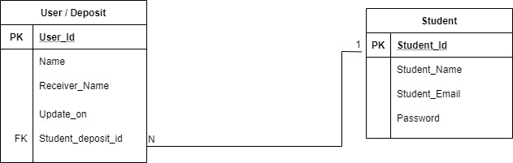

**IV.User Documentation**

User Guide: Student Pocket Money Management System

Welcome to the User Guide for Student Pocket Money Management System. This guide will walk you through the features and functionalities of the application, providing step-by-step instructions to help you effectively use the system. Let's get started!

Table of Contents:

1. Creating an Account

2. Logging In

3. Admin Create New Depostor

4.Student Deposte Money And Withdraw

**This Home page**

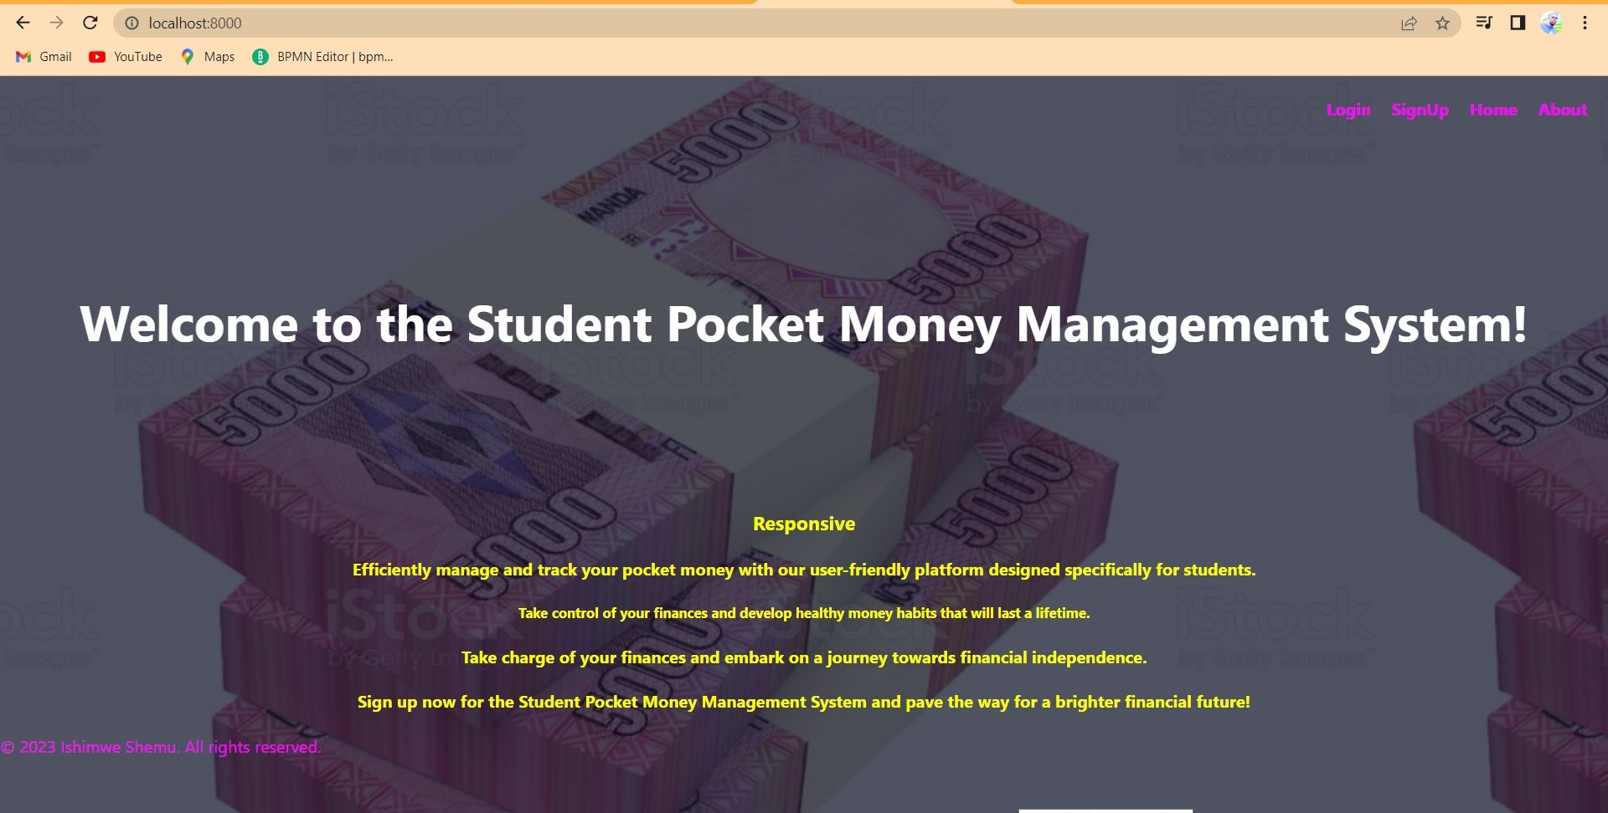

**This is the Signup Page**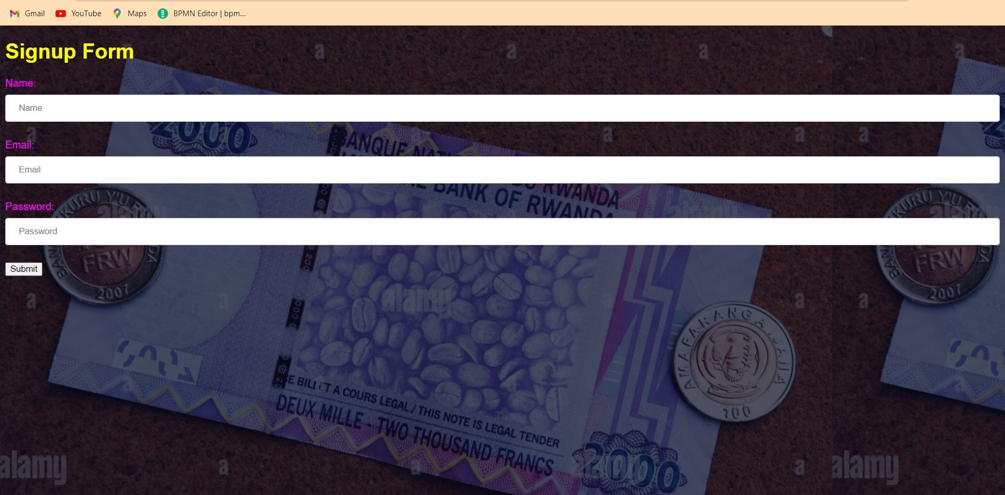

**This The Login page**

**You can Login as Adimn:**

**UserName:Shemusa@gmail.com**

**Password:123**

**Or use Other Creadential**

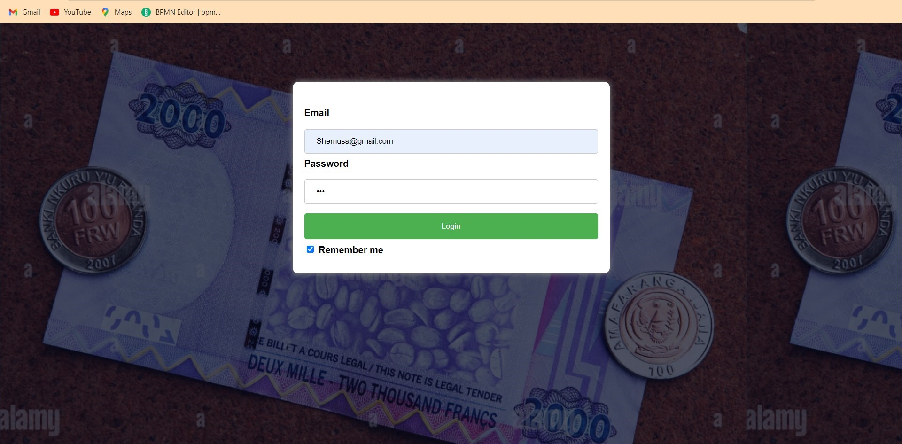

**This is the Deposte Form**

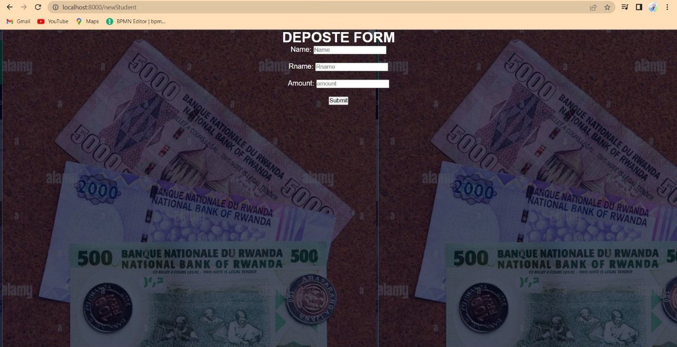

**This is the Update Form**

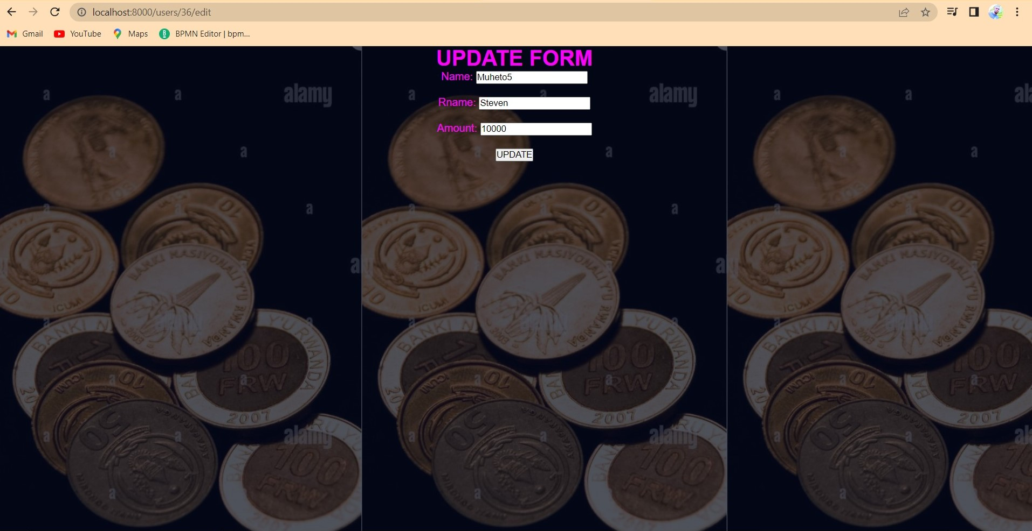

**This is the Display Page**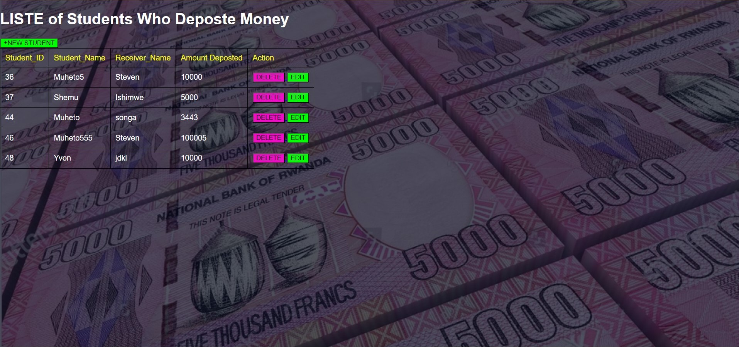

**V. Technical Documentation**

**Introduction:**

The Technical Documentation for Student Pocket Money Management System web application provides detailed information about the application's architecture, components, dependencies, and configuration.

Table of Contents:

1. System Overview

2. Architecture

3. Technologies Used

4. List of Dependency Used

7. APIs and Integration

8. Security Considerations

9. Testing

10. Deployment

11. Monitoring and Maintenance

12. Troubleshooting

13. Release Notes

**1. System Overview:**

The Student Pocket Money Management System web application is built using Spring Boot, a powerful Java framework that simplifies the development of robust and scalable applications. Spring Boot provides a comprehensive ecosystem for building web applications with features like dependency injection, MVC framework, and seamless integration with various libraries and tools.

**2. Architecture:**

The application follows a layered architecture, with the presentation layer implemented using Spring MVC and Thymeleaf for server-side rendering. Spring Boot acts as the back-end application framework, handling business logic and data access. The application leverages Spring Data JPA for database interactions and Spring Security for authentication and authorization.

1. **Technologies Used:**

- Backend: Spring Boot (Java)

- Frontend: HTML5, CSS3 and BootStrap

- Database: MySQL

- Testing: Spring Test

1. **List of Dependency Used:**

1. Spring Boot Starter Web: Provides the necessary dependencies for building web applications with Spring Boot, including an embedded web server and the Spring MVC framework.

2. Spring Boot Starter Thymeleaf: Enables server-side rendering using Thymeleaf, a popular Java-based template engine for web applications.

3. Spring Boot Starter Data JPA: Provides support for data access and persistence using Spring Data JPA, including database connectivity, entity management, and repository interfaces.

4. Spring Boot Starter Security: Facilitates authentication and authorization in the application using Spring Security, enabling secure access to resources and protecting against common security threats.

5. Spring Boot Starter Validation: Offers validation support by integrating the Hibernate Validator, allowing validation of form inputs and request payloads.

6. MySQL Connector/J: Enables connectivity to MySQL database by providing the JDBC driver.

7.Spring Data JPA to provide object-relational mapping capabilities and database persistence.

8. Spring Boot Starter Test: Provides dependencies for testing Spring Boot applications, including JUnit and Mockito for unit testing and Spring Test for integration testing.

9. Thymeleaf Extras Spring Security: Integrates Spring Security with Thymeleaf, enabling the use of security-related tags and expressions in the HTML templates.

10. Lombok: Simplifies Java code development by reducing boilerplate code through annotations, improving code readability and maintainability.

1. **Security Considerations:**

User Authentication: we have Implemented a secure user authentication mechanism to ensure that only authorized users can access the application.we have also Utilized strong password policies, such as enforcing 8 minimum password length.