**JAVASCRIPT**

JavaScript is a Scripting Language. A scripting language is a lightweight programming language. JavaScript is programming code that can be inserted into HTML pages. Its code can be executed by all modern web browsers. JavaScript is easy to learn.

It is the language for HTML, for the web, for servers, PCs, laptops, tablets, phones, and more.

Javascript can be used in the following ways:

* JavaScript: Writing Into HTML Output

Example

document.write("<h1>This is a heading</h1>");  
document.write("<p>This is a paragraph</p>");

* JavaScript: Reacting to Events

Example

<button type="button" onclick="alert('Welcome!')">Click Me!</button>

JavaScript: Changing HTML Content

* Using JavaScript to manipulate the content of HTML elements is a very common.

Example

x=document.getElementById("demo")  //Find the element  
x.innerHTML="Hello JavaScript";    //Change the content

* JavaScript: Changing HTML Styles

Changing the style of an HTML element, is a variant of changing an HTML attribute.

Example

x=document.getElementById("demo")  //Find the element   
x.style.color="#ff0000";           //Change the style

* JavaScript: Validate Input

JavaScript is commonly used to validate input.

Example

if isNaN(x) {alert("Not Numeric")};

* To insert a JavaScript into an HTML page, use the <script> tag.

The <script> and </script> tells where the JavaScript starts and ends.

**The HTML DOM (Document Object Model)**

When a web page is loaded, the browser creates a Document Object Model of the page.

The HTML DOM model is constructed as a tree of Objects:

The HTML DOM Tree of Objects

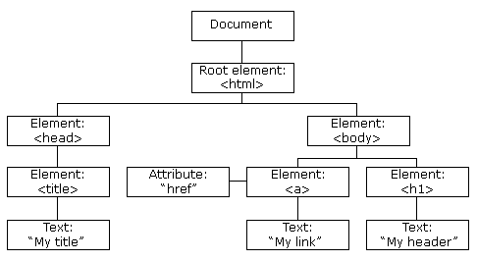

With the object model, JavaScript gets all the power it needs to create dynamic HTML:

* JavaScript can change all the HTML elements in the page
* JavaScript can change all the HTML attributes in the page
* JavaScript can change all the CSS styles in the page
* JavaScript can remove existing HTML elements and attributes
* JavaScript can add new HTML elements and attributes
* JavaScript can react to all existing HTML events in the page
* JavaScript can create new HTML events in the page