Intelligent Predictive Maintenance and Machine Failure Monitoring System
Hidden Markov Models on NASA C-MAPSS turbofan data
Unit 4 – Sequential Data · Industry-Oriented Project 1 · Technical Report
Team: Sai Ishita Chilukuri (RA2411003010608), Himanshu Roy (RA2411003010614), Munish Abhiram B (RA2411003010629), Shriyans Patro (RA2411003010636) · B.Tech CSE, SRM Institute of Science and Technology, Kattankulathur
Code, notebook and dashboard: GitHub repository (see README). Educational prototype – not a production system.

Abstract
Machine sensors drift long before a breakdown, but the drift is noisy and differs from machine to machine. We model the hidden health condition of a turbofan engine as a left-to-right Hidden Markov Model (HMM) over smoothed, PCA-reduced sensor sequences from NASA C-MAPSS FD001. The HMM's scaled Forward, Backward, Forward-Backward, Viterbi and Baum-Welch algorithms are implemented from scratch and verified against hmmlearn (identical results). Alerts are raised from the causal (filtering) probability of the Critical state. On the 100 held-out test engines the system alerts on 16 engines with a mean warning of 27 cycles before failure (fault F1 0.596, precision 0.774, recall 0.485); it clearly outperforms a non-temporal Gaussian mixture but does not beat a tuned single-threshold baseline on F1 (0.608). A Streamlit dashboard shows state probabilities, health trends and alerts.

1. Problem and objective
Industrial vibration, temperature and pressure sequences can reveal machine degradation before breakdown. Objective: identify latent machine-health conditions, detect deterioration early, and present it in a machine-health dashboard. Required tasks: clean sensor readings, extract window features, train an HMM, apply Forward-Backward and Viterbi, and visualise fault-state evolution. Evaluation metrics: fault recall, F1, log-likelihood and detection lead time.

2. Dataset and disclosures
NASA C-MAPSS sub-set FD001: one operating condition and one fault mode (high-pressure-compressor degradation). Training set: 100 engines run to failure (128–362 cycles, mean 206). Test set: 100 engines truncated before failure (31–303 cycles) with the true remaining useful life (RUL) supplied. Each cycle has 3 operating settings and 21 sensors.
- Synthetic data: C-MAPSS is simulated by a physics-based engine model; it is not measured data. We created no additional synthetic data.
- Access restrictions: none; the dataset is public (NASA Prognostics Center of Excellence). A public mirror of the same files is downloaded automatically.
- RUL is used only to evaluate. Health bands for evaluation: healthy RUL > 100, degrading 30 < RUL ≤ 100, fault RUL ≤ 30.

3. Method

3.1 Workflow
Dataset → preprocessing → sequence construction → model formulation → algorithm implementation → inference/estimation → evaluation → visualization → interpretation (the section order of the notebook).

3.2 Preprocessing and sequence construction
- No missing values; 7 constant sensors removed (data-driven check), leaving 14 informative sensors.
- Trailing (causal) 10-cycle rolling mean per sensor: the value at cycle t uses only cycles ≤ t.
- Standardisation and PCA (3 components, 97.1 % variance); PC1 (81 %) rises monotonically with wear and serves as a health indicator.
- Sequence per engine = (T × 3) array in cycle order. Splits are by engine: 70 fit / 30 validation (seed 42) from the training set, plus the official test set.

3.3 Model formulation
Hidden state z_t ∈ {1..K} (machine-health condition), first-order Markov chain with transition matrix A and start distribution π; emissions x_t | z_t = k ~ N(μ_k, diag σ²_k). Wear never reverses, so the topology is left-to-right (A_ij = 0 unless j ∈ {i, i+1}; last state absorbing; π_K = 0). Engines start with different normal wear, so π is learned over the non-final states. State K is the Critical state. Parameters are estimated by maximum likelihood (Baum-Welch) with an unsupervised initialisation that cuts each engine into K equal time chunks (no RUL used).

3.4 Algorithms implemented from scratch
Algorithm | Role in the project
Scaled Forward (scaling factors c_t) | Filtering P(z_t | x_1..t); log-likelihood = Σ ln c_t; basis of the causal alerts
Scaled Backward + Forward-Backward | Smoothed posteriors γ_t(i), ξ_t(i,j) for EM and retrospective state probabilities
Viterbi (log domain) | Most probable health-state path
Baum-Welch (EM) | Maximum-likelihood estimation on multiple sequences; AIC/BIC

Scaling matters: on a ~2,900-step sequence the unscaled forward likelihood underflows to exactly 0, while the scaled version gives a finite log-likelihood (−21,645).

3.5 Alert rule and leakage control
An alert is raised when the filtered probability of the Critical state is ≥ τ for 3 consecutive cycles; once raised it stays latched. τ is tuned on the validation engines (maximising cycle-level fault F1). Leakage safeguards: causal features (unit-tested by corrupting future data), engine-disjoint splits, scaler/PCA fitted on fit engines only, K and τ chosen on validation only, test set evaluated once, alerts from filtering (never from smoothing or Viterbi).

4. Verification against a reference implementation
Check | Our implementation | hmmlearn
Log-likelihood, same parameters (fit engines) | −38529.85125 | −38529.85125
Max |γ difference|, Viterbi path (engine 3) | ~1e-14, identical | –
Independent Baum-Welch training, same init/constraints: log-likelihood | −38529.85 | −38529.85
Viterbi agreement on 30 validation engines | 100 % | –

Eleven unit tests also compare Forward and Viterbi with brute-force enumeration of all state paths on tiny models, check that EM log-likelihood never decreases and that the left-to-right structure is preserved.

5. Evaluation
Choice of K: restricted to K ∈ {3,4,5,6}, we take the smallest K whose validation F1 is within 0.01 of the best (validation F1: 0.765, 0.783, 0.806, 0.825) → K = 6. Training log-likelihood and BIC keep improving with K, which is typical for HMMs, so they are not used alone.
Method (test set, 100 engines) | Fault recall | Precision | F1 | False-pos. rate | Engine recall | Mean lead (cycles)
HMM (from scratch), K=6 | 0.485 | 0.774 | 0.596 | 0.004 | 0.60 | 27.1
GMM, no temporal model | 0.334 | 1.000 | 0.501 | 0.000 | 0.32 | 25.2
PC1 threshold | 0.672 | 0.556 | 0.608 | 0.014 | 0.72 | 39.2

Fault = RUL ≤ 30 cycles (cycle level, alert latched); lead time = true RUL at the first alert; engine recall = share of the 25 engines that end inside the fault zone that were alerted. Held-out HMM log-likelihood per cycle: validation −2.712, test −2.200. Validation results (30 run-to-failure engines): F1 0.825, recall 0.745, precision 0.924, every engine alerted, mean lead 24.0 cycles.
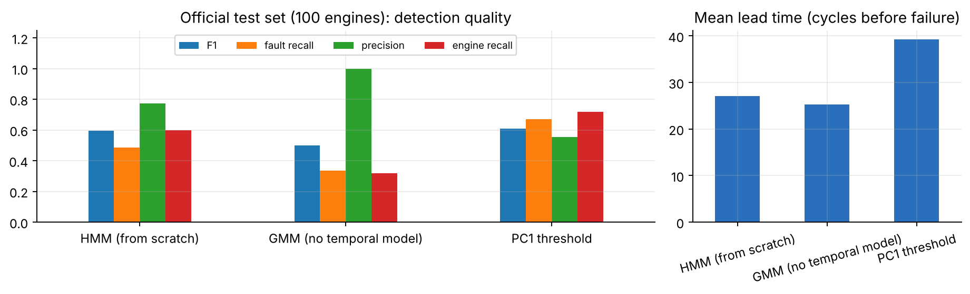
Figure 1 – Test-set comparison of the HMM and the baselines.

6. Visualization
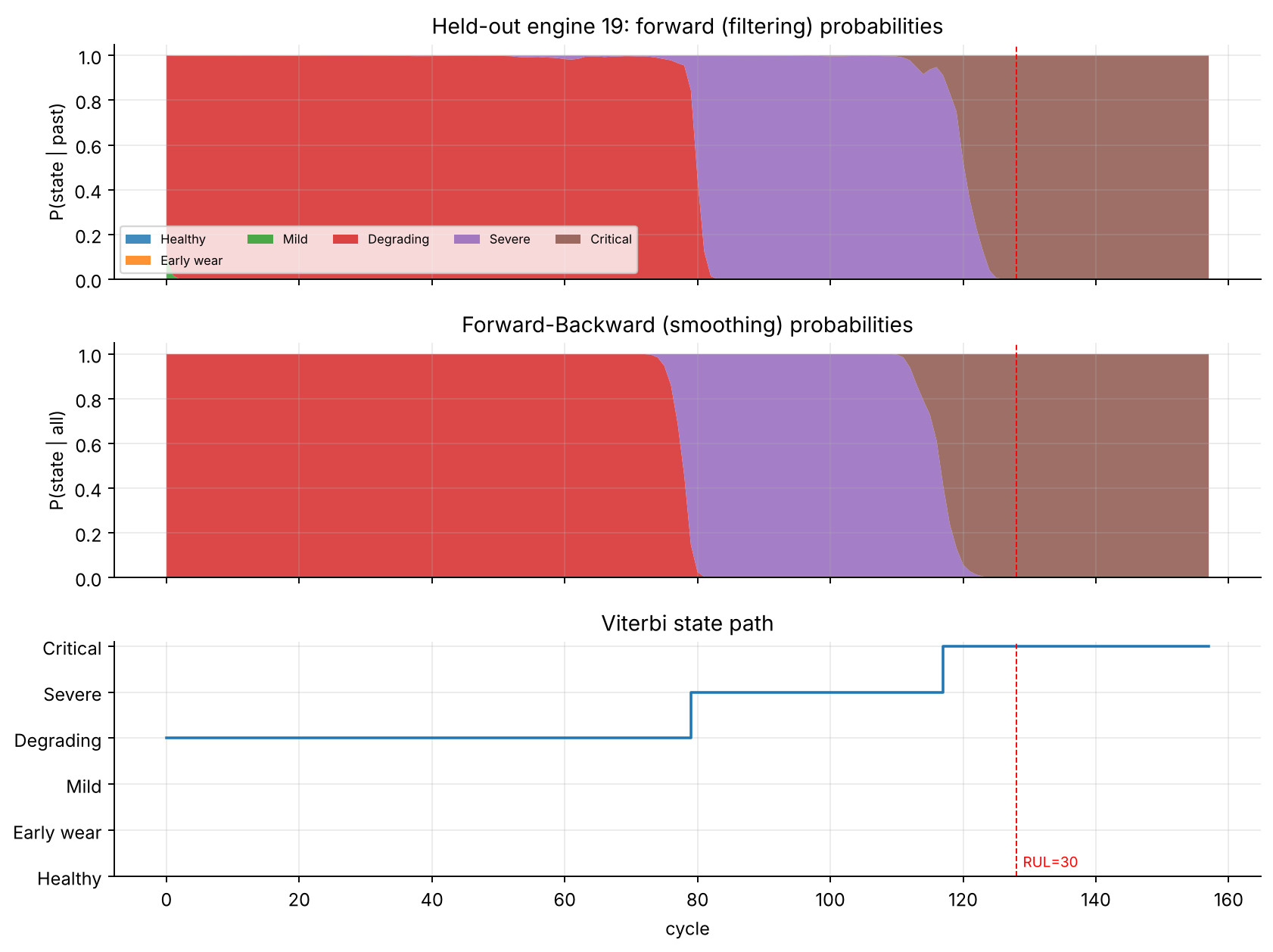
Figure 2 – Forward (filtering), Forward-Backward (smoothing) and Viterbi output on a held-out engine.
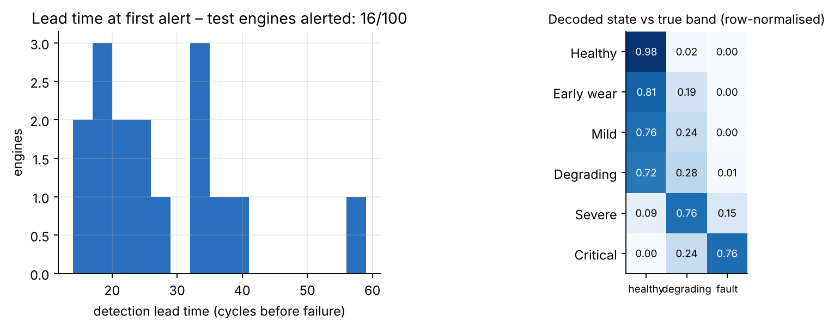
Figure 3 – Detection lead time on test engines (left) and decoded states vs true health band (right).
The Streamlit dashboard (app/streamlit_app.py) provides: engine selector and threshold sliders; a replay slider that reveals only the first t cycles, so the alert logic is causal; stacked state-probability chart, PC1 trend with the Viterbi state, P(Critical) against the threshold with the alert marker; sensor trends; a fleet table with alert status and lead time; and model/metric tabs.
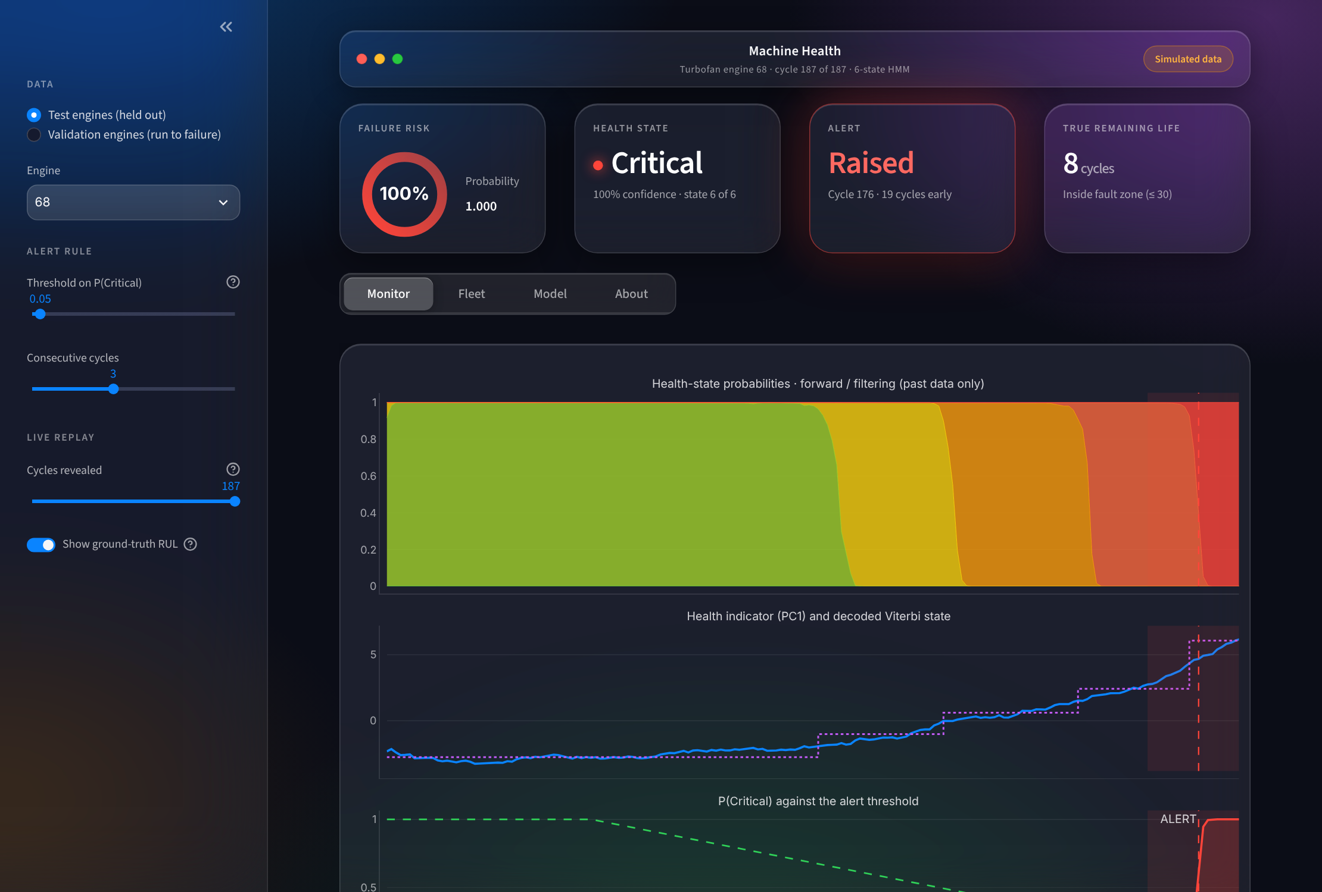
Figure 4 – Dashboard: engine monitor view (glass UI; test engine 68, alert 19 cycles before failure).

7. Interpretation
- The decoded states form a wear ladder: mean PC1 rises from −4.5 (Healthy) to +6.1 (Critical) while the mean true RUL on validation engines falls from about 168 to about 15 cycles – found without any RUL labels (the middle states are not perfectly monotone in RUL).
- Alerts come from the filtered probability, so they use information available at that cycle, and fire on average 27 cycles before failure on the test set.
- Honest comparison: the HMM is more precise than the PC1 threshold but less sensitive; its F1 is slightly below (0.596 vs 0.608) and it is clearly above the non-temporal GMM (0.501). We do not claim an accuracy advantage over a tuned threshold. The HMM adds a probabilistic state ladder with uncertainty and dwell times that a bare threshold lacks.
- Differences of 0.01–0.02 F1 are within noise with 30 validation engines; only 25 test engines end in the fault zone.

8. Limitations and future work
- Only FD001 (single operating condition, single fault mode); FD002–FD004 need operating-condition normalisation.
- Simulated data; results may not transfer to real machines. Thresholds and K depend on one 70/30 split (seed 42).
- Future work: IMS bearing data, cross-validated engine splits, hazard/RUL regression on top of the state posterior, semi-Markov (explicit duration) models.
- Educational prototype – not a production maintenance or safety system.

9. Reproducibility
Fixed seed (42), pinned requirements, automatic data download, executed notebook with saved outputs, scripts/train.py to regenerate all artifacts, 11 unit tests (pytest). Commands are in the README.

References
- Saxena, A., Goebel, K., Simon, D., Eklund, N. “Damage propagation modeling for aircraft engine run-to-failure simulation.” Int. Conf. on Prognostics and Health Management, 2008 (C-MAPSS).
- Rabiner, L. R. “A tutorial on hidden Markov models and selected applications in speech recognition.” Proc. IEEE 77(2), 1989.
- Bishop, C. M. Pattern Recognition and Machine Learning, Ch. 13 (scaled Forward-Backward, Viterbi).

