Game Design Document

Fill up the Following document

1. Write the title of your project.

**Ans. “World Of War Craft”**

1. What is the goal of the game?

**Ans. The goal of the game is when the player will complete all the levels , they will get a chance for a military campaign.**

1. Write a brief story of your game?

* **I want to make a “World Of War Craft” game in which there will be levels and so many obstacles like mountains, broken houses, water and so many other things.**
* **The player will first get to login their names, gender etc. and they will sign up as there player name as they want, gender etc.**
* **Then they will make their own avatar like clothing themselves and buying some of the things.**
* **There would be a team of 8-10 players.**
* **The players can send friend requests to each other, they can also chat and talk to each other.**
* **There would be so many types of guns like handgun, pistol, semiautomatic pistol, Luger pistol, Revolver, ak-47, golden legend RPG etc.**
* **And there would be some clothes to wear, the players will unlock some of the things when they will reach to next level or they will win. (Like clothes, guns, vehicles and some other places etc.)**
* **Vehicles will include helicopters, tank, airplanes, buses, cars and motorcycles.**
* **There would be 100 levels.**
* **There will be regular points. (Infinite Runner)**
* **The game would not be that difficult neither easy.**
* **And when they will kill any of the team then they will get a reward like written 1st on the trophy, some points and to unlock some of the things.**
* **There would be shops.**
* **They will get a feedback like you played very good, you won or you lost etc.**
* **The game will be updated in every season for eg: Like in summer the game will be very sunny, in spring there will be normal weather + flowers grown, in autumn there will be no leaves on the tress yellow coloured weather and last but not the least in winter it will be very coldy, there will be santas and snowfall.**

1. Which are the playing characters of this game?

* Playing characters are the ones which respond to the user based on the input from the user
* Cars, monkeys, dinos, wizards etc, are the playing characters in the game.

|  |  |  |
| --- | --- | --- |
| Number | Character Name | What can this character do? |
| 1 | Captain America | Moving |
| 2 | Iron man | Moving |
| 3 | Captain Marvel | Moving |
| 4 | Thor | Moving |
| 5 | Black Panther | Moving |
| 6 | Hulk | Moving |
| 7 | Spider Man | Moving |
| 8 | Wonder Woman | Moving |

1. Which are the Non Playing Characters of this game?

* Non Playing characters are the ones which don't have an action or a behavior when the user interacts with the game.
* Hurdles, stones, bananas, coins, etc are non playing characters in the game.

|  |  |  |
| --- | --- | --- |
| Number | Character Name | What can this character do? |
| 1 | Mountains/ valleys | Not Moving/ stopping player |
| 2 | Speed Breakers | Not Moving/ stopping player |
| 3 | roads | Not Moving/ stopping player |
| 4 | water | Not Moving/ stopping player |
| 5 | mountain | Not Moving/ stopping player |
| 6 | N/A | Not Moving/ stopping player |
| 7 | N/A | Not Moving/ stopping player |
| 8 | N/A | Not Moving/ stopping player |

Draw your imagination of this game. What does this game look like?

* Draw the game either on your computer or on paper,
* Add images of scenes of the game to show each of the playing and non-playing characters at least once.

**Ans.**

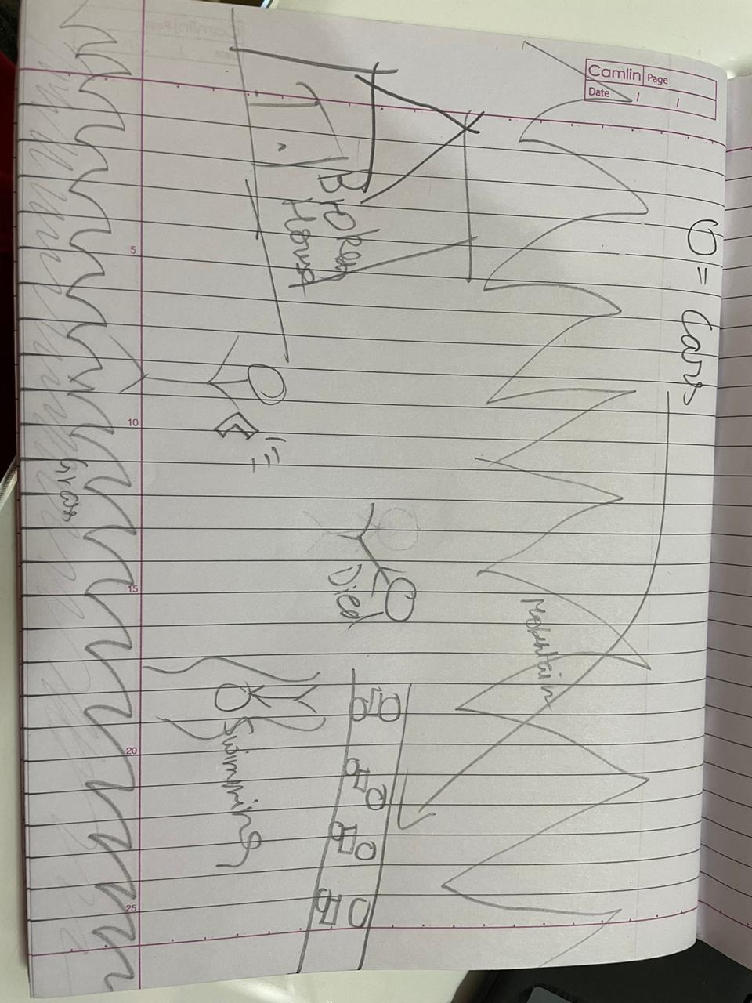

How do you plan to make your game engaging?

**Ans. Engaging parts would be:**

**... collecting energy drinks and fruits.**

**... Save player from touching obstacles**

**... sound effects, etc.**