Game Design Document

Fill up the following document

1. Write the title of your project.

Memory Game

1. What is the goal of the game?

Find out the same set of cards.

1. Write a brief story of your game.

The player would be given with a set of 16 cards (8 pairs).The player has to click on two cards at a time. If the cards are of the same symbol , they get matched and the player gains a point.If they are of different symbol, the cards turn around and the player will select another two cards.

1. Which are the playing characters of this game?

* Playing characters are the ones who respond to the user based on the input from the user.
* Cars, monkeys, dinos, wizards, etc., are the playing characters in the game.

|  |  |  |
| --- | --- | --- |
| Number | Character Name | What can this character do? |
| 1 | Player | Can select two cards |
| 2 |  |  |
| 3 |  |  |
| 4 |  |  |
| 5 |  |  |
| 6 |  |  |
| 7 |  |  |
| 8 |  |  |

1. Which are the Non-Playing Characters of this game?

* Non-Playing characters are the ones that don't have an action or behavior when the user interacts with the game.
* Hurdles, stones, bananas, coins, etc., are non-playing characters in the game.

|  |  |  |
| --- | --- | --- |
| Number | Character Name | What can this character do? |
| 1 | Cards | It can hold symbols |
| 2 |  |  |
| 3 |  |  |
| 4 |  |  |
| 5 |  |  |
| 6 |  |  |
| 7 |  |  |
| 8 |  |  |

Draw your imagination of this game. What does this game look like?

* Draw the game either on your computer or on paper.
* Add images of the game scenes to show each of the playing and non-playing characters at least once.

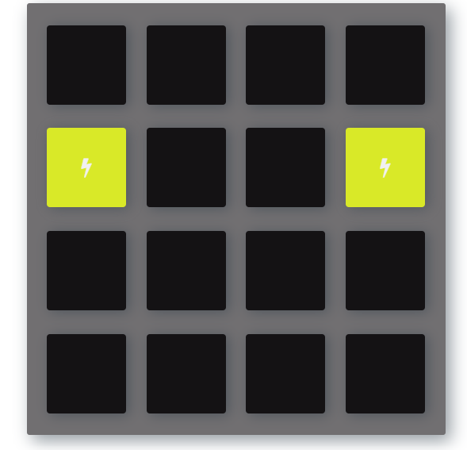

How do you plan to make your game engaging?

I have planned to include more levels and more number of cards to the game.