DBMS - Mini Project

Airport Management

Name: Ishita Bharadwaj

SRN: PES1UG20CS648

Section: K

Roll No: 43

# Short Description and Scope of the Project

Imagine an airport. What are the first things that come to mind? A cavernous terminal, information displays, long queues, baggage claim conveyors, arriving aircraft waiting to be fueled and catered for imminent departure. Airports have a tight flight schedule with its associated staff management, passenger processing, attention to minute detail, and much more. Proper airport management practices speed up the processes and improves the quality of service.

Airport management system is a database project implemented in MySQL. It primarily deals with the management of the airport, airlines, passengers, employees, ticket and flights for various airports. It is designed as per the airport management needs. There are a total of 11 tables each with a minimum of 5 records.

The system provides a broad overview of underlying operational factors that influence the airport management.

**ER Diagram**

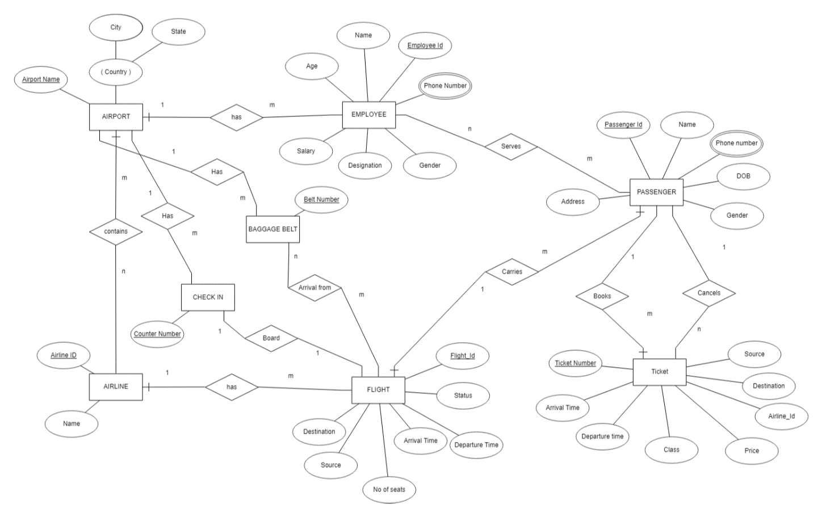

# Relational Schema

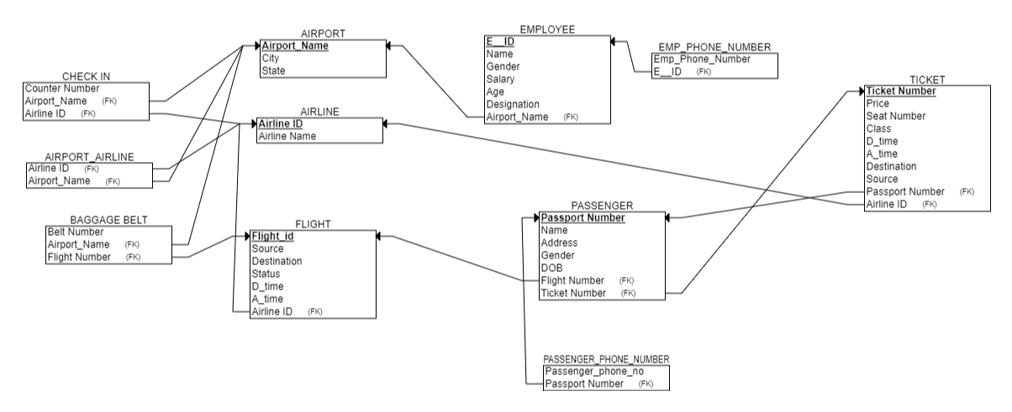

**DDL statements - Building the database**

CREATE TABLE `airport`(

    `airport_name` VARCHAR(40) NOT NULL,

    `city` VARCHAR(20) DEFAULT NULL,

    `state` VARCHAR(20) DEFAULT NULL

)ENGINE=InnoDB DEFAULT CHARSET=utf8mb4;

CREATE TABLE `airline`(

    `airline_id` INT NOT NULL,

    `airline_name` VARCHAR(20) DEFAULT NULL

)ENGINE=InnoDB DEFAULT CHARSET=utf8mb4;

CREATE TABLE `airport_airline`(

    `airline_id` INT NOT NULL,

    `airport_name` VARCHAR(40) DEFAULT NULL,

    KEY(`airline_id`,`airport_name`)

)ENGINE=InnoDB DEFAULT CHARSET=utf8mb4;

CREATE TABLE `flight`(

    `flight_id` varchar(5)  NOT NULL,

    `source` VARCHAR(20) DEFAULT NULL,

    `destination` VARCHAR(20) DEFAULT NULL,

    `status` VARCHAR(20) DEFAULT NULL,

    `d_time` TIME DEFAULT NULL,

    `a_time` TIME DEFAULT NULL,

    `airline_id` INT DEFAULT NULL,

    `tot_seat` INT DEFAULT NULL

)ENGINE=InnoDB DEFAULT CHARSET=utf8mb4;

CREATE TABLE `employee`(

    `e_id` VARCHAR(5) NOT NULL,

    `name` VARCHAR(20) DEFAULT NULL,

    `gender` char(1) DEFAULT NULL,

    `salary` INT DEFAULT NULL,

    `age` INT DEFAULT NULL,

    `designation` VARCHAR(20) DEFAULT NULL,

    `airport_name` VARCHAR(40) DEFAULT NULL

)ENGINE=InnoDB DEFAULT CHARSET=utf8mb4;

CREATE TABLE `emp_phone_no`(

    `e_id` VARCHAR(5) NOT NULL,

    `phone_no` VARCHAR(11) DEFAULT NULL,

    KEY(`e_id`,`phone_no`)

)ENGINE=InnoDB DEFAULT CHARSET=utf8mb4;

CREATE TABLE `passenger`(

    `passport_no` VARCHAR(20) NOT NULL,

    `name` VARCHAR(20) NOT NULL,

    `address` VARCHAR(20) DEFAULT NULL,

    `gender` CHAR(1) DEFAULT NULL,

    `dob` DATE DEFAULT NULL,

    `flight_id` VARCHAR(5) DEFAULT NULL,

    `ticket_no` VARCHAR(20) DEFAULT NULL,

    `bookedby_name` VARCHAR(20) DEFAULT NULL,

    PRIMARY KEY(`passport_no`,`ticket_no`)

)ENGINE=InnoDB DEFAULT CHARSET=utf8mb4;

CREATE TABLE `passenger_phone_no`(

    `passport_no` VARCHAR(20),

    `phone_no` VARCHAR(11),

    KEY(`passport_no`,`phone_no`)

)ENGINE=InnoDB DEFAULT CHARSET=utf8mb4;

CREATE TABLE `ticket`(

    `ticket_no` VARCHAR(5) NOT NULL,

    `airline_id` INT DEFAULT NULL,

    `price` INT DEFAULT NULL,

    `seat_no` VARCHAR(5) DEFAULT NULL,

    `class` VARCHAR(20) DEFAULT NULL,

    `d_time` TIME DEFAULT NULL,

    `a_time` TIME DEFAULT NULL,

    `source` VARCHAR(20) DEFAULT NULL,

    `destination` VARCHAR(20) DEFAULT NULL,

    `passport_no` VARCHAR(20) DEFAULT NULL,

    PRIMARY KEY(`ticket_no`)

)ENGINE=InnoDB DEFAULT CHARSET=utf8mb4;

CREATE TABLE `check_in`(

    `counter_no` VARCHAR(5) NOT NULL,

    `airport_name` VARCHAR(40) DEFAULT NULL,

    `airline_id` INT DEFAULT NULL,

    KEY(`counter_no`,`airport_name`,`airline_id`)

)ENGINE=InnoDB DEFAULT CHARSET=utf8mb4;

CREATE TABLE `baggage_belt`(

    `belt_no` VARCHAR(5) NOT NULL,

    `airport_name` VARCHAR(40) DEFAULT NULL,

    `flight_id` VARCHAR(5)  DEFAULT NULL,

    KEY(`belt_no`,`airport_name`,`flight_id`)

)ENGINE=InnoDB DEFAULT CHARSET=utf8mb4;

# Populating the Database

INSERT INTO `airport`(`airport_name`,`city`,`state`) VALUES

('Chattrapati Shivaji Airport', 'Mumbai', 'Maharashtra'),

('Indira Gandhi Airport', 'Delhi', 'Delhi'),

('Netaji Subhash Chandra Bose Airport', 'Kolkata','West Bengal'),

('Kempegowda Airport', 'Bangalore','Karnataka'),

('Madras Airport', 'Chennai','Tamil Nadu');

INSERT INTO `airline`(`airline_id`,`airline_name`) VALUES

(111,'Airlines1'),

(112,'Airlines2');

INSERT INTO `airport_airline`(`airline_id`,`airport_name`) VALUES

(111,'Chattrapati Shivaji Airport'),

(112,'Chattrapati Shivaji Airport'),

(111,'Indira Gandhi Airport'),

(112,'Indira Gandhi Airport'),

(111,'Kempegowda Airport'),

(112,'Kempegowda Airport');

INSERT INTO `flight` (`flight_id`,`source`,`destination`,`status`,`d_time`,`a_time`,`airline_id`,`tot_seat` )VALUES

('F1','Mumbai','Bangalore', 'On Time','14:30:00','15:00:00', 111,200 ),

('F2','Bangalore', 'Mumbai', 'Delayed','17:30:00','18:00:00',112,250 ),

('F3','Mumbai', 'Delhi','On Time', '01:00:00', '03:30:00',111,200),

('F4','Delhi', 'Bangalore','On Time', '07:00:00', '10:00:00',112,250);

INSERT INTO `employee`(`e_id`,`name`,`gender`,`salary`,`age`,`designation`,`airport_name`) VALUES

('E1','Parth','M','40000','24','Passenger assistant','Chattrapati Shivaji Airport'),

('E2','Ramesh','M','30000','20','Airline baggage handler','Chattrapati Shivaji Airport'),

('E3','Shikha','F','35000','19','Passenger assistant','Kempegowda Airport'),

('E4','Raj','M','25000','23','Airline baggage handler','Kempegowda Airport'),

('E5','Ram','M','20000','26','Passenger assistant','Indira Gandhi Airport'),

('E6','Rani','F','22000','30','Passenger assistant','Indira Gandhi Airport'),

('E7','Priya','F','29000','29','Passenger assistant','Kempegowda Airport'),

('E8','Anjali','F','30000','30','Passenger assistant','Kempegowda Airport');

INSERT INTO `emp_phone_no`(`e_id`,`phone_no`)VALUES

('E1','9123456789'),

('E2','9876543219'),

('E3','9111111111'),

('E4','9444444444'),

('E5','9555555555'),

('E6','9666666666');

INSERT INTO `passenger`(`passport_no`,`name`,`address`,`gender`,`dob`,`flight_id`,`ticket_no`,`bookedby_name`)VALUES

('P1','Parth','A22','M','2002-03-28','F1','T1','Parth'),

('P2', 'Tushar', 'B22', 'M','2001-08-12', 'F1', 'T2','Tushar'),

('P3', 'Raj', 'D45', 'M','1972-06-13','F1', 'T3','Raj'),

('P4','Manmohan','A23','M','1989-04-14','F2','T4','Manmohan'),

('P5', 'Ajit', 'B23', 'M','1990-04-14', 'F2', 'T5','Ajit'),

('P6', 'Nirmala', 'D46', 'F','1991-04-08', 'F2', 'T6','Nirmala'),

('P7','Smriti','A27','F','1971-01-01','F3','T7','Smriti'),

('P8', 'Kiran', 'B28', 'F','2000-10-09', 'F3', 'T8','Kiran'),

('P9', 'Rahul', 'D44', 'M','1996-12-12', 'F3', 'T9','Rahul'),

('P10','Sheela','A21','F','1996-12-13','F4','T10','Sheela'),

('P11', 'Arun', 'B25', 'M','1997-12-14', 'F4', 'T11','Arun'),

('P12', 'Suma', 'D46', 'F','1998-12-15','F4', 'T12','Suma'),

('P13','Meghana','A27','F','1971-01-01','F4','T13','Smriti'),

('P14', 'Ishita', 'B9', 'F','2000-10-09', 'F4', 'T14','Kiran'),

('P15','Sailaja','A4','F','1971-01-01','F4','T15','Smriti'),

('P16', 'Hita', 'B28', 'F','2000-10-09', 'F4', 'T16','Kiran'),

('P7','Smriti','A33','F','1971-01-01','F4','T17','Smriti'),

('P8', 'Kiran', 'B34', 'F','2000-10-09', 'F4', 'T18','Kiran');

INSERT INTO `passenger_phone_no`(`passport_no`,`phone_no`)VALUES

('P1','9123456789'),

('P2','9876543219'),

('P3','9111111111'),

('P4','9444444444'),

('P5','9555555555'),

('P6','9666666666'),

('P7','9777777777'),

('P8','9888888888'),

('P9','9999999999'),

('P10','9110011111'),

('P11','9123456788'),

('P12','9121212121');

INSERT INTO `ticket`(`ticket_no`,`airline_id`,`price`,`seat_no`,`class`,`d_time`,`a_time`,`source`,`destination`,`passport_no`)VALUES

('T1', 111, 6000, 'A-2' , 'Business Class', '15:00:00', '14:30:00','Mumbai','Bangalore','P1'),

('T2', 111, 6000, 'B-3' , 'Economy Class', '15:00:00', '14:30:00','Mumbai','Bangalore','P2'),

('T3', 111, 6000, 'B-1' , 'Economy Class', '15:00:00', '14:30:00','Mumbai','Bangalore','P3'),

('T4', 112, 7000, 'A-1' , 'First Class', '18:00:00', '17:30:00','Bangalore','Mumbai','P4'),

('T5', 112, 7000, 'B-12' , 'Economy Class', '18:00:00', '17:30:00','Bangalore','Mumbai','P5'),

('T6', 112, 7000, 'B-4' , 'Economy Class', '18:00:00', '17:30:00','Bangalore','Mumbai','P6'),

('T7', 111, 8000, 'A-4' , 'First Class', '01:00:00', '03:30:00','Mumbai','Delhi','P7'),

('T8', 111, 8000, 'B-14' , 'Economy Class', '01:00:00', '03:30:00','Mumbai','Delhi','P8'),

('T9', 111, 8000, 'B-3' , 'Economy Class', '01:00:00', '03:30:00','Mumbai','Delhi','P9'),

('T10', 112, 7500, 'A-8' , 'First Class', '07:00:00', '10:00:00','Delhi','Bangalore','P10'),

('T11', 112, 7500, 'B-8' , 'Economy Class', '07:00:00', '10:00:00','Delhi','Bangalore','P11'),

('T12', 112, 7500, 'B-11' , 'Economy Class', '07:00:00', '10:00:00','Delhi','Bangalore','P12'),

('T13', 112, 7500, 'B-13' , 'Economy Class', '07:00:00', '10:00:00','Delhi','Bangalore','P13'),

('T14', 112, 7500, 'B-21' , 'Economy Class', '07:00:00', '10:00:00','Delhi','Bangalore','P14'),

('T15', 112, 7500, 'B-30' , 'Economy Class', '07:00:00', '10:00:00','Delhi','Bangalore','P15'),

('T16', 112, 7500, 'B-6' , 'Economy Class', '07:00:00', '10:00:00','Delhi','Bangalore','P16'),

('T17', 112, 8000, 'A-5' , 'First Class', '01:00:00', '03:30:00','Delhi','Bangalore','P7'),

('T18', 112, 8000, 'B-15' , 'Economy Class', '01:00:00', '03:30:00','Delhi','Bangalore','P8');

INSERT INTO `check_in`(`counter_no`,`airport_name`, `airline_id`) VALUES

('C1','Chattrapati Shivaji Airport',111),

('C2','Chattrapati Shivaji Airport',111),

('C3','Chattrapati Shivaji Airport',112),

('C4','Chattrapati Shivaji Airport',112),

('C1','Indira Gandhi Airport',111),

('C2','Indira Gandhi Airport',111),

('C3','Indira Gandhi Airport',112),

('C4','Indira Gandhi Airport',112),

('C1','Kempegowda Airport',111),

('C2','Kempegowda Airport',111),

('C3','Kempegowda Airport',112),

('C4','Kempegowda Airport',112);

INSERT INTO `baggage_belt`(`belt_no`,`airport_name`,`flight_id`)VALUES

('B1','Chattrapati Shivaji Airport','F2'),

('B1','Indira Gandhi Airport','F3'),

('B1','Kempegowda Airport','F1'),

('B2','Kempegowda Airport','F4');

Inserting 1 row at a time into employee table

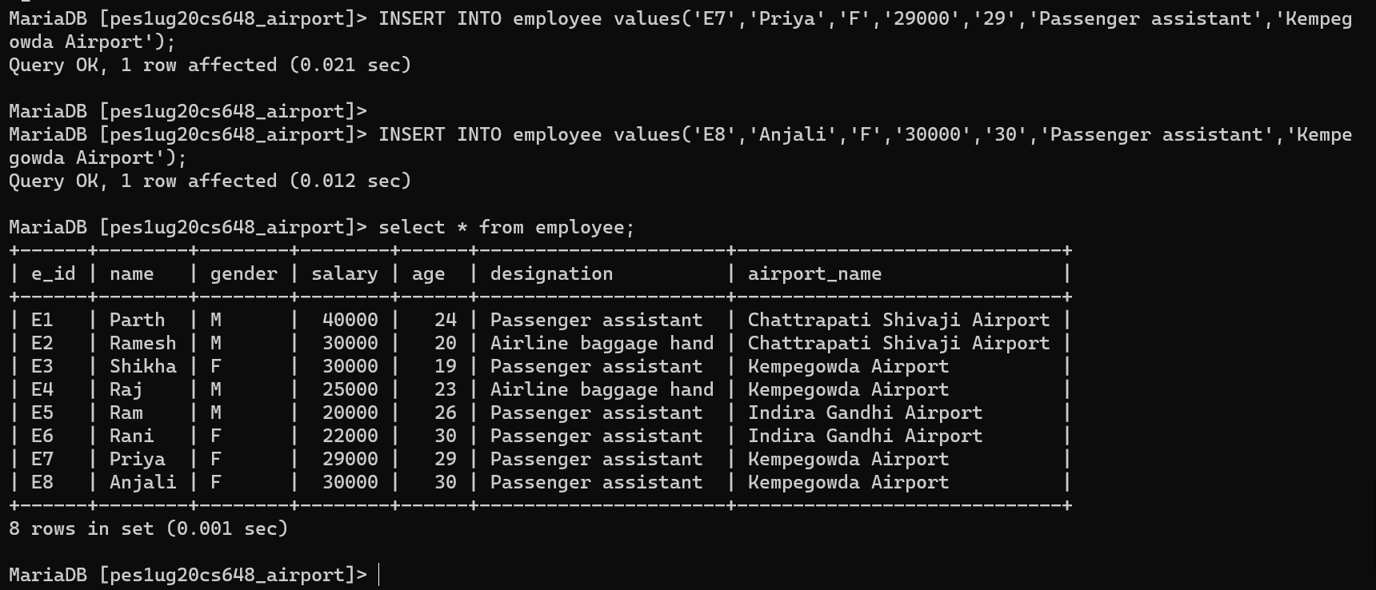

Inserting few more rows into passenger and alter primary key of table.

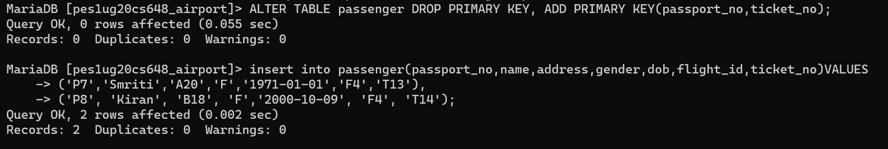

**Adding Constraints**

ALTER TABLE `airport`

  ADD PRIMARY KEY (`airport_name`);

ALTER TABLE `airline`

    ADD PRIMARY KEY (`airline_id`);

ALTER TABLE `airport_airline`

    ADD CONSTRAINT `airlinefk1` FOREIGN KEY (`airline_id`) REFERENCES `airline`(`airline_id`),

    ADD CONSTRAINT `airportfk1` FOREIGN KEY (`airport_name`) REFERENCES `airport`(`airport_name`);

ALTER TABLE `flight`

    ADD PRIMARY KEY(`flight_id`),

    ADD CONSTRAINT `airlinefk2` FOREIGN KEY (`airline_id`) REFERENCES `airline`(`airline_id`);

ALTER TABLE `employee`

    ADD PRIMARY KEY(`e_id`),

    ADD CONSTRAINT `airportfk3` FOREIGN KEY (`airport_name`) REFERENCES `airport`(`airport_name`);

ALTER TABLE `emp_phone_no`

    ADD CONSTRAINT `empfk1` FOREIGN KEY (`e_id`) REFERENCES `employee`(`e_id`);

ALTER TABLE `passenger`

    ADD CONSTRAINT `flightfk1` FOREIGN KEY (`flight_id`) REFERENCES   `flight`(`flight_id`),

    ADD CONSTRAINT `ticketfk1` FOREIGN KEY (`ticket_no`) REFERENCES   `ticket`(`ticket_no`);

ALTER TABLE `passenger_phone_no`

    ADD CONSTRAINT `passengerfk1` FOREIGN KEY (`passport_no`) REFERENCES `passenger`(`passport_no`);

ALTER TABLE `ticket`

    ADD CONSTRAINT `passengerfk2` FOREIGN KEY (`passport_no`) REFERENCES `passenger`(`passport_no`);

    ADD CONSTRAINT `airlinefk5` FOREIGN KEY (`airline_id`) REFERENCES `airline`(`airline_id`);

ALTER TABLE `check_in`

    ADD CONSTRAINT `airportfk4` FOREIGN KEY(`airport_name`) REFERENCES `airport`(`airport_name`),

    ADD CONSTRAINT `airlinefk4` FOREIGN KEY(`airline_id`) REFERENCES `airline`(`airline_id`);

ALTER TABLE `baggage_belt`

    ADD CONSTRAINT `airportfk5` FOREIGN KEY(`airport_name`) REFERENCES `airport`(`airport_name`),

    ADD CONSTRAINT `flightfk2` FOREIGN KEY(`flight_id`) REFERENCES `flight`(`flight_id`)

**Tool Used**

**//specify the tools used (front end and back end)**

Frontend- React

Backend – Express and Node

Database- MySQL (from xampp)

**Join Queries**

Showcase at least 4 join queries

Write the query in English Language, Show the equivalent SQL statement and also a screenshot of the query and the results

1)To display all airline details that have a flight from different airports.

SELECT DISTINCT airline.airline_id,airline.airline_name, airport_name from

airport_airline, airline, flight

where airline.airline_id = flight.airline_id and airport_airline.airline_id = airline.airline_id;

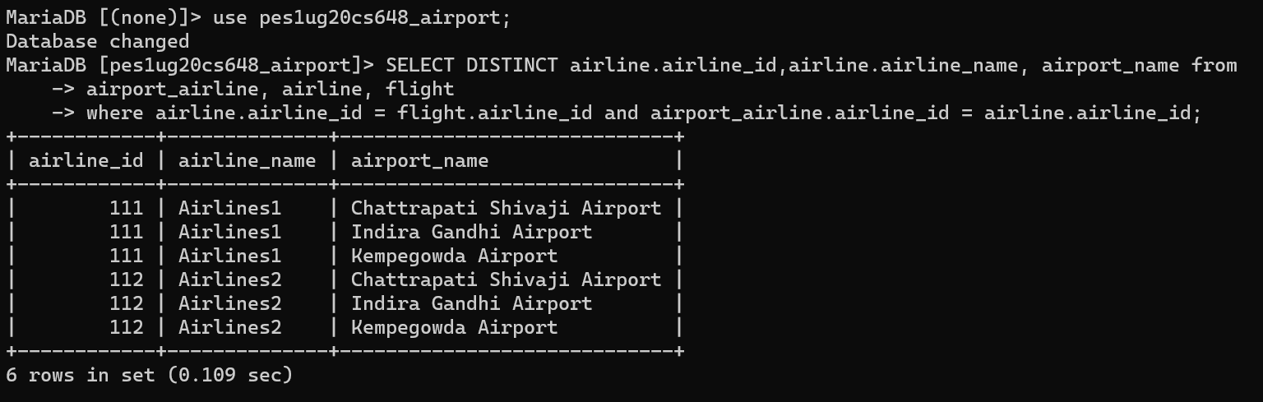

2) To display name of passenger and details about his flight

SELECT name, ticket_no, flight.flight_id, source, destination, status, d_time, a_time, airline_id from passenger join flight

on passenger.flight_id = flight.flight_id;

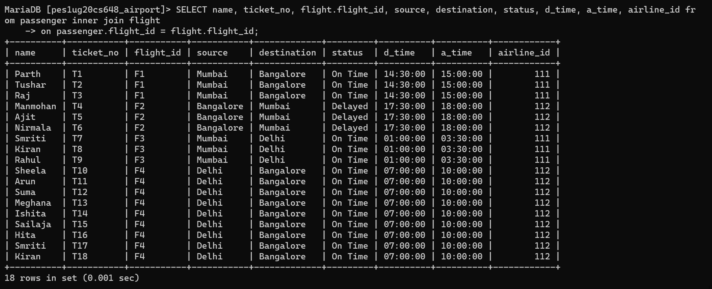

3) To display all passengers travelling in groups on the same flight.

select * from passenger where bookedby_name in (select bookedby_name from passenger

group by bookedby_name

having count(bookedby_name) >1);

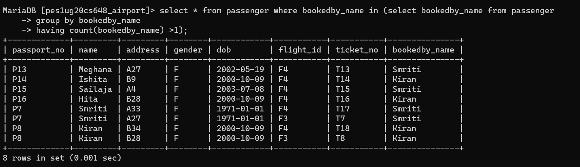

4) To display counter numbers assigned in Bangalore airport for all flights arriving at Bangalore.

SELECT * from check_in as c where

EXISTS (SELECT a.airport_name from airport_airline as a,flight as f

where c.airport_name = a.airport_name and a.airline_id = f.airline_id

and f.source='Delhi'and f.destination='Bangalore' and a.airport_name = 'Kempegowda Airport');

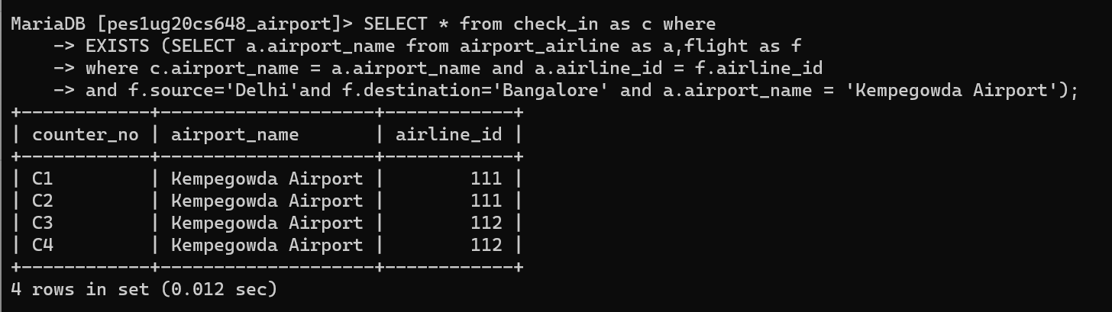

5)Display list of passengers travelling for less than 2 hrs on a flight.

SELECT passport_no,name,gender,passenger.flight_id,ticket_no from passenger where passenger.flight_id in (select distinct flight_id from flight where timestampdiff(minute,d_time,a_time) <120);

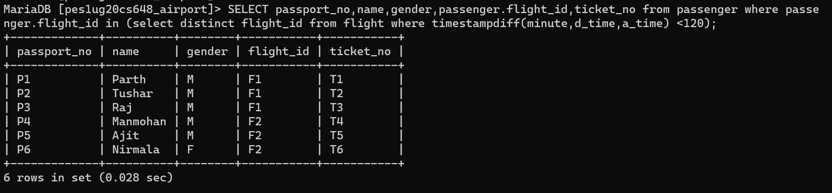

6)Display the baggage belts at Kempegowda Airport assigned to different flights arriving at the airport.

SELECT * from baggage_belt as b where

EXISTS (SELECT flight_id from flight as f where b.flight_id = f.flight_id and f.destination='Bangalore');

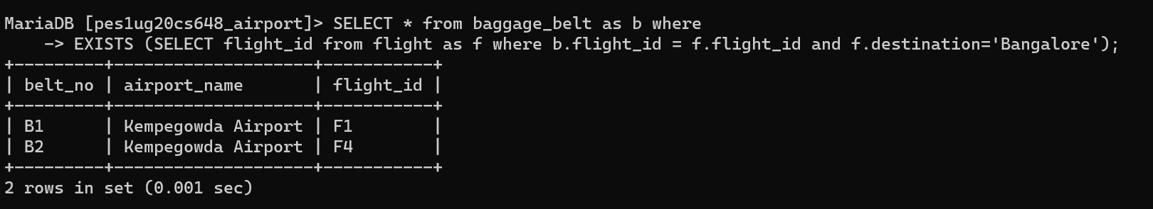

7)Display names of employees working at the airport in Delhi(Indira Gandhi Airport).

select * from employee

where airport_name = (select airport_name from airport where city='Delhi');

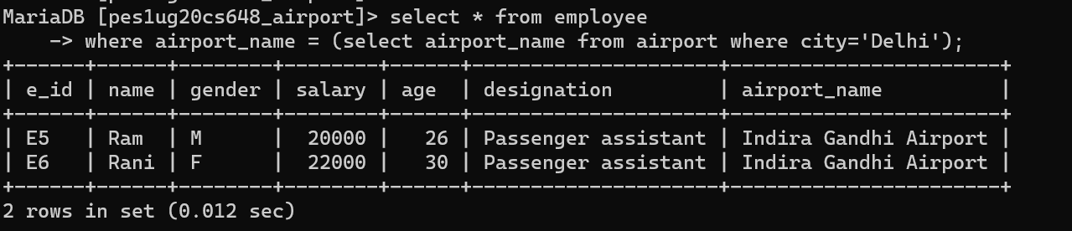

8) Display all airport that don't have any flights scheduled.

SELECT * from airport where

NOT EXISTS (select airport_name from airport_airline, flight

where airport.airport_name=airport_airline.airport_name

and airport_airline.airline_id = flight.airline_id);

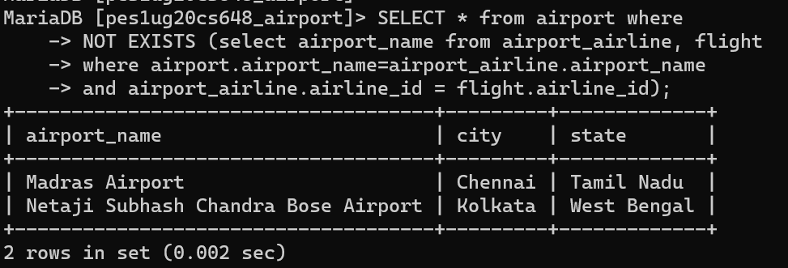

# Aggregate Functions

Showcase at least 4 Aggregate function queries

Write the query in English Language, Show the equivalent SQL statement and also a screenshot of the query and the results

1)Count number of passengers travelling from Mumbai to Bangalore

SELECT count(*) as People

from ticket

where source='Mumbai' and destination='Bangalore';

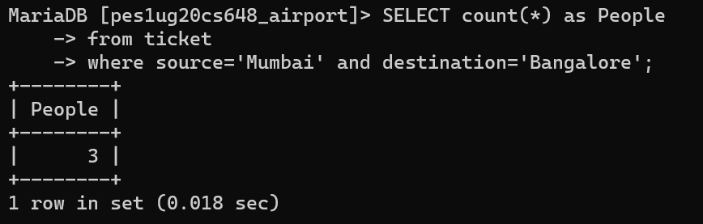

2) Display the class (Economy or Business class) which is most used for travelling.

SELECT MAX(class) as Max_Class

from ticket;

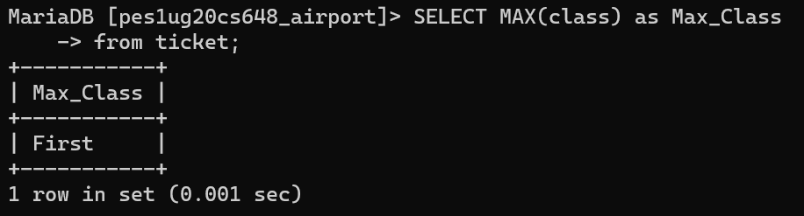

3)Find average price of all Passenger assistants at Kempegowda Airport.

SELECT designation, avg(salary)

from employee

group by designation;

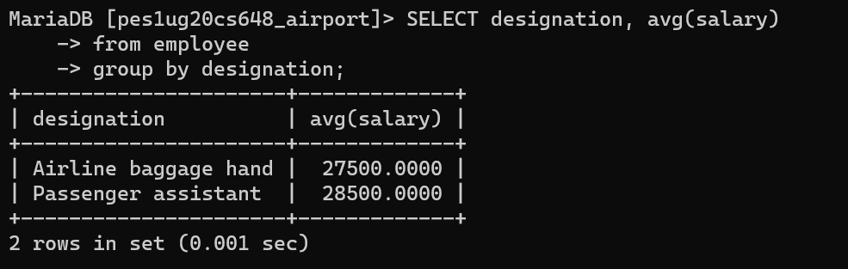

4) Number of flights per airport

SELECT airport.airport_name, count(flight_id)

from airport join airport_airline join flight

on airport.airport_name=airport_airline.airport_name and airport_airline.airline_id = flight.airline_id

group by airport_name;

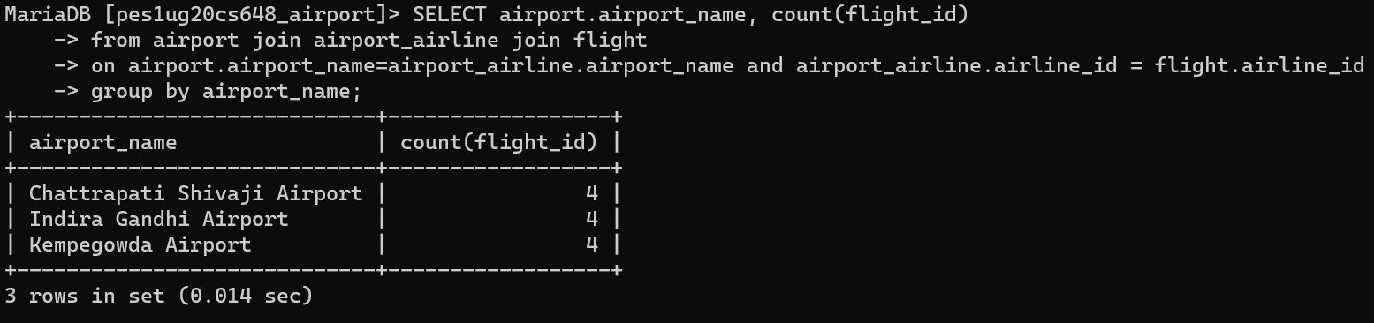

# Set Operations

Showcase at least 4 Set Operations queries

Write the query in English Language, Show the equivalent SQL statement and also a screenshot of the query and the results

1)Find set of passengers either travelling from Mumbai to Delhi or from Delhi to Mumbai

SELECT passport_no,name, flight.flight_id, source, destination

from passenger join flight

where passenger.flight_id = flight.flight_id and source = 'Mumbai' and destination = 'Bangalore'

UNION

SELECT passport_no,name, flight.flight_id, source, destination

from passenger join flight

where passenger.flight_id = flight.flight_id and source = 'Bangalore' and destination = 'Mumbai';

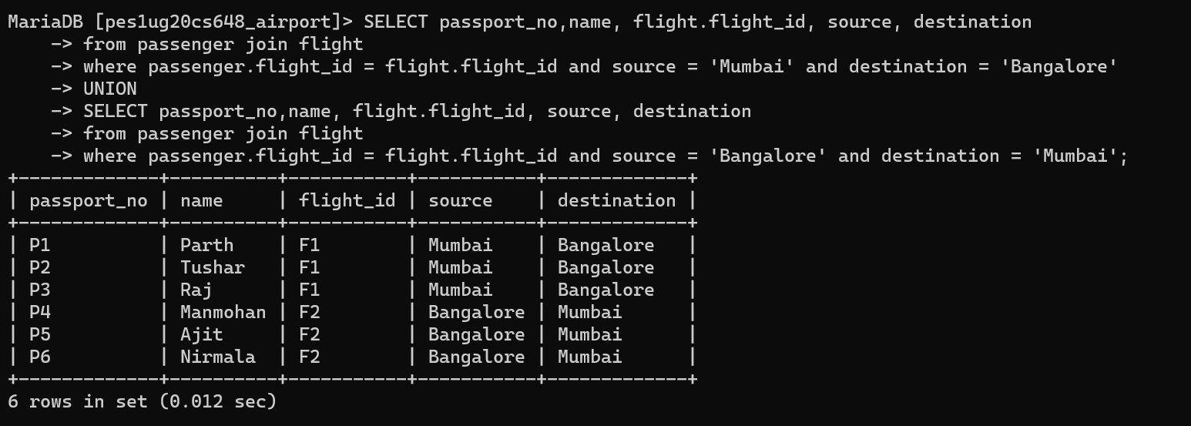

2)Find set of passengers who travelled from mumbai to delhi **and then** delhi to bangalore

SELECT passport_no,name

from passenger join flight

where passenger.flight_id = flight.flight_id and source = 'Mumbai' and destination = 'Delhi'

INTERSECT

SELECT passport_no,name

from passenger join flight

where passenger.flight_id = flight.flight_id and source = 'Delhi' and destination = 'Bangalore';

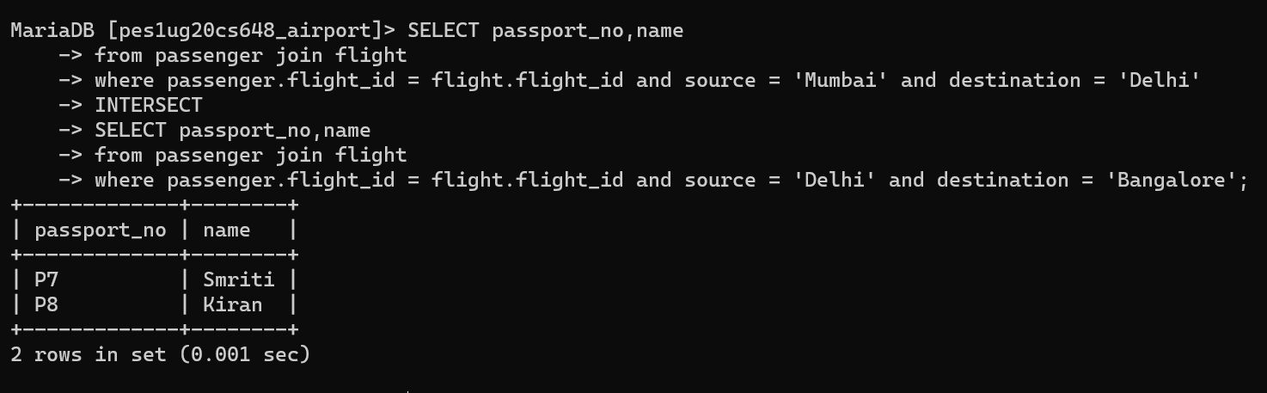

3)Find the passengers travelling in Business and First class.

SELECT p.passport_no,p.name,t.ticket_no,t.class,t.source,t.destination

from passenger as p join ticket as t

where p.ticket_no = t.ticket_no

EXCEPT

SELECT p.passport_no,p.name,t.ticket_no,t.class,t.source,t.destination

from passenger as p join ticket as t

where p.ticket_no = t.ticket_no and t.class = 'Econo';

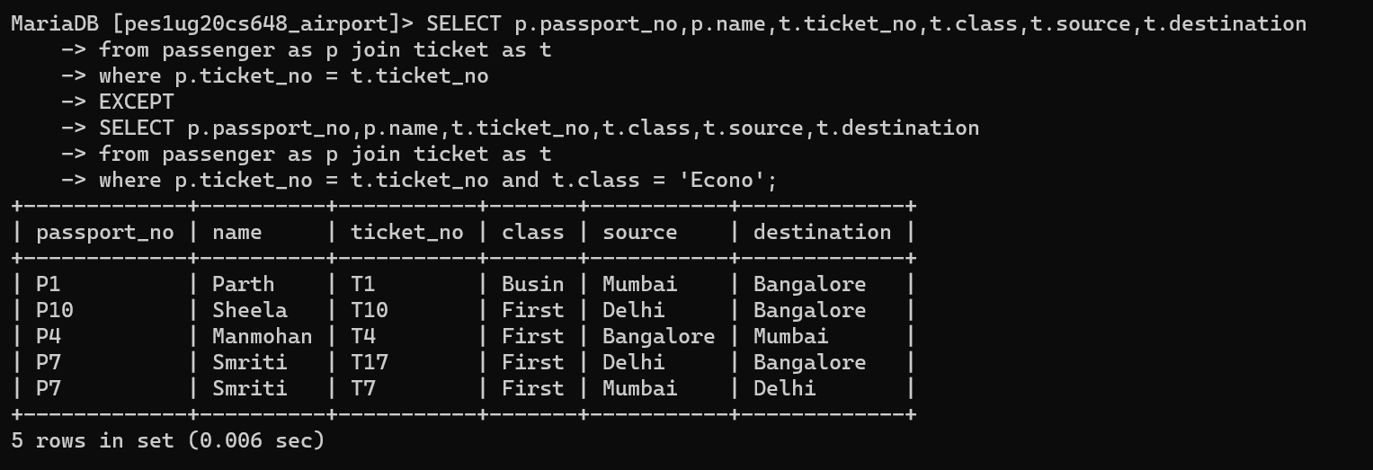

4)To display all flights that are either on time or delayed

SELECT flight_id,source,destination,status,d_time,a_time,airline_id from flight where status = 'On Time'

UNION ALL

SELECT flight_id,source,destination,status,d_time,a_time,airline_id from flight where status = 'Delayed';

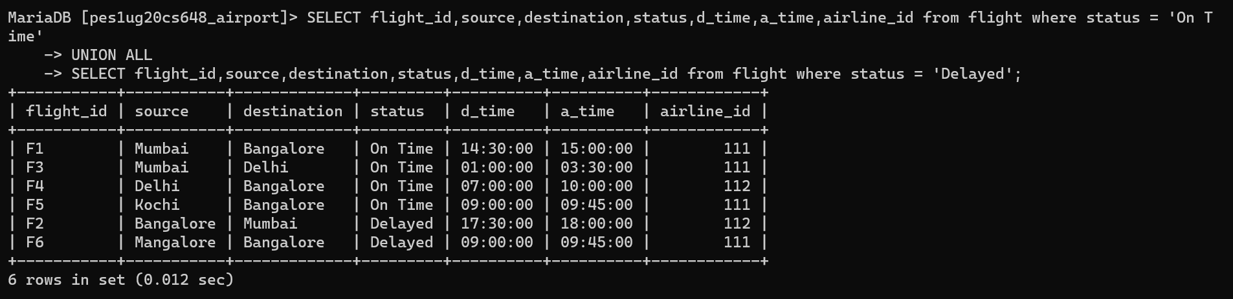

**View**

Demonstrate creation and querying one view

1. View to display name of passenger and details about his flight

SELECT name, ticket_no, flight.flight_id, source, destination, status, d_time, a_time, airline_id from passenger inner join flight

on passenger.flight_id = flight.flight_id;

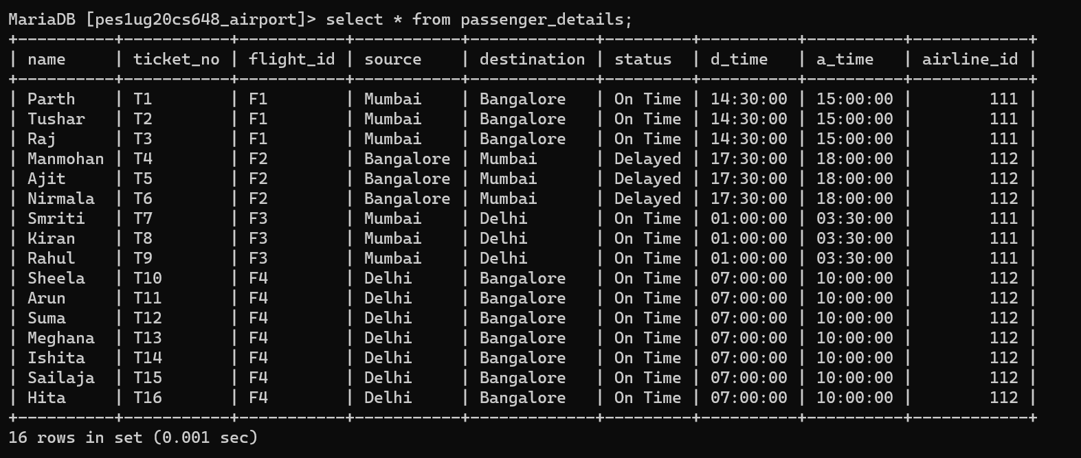

2)Query passenger_details to get name and flight details of all passengers travelling from Delhi to Bangalore

SELECT * from passenger_details

where source='Delhi' and destination='Bangalore';

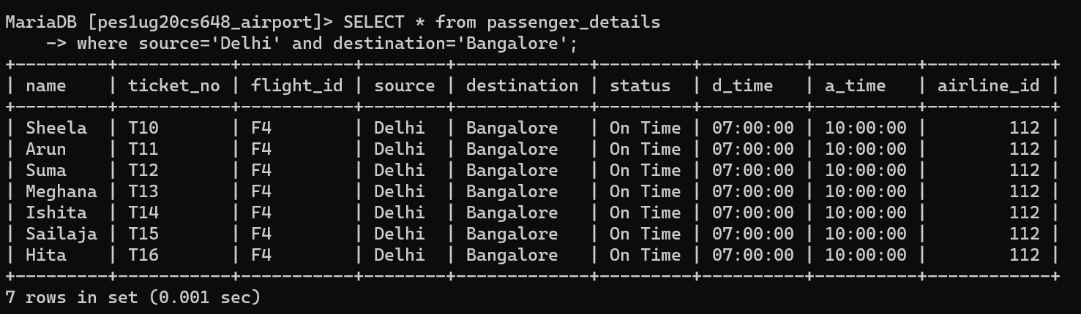

**Triggers (Functions or Procedures)**

Create a Function or a Procedure. State the objective of the function / Procedure. Run and

display the results.

Function –

DELIMITER $$

CREATE FUNCTION duration_func(d_time time, a_time time, flightid varchar(5))

RETURNS int

BEGIN

DECLARE duration int;

SET duration = (select timestampdiff(minute,d_time,a_time) from flight as f where f.flight_id = flightid);

RETURN duration;

END$$

DELIMITER ;

SELECT flight_id,source,destination,duration_func(d_time,a_time, flight.flight_id) as duration from flight;

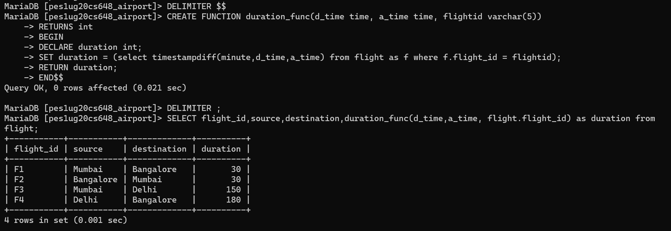

Trigger calling the function –

delimiter $$

create trigger duration_check

after insert

on flight for each row

begin

set @duration = duration_func(NEW.d_time,NEW.a_time, NEW.flight_id);

end; $$

delimiter ;

INSERT INTO flight (flight_id, source, destination, status, d_time, a_time, airline_id, tot_seat )VALUES

('F5','Kochi', 'Bangalore','On Time', '09:00:00', '9:45:00',111,300);

INSERT INTO flight (flight_id, source, destination, status, d_time, a_time, airline_id,tot_seat )VALUES

('F6','Mangalore', 'Bangalore','Delayed', '09:00:00', '9:45:00',111,300);

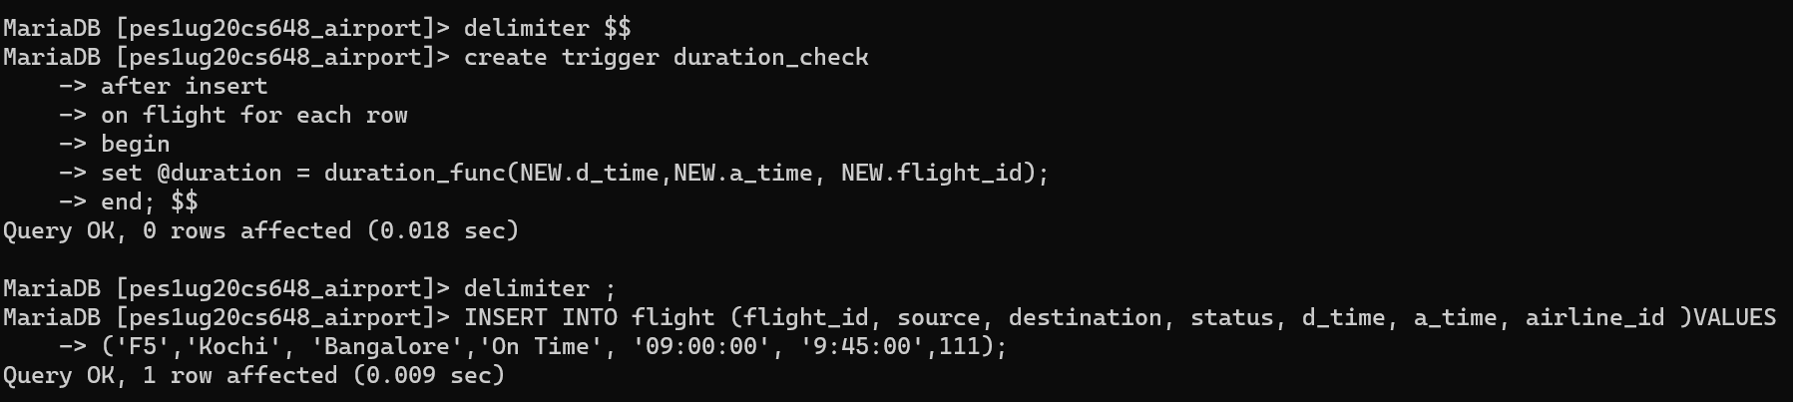

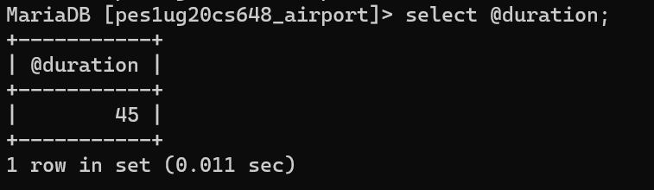

**Developing a Frontend**

The frontend should support

1. Addition, Modification and Deletion of records from any chosen table
2. There should be a window to accept and run any SQL statement and display the result

This frontend was developed using Node JS and Express at the backend and React for frontend

View the table Airport

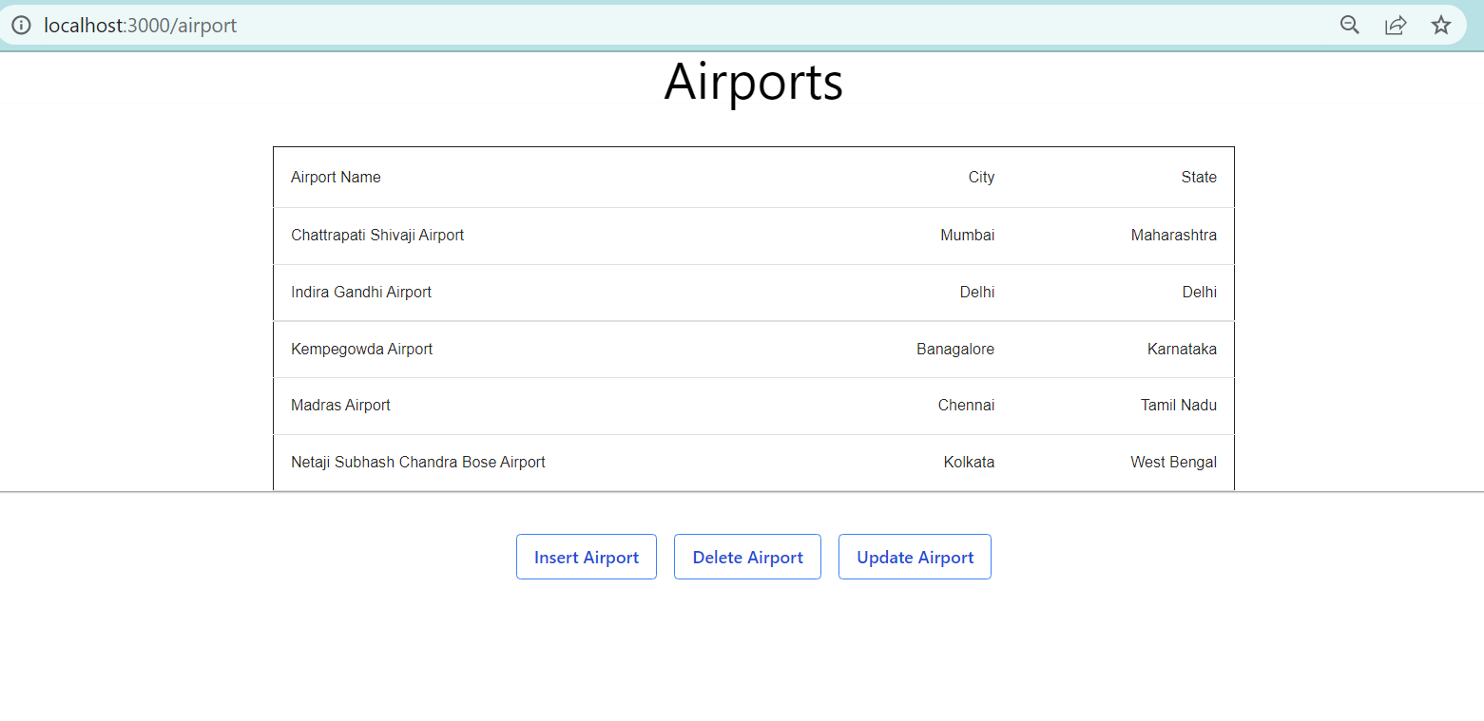

Insert a row into table Airport

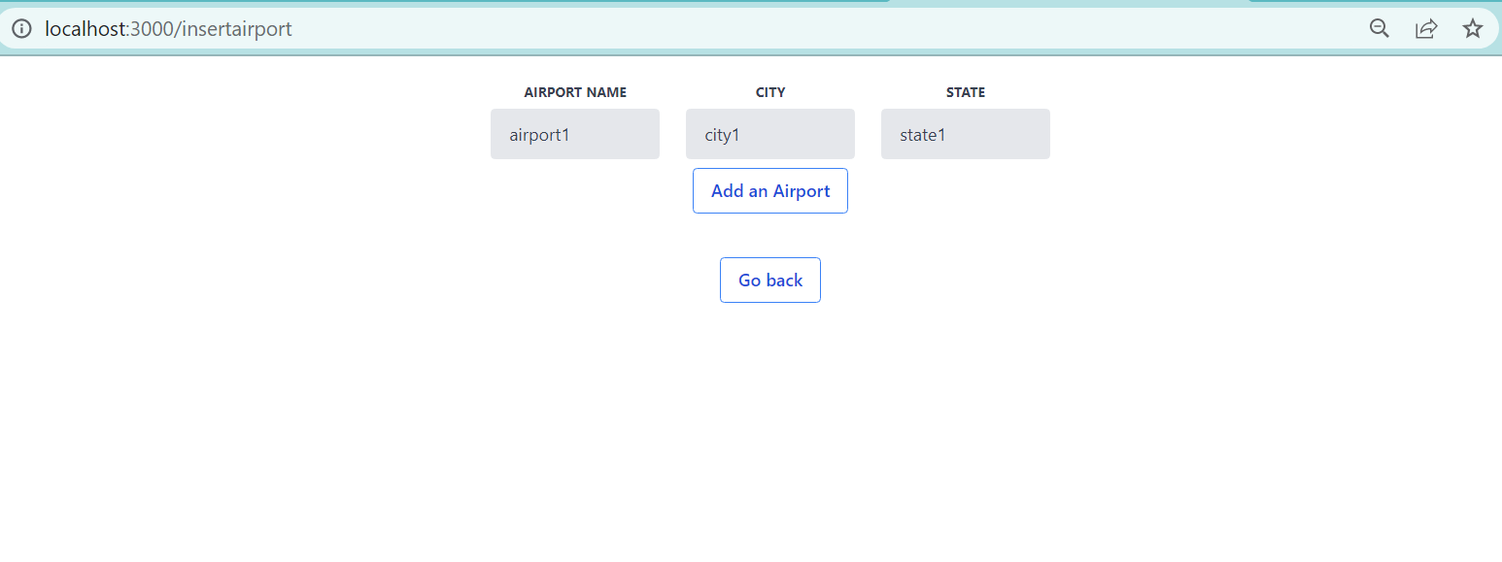

View table airport after insertion.

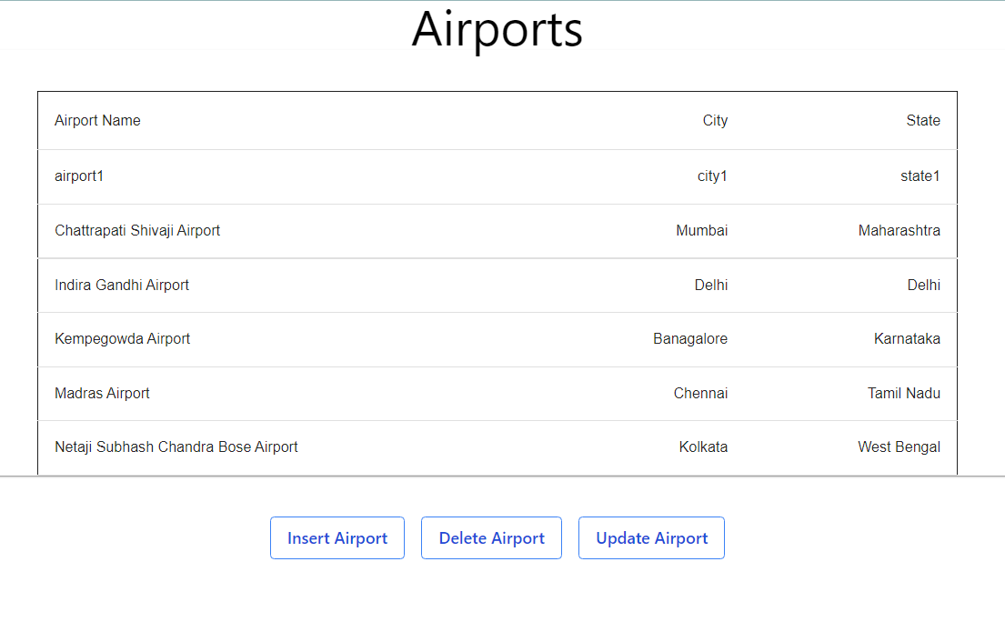

Update an airport

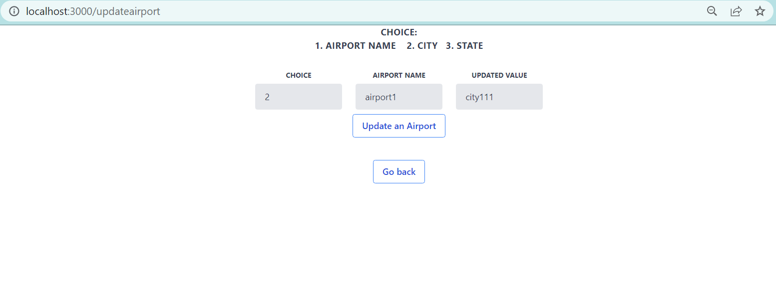

View table Airport after updating

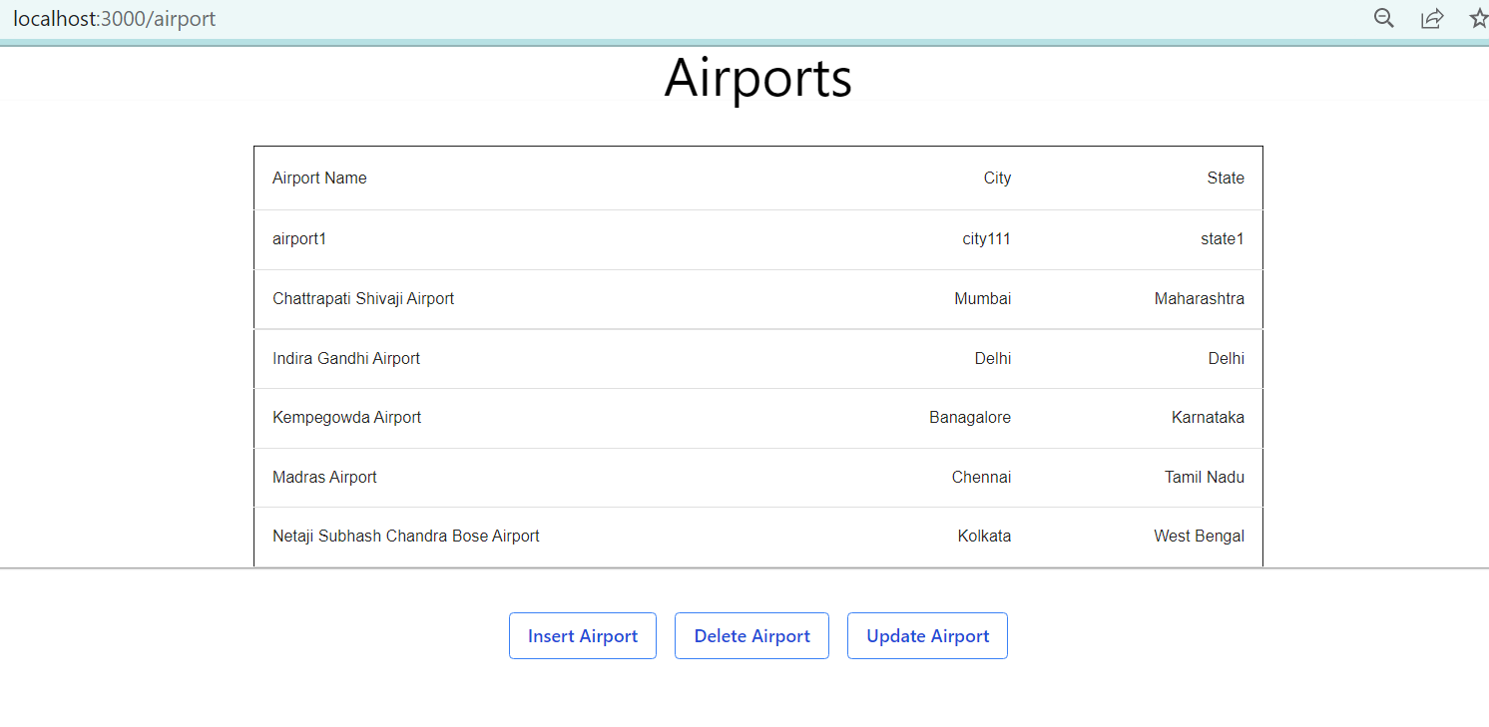

Delete an airport

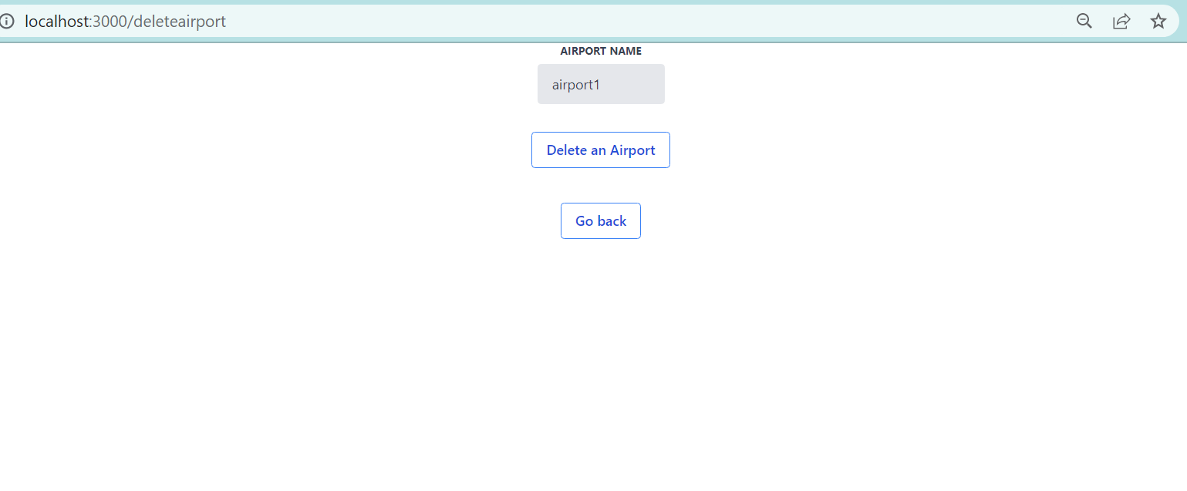

View airport table after deletion

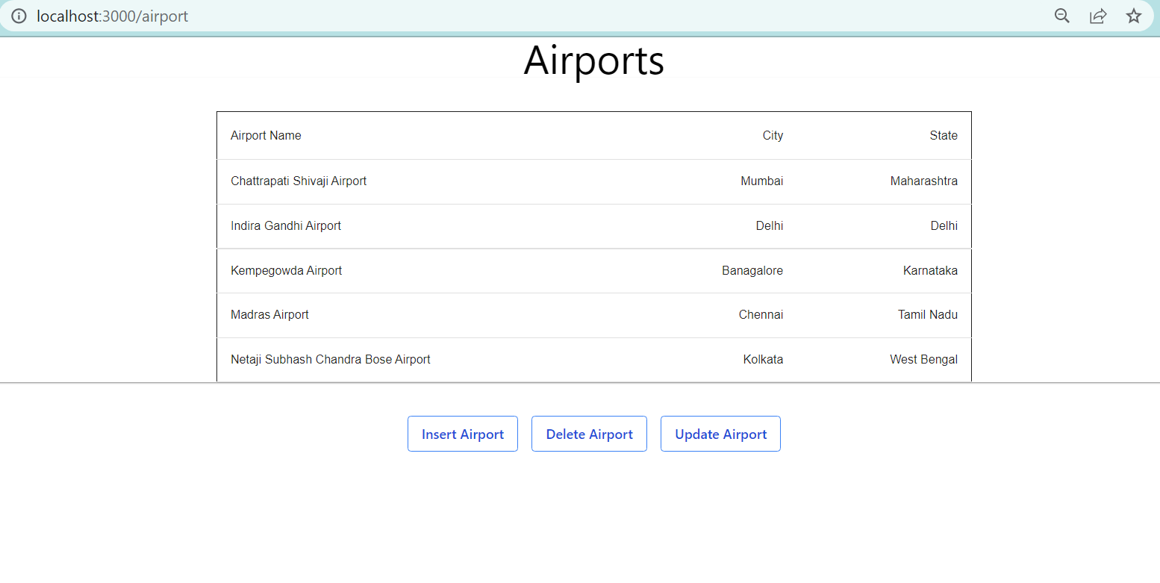

Query Page – An input box to accept and run any SQL statement and display the result

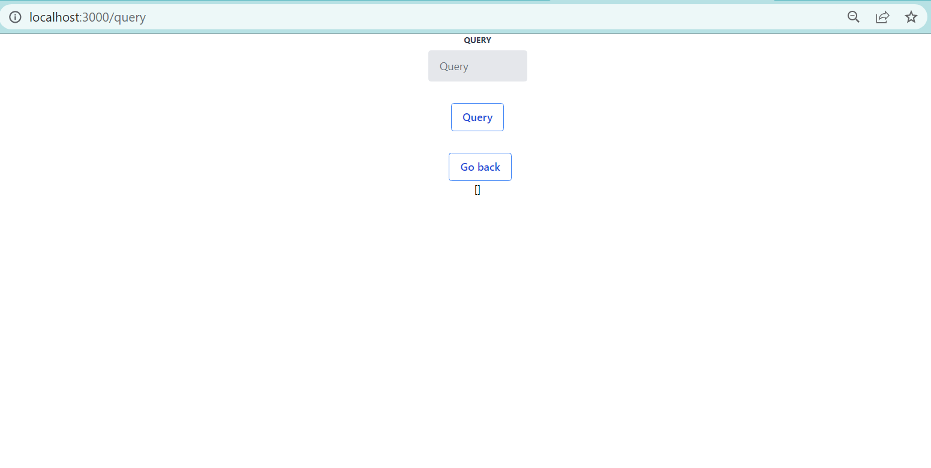

Query 1: select * from ticket;

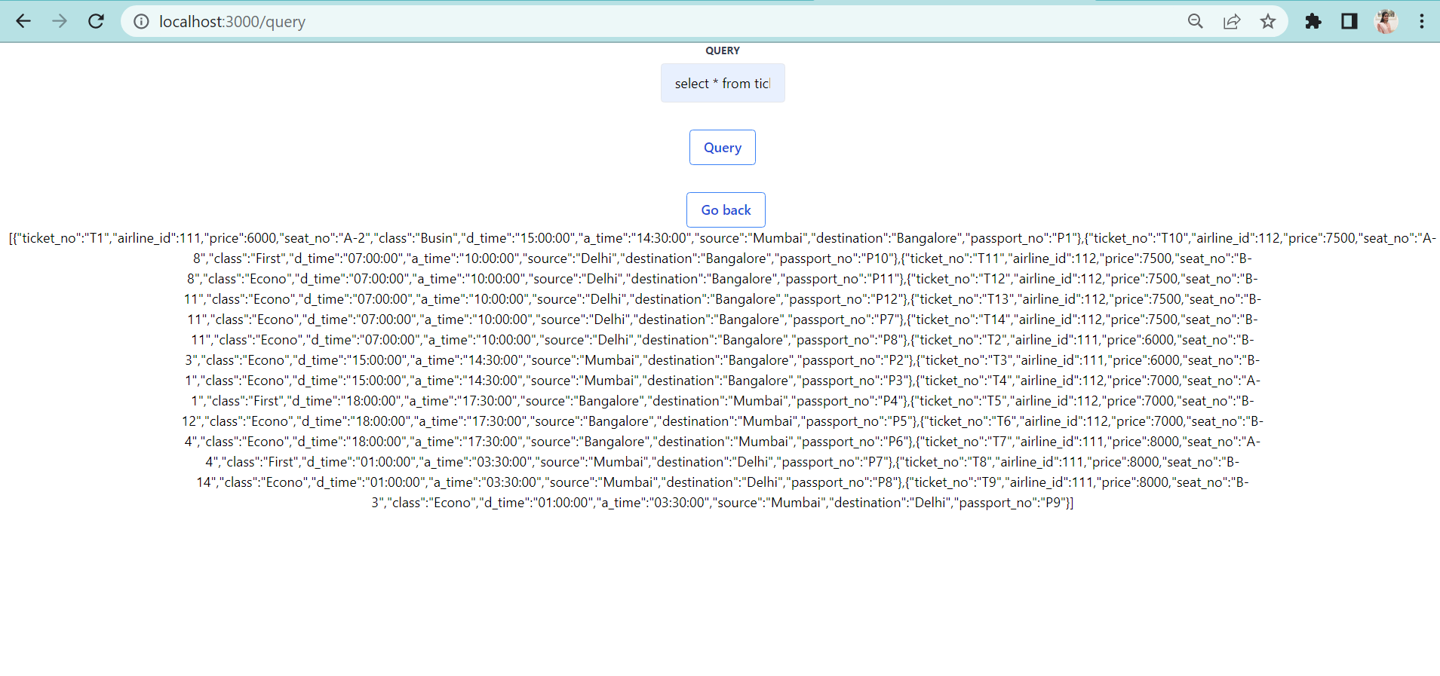

Query 2: Select * from airport;

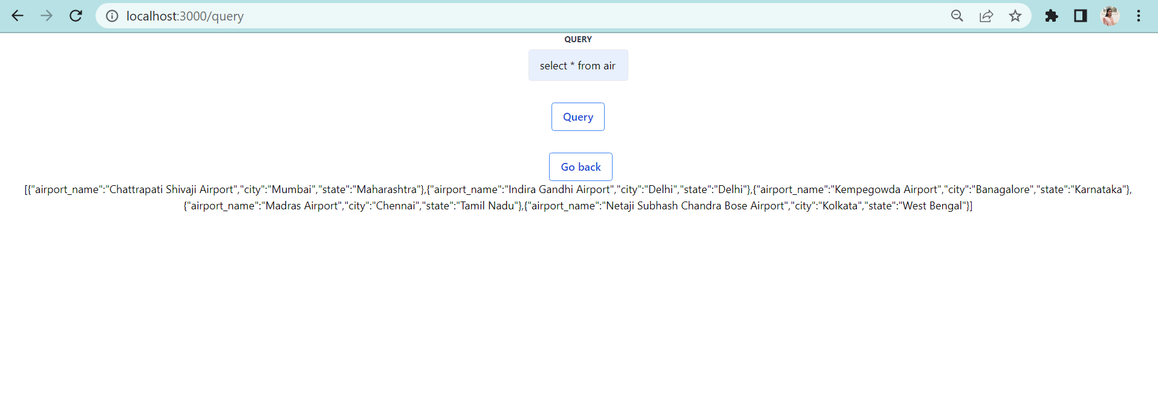

**Review Questions**

1)For each flight show how seats are filled

select t.ticket_no, p.passport_no, p.name, t.seat_no, t.class, p.flight_id

from ticket as t, passenger as p,flight as f

where t.ticket_no = p.ticket_no and p.flight_id = f.flight_id

order by f.flight_id;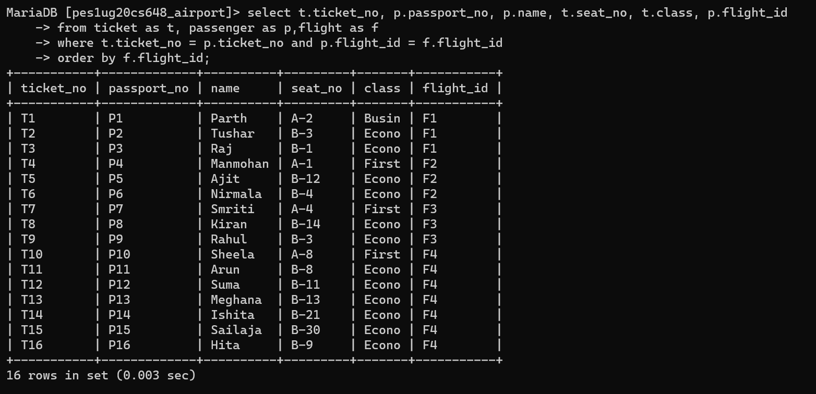

select count(*) as no_of_seats, f.flight_id

from ticket as t, passenger as p,flight as f

where t.ticket_no = p.ticket_no and p.flight_id = f.flight_id

group by f.flight_id;

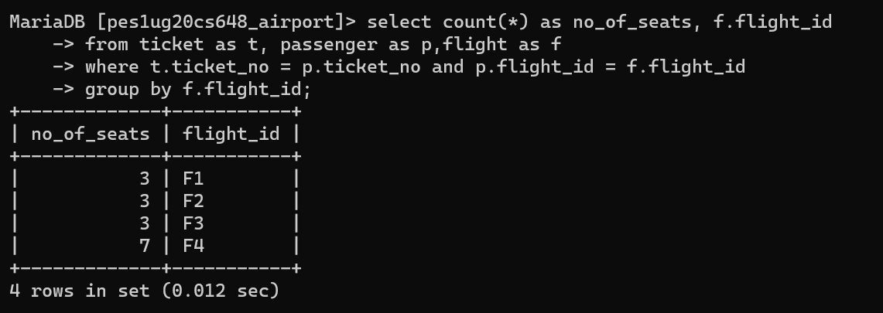

2) Details of passenger who have booked >2 for the same flight

select bookedby_name as Booked_By, count(bookedby_name) as count from passenger

group by bookedby_name

having count(bookedby_name) >2;

