NAME: ISHITA JINDAL

REG. NO.: 21BCB0061

EMAIL: [ishitajindal1203@gmail.com](mailto:ishitajindal1203@gmail.com)

1. Health and Wellness Data Aggregation Dashboard

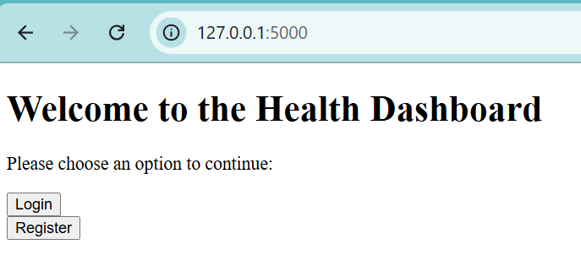

1. Admin Role

1. User Role

The health dashboard project provides a comprehensive platform for users to visualize, analyze, and reflect on key aspects of their health. By presenting insights through various data visualizations, the dashboard enables users to understand how their daily habits contribute to overall well-being and allows them to make informed lifestyle changes.

**BMI Distribution**: This chart allows users to see where their BMI stands in relation to the overall population. If their BMI falls outside the healthy range, it can motivate adjustments to diet or exercise. This distribution can also guide personalized health tips or interventions, helping users maintain a balanced BMI.

**Water Intake vs. Mood**: By grouping water intake levels and comparing them with mood, this chart highlights the potential link between hydration and emotional well-being. Higher levels of water intake often align with improved mood, offering a simple reminder of the mental and emotional benefits of staying hydrated.

**Calories Burned by Gender**: This bar chart compares exercise-related calorie burn across genders, revealing activity patterns and helping identify workout trends by demographic. Such insights can inform personalized exercise recommendations, supporting users in setting achievable fitness goals.

**Sleep Quality vs. Mood**: This scatter plot visually emphasizes how better sleep quality correlates with positive mood. This connection highlights the importance of sleep for emotional well-being and can encourage users to prioritize habits that improve sleep hygiene.

**Correlation Heatmap of Health Metrics**: This heatmap reveals relationships between various health metrics, like steps and calories burned or stress levels. By understanding these associations, users can make holistic lifestyle adjustments—such as increasing activity levels to manage stress—for overall better health outcomes.

Moving forward, the health dashboard could incorporate predictive analytics to forecast potential health outcomes based on behaviour patterns. By introducing machine learning algorithms, the system could deliver personalized recommendations, such as hydration reminders for those with low water intake or sleep optimization tips for users with poor sleep quality.

1. **Customer Feedback Aggregator and Sentiment Analysis**

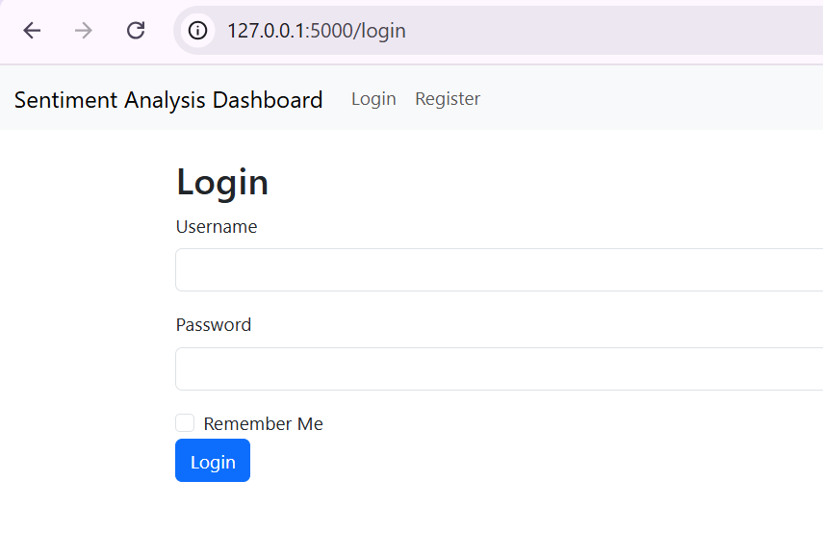

The sentiment analysis dashboard offers meaningful insights into customer feedback, providing organizations with a comprehensive view of public sentiment and feedback trends.

**Distribution of Sentiment Scores**: This histogram shows how sentiment scores vary across feedback data, with peaks indicating the most common sentiment levels. By visualizing this distribution, organizations can easily identify whether feedback is generally positive, negative, or neutral. This insight can guide strategies to maintain or improve customer satisfaction.

**Sentiment Category Distribution**: The sentiment category pie chart breaks down feedback into positive, neutral, and negative sentiments, giving an immediate snapshot of customer sentiment. This visualization helps prioritize areas for improvement and highlights the percentage of satisfied versus dissatisfied customers.

**Feedback Source Distribution**: This bar chart illustrates where feedback originates, whether from social media, surveys, or review sites. Understanding feedback sources allows businesses to identify which platforms are most impactful and ensure they’re engaging with customers where they’re most active.

**Average Sentiment Score Over Time**: This line chart tracks changes in sentiment over a specified period, helping organizations detect trends, whether from new campaigns, product launches, or seasonal fluctuations. Observing sentiment over time can reveal the effects of recent actions on public perception, guiding future decisions.

**Correlation Heatmap of Sentiment Metrics**: This heatmap highlights relationships between sentiment scores and feedback counts (positive, neutral, negative). Recognizing these correlations enables businesses to understand the weight of each feedback type on overall sentiment, providing insights into what contributes most to public perception.

These insights give organizations a solid foundation for understanding customer sentiment, allowing them to respond thoughtfully, improve customer experiences, and build stronger brand loyalty.