**NAME: ISHITA JINDAL**

**REG NO.: 21BCB0061**

**ASSIGNMENT-03 INFORMATICA**

Q1)

1.

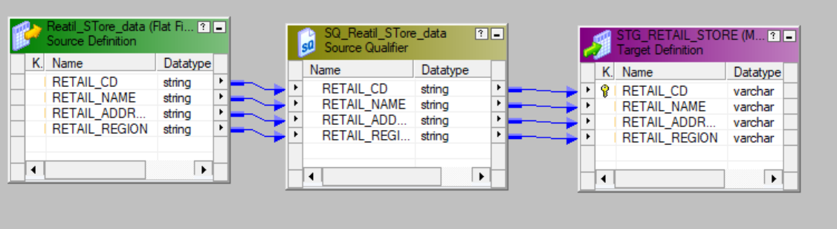

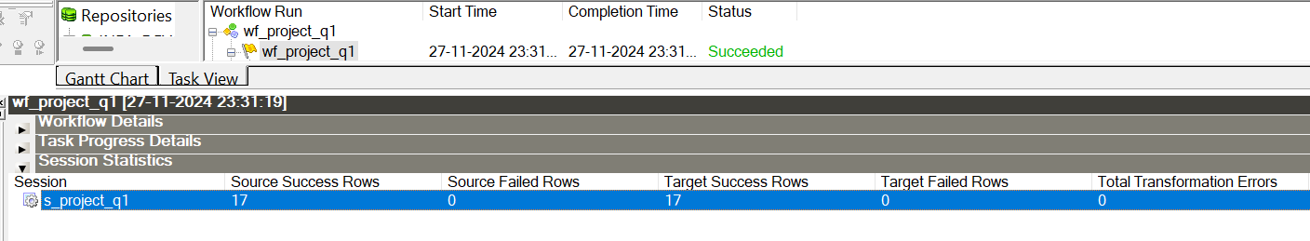

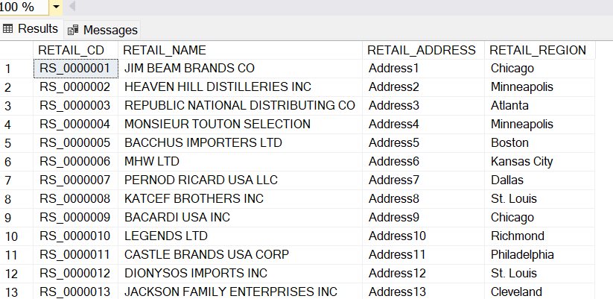

2.

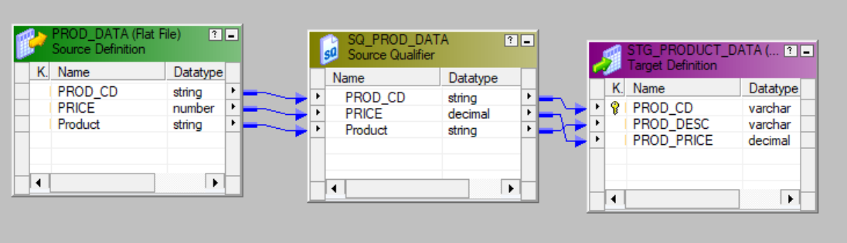

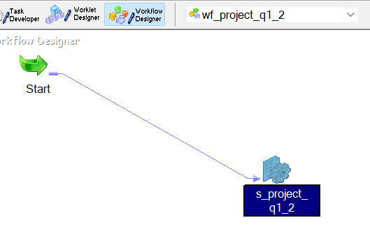

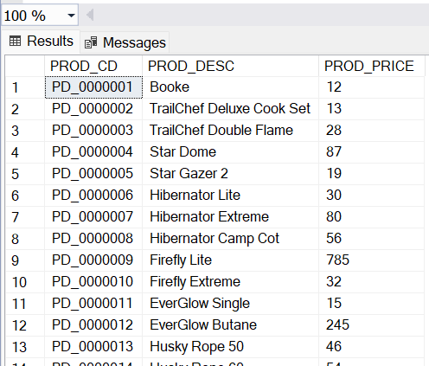

3.

5.



