**NAME: ISHITA JINDAL**

**REG NO.: 21BCB0061**

**ASSIGNMENT-03 INFORMATICA**

Q2)

1.

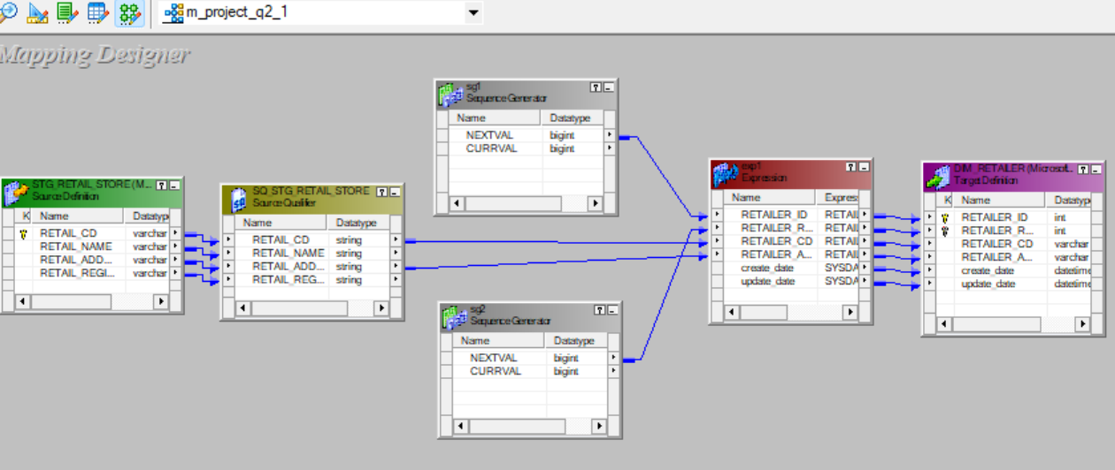

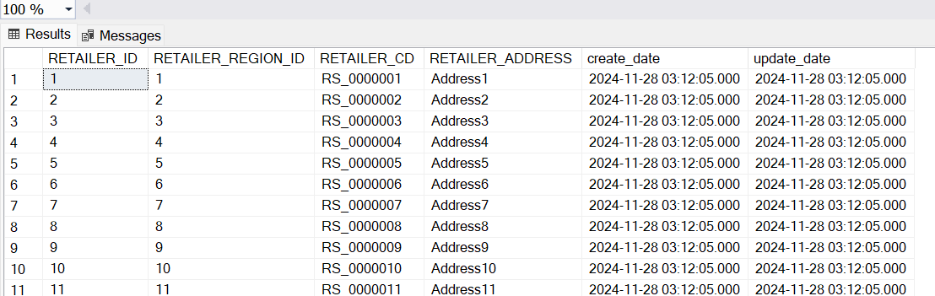

2.

3.

4.

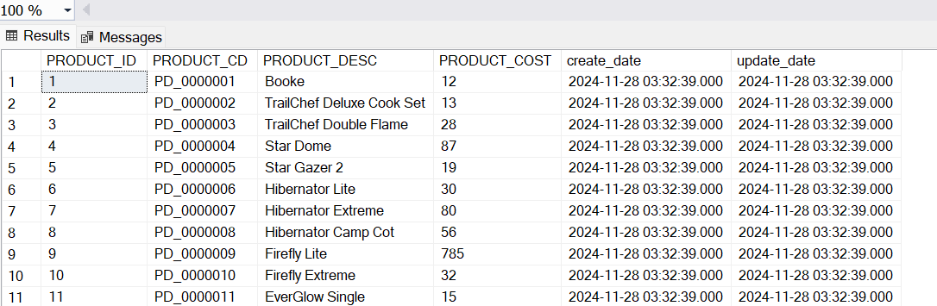

5.

6.

7.

