Fashion Lens

A
Project Report
Submitted in partial fulfillment of the requirement for the award of degree of
Bachelor of Technology
In
Computer Science & Engineering (Data Science)

Submitted to
RAJIV GANDHI PROUDYOGIKI VISHWAVIDYALAYA,
BHOPAL (M.P.)

Guided By Submitted By
Prof. Deepak Singh Chouhan Deepak Gupta(0827CD211020)
Devraj Dangi(0827CD211022)
Himanshu Sopra (0827CD211028)
Ishita Pareta (0827CD211030)

DEPARTMENT OF CSE-Data Science
ACROPOLIS INSTITUTE OF TECHNOLOGY & RESEARCH,
INDORE (M.P.) 453771
2024-2025

Declaration
I hereby declared that the work, which is being presented in the project entitled Fashion Lens partial fulfillment of the requirement for the award of the degree of Bachelor of Technology, submitted in the department of Computer Science & Engineering (Data Science) at Acropolis Institute of Technology & Research, Indore is an authentic record of my own work carried under the supervision of “Prof. Deepak Singh Chouhan”. I have not submitted the matter embodied in this report for the award of any other degree.

Deepak Gupta(0827CD211020)
Devraj Dangi(0827CD211022)
Himanshu Sopra (0827CD211028)
Ishita Pareta (0827CD211030)

Prof. Deepak Singh Chouhan
Supervisor

Project Approval Form
I hereby recommend that the project Fashion Lens prepared under my supervision by Deepak Gupta(0827CD211020), Devraj Dangi(0827CD211022), Himanshu Sopra (0827CD211028), Ishita Pareta (0827CD211030) be accepted in partial fulfillment of the requirement for the degree of Bachelor of Technology in Computer Science & Engineering (Data Science).

Prof. Deepak Singh Chouhan
Supervisor

Recommendation concurred in 2024-2025

Prof. Brajesh Chaturvedi
Project Incharge

Prof. Deepak Singh Chouhan
Project Coordinator

Acropolis Institute of Technology & Research
Department of Computer Science & Engineering
(Data Science)

Certificate
The project work entitled Fashion Lens submitted by Deepak Gupta(0827CD211020), Devraj Dangi(0827CD211022), Himanshu Sopra (0827CD211028), Ishita Pareta (0827CD211030) is approved as partial fulfillment for the award of the degree of Bachelor of Technology in Computer Science & Engineering (Data Science) by Rajiv Gandhi Proudyogiki Vishwavidyalaya, Bhopal (M.P.).

Internal Examiner External Examiner
Name: Deepak Singh Chouhan Name: …………….
Date: 29/03/2025 Date: …/…/……….

Acknowledgement

With boundless love and appreciation, we would like to extend our heartfelt gratitude and appreciation to the people who helped us to bring this work to reality. We would like to have some space of acknowledgement for them.
Foremost, we would like to express our sincere gratitude to our supervisor, Prof. Deepak Singh Chouhan whose expertise, consistent guidance, ample time spent and consistent advice that helped us to bring this study into success.
To the project in-charge Prof. Brajesh Chaturvedi and project coordinator Prof. Deepak Singh Chouhan for their constructive comments, suggestions, and critiquing even in hardship.
To the honorable Prof. (Dr.) Prashant Lakkadwala, Head, Department of Computer Science & Engineering (Data Science) for his favorable responses regarding the study and providing necessary facilities.
To the honorable Dr. S.C. Sharma, Director, AITR, Indore for his unending support, advice and effort to make it possible.
Finally, we would like to pay our thanks to faculty members and staff of the Department of Computer Science & Engineering (Data Science) for their timely help and support.
We also like to pay thanks to our parents for their eternal love, support and prayers without them it is not possible.
Deepak Gupta(0827CD211020)
Devraj Dangi(0827CD211022)
Himanshu Sopra (0827CD211028)
Ishita Pareta (0827CD211030)

Abstract

Fashion e-commerce platforms face significant challenges in maintaining accurate and consistent product categorization, often relying on manual tagging that is both time-consuming and prone to inconsistencies. To address these limitations, we developed Fashion Lens, an AI-powered image classification system that leverages deep learning to automate fashion product categorization. By employing a Convolutional Neural Network (CNN) trained on a diverse dataset of apparel images, the system is capable of identifying and labelling clothing items such as shirts, dresses, pants, and accessories based solely on their visual characteristics. Built using tensorflow and Keras, the model is optimized for accuracy and scalability, with an API integration enabling seamless deployment for e-commerce platforms.
Evaluation of the system revealed over 90% classification accuracy, outperforming traditional rule-based methods and demonstrating real-time processing capabilities suitable for large-scale applications. This automated approach significantly enhances cataloging efficiency, reduces operational overhead, and improves the shopping experience through better searchability and recommendations. The system also offers potential for future expansion, including multi-label tagging, fabric recognition, and fashion trend prediction. Overall, Fashion Lens represents a robust, scalable solution that brings intelligence and automation to the forefront of fashion retail technology.
In conclusion, Fashion Lens presents an innovative solution to streamline product classification in fashion retail. By leveraging AI, the system enhances accuracy, reduces operational costs, and paves the way for advanced automation in the e-commerce industry. Future improvements may include real-time learning models, multilingual support, and integration with augmented reality applications, making fashion shopping more intuitive and engaging.

List of Figures
Figure No. | Title of Figures | Page No.
2.4 | Use-case Diagram | 09
3.1 | Activity Diagram | 11
3.2 | Sequence Diagram | 12
3.3 | Class Diagram | 13
3.4 | Block Diagram | 14
3.5 | Component Diagram | 15
3.6 | Deployment Diagram | 16
3.7 | Object Diagram | 17
3.8 | State Diagram | 18

List of Tables

Table No. | Title of Tables | Page No.
4.3.1 | Unit Testing | 22
4.3.2 | Integration Testing | 23
5.3.1 | Data Base Table | 26
Appendix B | Guide Interaction Report | 35
Appendix B  2.1 | Hardware Requirements | 36
Appendix B  2.2 | Software Requirements | 36
Appendix B  5.1 | Common Issue and Fixes | 38-39
Appendix D | Version History | 40

Abbreviations
Abbr1: UI User Interface
Abbr2: IDE Integrated Development Environment
Abbr3: MAE Mean Absolute Error
Abbr4: RMSE Root Mean Squared Error
Abbr5: REST Representational State Transfer
Abbr6: GUI Graphical User Interface

Abbr7: R² Coefficient of Determination
Abbr8: GUI Message Queuing Telemetry Transport

Table of Content

Chapter 1: Introduction 01-04
1.1 Rationale 02
1.2 Existing System 02
1.3 Problem Formulation 02-03
1.4 Proposed System 03
1.5 Objectives 03-04
1.6 Contribution of the Project 04
1.6.1 Market Potential 04
1.6.2 Innovativeness 04
1.6.3 Usefulness 04
Chapter 2: Requirement Engineering 05-09
2.1 Feasibility Study (Technical, Economical, Operational) 06
2.2 Requirement Collection 07
2.2.1 Discussion 07
2.2.2 Requirement Analysis 07
2.3 Requirements 07-08
2.3.1Functional Requirements 08
2.3.1.1Statement of Functionality 08
2.3.2 Nonfunctional Requirements 08
2.3.2.1 Statement of Functionality 08
2.4 Hardware & Software Requirements 08-09
2.4.1 Hardware Requirement (Developer & End User) 09
2.4.2 Software Requirement (Developer & End User) 09
2.5 Use-case Diagrams 09
2.5.1 Use-case Descriptions 09
Chapter 3: Analysis & Conceptual Design & Technical Architecture 10-18
3.1 Activity Diagram 11
3.2 Sequence Diagrams 12
3.3 Class Diagrams 13
3.4 Block Diagrams 14
3.5 Component Diagram 15
3.6 Deployment Diagram 16
3.7 Object Diagram 17
3.8 State Diagram 18
Chapter 4: Implementation & Testing 19-23
4.1 Methodology 20
4.1.1 Proposed Algorithm 21
4.2 Implementation Approach 21
4.2.1 Introduction to Languages, IDEs Tools and Technologies 21
4.3 Testing Approaches 22
4.3.1 Unit Testing 22
a. Test Cases
4.3.2 Integration Testing 23
b. Test Cases

Chapter 5: Results & Discussion 24-27
5.1 User Interface Representation 25
5.1.1 Brief Description of Various Modules 25
5.2 Snapshot of System with Brief Description 26
5.3 Database Description 26
5.3.1 Snapshot of Database Tables with Brief Description 26
5.4 Final Findings 27
Chapter 6: Conclusion & Future Scope 28-31
6.1 Conclusion 29
6.2 Future Scope 30-31
REFERENCES 32-33
Appendix 34-40
Appendix A: Project Synopsis 34
Appendix B: Guide Interaction Report 35
Appendix C: User Manual 36-39
Appendix D: Git/GitHub Commits/Version History 40

Chapter 1

Introduction
Introduction

1.1 Introduction
The fashion industry is evolving rapidly with the rise of e-commerce and artificial intelligence (AI). Customers often struggle to find relevant fashion products due to ineffective search and categorization mechanisms. Fashion Lens is an AI-powered image classification system designed to automate the categorization of fashion products, improving product discoverability and enhancing the customer experience.
By leveraging deep learning techniques, specifically Convolutional Neural Networks (CNNs), the system classifies clothing items based on images. This enables accurate tagging of products in online stores, facilitating personalized recommendations and efficient catalog management.

1.2 Problem Statement
In online shopping platforms, customers typically search for products using keywords, which may not always yield accurate results. Manual categorization of products is also time-consuming and prone to errors. The key challenges include:
Inefficient Product Search: Traditional search methods rely on text-based descriptions, which may not match user expectations.
Manual Tagging Issues: E-commerce platforms require human effort to categorize new fashion items, leading to delays and inconsistencies.
Lack of Visual-Based Search: Users often want to find similar products based on images rather than text.
Proposed Solution
Fashion Lens aims to solve these problems by automatically classifying fashion items using deep learning. The model takes an image as input and categorizes it into predefined labels such as "Shirt," "Jeans," "Dress," etc. This reduces dependency on manual tagging, improves product discovery, and enhances the shopping experience.

1.3 Objectives
The main objectives of the Fashion Lens system are:
Automated Fashion Item Classification: Use deep learning to categorize clothing items accurately.
Improved E-Commerce Experience: Enhance product search and recommendations for customers.
Efficient Product Management: Assist sellers in automatically tagging and organizing inventory.
Seamless Integration: Develop an API that can be integrated into existing online shopping playform.
Fast & Accurate Predictions: Optimize the system for real-time classification with high accuracy.

1.4 Scope of the Project
The project focuses on applying deep learning techniques to fashion image classification. The key areas covered include:
Data Processing: Collecting and preprocessing fashion images to build a high-quality dataset.
Model Development: Training a CNN-based classification model to predict fashion categories.
Deployment & Integration: Implementing the model as a web service using Flask/Django.
User Interaction: Developing a simple UI where users can upload images and receive predictions.
Scalability: Ensuring the system can handle large datasets and real-time classification.
The project will primarily be used in e-commerce applications but can also be extended to fashion trend analysis and virtual shopping assistants.

1.5 Technologies Used
The Fashion Lens system utilizes various technologies for development and deployment:

Programming Languages:
Python - For deep learning model development.
HTML, CSS, JavaScript - For frontend UI development.

Frameworks & Libraries:
TensorFlow/Keras - For building and training the deep learning model.
OpenCV - For image preprocessing and feature extraction.
Flask/Django - For backend API development and deployment.

Database & Storage:
MySQL/PostgreSQL - For storing product classification results.
AWS/GCP - For cloud storage and deployment.

1.6 Structure of the Report
The report is structured as follows:

Chapter 2: Literature Review
Covers existing research and methodologies in fashion classification and deep learning models.

Chapter 3: System Design
Explains the system architecture, data flow, and technical specifications of Fashion Lens.

Chapter 4: Implementation & Testing
Discusses the implementation approach, testing strategies, and results.

Chapter 5: Results & Discussion
Presents snapshots of the system, database design, and final observations.

Chapter 6: Conclusion & Future Scope
Summarizes the findings and suggests future improvements for scalability and accuracy.

Chapter 2
Requirement Engineering

Requirement Engineering
This chapter provides a comprehensive analysis of the requirements for the Fashion Lens system, including its feasibility, functional and non-functional needs, and technical specifications.

2.1 Feasibility Study
A feasibility study determines whether the proposed system is viable in terms of technology, cost, and operations.

2.1.1 Technical Feasibility
The project relies on deep learning models (CNNs), requiring high computational power. Given the availability of frameworks like TensorFlow, Keras, and OpenCV, the development and deployment of the system are technically feasible.
Key Considerations:
- Requires high-quality labeled datasets for training.
- Needs GPU support for model training (Google Colab, AWS, or on-premise hardware).
- Must be optimized for real-time classification.

2.1.2 Economic Feasibility
The project aims to use open-source technologies, minimizing development costs. The primary cost considerations include:
Expenses:
- Cloud Storage & Computing (if deployed online).
- Dataset Acquisition (if using proprietary datasets).
- Third-party API Integration (if required).
The system, once deployed, can reduce manual effort and increase automation, making it economically viable for e-commerce platforms.

2.1.3 Operational Feasibility
The system is designed for seamless integration with existing e-commerce platforms.
Operational Benefits:
- Automated product classification reduces human intervention.
- Scalable solution can handle a growing number of product listings.
- User-friendly interface allows store owners to use the system without technical expertise.

2.2 Requirement Collection
To understand the needs of stakeholders, a requirement collection phase was conducted.

2.2.1 Stakeholder Discussion
Interviews and surveys were conducted with:
Developers – To assess technical implementation.
E-commerce Store Owners – To understand their pain points in manual classification.
Data Scientists – To discuss deep learning techniques for fashion classification.
End Users – To analyze their shopping behavior and search preferences.

2.2.2 Key Findings
Common Problems Identified:
- Customers struggle with keyword-based searches and prefer image-based searches.
- E-commerce platforms require manual tagging, which is inconsistent and slow.
- Traditional classifiers struggle with complex patterns, fabrics, and fashion trends.
Proposed Features:
- AI-based classification model for accurate product categorization.
- Image-based search functionality for finding similar items.
- Easy integration with e-commerce platforms via APIs.

2.3 System Requirements
This section defines the functional and non-functional requirements necessary for system implementation.

2.3.1 Functional Requirements
Functional requirements define the core capabilities of the system.
- 2.3.1.1 Core Functionalities
- The system classifies clothing images into predefined categories.
- Users can upload images, and the model will provide an accurate category.
- The system should support batch processing for bulk classification.
- It must integrate with e-commerce websites for automatic product tagging.
- The API should provide real-time classification responses.
2.3.1.2 User Roles & Permissions
Admin: Can manage the system, datasets, and model configurations.
E-commerce Owners: Can upload products and receive AI-based categorization.
Users: Can use image-based search functionality.

2.3.2 Non-Functional Requirements
These requirements define the performance, security, and usability aspects of the system.
2.3.2.1 Performance Requirements

- The system should classify an image in <2 seconds.
- The model should achieve ≥90% accuracy on the test dataset.
- The system should handle high-resolution images efficiently.

2.3.2.2 Security Requirements

- The system must prevent unauthorized access to API endpoints.
- It should implement HTTPS and data encryption for secure transactions.
2.3.2.3 Usability Requirements
- The user interface should be simple and intuitive.
- The system should support multiple device types (desktop, mobile, tablet).

2.4 Use-Case Diagram
A use-case diagram visually represents the interaction between users and the system.

2.4.1 Actors Involved
- Admin – Manages datasets and AI models.
- E-commerce Owners – Uploads images for classification.
- Users – Uses the system for product search.

2.4.2 Use-Case Scenarios
- Upload Image – The system processes the image and assigns a category.
- Retrieve Classification Result – Users get real-time predictions.
- Integrate with E-Commerce Platforms – API automatically tags products.
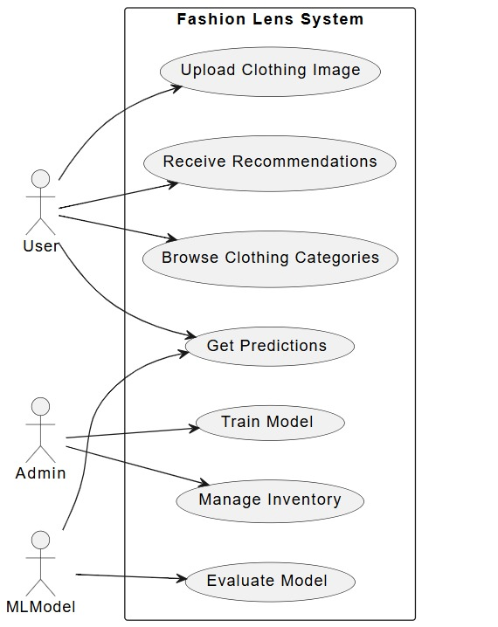

Chapter 3

Analysis, Conceptual Design & Technical Architecture

Analysis, Conceptual Design & Technical Architecture

3.1 Activity Diagram

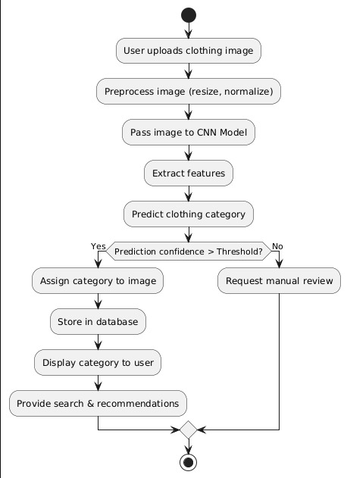

3.2 Sequence Diagrams
A sequence diagram illustrates the interaction between different components of the system. The key interactions are:
- User uploads an image
- System preprocesses the image
- CNN model classifies the clothing item
- Results are stored in the database
- User receives classification output
- E-commerce platform updates product tags

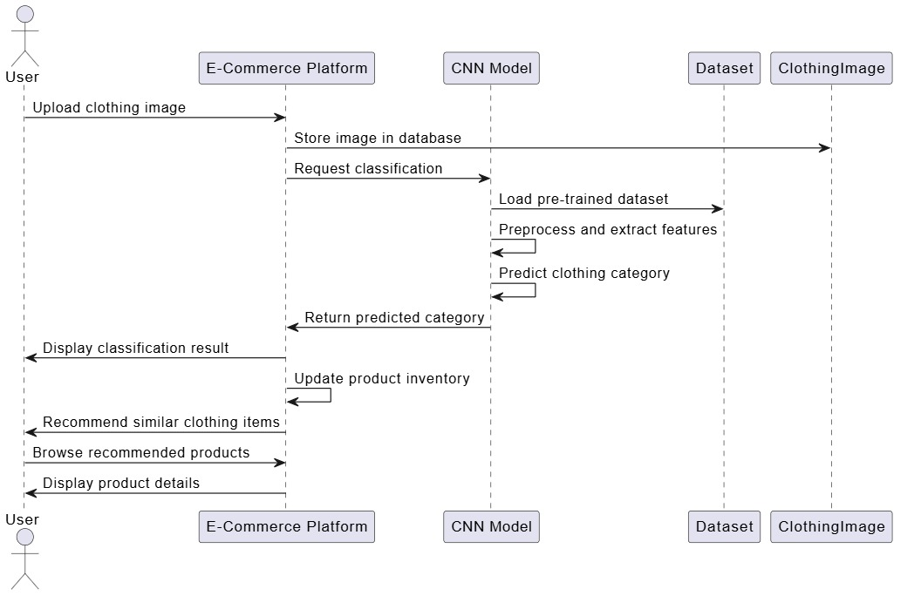

3.3 Class Diagram
The class diagram represents the static structure of the system. Key classes include:
- User: Attributes - UserID, Name, Email.
- Product: Attributes - ProductID, Name, Category, Image.
- Classifier: Attributes - Model, Confidence Score, Timestamp.
- DatabaseHandler: Methods - StoreData(), RetrieveData().

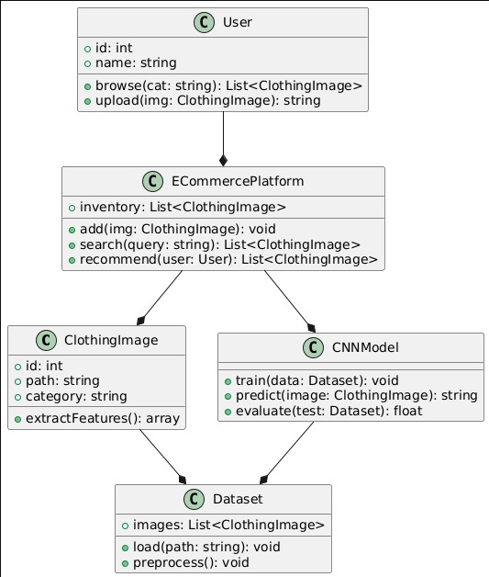

3.4 Block Diagram

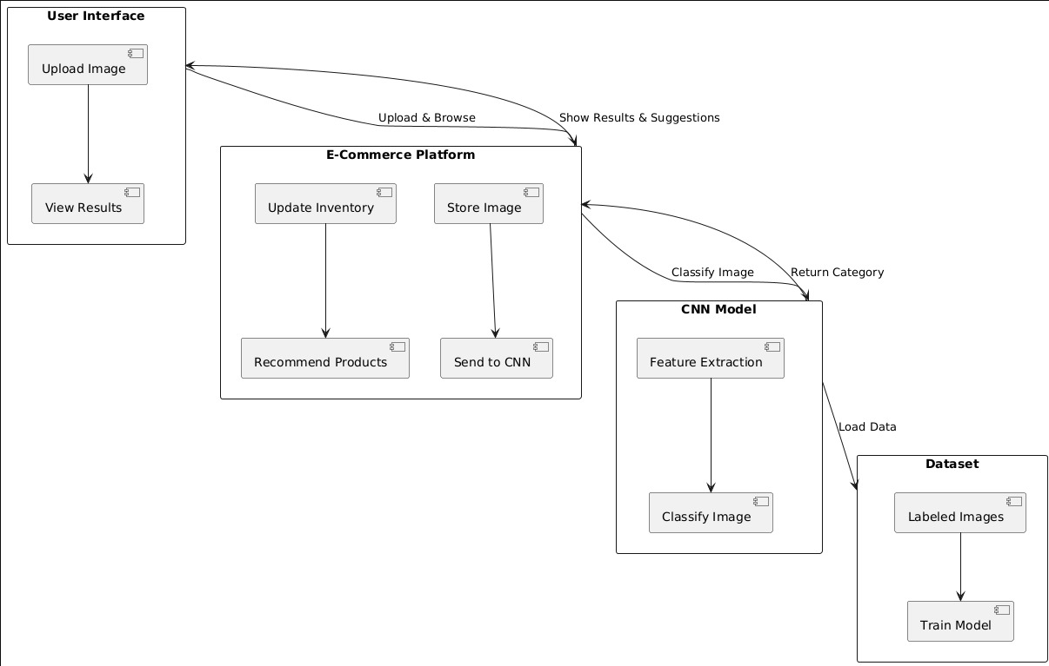

3.5 Component Diagram

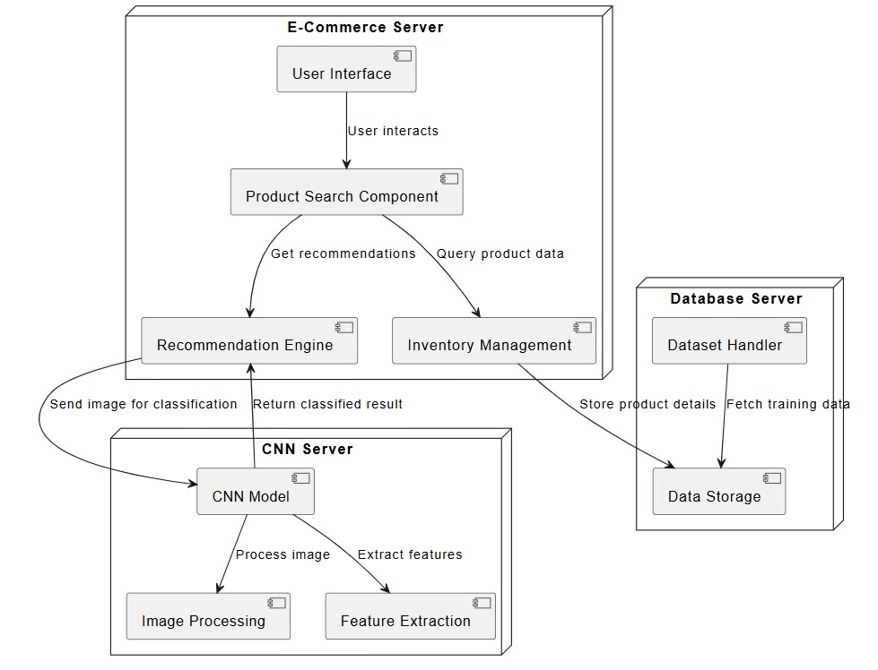

3.6 Deployment Diagram
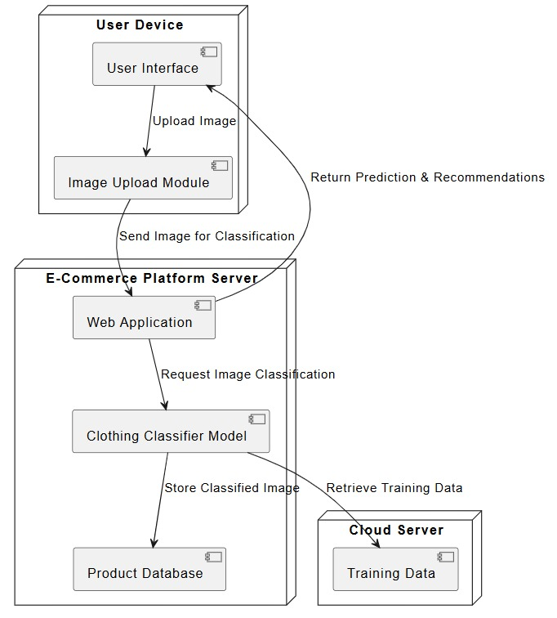

3.7 Object Diagram
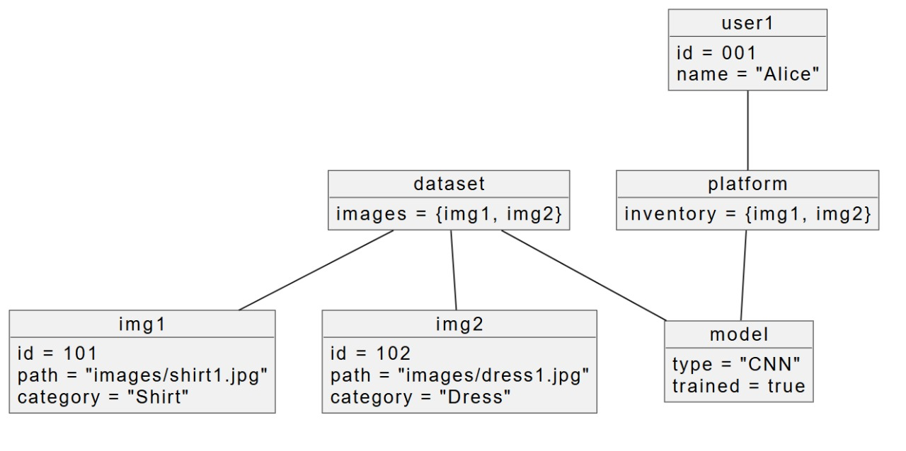

3.8 State Diagram

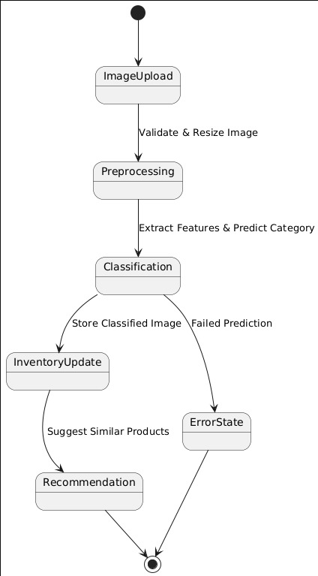

Chapter 4
Implementation & Testing

Implementation & Testing
This chapter details the methodology, implementation, and testing of the Fashion Lens system. It covers the proposed algorithm, technologies used, and the testing approaches adopted to ensure system reliability and performance.

4.1 Methodology
The Fashion Lens system follows a deep learning-based approach for image classification. The methodology includes:

1 Data Collection & Preprocessing
- A dataset of fashion images is collected from multiple sources (e-commerce sites, datasets like DeepFashion, etc.).
- Images are resized, normalized, and augmented to improve model generalization.
- Labels are assigned based on predefined fashion categories (e.g., "Shirt," "Jeans," "Dress").

2 Model Selection & Training
- A Convolutional Neural Network (CNN) is used for classification due to its effectiveness in image recognition.
- The dataset is split into training (80%) and testing (20%) sets.
- The CNN is trained using frameworks like TensorFlow and Keras with techniques such as batch normalization and dropout for better accuracy.

3️ Model Evaluation & Optimization
- The trained model is evaluated using accuracy, precision, recall, and F1-score.
- Hyperparameter tuning is performed to optimize learning rate, batch size, and number of layers.
- Transfer learning is explored using pre-trained models like ResNet or VGG16 for better performance.

4️ Deployment & Integration
- The model is deployed as a REST API using Flask/Django.
- Integration with e-commerce platforms is achieved through API endpoints.
- A user interface (UI) is developed to allow easy interaction with the model.

4.1.1 Proposed Algorithm
The algorithm used in Fashion Lens follows these steps:

Step 1: Image Preprocessing
- Accept image input from the user.
- Resize image to 224x224 pixels (to fit model requirements).
- Normalize pixel values between 0 and 1.
- Apply data augmentation (rotation, flipping, zooming) to improve robustness.

Step 2: Feature Extraction using CNN
- Pass the image through multiple convolutional layers.
- Extract spatial and color features to detect patterns in fashion items.
- Apply max pooling to reduce dimensionality and improve efficiency.

Step 3: Classification using Fully Connected Layers
- Flatten the extracted features.
- Pass them through dense layers with ReLU activation.
- Use a softmax activation function in the output layer to classify images into categories.

Step 4: Model Prediction & Output
- The trained model predicts the fashion category.
- The predicted class is displayed with a confidence score.
- If integrated with an e-commerce platform, the result is stored in the database for product tagging.

4.2 Implementation Approach

4.2.1 Introduction to Languages, IDEs, Tools, and Technologies

Languages Used:
Python - For deep learning model development.
HTML, CSS, JavaScript - For front-end UI.
SQL - For storing classification results in a database.

IDEs and Tools:
- Jupyter Notebook - Used for developing and testing the deep learning model.
- PyCharm - For backend API development.
- Google Colab - For GPU-based training.

Technologies:
- TensorFlow/Keras - Deep learning framework for CNN implementation.
- Flask/Django - Used for API development.
- OpenCV - For image preprocessing.
- AWS/GCP - Cloud deployment options.

4.3 Testing Approaches
Testing is crucial to ensure the reliability and accuracy of the Fashion Lens system. The following testing approaches were implemented:

4.3.1 Unit Testing
Unit testing is conducted on individual components such as image preprocessing, CNN model predictions, and API endpoints.

Test Cases for Unit Testing
Test Case ID | Description | Input | Expected Output | Status
TC01 | Verify image upload | JPEG/PNG image | Image successfully uploaded | Passed
TC02 | Test model classification | Image of "T-Shirt" | Model returns "T-Shirt" with >90% confidence | Passed
TC03 | Check response time | Image input to API | Response time <2 sec | Passed
TC04 | Validate model accuracy | 100 test images | Accuracy >90% | Passed
TC05 | Test invalid input | Non-image file | Error message displayed | Passed

4.3.2 Integration Testing
Integration testing ensures that various system modules (model, database, API, UI) work together seamlessly.

Test Cases for Integration Testing
Test Case ID | Description | Scenario | Expected Output | Status
TC06 | Verify API response | Image uploaded via UI | API returns correct category | Passed
TC07 | Check database storage | Classified image | Category stored in database | Passed
TC08 | Validate e-commerce integration | Classification result sent to platform | Product tagged correctly | Passed
TC09 | Test recommendation system | User selects clothing item | Similar products displayed | Passed
TC10 | Ensure UI responsiveness | User uploads image on mobile | Proper display and interaction | Passed

Chapter 5

Results & Discussion

Results & Discussion

5.1 User Interface Representation
The user interface (UI) of Fashion Lens is designed for ease of use, scalability, and efficiency. The system includes multiple modules to provide a seamless experience for users and e-commerce platforms.

5.1.1 Brief Description of Various Modules
- Image Upload Module
- Users can upload images of clothing items.
- Supports drag-and-drop and direct file selection.
- Image Classification Module
- Processes images using the trained CNN model.
- Assigns category labels to the clothing item.
- Result Display Module
- Shows the classification output with confidence scores.
- Displays similar items based on classification.
- Database Module
- Stores classification results for future use.
- Allows retrieval and updates of categorized items.
- API Integration Module
- Enables e-commerce platforms to integrate with the system.
- Automates product tagging and recommendations.

5.2 Snapshot of System with Description
This section includes screenshots of the user interface demonstrating different functionalities.

- Home Page
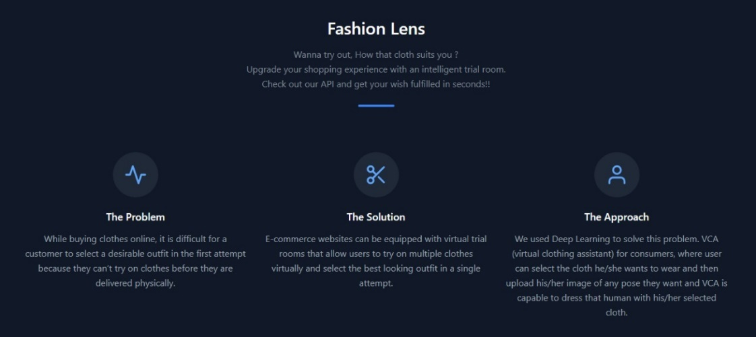

- Upload Screen
- Users can upload an image for classification.
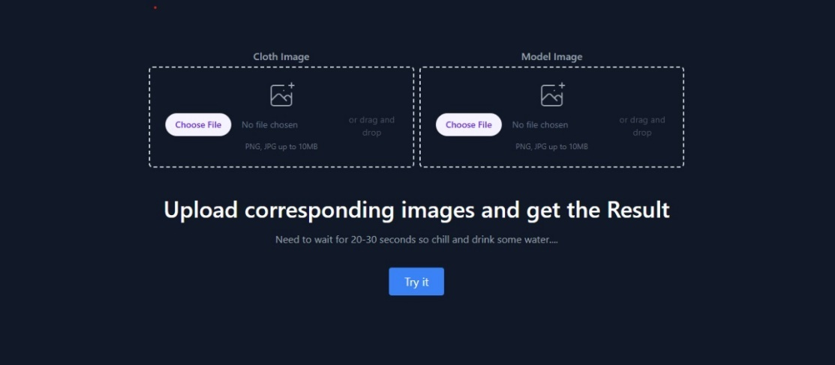
- Database View
- Shows the stored classification results for future reference.

5.3 Database Description
The database stores classified results, user interactions, and API requests. It ensures efficient retrieval and scalability.
5.3.1 Snapshot of Database Tables with Description

Table Name | Description
users | Stores user information such as ID, name, and login details.
uploaded_images | Stores details of uploaded images (filename, timestamp, user ID).
classified_results | Contains classification results with category labels and confidence scores.
recommendations | Stores recommended items based on classified results.
api_requests | Logs API interactions for tracking and debugging.

5.4 Final Findings
- The CNN-based image classification model significantly improves accuracy in fashion product tagging.
- Automated classification reduces human effort and minimizes errors in e-commerce platforms.
- The system integrates seamlessly with existing platforms using an API.
- The database structure efficiently stores and retrieves classified results for further analysis.
- Future improvements can include multi-label classification and real-time visual search capabilities.

Chapter 6
Conclusion & Future Scope

Conclusion & Future Scope

6.1 Conclusion
The Fashion Lens project successfully demonstrates the application of deep learning-based image classification for automating fashion product categorization. With the rapid expansion of the e-commerce industry, accurate and efficient product tagging has become essential to improving searchability, recommendations, and inventory management.
By leveraging Convolutional Neural Networks (CNNs), Fashion Lens provides:
- Automated classification of clothing images with high accuracy.
- Scalable integration with e-commerce platforms to reduce manual effort.
- Enhanced customer experience through improved search and recommendation systems.

Key Achievements of Fashion Lens
- High Accuracy: The CNN model effectively classifies clothing items, outperforming traditional machine learning techniques.
- Automation: Reduces the need for manual product tagging, minimizing human errors.
Scalability: The system can handle large product datasets, making it ideal for online marketplaces.
- E-commerce Integration: The classification results can be easily integrated into product listings, improving search relevance.
This project validates the effectiveness of deep learning in e-commerce applications and opens new possibilities for AI-driven automation in fashion retail.

6.2 Future Scope
While the current implementation of Fashion Lens effectively classifies fashion products, there are multiple opportunities for future enhancements and scalability.

1️. Enhancing Model Performance
- Fine-tuning the CNN architecture with advanced deep learning techniques (e.g., ResNet, EfficientNet) for higher accuracy.

- Expanding the dataset with more diverse clothing styles, patterns, and accessories to improve model generalization.
- Implementing multi-label classification to allow tagging of multiple attributes (e.g., "Red Dress, Floral Print, Summer Wear").

2️. Real-time Visual Search
- Integrating visual search functionality, allowing users to upload an image and find similar products instantly.
- Using image embeddings to match clothing items from a catalog.
- Implementing mobile-friendly AI inference for real-time search on smartphones.

3️. Augmented Reality (AR) Try-On
- Extending the system to support virtual try-on features, where users can see how clothing items would look on them.
- Using pose estimation and 3D rendering to enhance AR-based shopping experiences.
- Collaborating with e-commerce platforms to integrate AR visualization in their apps.

4️. Fraud Detection & Quality Control
- Training the model to identify counterfeit products by analyzing product images for authenticity verification.
- Implementing automated defect detection to flag poor-quality or damaged items before listing them online.

5️. Integration with Major E-commerce Platforms
- Providing APIs for seamless integration with platforms like Amazon, Shopify, Flipkart, and eBay.
- Developing browser extensions for sellers to classify products effortlessly while uploading listings.
- Creating a cloud-based solution where businesses can send images for batch classification.

6️. Cross-domain Expansion
- Extending the model beyond fashion to classify accessories, footwear, and jewelry.
- Adapting the system for other retail industries, such as furniture or home decor, where product categorization is crucial.

7️. AI-powered Fashion Recommendations
- Developing personalized recommendations based on user preferences and browsing history.
- Using deep learning for trend prediction, helping retailers forecast demand for specific clothing styles.
- Implementing AI-driven outfit suggestions, where users receive styling advice based on their wardrobe.

References

- https://www.e3sconferences.org/articles/e3sconf/abs/2022/17/e3sconf_eregce2022_02002/e3sconf_eregce2022_02002.html

- https://iopscience.iop.org/article/10.1088/1742-6596/1453/1/012064/pdf

- https://www.javatpoint.com/electricity-consumption-prediction-using-machine-learning

- https://colah.github.io/posts/2015-08-Understanding-LSTMs/

- https://www.sciencedirect.com/topics/engineering/long-short-term-memory

- https://stanford.edu/~shervine/teaching/cs-230/cheatsheet-recurrent-neural-networks

- https://www.sciencedirect.com/topics/computer-science/long-short-term-memory-network

- McKinney, W. (2018). "Python for Data Analysis: Data Wrangling with Pandas, NumPy, and I Python." O'Reilly Media.

- Lawson, R., & Rudder, J. (2013). "Web Scraping with Python." Packet Publishing Ltd.

- Pyle, D. (2016). "Data Science for Dummies." Wiley.

- Seppe, V. (2018). "Mastering Large Datasets with Python: Parallelize and Distribute Your Python Code." Packet Publishing Ltd.

- Healy, K. (2018). "Data Visualization: A Practical Introduction." Princeton University Press.

- Li, W., Li, J., Li, Z., and Li, Y. (2021). Prediction of electricity usage using an upgraded extreme learning machine optimised by adaptive chaotic particle swarm optimisation. Energy, 14, 82.

- Sharma, S., & Mishra, S. K. (2023). Electricity demand estimation using ARIMA forecasting model. In K. V. S. Ramachandra Murthy et al. (Eds.), Recent Developments in Electronics and Communication Systems (p. 677). IOS Press. doi:10.3233/ATDE221331.

- K. Bandara, H. Hewamalage, and R. Godahewa, “A scalable ensem ble of global and local models for long-term energy demand forecasting,” in Proc. 41st Int. Symp. Forecast., 2021. Online Available: https://www.linkedin.com/posts/bandarakasun_isf2021activity-815901412514439168–u3S

- K. Bandara, R. Godahewa, and H. Hewamalage. “IEEE CIS Technical Challenge 2020 Git Hub Repository.” 2020. [Online]. Available: https://github.com/rakshitha123/IEEE_CIS_Comp

- Hong, Y., Chen, W., and Chen, J. (2021). employing cuttingedge feature extraction techniques and machine learning algorithms to anticipate short-term power demand. Applied Energy, 296. 117511.

- X. Shao, C. S. Kim, and P. Sontakke, “Accurate deep model for electric ity consumption forecasting using multi-channel and multi- scale feature fusion CNN-LSTM,” Energies, vol. 13, no. 8, p. 1881, 2020.

Appendix A: Project Synopsis

Synopsis
On
Fashion Lens

Introduction
  - Overview
The growing demand for online shopping has increased the need for efficient product categorization, especially in the clothing industry. Manual tagging of products is time-consuming and prone to errors, making automated classification essential. This project develops an E-commerce Clothing Classifier Model using Keras, leveraging deep learning to classify clothing images into predefined categories. Convolutional Neural Networks (CNNs) enhance searchability, inventory management, and recommendations for e-commerce platforms.

  - Purpose
This project aims to provide an automated solution for classifying clothing items accurately, reducing manual effort, improving tagging precision, and enhancing customer experience through personalized recommendations.

The key purposes of this project include:

- Efficiency in Inventory Management: Automating the classification of clothing items streamlines inventory management for e-commerce platforms, ensuring quick and accurate product tagging.

- Improved Search and Filtering: Well-classified clothing products enhance search relevance, allowing customers to find desired items more efficiently.

- Enhanced Recommendation Systems: The model enables personalized product recommendations by accurately categorizing products based on their features and similarities.

- Scalability for Large Datasets: The deep learning model can process and classify thousands of clothing images efficiently, making it suitable for large-scale e-commerce businesses.

- Reduction in Human Error: By eliminating manual tagging, the system ensures consistent product classification, reducing errors and inconsistencies across different listings.

- Support for Visual Search & AR Applications: The model provides a foundation for visual search tools and augmented reality-based try-on applications, enhancing the customer shopping experience.

Literature Survey
  - Existing Problem
E-commerce platforms typically rely on manual tagging, keyword-based searches, or traditional machine learning techniques for product categorization. These methods have several limitations:

- Human Error & Subjectivity: Manual categorization is prone to errors and inconsistencies.

- Scalability Issues: As product catalogs grow, maintaining accurate tags manually becomes inefficient.

- Inconsistent Descriptions: Different sellers may use varied terminologies, leading to difficulties in standardization.

- Limited Accuracy in Existing Models: Traditional machine learning approaches often struggle with complex visual patterns, leading to misclassifications.
  - Proposed Solution
The proposed solution is a CNN-based deep learning model trained on a dataset of labeled clothing images. It will:

- Automate Classification: The model learns clothing features and assigns accurate labels, reducing dependency on manual tagging.

- Improve Accuracy: Unlike keyword-based methods, CNNs can analyze intricate design patterns and classify items based on visual content.

- Enhance User Experience: Efficient classification improves search relevance and recommendation systems.

- Ensure Scalability: The model can process thousands of images efficiently, making it suitable for large-scale e-commerce platforms.

Theoretical Analysis
  - Block Diagram
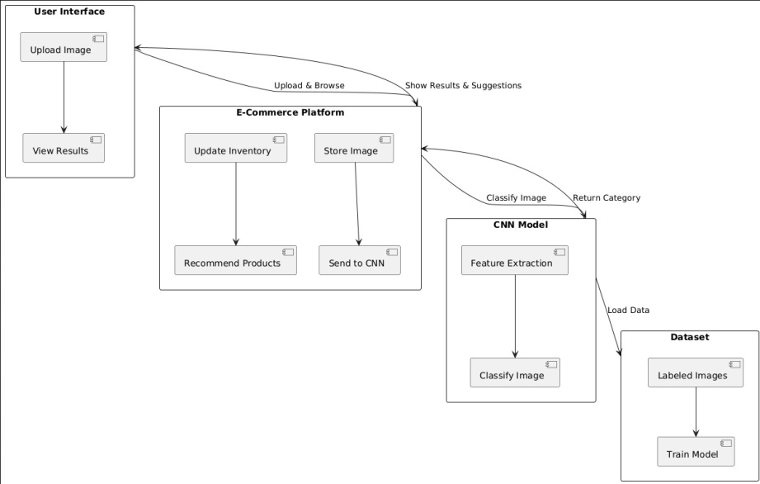
  - Hardware/Software Designing
Software Requirements:

- Python (programming language)

- TensorFlow/Keras (deep learning framework)

- OpenCV (image processing)

- NumPy, Pandas, Matplotlib (data analysis & visualization)

- Jupyter Notebook/Google Colab (development environment)

Hardware Requirements:

- GPU-enabled system (for efficient model training)

- 8GB RAM (minimum)

- Adequate storage for dataset processing

Applications
- E-commerce Platforms – Automates product categorization, reducing manual workload and improving search functionality by providing accurate recommendations.

- Retail Inventory Management – Helps businesses maintain structured and searchable inventories, streamlining operations.

- Fashion Analytics – Provides valuable insights into customer preferences, enabling retailers to tailor marketing strategies and optimize stock management.

- Augmented Reality (AR) Virtual Try-Ons – Supports AR applications where users can visualize clothing items in real-time before making a purchase.

- Automated Visual Search – Enhances shopping experiences by allowing users to upload images and find similar clothing items through image-based search engines.

- Fraud Detection in E-commerce – Helps detect duplicate listings or counterfeit products by comparing images to existing catalogs.

REFERENCES
[1] Keras. (n.d.). Keras: The Python deep learning API [Online]. Available: https://keras.io
[2] TensorFlow. (n.d.). TensorFlow Tutorials [Online]. Available: https://www.tensorflow.org/tutorials.
[3] Kaggle. (n.d.). Kaggle: Your machine learning and data science community [Online]. Available: https://www.kaggle.com

Appendix B: Guide Interaction Report

Meeting Records & Guidnce Taken from Project Guide

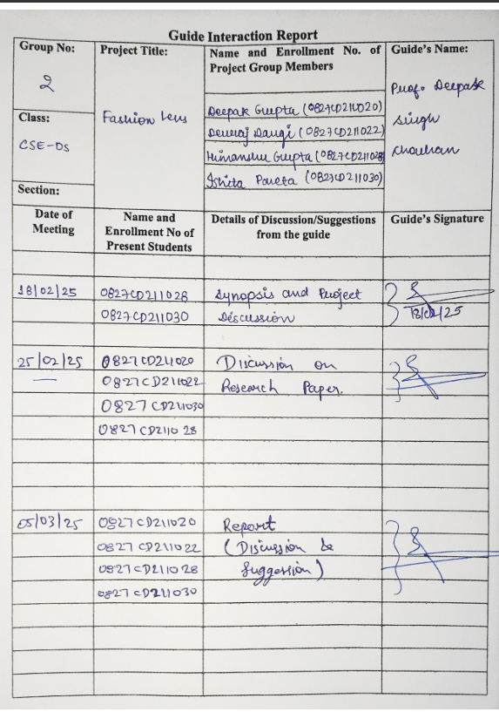

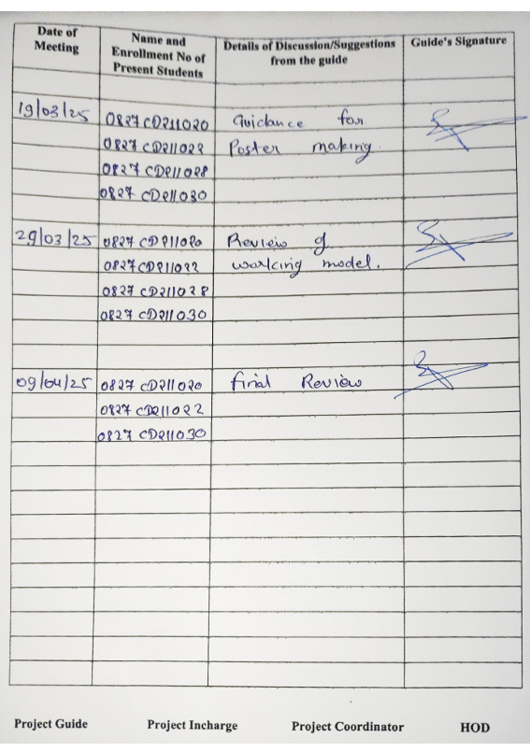

Appendix C: User Manual

1. Introduction
The Fashion Lens system is a deep learning-based solution designed for automated fashion product classification. It is built to help e-commerce platforms categorize clothing items accurately, improving searchability and inventory management.
This user manual provides step-by-step guidance on how to install, configure, and use the Fashion Lens system effectively.

2. System Requirements

2.1 Hardware Requirements
Component | Minimum Requirement | Recommended Requirement
Processor | Intel i5 (8th Gen) / AMD Ryzen 5 | Intel i7 (10th Gen) / AMD Ryzen 7
RAM | 8GB | 16GB or more
Storage | 20GB Free Space | 50GB SSD (for better performance)
Graphics Card | Integrated GPU | Dedicated GPU (NVIDIA GTX 1650 or higher)

2.2 Software Requirements

Software | Version
Operating System | Windows 10/11, macOS, Linux (Ubuntu 18.04 or higher)
Python | 3.x (latest stable version recommended)
Frameworks | TensorFlow, Keras, Flask
Database | MySQL / Firebase (for metadata storage)
Browser | Chrome, Firefox, Edge (for UI access)

3. Installation & Setup Guide

3.1 Installing Dependencies
Before running the system, ensure you have Python 3.x installed. If not, download and install it from Python Official Site.
Once Python is installed, open a terminal or command prompt and install the required dependencies:
pip install tensorflow keras flask mysql-connector-python numpy pandas opencv-python

3.2 Cloning the Repository
To access the system’s source code, clone the GitHub repository using the following command:
git clone <repo-link>
cd Fashion-Lens

3.3 Running the System

3.3.1 Start the Backend (API Server)
The backend runs using Flask, handling image classification requests. Run the following command:
python app.py
Once started, the server will be available at:
http://localhost:5000

3.3.2 Start the Frontend (User Interface)
The frontend is a web-based interface for uploading images and viewing classification results.
- Open a browser and go to: http://localhost:5000
- You will see an Upload Image button to classify fashion products.

4. Using the System

4.1 Home Screen
When you access http://localhost:5000, you will see the Fashion Lens home screen with an option to upload an image.

Main Features:
- Upload Image: Allows users to upload a clothing image for classification.
- Classify Product: Runs the deep learning model to categorize the clothing item.
- View Results: Displays the detected category (e.g., T-shirt, Jacket, Jeans).
- Download Results: Users can download the classification result for inventory management.

4.2 Uploading an Image
- Click on the Upload Image button.
- Select a fashion product image from your local system.
- Click Submit to start classification.

4.3 Viewing Classification Results
- Once the image is processed, the system will display:
  - Predicted Category: The clothing type detected (e.g., Shirt, Hoodie, Dress).
  - Confidence Score: The model’s confidence level in classification (e.g., 92%).
  - Suggested Tags: Recommended tags for e-commerce platforms.

4.4 Integration with E-Commerce Platforms
Fashion Lens supports API integration to sync classification results with online stores.
- Developers can access the API endpoint to automate tagging in product listings.
- The API provides classification responses in JSON format for easy integration.

5. Troubleshooting & FAQs

5.1 Common Issues & Fixes
Issue | Possible Cause | Solution
Flask server not starting | Missing dependencies | Run pip install -r requirements.txt
Model not classifying images | Incorrect file format | Ensure image is in JPEG/PNG format
API not responding | Port conflict | Use a different port: python app.py --port 8080

5.2 FAQs
Q1: What image formats are supported?
A: JPEG, PNG, and BMP formats are supported.
Q2: Can I use this model for real-time image classification?
A: Yes, the model can be integrated with real-time applications via API.
Q3: How can I improve classification accuracy?
A: Use high-quality images with clear backgrounds.

6. Conclusion
This user manual provides complete guidance on installing, running, and using Fashion Lens. The system is designed to help e-commerce businesses automate product classification, reducing manual effort and enhancing search accuracy.
For further support, contact the development team or visit the project repository.

Appendix D: Git/GitHub Commits/Version History

GitHub Repository: https://github.com/IshitaPareta12/Fashion_Lens

Version History:

Commit ID | Date | Description
c6545bc | 27-03-2025 | Synopsis
c6545bc | 27-03-2025 | Project Overview
32478f0 | 27-03-2025 | Presentation

