**One Shop Store**

**Ishita Shah**

**01/15/2018**

## A One Store : [Shopping site for used Items for the Student Community]

## Project Overview:

* The function/purpose of the website : With this website I aim to help the people buy the things they need and at lower prices, discounted rates, they could even bid for the items they are interested in.
* The intended users of the website: Everyone who wants to own things at comparatively lower price and be a part of the shared economy.
* Proposed content for website: Items ranging from Clothes, Furniture, Accessories, Books, household chores. Content includes a home page, categories of all the products offered, about us information, Contact us information

## Site Map:

This website would have a Login, Signup, home page, and that has the link (breadcrumbs) to Know us, Contact us, my account details.

It would have a Admin side and the User side (for the users).

Categories for the Products, product display page with along with the details about the product and “Buy me” and “Add to Cart” functionalities.

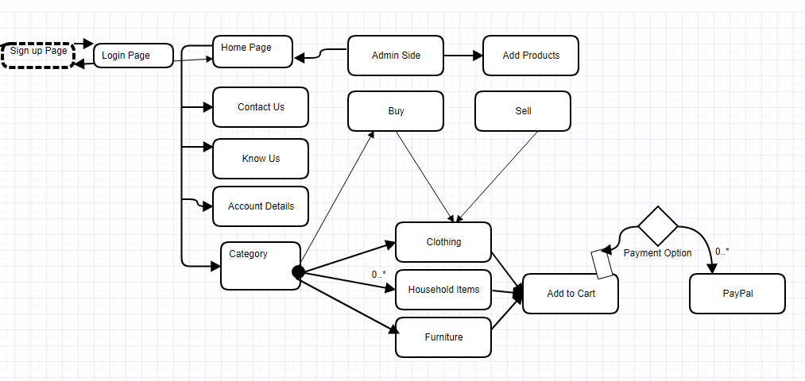

## Page design

For **each** page listed in your site map, provide *at least* the following requirements:

**Login and Signup**

* Register and grant the access to get into the website with authorized access.
* Customer and admin both
* Name, User-ID, E-mail Address, Password would be data fields.
* User Id and password ( Case-sensitive)
* Sign up page would go to login page and vice versa, login would also take you to the home page in case the user has already setup the account with the website.

**Home Page**

**Gives you a brief idea, what the website is all about in detail.**

* Would take you to all the pages and links, got breadcrumbs too for contact us, Know us, Categories of the products.
* Customer and admin both
* Contact us, Know us, Categories, Account details
* All are independent pages and would take you to the home page back.

**Categories**

* Furniture, Clothes, Footwear etc , would take you back to categories and finally the home page
* Customer and Admin
* Filters like male, female, price, pattern, furniture
* Brief idea about the product, the customers could even bid before buying it.

**Payment mode – Paypal ( For instance)**

**The final page that would help buy the product/products.**

**Add Products**

* Add products would help adding the products from the admin side
* Strictly only for the Admin

**Database**

* A database is needed to store this entire website’s data and get it updated dynamically.
* MySQL using XAMPP would be the preferred option.
* Even the login details would be stored there and inferred from there to authenticate the user.

## Project tasks, assignments and schedule:

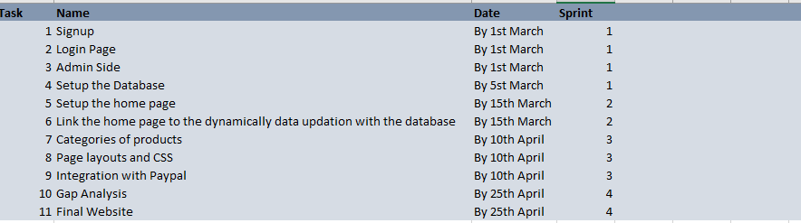

Plan to wrap up the Final Project by 25th of April 2018.