Ishitha S

Rajalakshmi enginnering college

OOPS WEEK-1

1. Given an input integer, you must determine which primitive data types are capable of properly storing that input.

PROGRAM:

import java.util.*;

public class DataType{

public static void main(String[] args){

Scanner sc=new Scanner(System.in);

System.out.print("Enter the number:");

long x=sc.nextLong();

if (x>=Byte.MIN_VALUE && x<=Byte.MAX_VALUE) System.out.println("Byte");

if (x>=Short.MIN_VALUE && x<=Short.MAX_VALUE) System.out.println("Short");

if (x>=Integer.MIN_VALUE && x<=Integer.MAX_VALUE) System.out.println("int");

if (x>=Long.MIN_VALUE && x<=Long.MAX_VALUE) System.out.println("long");

}

}

OUTPUT:  
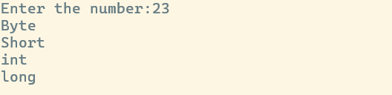

2. You are developing a financial application that needs to handle both whole numbers and decimal values.

PROGRAM:  
import java.util.*;

public class Cents{

public static void main(String[] args){

Scanner sc=new Scanner(System.in);

System.out.print("Enter the number:");

int x=sc.nextInt();

float y=(x/100.0f);

System.out.printf("Dollars:%.2f",y);

}

}

OUTPUT:



3. In a game, the player's score is calculated as a double value with high precision. However, for display purposes, you need to show the score as an integer.

PROGRAM:

import java.util.*;

public class GameScore{

public static void main(String[] args){

Scanner sc=new Scanner(System.in);

System.out.print("Enter the number:");

double x=sc.nextDouble();

System.out.println((int)x);

}

}

OUTPUT:



4. You are developing a payroll system where you need to calculate the adjusted salary based on a percentage increase. The initial salary is given as an int, and the percentage increase is given as a double.

PROGRAM:

import java.util.*;

public class Salary{

public static void main(String[] args){

Scanner sc=new Scanner(System.in);

System.out.print("Enter the Initial Salary:");

int a=sc.nextInt();

System.out.print("Enter the Percentage increase:");

double b=sc.nextDouble();

double c=(a+(a*(b/100)));

System.out.println("output:"+c);

}

}  
OUTPUT:

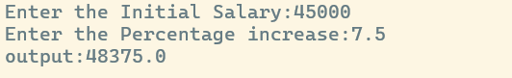

5. A mobile application for a puzzle game requires players to reverse the digits of a given number to form a new number. The goal is to check if the reversed number is equal to the original number.

PROGRAM:

import java.util.*;

public class Rev{

public static void main(String[] args){

Scanner sc=new Scanner(System.in);

System.out.print("Enter the number:");

int a=sc.nextInt();

int rem,rev=0;

for(;a!=0;a/=10){

rem=a%10;

rev=rev*10+rem;

}

System.out.println("The reversed number:"+rev);

}

}  
OUTPUT:



6. A graphics tool allows users to create complex shapes for designs. One of the patterns you need to implement is a diamond shape using stars (*). The user provides the number of rows in the top half of the diamond.

PROGRAM:

import java.util.*;

public class Pattern{

public static void main(String[] args){

Scanner sc=new Scanner(System.in);

System.out.print("Enter the number:");

int n=sc.nextInt();

int i,j,k=1;

for(i=1;i<=n;i++){

for(j=0;j<(n-i);j++) System.out.printf("%c",' ');

for(j=0;j<(i+i-1);j++) System.out.printf("%c",'*');

System.out.println();

}i--;

for(i--;i>0;i--){

for(j=0;j<k;j++) System.out.printf("%c",' ');

for(j=0;j<(i+i-1);j++) System.out.printf("%c",'*');

System.out.println();

k++;

}

}

}  
OUTPUT:

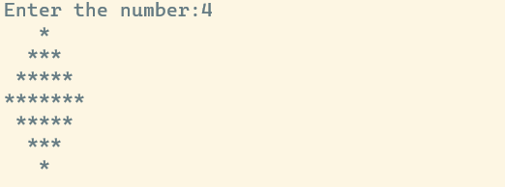

7. You are developing a software for an advanced math visualization tool. One of the features is to generate complex patterns that combine mathematical concepts with visual representations. Specifically, you need to create a pattern that combines Pascal's Triangle and a half-diamond shape.

PROGRAM:

import java.util.*;

public class Pattern_printin{

public static void main(String args[]){

Scanner inp=new Scanner(System.in);

System.out.print("Input : ");

int n=inp.nextInt();

for(int i=0;i<n;i++){

for(int k=n-1;k>i;k--){

System.out.print(' ');

}

for(int j=0;j<=i;j++){

System.out.print((fact(i)/(fact(j)*fact(i-j))));

System.out.print(' ');

}

System.out.println();

}

for(int x=n-2;x>=0;x--){

for(int y=n-1;y>x;y--){

System.out.print(' ');

}

for(int z=0;z<=x;z++){

System.out.print((fact(x)/(fact(z)*fact(x-z))));

System.out.print(' ');

}

System.out.println();

}

}

public static int fact(int n){

if(n == 0)

return 1;

else

return n*fact(n-1);

}

}  
OUTPUT:

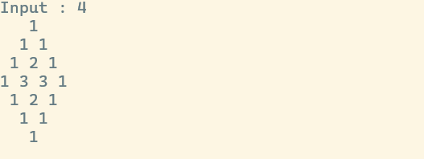

8. 4. We use the integers a, b, and n to create the following series: (a+20.b), (a+20.b+21.b),...,(a+20.b+21.b+.....+2n-1.b).You are given q queries in the form of a, b, and n. For each query, print the series corresponding to the given a, b, and n values as a single line of n space-separated integers.

PROGRAM:

import java.util.*;

public class Pattern_printin{

public static void main(String args[]){

Scanner inp=new Scanner(System.in);

System.out.print("Input : ");

int n=inp.nextInt();

for(int i=0;i<n;i++){

for(int k=n-1;k>i;k--){

System.out.print(' ');

}

for(int j=0;j<=i;j++){

System.out.print((fact(i)/(fact(j)*fact(i-j))));

System.out.print(' ');

}

System.out.println();

}

for(int x=n-2;x>=0;x--){

for(int y=n-1;y>x;y--){

System.out.print(' ');

}

for(int z=0;z<=x;z++){

System.out.print((fact(x)/(fact(z)*fact(x-z))));

System.out.print(' ');

}

System.out.println();

}

}

public static int fact(int n){

if(n == 0)

return 1;

else

return n*fact(n-1);

}

}  
OUTPUT:

