CSE B | 230701117

WEEK 02

Java

1. You are given an array of integers nums. You are also given an integer original

which is the first number that needs to be searched for in nums.

PROGRAM:

import java.util.\*;

public class Occurrence{

public static void main(String[] args){

Scanner sc=new Scanner(System.in);

int n,op,flag=1;

n=sc.nextInt();

int[] arr=new int[n];

for(int i=0;i<n;i++) arr[i]=sc.nextInt();

op=sc.nextInt();

for (int i:arr) {

if (op==i) op\*=2;

}

System.out.println(op);

}

}

OUTPUT:  
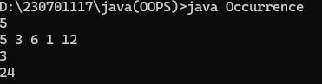

1. You are given an array prices where prices[i] is the price of a given stock on the ith day. You want to maximize your profit by choosing a single day to buy one stock and choosing a different day in the future to sell that stock. Return the maximum profit you can achieve from this transaction. If you cannot achieve any profit, return 0.

PROGRAM:

import java.util.\*;

public class MaxProfit{

public static void main(String[] args){

Scanner sc=new Scanner(System.in);

int n=sc.nextInt();

int[] arr=new int[n];

for(int i=0;i<n;i++) arr[i]=sc.nextInt();

int buy=arr[0];

int profit=0;

for (int i=1;i<n;i++){

if (buy>arr[i]) buy=arr[i];

else{

int check=(arr[i]-buy);

if(check>profit) profit=check;

}

}

System.out.println(profit);

}

}

OUTPUT:

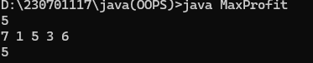

1. Given an Array of N with the elements of 0's, 1's and 2's. Your task is to arrange the array elements in the following order. 0's followed by 1's followed 2's

PROGRAM:

import java.util.\*;

public class ZeroOneTwo{

public static void main(String[] args){

Scanner sc=new Scanner(System.in);

int n=sc.nextInt();

int[] arr=new int[n];

for(int i=0;i<n;i++) arr[i]=sc.nextInt();

Arrays.sort(arr);

for(int i:arr) System.out.printf("%d ",i);

}

}  
OUTPUT:

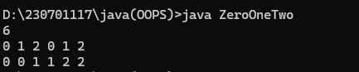

1. Given an array arr[] of size N-1 with integers in the range of [1, N], the task is to find the missing number from the first N integers. Note: There are no duplicates in the list.

PROGRAM:

import java.util.\*;

public class MissingNum{

public static void main(String[] args){

Scanner sc=new Scanner(System.in);

int n=sc.nextInt();

int i;

int[] arr=new int[n];

for(i=0;i<(n-1);i++) arr[i]=sc.nextInt();

arr[i]=n+1;

Arrays.sort(arr);

for(i=0;i<n;i++){

if (arr[i]!=(i+1)){

System.out.println((i+1));

break;

}

}

}

}

OUTPUT:

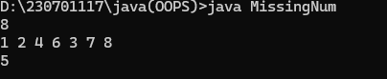

1. Given an array of N elements, You task is to move the Zeroes to the end of the Array.

PROGRAM:

import java.util.\*;

public class MoveZeroLast{

public static void main(String[] args){

Scanner sc=new Scanner(System.in);

int n=sc.nextInt();

int[] arr=new int[n];

for(int i=0;i<(n-1);i++) arr[i]=sc.nextInt();

int temp=0;

for(int i=0;i<n;i++){

if(arr[i]!=0){

arr[temp++]=arr[i];

}

}

while(temp<n) arr[temp++]=0;

for(int j:arr) System.out.print(j);

}

}

OUTPUT:

