
BAPINEEDU BOLLEMPALLI
Senior Director - Data & Analytics Practice - Virtusa
Chief Architect: Seasoned Data Platform Modernization professional, successful in providing Data Modernizing strategy to achieve organization's mission and goals.


Hyderabad, Telangana bbapineedub@gmail.com +91-9989393073
Profile Summary
Chief Architect @ Data and Analytics practice at Virtusa with 23 years of rich experience in Data and Analytics space. Modernization of Traditional Data Platforms leveraging new gen technologies. Predominantly in Banking and Financial Services domain.

- Currently working in Data and Analytics practice @Virtusa as Chief Architect for Top Global banking clients. Providing Data Strategy in the areas of Cloud Migration, Data Integration, Data Governance, Data Ingestion, Big Data and Advanced Analytics. Handling delivery assurance for critical projects from solutioning and technology front.
.
- Providing low code solutions to customers to scale, migrate and structure their legacy to new gen data platforms. At the same time supporting their existing data platforms to realize the current business needs and future business goals from Data perspective.

- Introduced best-in-class Data Platform Modernization, Data & Analytics solutions and Big Data solutions with automated deployments, high performance column store databases and near real-time data availability.

- Developed Finacle operational data store / Finacle Analytics Solutions from scratch and successfully launched Finacle Analytics solution (Big Data Platform) in 6 months. Contributed to the creation and improvement of custom Big Data analytical solutions for Finacle UBS and implemented them into use for various customers across globe.

- Provided state of art Data Platform Modernization solutions for various International BFSI clientele like JPMC, CITI Bank, HBOS, Barclays, Lloyd’s TSB, Sainsbury’s Bank, Co-operative Bank, Westpac, Ironshore Insurance etc...

- Conceptualized, developed and enforced standards for the process of data quality, data lineage, data governance, metadata management inclusive of data integration, data collection and analysis.

- Performed and interpreted data studies and experiments concerning new structured and unstructured data sources or new uses for existing data sources.

- Lead and supervised groups researching strategic business data and conducting data analysis. Determine new ways to improve data and search quality, and predictive capabilities.

- Motivational leader with excellence in Strategy Definition and Execution, Architecture, Consulting, Sales Support, Customer Relationship Management, Building High Performance Teams & Global Delivery.

- Analyzed and studied various customer requirements to provide response from solutioning standpoint for RFP and RFI. Assisting sales teams in proposal building in BFSI space.

Area of Excellence  Data Modernization  AWS  Metadata Management  Data Governance  Due Diligence  Data Warehousing  Pre-Sales/Sales Support  Business Intelligence  Strategy Definition  Data Migration  Soft Skills  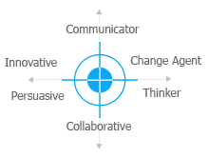 |  |  | Education  - Master of Science in Engineering from Indian Institute of Sciences (IISC), Bangalore, Karnataka, India in 1995  - BE (Civil Engineering) from Osmania University, Hyderabad, A.P, India in 1991  - Diploma for Global Leadership from U21 and Harvard Business School in 2008  Career Timeline  - 2017 – Till Date – Senior Director, Chief Architect  - 2010 – 2017 – Principal Consultant, Sr. Product Line manager  - 2006 – 2010 – COE Lead, Sr DW Architect, Program Manager  - 2000 – 2006 – Tech Team Lead, DW Architect, Project Manager  - 1996 – 2000 – Team member/ Module Lead
Notable Achievements Across Career  - Work Experience  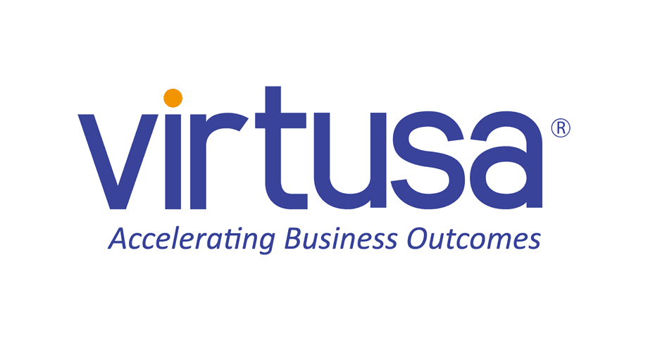          Previous Experience  Certifications/ Trainings  IT Skills | - Top Talent Award in Virtusa  - On the Spot award for launching Finacle Analytics product & completion of POC in record time of 1 month  - Streamlined the concept of BI/DW ETL Concepts, Relational Model (3NF, 4NF) and Dimensional Modeling by using Star, Snowflake Schema and Cubes  - Provided Active Metadata Solutions for Data Governance  - Spearheaded Data Modernization engagements for key clientele which involves various International companies in Banking, Insurance, Retail & Utilities domain like:  - Ironshore (Insurance), Westpac, Barclays, HBOS (Halifax Bank of Scotland)  - Lloyds TSB, Sainsbury’s Bank, Tesco & Thames Water  - Led the designing of Data Warehouse Architecture, Dimensional Modeling and Technical Documentation  - Achieved recognition for the efforts & rewarded with:  - Outstanding and Excellent Performer  - Customer appreciations for Data Warehouse Development Work done at Tesco, HBOS and Sainsbury Banks at offshore and onsite  - Showed outstanding performance and won:  - Best Performer Award from Mahindra Satyam Ltd., Hyderabad  - Best Assessment Award while working with Customer in Genpact India, Hyderabad  - Best Star Performer in Tesco Award with Mahindra Satyam  - Excellent Performer in Genpact  Since Apr’17 to till date at Virtusa Hyderabad as Chief Architect – Data & Analytics practice - BFS  Highlights:  - Provided Data Strategy and Solutions for a US Based Top Global Banking customers in areas of Data Migration, Data Modernization and building Data Platforms leveraging new gen technologies  - Provided solutions for Data Management, Governance  - Provided real time solutions for data quality, Lineage and remediation as per regulatory compliance articles of OCC, BCBS, BASEL  - Providing Solutions for Pro-active Proposals and RFP in Data and Analytics arena  - Actively providing thought leadership from offshore delivery standpoint.  - Providing robust future state Solution Roadmaps for Banking and Financial Services clients like CITI, JPMC, M&T. Providing them Modernized Data Management Solutions like Cloud Migration, Real time analytics, Big Data lakes for their Reporting and Advanced Analytics purposes  - Manage the COE and build people capability by upskilling, Cross skilling, Ramping up, Resource Utilization and Optimization.  - Delivery Assurance in Data and Analytics space.  - Providing solutions for quick POC in Data Integration space.  - Tech stack comparison and validation for various use cases.  Since Oct’13 to Nov’16: Infosys Ltd / Edgeverve, Hyderabad as Senior Product Line Manager – Big Data Analytics in Finacle Core Banking Solutions  Highlights:  - Head of Finacle Digital Commerce Strategy, Planning and Execution of the Product Roadmaps for Finacle Digital Wallet and Finacle Analytics Platform. This in turn includes engineering phased wise deliveries and claiming quick customer benefits for use case requirements in Finacle Core Banking space.  - Implementing Finacle Analytics Platform at various customer sites. Provides support for Implementation and Customization teams from Product Engineering standpoint  - Architecting Active Metadata Solution for version control and metadata maintenance.  - Providing technical support to Pre-Sales teams across globe to address queries from customers on product capability and technology landscape  - Analyzed and studied various customer requirements to provide response from Product standpoint for RFP and RFI. Assisting sales teams in proposal building in Big Data Analytics space  Since Oct’11: Genpact India, Hyderabad as DWBI COE Lead/ Principal Consultant  Highlights:  - Strategizing the IT Roadmaps which in turn initiating on time deliveries and quick customer benefits  - Implementing various BI/ DW plans to enhance cross skilling in resources and competency building during dynamic resource pooling  - Analyzed and studied AS-IS state DW architecture for Iron Shore and Westpac; provided a robust solution for best in class performance in DW/BI arena  - Worked as Senior Architect for TOM Data Management & Reporting process for Ironshore (Insurance Domain) providing HLD and supervising development work  Dec’06 - Nov’10: Mahindra Satyam Ltd., Hyderabad as Program Manager/ DWBI COE Lead  Highlights:  - Bagged the Star Performer Recognition in Barclays and Tesco Projects  - Managed design and development of data warehouses for various UK Banks like:  - Barclays, HBOS (Halifax Bank of Scotland), Lloyds TSB  - Sainsbury’s Bank and Leading Retailer Tesco in UK  Sep’00 - Dec’06: Steria, Noida (Formerly Xansa India) as Project Manager/ Data Warehouse Architect  Dec’98 - Aug’00: Simplex Technologies, Edinburgh, Scotland as Sr. Software Engineer  Apr’96 - Dec’98: Tata Consultancy Services (TCS), Chennai, India as Module Leader/ Team Member  - Kafka Certified by Edureka  - Big Data Certified by IBM  - AWS Essentials – Linux Academy  - Certificate of Global Business Leadership from U21 and Harvard Business School  - Certificate of Customized Teradata Training - NCR, Edinburgh  - Trained in Trillium (Customer De-duplication and Matching Tool) - Harte Hanks London  - CEBC Certification – Code of Ethical Business Conduct and Self-Assessment – Mahindra Satyam Ltd.  - Satyam Function Point Champion - Satyam Computer Services Ltd.  - SPMP (Satyam Project Manager Practitioner) - Satyam Computer Services Ltd.  - Satyam Assessor Certification - Satyam Computer Services Ltd.  - RDBMS and Teradata - Mahindra Satyam Ltd.  - 4NF and Dimensional Modeling – Mahindra Satyam Ltd.  - Data Modeling- Mahindra Satyam Ltd.  - Trillium  Cloud: AWS  Hardware: MS Windows, IBM Mainframe, LINUX (RHL)  Operating Systems: Windows XP, HP-UNIX, OS/390, Linux  Languages: R Programming, SQL, PL/SQL, C++, Java 7  Databases: Teradata, SQL Server 2008, DB2, Oracle  Big Data Ecosystem: Apache Hadoop, Hive, Sqoop, Hbase, Spark  Modeling Frameworks: IBM IFW, FSLDM  Case Tools: Clear Case, Clear Quest, SharePoint, IBM CLM  Tools & Utilities: Talend, Splunk, Kafka, Tableau, Ab Initio, ERWIN, TRILLIUM, Test Director, MS Project, Splunk, Kafka  Domain Knowledge: Insurance, Banking, Retail, Utilities, Credit Cards & Manufacturing

