Course Title: Social Immersive Learning
Course Code: 24UC0022
Name: L.Ishitha
Roll No: 2420030041
Section: 10

Title of the Event
Bathukamma Celebrations

Student Name: - P. Moukshitha,
Roll No: -2420030164,
Section: -10

Organized by
KLH University | Student Activity Center
Venue: University Grounds

Dates
26th September, 1:00 PM to 4:00 PM

Event Summary
Bathukamma Celebrations were held at the university grounds to mark the traditional Telangana floral festival, which honors and worships Goddess Bathukamma with vibrant flower arrangements and cultural activities. This special event encouraged students to connect with their cultural roots by participating in the creation of beautiful Bathukamma stacks and enjoying festive music, dances, and rituals. The celebrations fostered a spirit of unity and tradition among students, showcasing the diverse collective heritage of Telangana. All participants were required to dress in traditional or ethnic wear, which added to the authentic and colorful atmosphere of the day.

Key Highlights
- Organization of a Bathukamma competition where students brought their own flowers and materials.
- Enthusiastic participation in making elaborate Bathukamma stacks.
- Traditional songs and dances performed as part of the celebration.
- Cultural immersion fostered through active involvement and community gathering in ethnic dress.

My Participation
During the Bathukamma Celebrations, I actively participated by bringing fresh flowers and contributing to my team’s Bathukamma arrangement. I engaged in the traditional rituals, songs, and dances alongside fellow students, experiencing the festival’s cultural significance first-hand. The event offered me the chance to connect with my heritage, work with peers in a creative and joyful environment, and learn more about the customs and artistry involved in the Bathukamma tradition. It was a memorable day that strengthened my appreciation for Telangana’s vibrant culture.

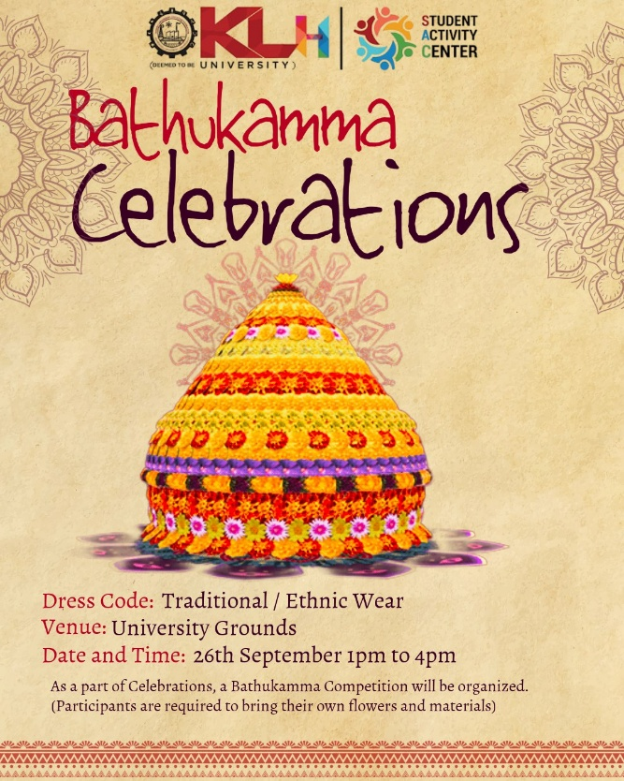
Event Photograph

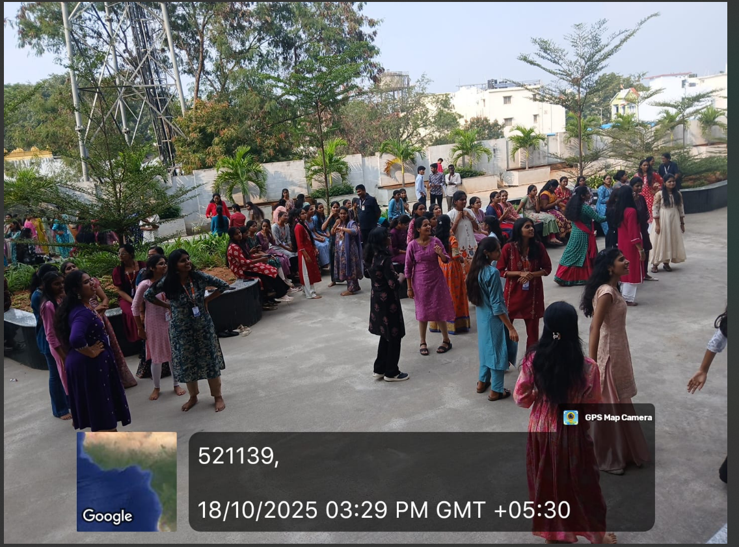

Conclusion
Participating in the Bathukamma Celebrations provided a rich and immersive cultural experience. The event not only deepened my understanding of regional traditions but also allowed for meaningful interaction and bonding with other students.

Acknowledgment
Special thanks to the Student Activity Center and KLH University for organizing such a wonderful and culturally significant event, and for recognizing and valuing all participants’ efforts.

