Course Title: Social Immersive Learning
Course Code: 24UC0022
Name: P. Moukshitha
Roll No: 2420030164
Section: 10

Title of the Event
Study Abroad Fair 2025 – Meet 40+ University Delegates

Student Name: - L.Ishitha
Roll No: - 2420030041
Section: - 10

Organized by
KLH Bachupally Campus, in association with Oaks Overseas.
Details: International Relations (IR) Team.
Room No: HC14, Date: 30/10/2025, 10 AM onwards.

Dates
30th October 2025, 10:00 AM onwards

Event Summary
The Study Abroad Fair 2025 was organized at KLH University, Bachupally Campus, in collaboration with Oaks Overseas. This event brought together more than 40 university delegates from various countries—including the UK, Canada, Germany, and Singapore—providing students with the exclusive opportunity to interact directly with international representatives. The fair aimed to introduce students to a multitude of global higher education options, admission processes, and scholarship opportunities, while also offering personalized counseling sessions to guide students towards shaping a global career. The event saw enthusiastic participation, sparking awareness and interest in overseas education among attendees.

Key Highlights
- Direct face-to-face interactions with university delegates from over 40 prestigious global institutions.
- Expert counseling on studying in countries such as the UK, Canada, Germany, and Singapore.
- Informative guidance regarding application procedures, visa processes, and scholarship avenues.
- Insightful discussions on building international careers and adapting to global standards.
- Professional networking opportunities in a highly engaging and organized setting.

My Participation
As a participant in the Study Abroad Fair 2025, I had the opportunity to engage in insightful discussions with university delegates and overseas education counselors. I gained valuable knowledge about various academic programs, admission criteria, and scholarship possibilities offered by different international universities. The event enabled me to clarify doubts related to the application process and visa requirements, and inspired me to explore higher education opportunities abroad. Additionally, networking with experts and peers expanded my outlook on future career prospects and gave me the confidence to pursue my study abroad aspirations.

Event Photographs
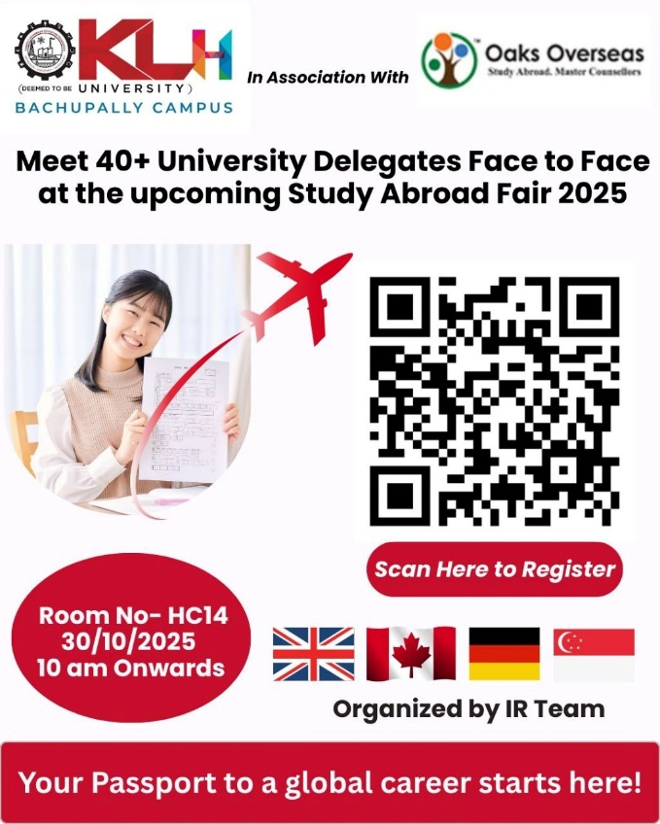
​
​
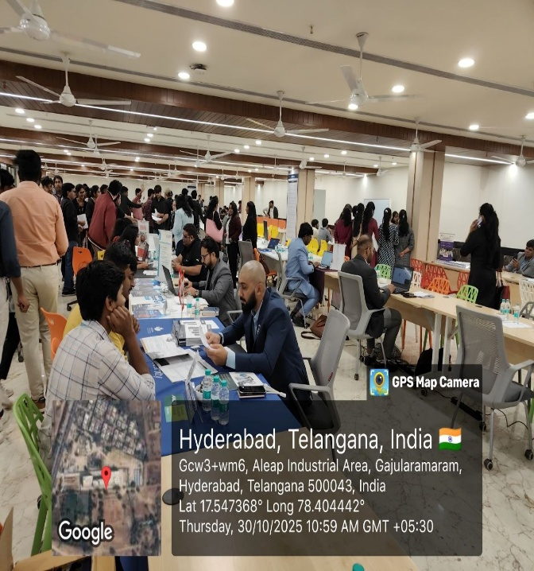

Conclusion
Attending the Study Abroad Fair was an enriching experience, providing practical information, broadening my horizons, and motivating me to consider international education pathways for my future. The event was well-coordinated and addressed the varied queries of students interested in global careers.

Acknowledgment
Special thanks to the International Relations Team, Oaks Overseas, and KLH University for hosting such an informative event, and for recognizing my active participation.

