-Instruction

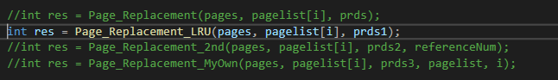If you want to run lru algorithm, you comment out the calling of function Page_Replacement_LRU. Then run it.

If you want to run 2nd chance algorithm, you comment out the calling of function Page_Replacement_2nd. Then run it.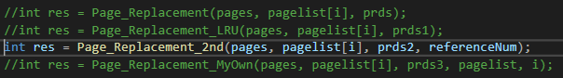

If you want to run my own algorithm, you comment out the calling of function Page_Replacement_MyOwn. Then run it.

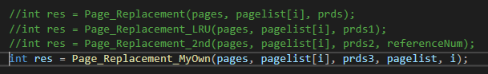

-Explanation of my own algorithm

The idea is simple, for every reference I did following :

1. If referred page is already present, increment hit count.
2. If not present, find if a page that is never referenced in future. If such a page exists, replace this page with new page. If no such page exists, find a page that is referenced farthest in future. Replace this page with new page.

So the “Predict” function is to find a page that is never referenced in future or that is referenced farthest in future.

Then, replace it and return its index.