**A CRM Application To Supply leftover Food To Poor**

By

Name: Muhammad Shoaib

E-Mail: 21wj1a6643@gniindia.org

**Project Abstract:**

In our project, we aim to address the critical issue of food wastage while simultaneously contributing to the welfare of underserved communities. Our solution utilizes the Salesforce Customer Relationship Management (CRM) platform to streamline the process of collecting surplus food from various sources and distributing it efficiently to those who need it most.

**INDEX Page**

**Topic Page No**

Introduction

1. Salesforce developer account creation
2. Create Venue, Drop-Off Point, Task, Volunteer, Execution Details
3. Creating a Custom Tab
4. Create a Lightning App
5. Creating a Fields Tab
6. Create Flow to create a record in Venue object
7. Create a Trigger
8. Profiles
9. Creation of Users
10. Creation of Public Groups
11. Creation of Report Types
12. Creation of Report on Venue with Drop-Off with Volunteer
13. Creation of Report on Volunteers with Execution Details and Tasks
14. Creation of Dash-Boards
15. Creation of Sharing rules
16. Creation of Home Page

**INTRODUCTION**

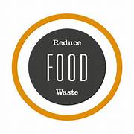

The primary purpose of your application would be to connect surplus food providers (such as restaurants, caterers, or individuals) with people who are hungry or food-insecure. By doing so, you can reduce food waste and ensure that edible food doesn’t go to waste.

### Milestone 1 :- Salesforce Developer Account Creation

Creating a developer org in salesforce.

1. Go to <https://developer.salesforce.com/signup>
2. On the sign up form, enter the following details :
   1. First name: Muhammad
   2. Email: imdshoiab@gmail.com
   3. Role : Developer
   4. Company : Guru Nanak Institutions Technical Campus
   5. County : India
   6. Postal Code : 505001
   7. Username : ishoiab@salesforce.com

Click on sign me up after filling these.

**Create Venue Object**

For creating the customer object follow the steps:

To create an object:

1. From the setup page >> Click on Object Manager >> Click on Create >>Click on Custom Object.
2. Enter the label name >> Venue
3. Plural label name >> Venues
4. Enter Record Name Label and Format

* Record Name >> Venue Name
* Data Type >> Text

1. Click on Allow reports and Track Field History,Allow Activities.
2. Allow search >> Save.

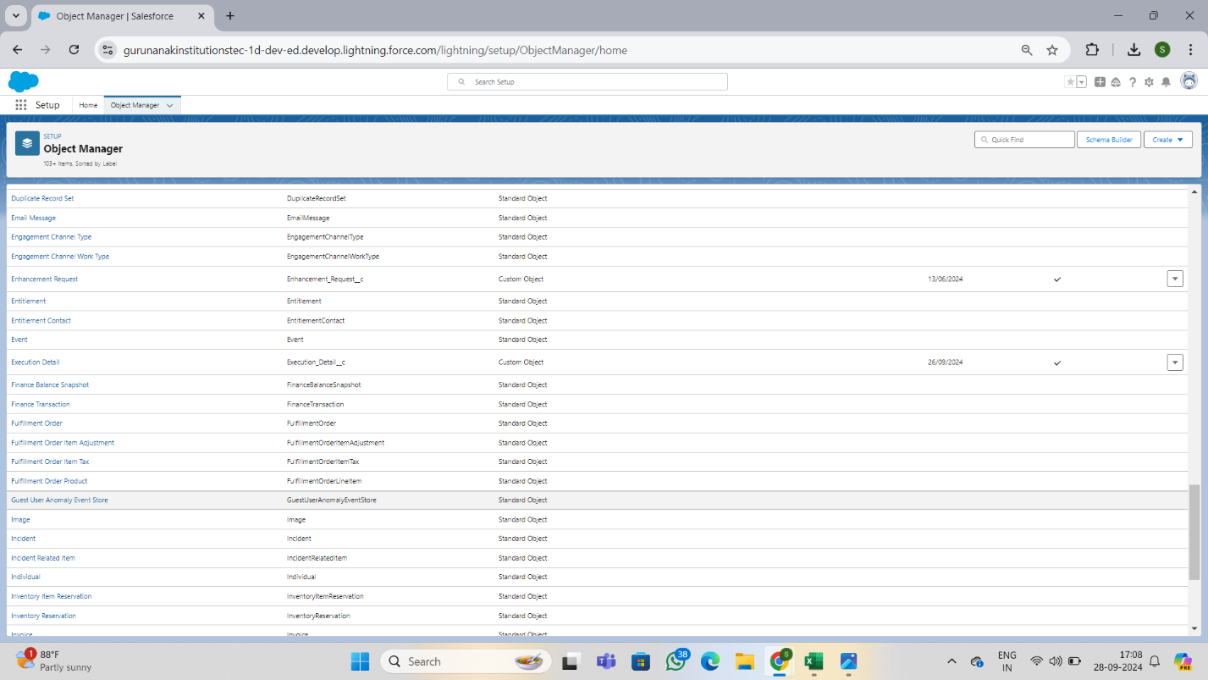

**Create Drop-Off Point Object**

To create an object:

1. From the setup page >> Click on Object Manager >> Click on Create >> Click on Custom Object.
2. Enter the label name >> Drop-Off Point
3. Plural label name>> Drop-Off Points
4. Enter Record Name Label and Format

* Record Name >> Drop-Off point Name
* Data Type >> Text

1. Click on Allow reports and Track Field History,Allow Activities
2. Allow search >> Save.

**Create Task Object**

To create an object:

1. From the setup page >> Click on Object Manager >> Click on Create >> Click on Custom Object.
2. Enter the label name>> Task
3. Plural label name>> Tasks
4. Enter Record Name Label and Format

* Record Name >> Task Name
* Data Type >> Text

1. Click on Allow reports and Track Field History,Allow Activities
2. Allow search >> Save.

**Create Volunteer Object**

To create an object:

1. From the setup page >> Click on Object Manager>> Click on Create >> Click on Custom Object.
2. Enter the label name>> Volunteer
3. Plural label name>> Volunteers
4. Enter Record Name Label and Format

* Record Name >> Volunteer Name
* Data Type >> Text

1. Click on Allow reports and Track Field History, Allow Activities
2. Allow search >> Save.

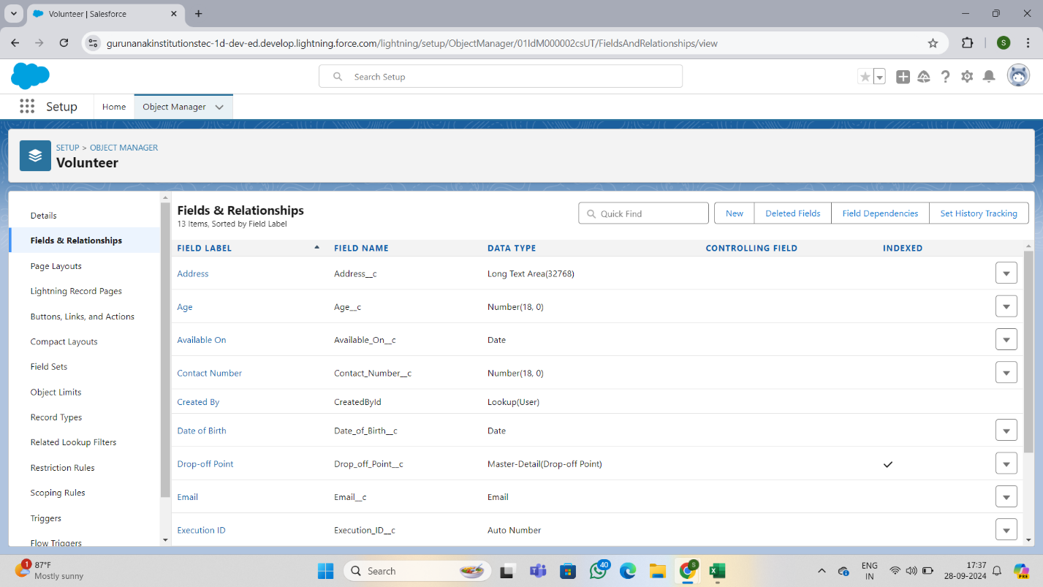

**Create Execution Details Object**

To create an object:

1. From the setup page >> Click on Object Manager >> Click on Create >> Click on Custom Object.
2. Enter the label name >> Execution Detail
3. Plural label name >> Execution Details
4. Enter Record Name Label and Format

* Record Name >> Execution Detail Name
* Data Type >> Text

1. Click on Allow reports and Track Field History, Allow Activities
2. Allow search >> Save.

**Activity 2: Creating a Custom Tab**

In this Activity we are going

To create a Tab:(Venue)

1. Go to setup page >> type Tabs in Quick Find bar >> click on tabs >> New (under custom object tab)
2. Select Object(Venue) >> Select the tab style >> Next (Add to profiles page) keep it as default >> Next (Add to Custom App)  uncheck the include tab .
3. Make sure that the Append tab to users' existing personal customizations is checked.
4. Click save

**Activity 3:** Create A Lightning App

Creating roles as per the business requirement.

1. Go to Setup and Click on Roles, then click on Expand all and Add a Role just below the Sales Representative.

2. Label - Sales Executive; Reports to - Sales Representative

3. Similarly Create a Role Name “Sales Manager” below Sales Executive which reports to Sales Executive.

4. Similarly Add a Role below Sales Manager labelled as “Customer” which reports to Sales Manager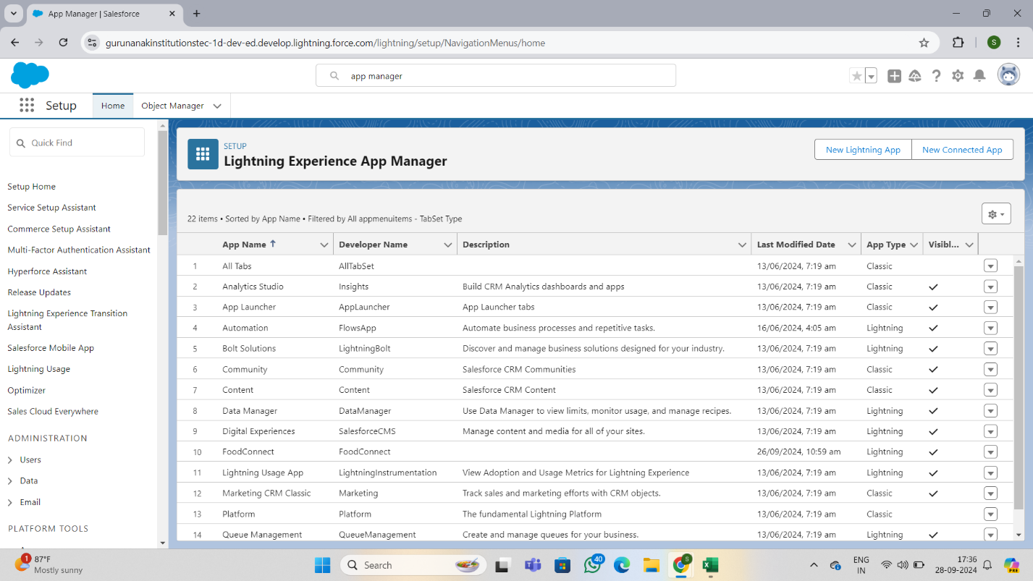.

**Activity 4:** **Creation of Relationship fields in objects**

Creating an app where the objects will be displayed.

1. From Setup, Go to App Manager and click on New Lightning App and Name it as “Property Details” and add “Customer” and “Property” Object.

2. Click Next and Next then add “System Admin” Profile and Save.

1. Now click on “Fields & Relationships” >> New
2. Select Master Detail relationship
3. Select the related object “Drop-Off point” and click next.
4. Field Name : Drop_Off_point
5. Field label : Auto generated
6. Next >> Next >> Save.

. 

**Activity 5:** **Create a Trigger**

1. Log into the trailhead account, navigate to the gear icon in the top right corner.
2. Click on developer console and you will be navigated to a new console window.
3. Click on the File menu in the toolbar, and click on new >> Trigger.
4. Enter the trigger name and the object to be triggered.
5. Enter Name : DropOffTrigger

sObject: Drop-Off Point

1. Click on Submit.

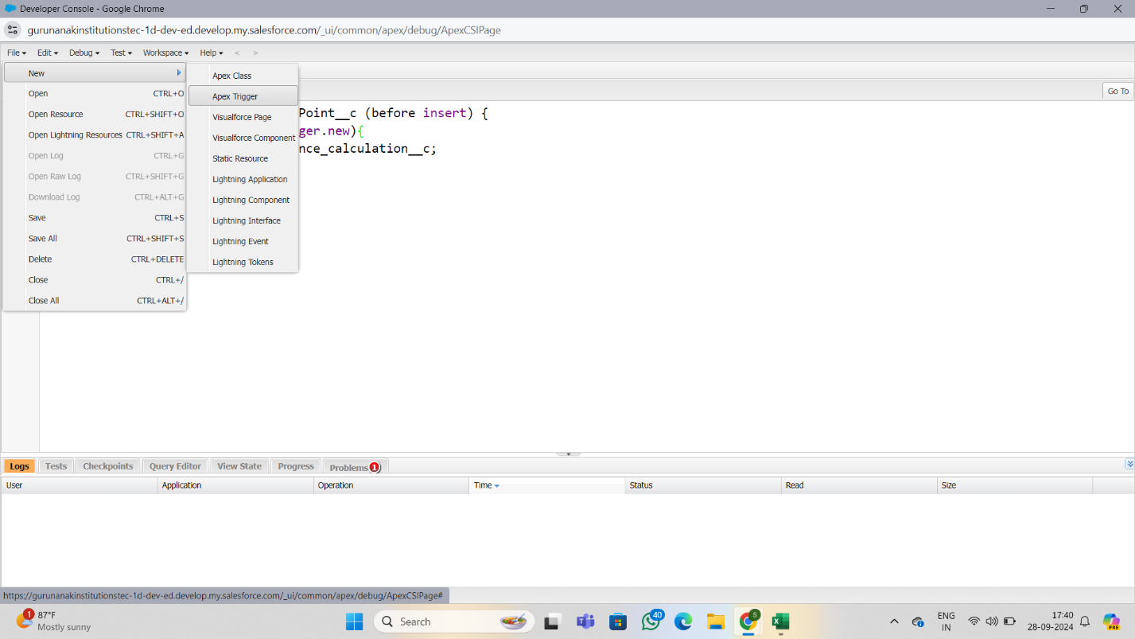

**Activity 6**: Trigger Code

1. Setup go to Object Manager then go to Search for User select Fields and Relationships.

2. Create new Field Named as “Verified” as Data type “Check Box”.

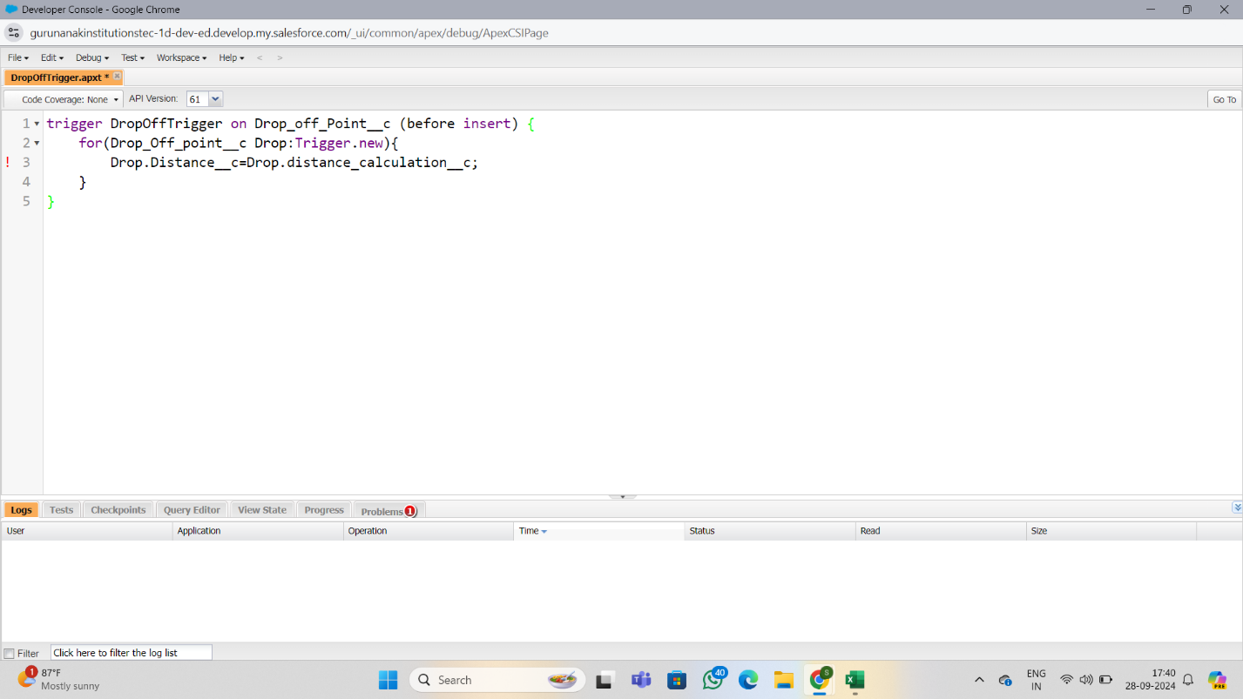

**Activity7:** Create Users

**Creation of User1**

1. 1. Go to setup page >> type users in Quick Find bar >> click on us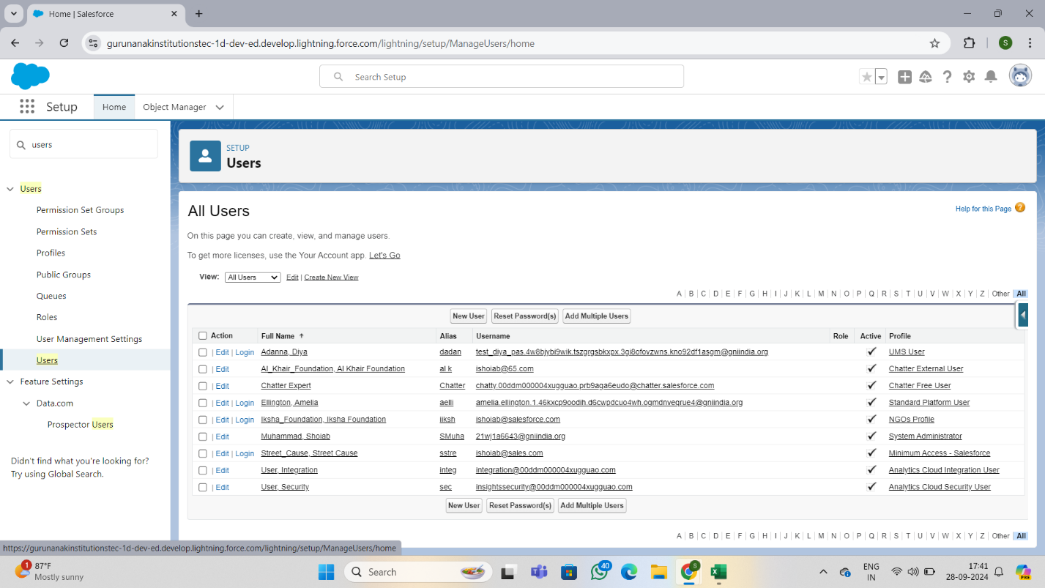ers>> New user. 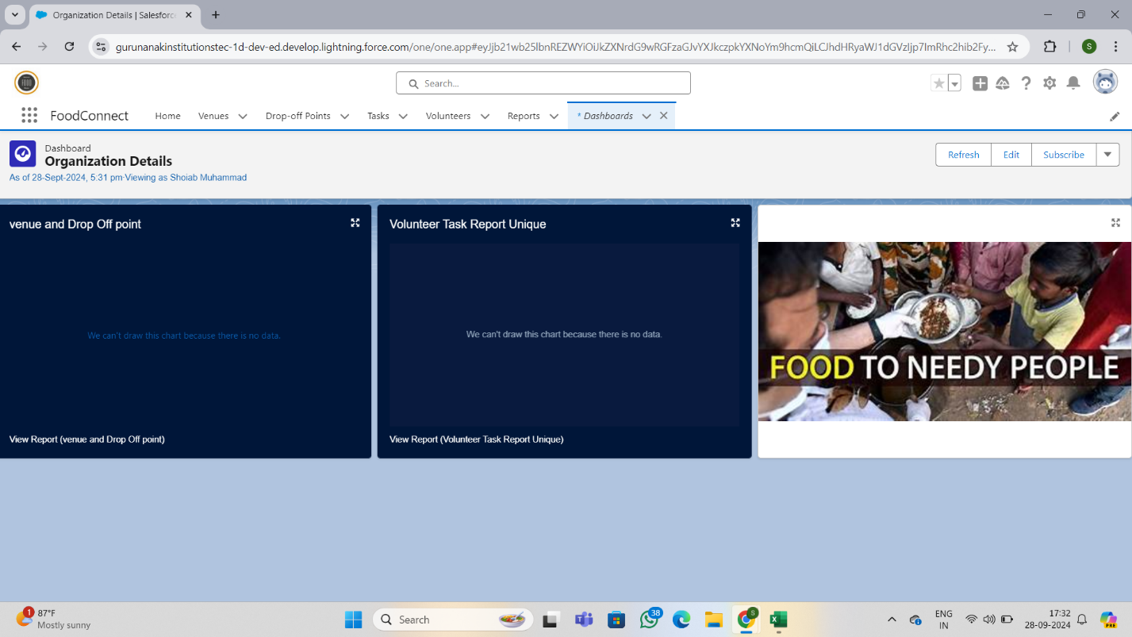
2. In General Information give details as: (Note : create users as per your wish NGO’s)

First Name : Iksha Foundation

Last Name : Iksha_Foundation

Alias : iiksh

Email : Give Your Email

Username : [ikshafoundation@sb.com](mailto:ikshafoundation@sb.com) (give the username different)

Nickname : Auto Populated

User License : Salesforce Platform

Profile : NGOs Profile

Active : Check

**Creation of User2, User3**

1. 1Create another Two Users by following steps in Activity - 1 with similar User License and Profile.
2. Give Different First Name, Last Name based on Different NGO’s.

**Activity 8:** Creation of Public Groups

**Creation Of Public Group 1**

1. 1Go to setup page  >>  type Public Groups in Quick Find bar  >>  click on Public Groups >>  click on New.
2. Under Group Information:

Label : Iksha

Group Name : Iksha

Grant Access Using Hierarchies : Check

1. In Search, Select Users.
2. In Selected Members Add Iksha Foundation and System Administrator

**Creation of Public Group 2**

1. By Following Steps in Activity 1, Create other  two Public Groups for other two users.
2. After Saving this would look like this.

**Activity 9:** **Creation of Report on Venue with Drop-Off with Volunteer**

1. 1Go to the app(Food Connect)  >>  click on the reports tab
2. Click on New Folder.

Folder Label : Custom Reports

Folder Unique Name : CustomReports Open Custom Reports and click on New Report

1. Select Report Type : Venue with Drop-Off with Volunteer
2. Then click on Start Report.
3. In GROUP ROWS : Add Volunteer Name
4. In Columns : Add Venue Name, Drop-Off point Name, Distance.
5. Now click on Save & Run.
6. Give Label as :
7. Report Name : venue and Drop Off point
8. Report Unique Name : Auto Populated
9. Click on Select Folder and select Custom Report, then click on Save.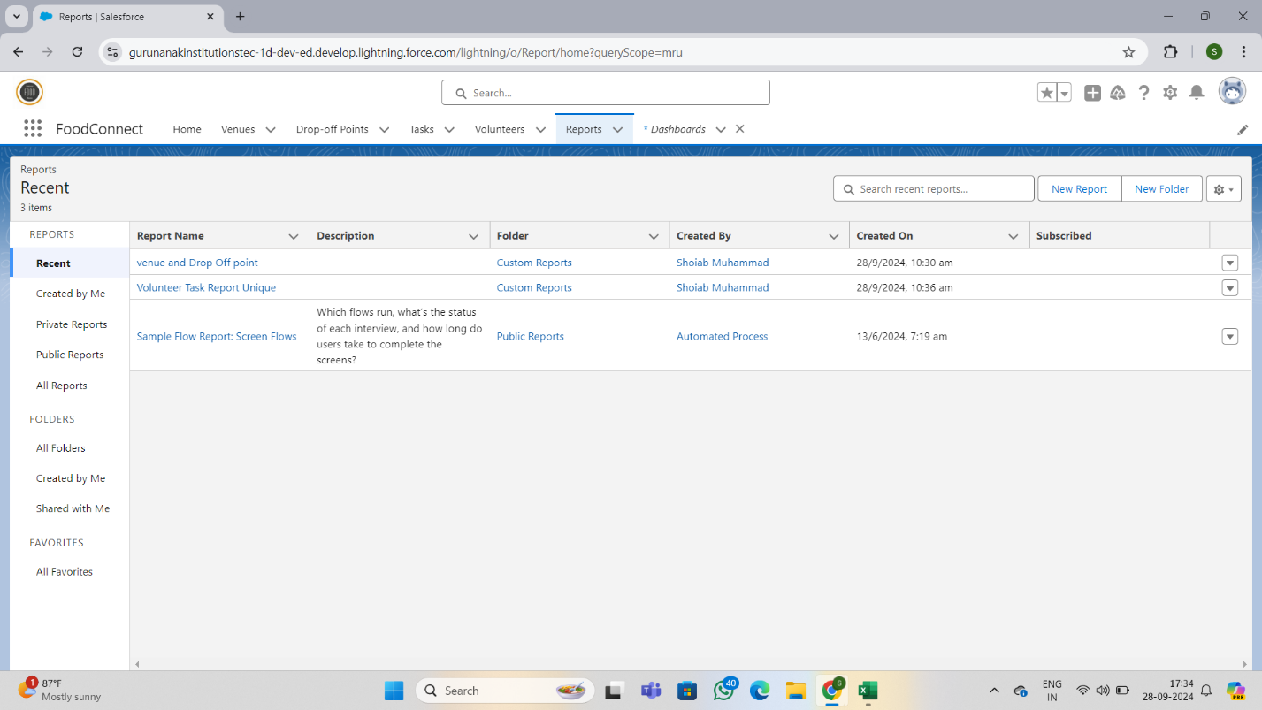

**Activity 10:** **Adding venue and Drop Off point Report to the Dashboard**

1. 1Go to the app(FoodConnect)  >>  click on the Dashboards tab.
2. Click on New Folder.

Folder Label : Custom Dashboards

Folder Unique Name : Auto Populated

1. Open Custom Dashboards and click on New Dashboards
2. Name : Organization Details
3. Click on Widget and select Chart or Table
4. In Select Report : Select venue and Drop Off point Report.
5. Then click on select
6. In Add Component:

Display As : Select Lightning Table

Component Theme : Select Dark (Optional)

9.Now Click on Save



**Activity 11: Adding Volunteer Task Report to the Dashboard**

1. Click on Widget and select Chart or Table
2. In Select Report : Select Volunteer Task Report.
3. Then click on select
4. In Add Component:

Display As : Select Line Chart

Component Theme : Select Dark (Optional

5.Now click on save



**Activity 12:** **Creation of Home Page**

1. 1Go to setup >> type Lightning App Builder in quick find box  >>  Click on the Lightning App Builder and Select the New.
2. Select Home Page and give Label as HOME Page.
3. Select Standard Home Page.
4. Near Components search for Flow and Drag and Drop in Right Side Section..
5. On the right hand side:

Flow : Venue Flow

1. Near Components search for Dashboard, then Drag and Drop it in first Section.
2. Click on Save and Activation, then click on App Default, then Add Assignments.
3. Add Food Connect App and then Save.
4. Food Connect Home Page would Look Like this.

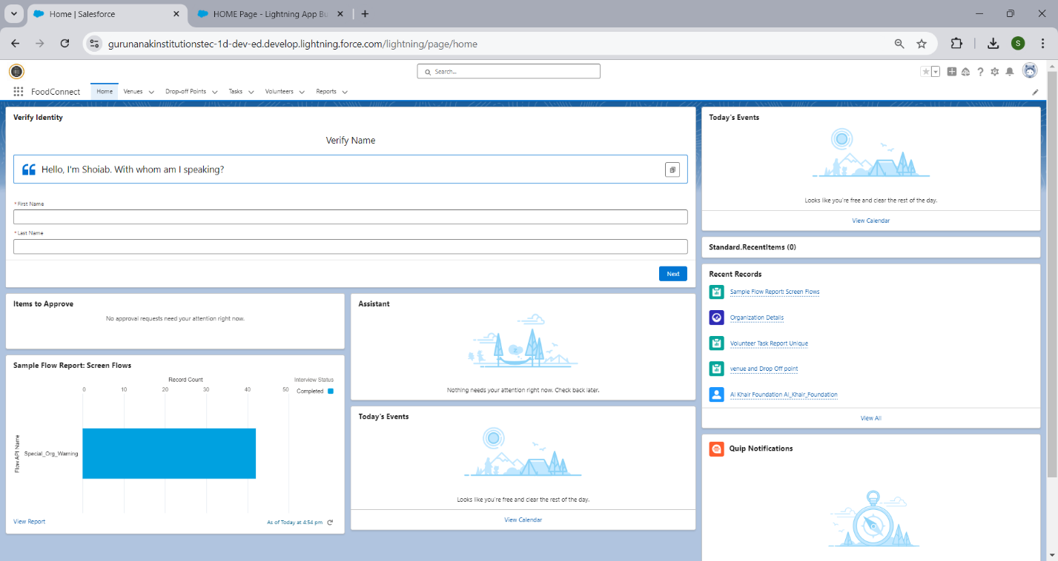



**Thank you**