**Rollup Menu**

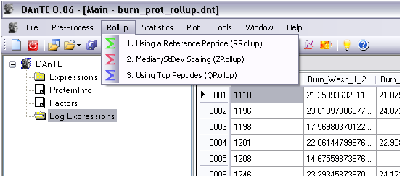

**RRollup - Reference Peptide Based Scaling**

Note that this method correctly works only with log transformed data.

A reference peptide which has the most presence across all the datasets, is chosen from the group of peptides that belong to a protein. If there are multiple candidates, the most abundant one is chosen. Then the ratios of peptide abundances with respect to the reference are computed (since the data is assumed to be in log scale, the differences are used) and their median is used as a scaling factor. Protein abundance is obtained as the median of the resulting peptide abundances.

The options window is shown below:

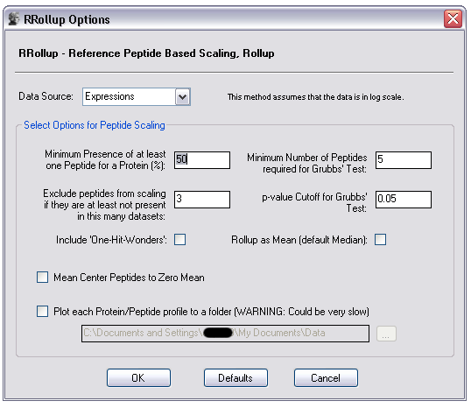

Minimum Presence of at least one Peptide for a Protein: Peptides that have too many missing values below this percentage are dropped.

Exclude peptides from scaling if they are at least not present in this many datasets: Within a group of peptides for a specific protein, the ones that do not overlap well (controlled by this value) are not scaled but they are kept to calculate the final protein abundance.

Include Single peptide/protein matches (i.e. 'One-Hit-Wonders'): Protein with only one observed peptide will be included in the final list of proteins. The rational behind this is that if a particular protein may have only one peptide but it may be quite abundant and present throughout giving some strong confidence on the presence of the protein.

If the plotting is enabled using the checkbox, the scaling results will be plotted for each peptide group as follows:

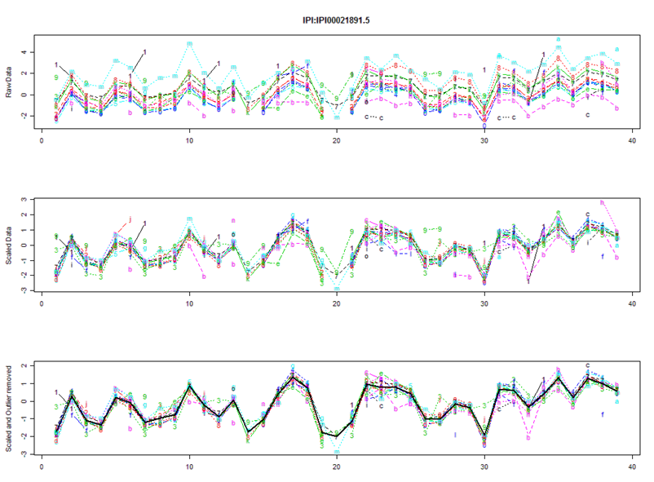

**ZRollup - Median / Standard Deviation Based Scaling**

Peptides are median centered first and then scaled by the row standard deviation. Protein abundance is obtained as the median of the abundances of the peptides in the group.

Available adjustments are as follows:

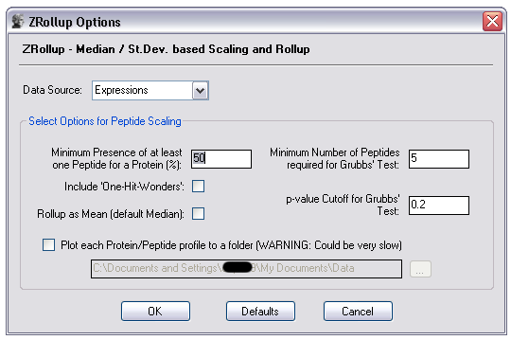

Minimum Number of Peptides required for Grubb's Test: Grubb's test for outliers is performed for peptide groups in each dataset. This value controls the minimum number required to perform the test.

p-value Cutoff for Grubb's Test: This controls the cutoff value for removing the outliers in Grubb's test.

Include Single peptide/protein matches (i.e. 'One-Hit-Wonders'): Same as in the first method.

If the plotting is enabled using the checkbox, the scaling results will be plotted for each peptide group as follows:

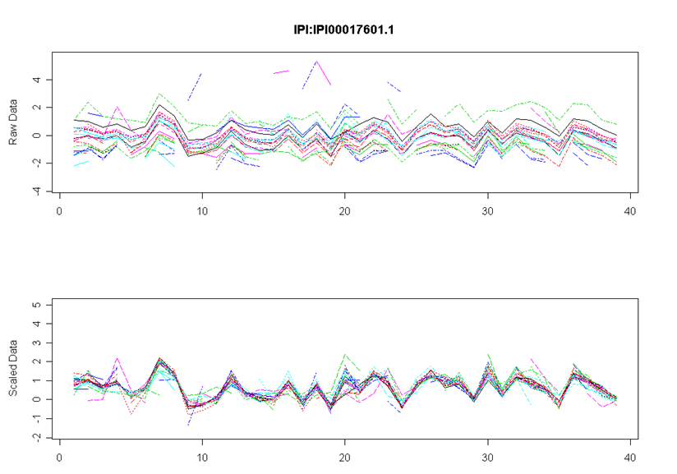

**QRollup method**

QRollup method simply takes the top user selected percentage of peptides and averages (either mean or median) to obtain the protein abundance. The parameters to control are:

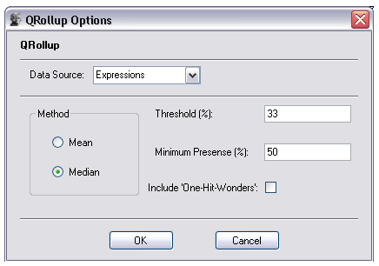

Threshold: All peptides that have abundance values above this percentage at each dataset are used for protein abundance calculation.

Minimum Presence: Minimum presence of the most present peptide in a peptide group.

Method: Method to calculate Protein abundance from peptides. Either mean or median of the peptides in the group.

Include Single peptide/protein matches (i.e. 'One-Hit-Wonders'): Same as in first method.