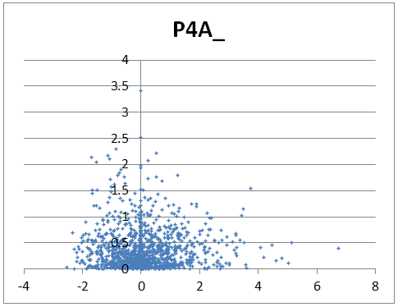You can make a Volcano plot of fold change values using Microsoft Excel. This plot is appropriate for fold change data represented as Log2 or Log10 fold changes, where 0 means unchanged, positive is up-regulated, and negative is down-regulated. You can compute the Log2 values of the fold change data before loading into Inferno or after (using menu Data, then Log Transform).

Use the following steps to export the data to Excel (or LibreOffice Calc, Google Sheets, etc.) for plotting.

* First, export the table with Fold-change data (i.e. the table used for ANOVA)
  + In the list at the left, select the appropriate data table
  + For just peptide information
    - Click any value in the table
    - Press Ctrl+A to select all the data then Ctrl+C to copy it
    - Paste into a blank Excel worksheet
  + For peptide information with protein names
    - In the data table list at the left, right click the data table name and choose "Save with Protein Info" to create a CSV file
* Open the CSV file in Excel
* Add a new, blank worksheet
  + In the following examples, the new worksheet is called Sheet1
* Copy the p-values to the new worksheet
  + In InfernoRDN, select the p-values data table
  + Click any value in the table
  + Press Ctrl+A to select all the rows, then Ctrl+C to copy them
  + Paste the copied p-values onto the blank worksheet in Excel
* Add a new column named p-value to the right of the fold change data
  + For example, the new column might be column L, in which case you type "p-value" in cell L1

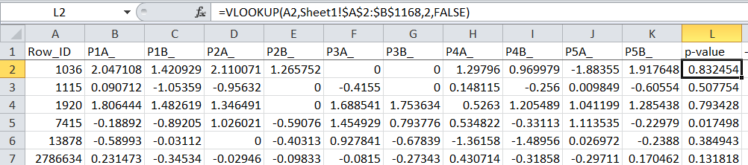

* Use the VLookup function to lookup the p-value for each row of the fold-change table
  + For example, if the p-value data is on a worksheet named "Sheet1" in columns A through C and rows 2 through 1168, and if the newly added p-value column on the fold-change worksheet is column L, then you would put this equation in cell L2

=VLOOKUP(A2,Sheet1!$A$2:$B$1168, 2, FALSE)

* This equation means "Use the value in cell A2 to search the data in column A on Sheet1 to find a match. If a match is found, show the value in column B of the matching row. If no match, show N/A".
* Copy this procedure down for every row (for example, elect the target cells, then Fill Down)
* Once you have a p-value for each row, transform it with -Log10, for example, place this in cell M2

=-LOG10(L2)

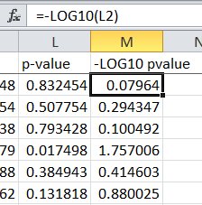

* Again, copy this value down for all rows.
* You can now create the volcano plot using any column of fold change data and the -Log10(pvalue) column.
* To compare several conditions, duplicate the plot and adjust the source data for the x-axis. This image compares 4 conditions, P4A_, P4B_, P5A_, and P5B_

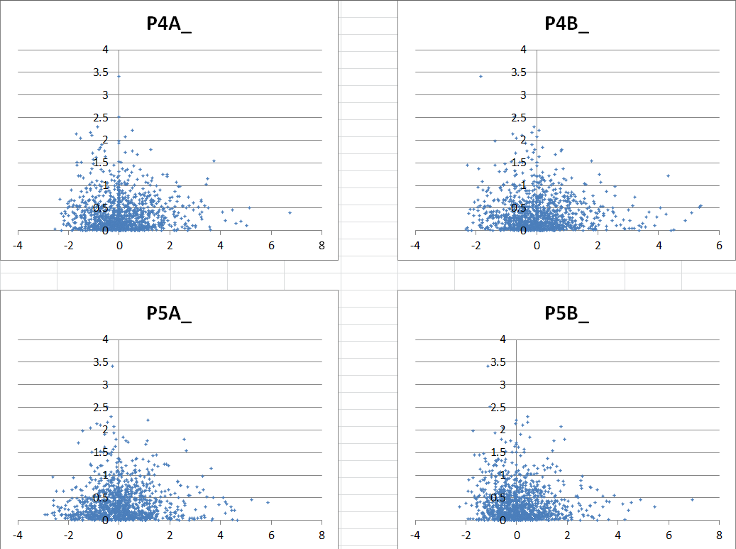

* If you want to plot the data with different colors depending on p-value, then sort the data by p-value (in the above example, sort column M), then add several series to the plot; one for each range of p-values.