SmartCare v0.3 - Domain Model Workbook
Week 6 student resource

Requirement-to-Concept Trace
Requirement | Concept | State/behaviour | Decision
FR-01 | Patient | patient_id, name, contact details | Keep Patient class
FR-02 | Patient | searchable patient identity | Patient remains core concept
FR-03 | Patient | update patient details | Behaviour belongs to Patient/domain logic
FR-04 | Practitioner | practitioner_id, name | Keep Practitioner class
FR-05 | Practitioner | availability | Availability is state of Practitioner
FR-06 | Appointment | appointment_id, date_time | Keep Appointment class
FR-07 | Practitioner + Appointment | availability / appointment time | Relationship supports availability checking
FR-08 | Appointment + Practitioner | date_time + practitioner | Conflict rule; no new class needed
FR-09 | Appointment | view appointment details | Appointment holds booking information
FR-10 to FR-12 | Appointment | cancel, status, history | Appointment state/behaviour; no Cancellation or Status class needed

CRC Cards

Patient
Responsibilities | Collaborators
Store patient details | Appointment
Allow patient details to be updated | Appointment

Practitioner
Responsibilities | Collaborators
Store practitioner details | Appointment
Store practitioner availability | Appointment

Appointment
Responsibilities | Collaborators
Store appointment date/time and status | Patient, Practitioner
Connect one patient and one practitioner; support cancellation/status changes | Patient, Practitioner

Optional class
Responsibilities | Collaborators
No optional class selected for v0.3. | -
Avoid adding unsupported manager/controller/notification classes. | -

UML Class Diagram
UML model based on confirmed Stage 2 requirements: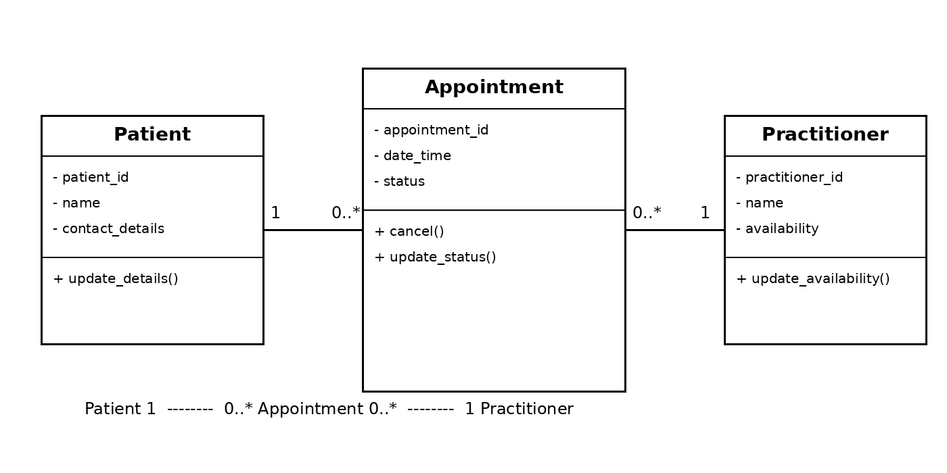

Design Rationale
Patient, Practitioner and Appointment were selected because they are the main business concepts directly supported by the SmartCare requirements. Appointment connects a Patient and a Practitioner and stores booking-specific state such as date/time and status. A patient may have many appointments and a practitioner may have many appointments, while each appointment refers to exactly one patient and one practitioner. Name and Status are attributes rather than classes. Cancellation is behaviour/state change on Appointment. Database is an implementation detail. Clinic was not added because the first version describes one small clinic and there is no confirmed need to model multiple clinics. This keeps the model small, traceable and maintainable.

AI Design Review Record
AI suggestion | Evidence | Decision | Reason | Model change
Use Patient, Practitioner and Appointment as core classes | FR-01 to FR-12 | Accepted | Directly supported by confirmed requirements | Keep all three core classes
Model Practitioner-to-Appointment as one-to-many | FR-05 to FR-08 | Accepted | A practitioner can have multiple bookings; each booking needs one practitioner | Add 1 to 0..* association
Create a separate Status class | FR-11 | Modified | Status is required, but no evidence it needs its own entity | Keep status as Appointment attribute
Add NotificationManager | No confirmed FR | Rejected | Reminders/notifications are not confirmed requirements | No notification class
Add ClinicController/manager classes | No confirmed FR | Rejected | These are architectural helpers and over-design the domain model | Keep model limited to domain entities

