1. (a) Write a program in assembly language to find L.C.M of two

single-digit numbers.

Code

ORG 100h

.DATA

num1 DB 10

num2 DB 10

gcd_res DB 0

lcm_res DW 0

resultMsg DB 'The LCM is: $'

.CODE

main:

MOV AL, num1

MOV BL, num2

CALL gcd

MOV gcd_res, AL

MOV AL, num1

MOV AH, 0

MOV DL, num2

MUL DL

MOV CL, gcd_res

DIV CL

MOV lcm_res, AX

LEA DX, resultMsg

MOV AH, 09h

INT 21h

MOV AX, lcm_res

CALL PrintDecimal

MOV AH, 4Ch

INT 21h

gcd PROC

CMP BL, 0

JE end_gcd

gcd_loop:

MOV AH, 0

DIV BL

MOV AL, BL

MOV BL, AH

CMP BL, 0

JNE gcd_loop

end_gcd:

RET

gcd ENDP

PrintDecimal PROC

MOV CX, 10

MOV BX, 0

decimal_loop:

XOR DX, DX

DIV CX

PUSH DX

INC BX

CMP AX, 0

JNE decimal_loop

print_digits:

POP DX

ADD DL, '0'

MOV AH, 02h

INT 21h

DEC BX

JNZ print_digits

RET

PrintDecimal ENDP

Output:

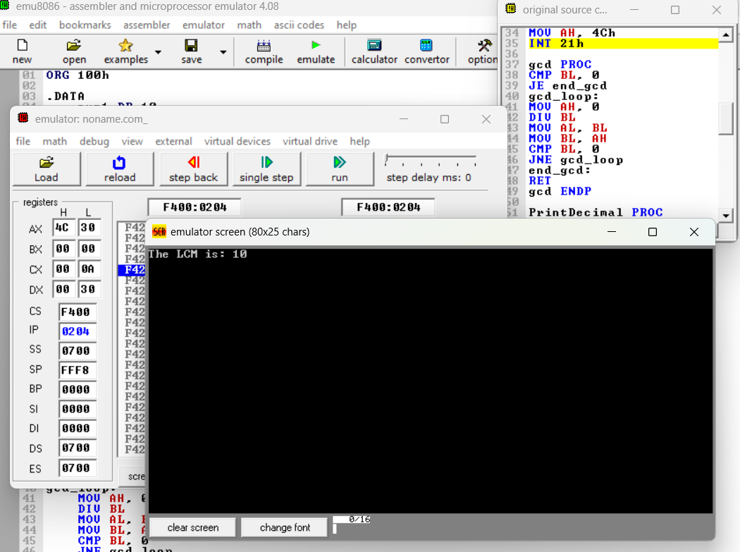

(b) Write an assembly language program to display the nth term

of a fibonacci series. “n” must be a single digit number which may

be taken from the user.

Code

.model small

.stack 100h

.data

msg db 'Enter the value of n (0-9): $'

fib_res db ?

n db ?

result_msg db 0Dh, 0Ah, 'Fibonacci term: $'

result db '00$', 0Dh, 0Ah

.code

main:

mov ax, @data

mov ds, ax

mov ah, 09h

lea dx, msg

int 21h

mov ah, 01h

int 21h

sub al, '0'

mov n, al

mov al, n

cmp al, 0

je fib_zero

cmp al, 1

je fib_one

mov cl, al

mov al, 1

mov bl, 0

dec cl

fib_loop:

mov ah, al

add al, bl

mov bl, ah

dec cl

jnz fib_loop

mov fib_res, al

display_result:

mov ah, 09h

lea dx, result_msg

int 21h

mov al, fib_res

aam

add ah, '0'

add al, '0'

mov result[0], ah

mov result[1], al

jmp display_final

single_digit:

add al, '0'

mov result[0], al

mov result[1], '$'

display_final:

lea dx, result

mov ah, 09h

int 21h

mov ah, 4Ch

int 21h

fib_zero:

mov fib_res, 0

jmp display_result

fib_one:

mov fib_res, 1

jmp display_result

Output:

Practice set:

2. Write an assembly language program to find the factorial of a

given single-digit number.

Code

ORG 100h

.DATA

result dw 1

msg_prompt db 'Enter a single-digit number (0-9): $'

msg_result db 0Dh, 0Ah, 'Factorial is: $'

error_msg db 0Dh, 0Ah, 'Error: Enter a single-digit number.$'

.CODE

start:

mov ah, 09h

lea dx, msg_prompt

int 21h

mov ah, 01h

int 21h

sub al, '0'

cmp al, 9

ja error

cmp al, 0

jl error

jmp calculate

error:

mov ah, 09h

lea dx, error_msg

int 21h

jmp exit

calculate:

mov bl, al

mov ax, 1

factorial_loop:

cmp bl, 1

jbe end_factorial

mul bl

dec bl

jmp factorial_loop

end_factorial:

mov result, ax

mov ah, 09h

lea dx, msg_result

int 21h

mov ax, result

call display_number

exit:

mov ah, 4Ch

int 21h

display_number proc

mov bx, 10

xor cx, cx

next_digit:

xor dx, dx

div bx

add dl, '0'

push dx

inc cx

test ax, ax

jnz next_digit

display_loop:

pop dx

mov ah, 02h

int 21h

loop display_loop

ret

display_number endp

Output:

