1. (a) Write a program in assembly language to print the numbers from 0 to 9.

Code

org 100h

start:

mov cx, 10

mov bl, '0'

print_loop:

mov ah, 02h

mov dl, bl

int 21h

mov dl, ' '

int 21h

inc bl

loop print_loop

mov ah, 4Ch

int 21h

Output:

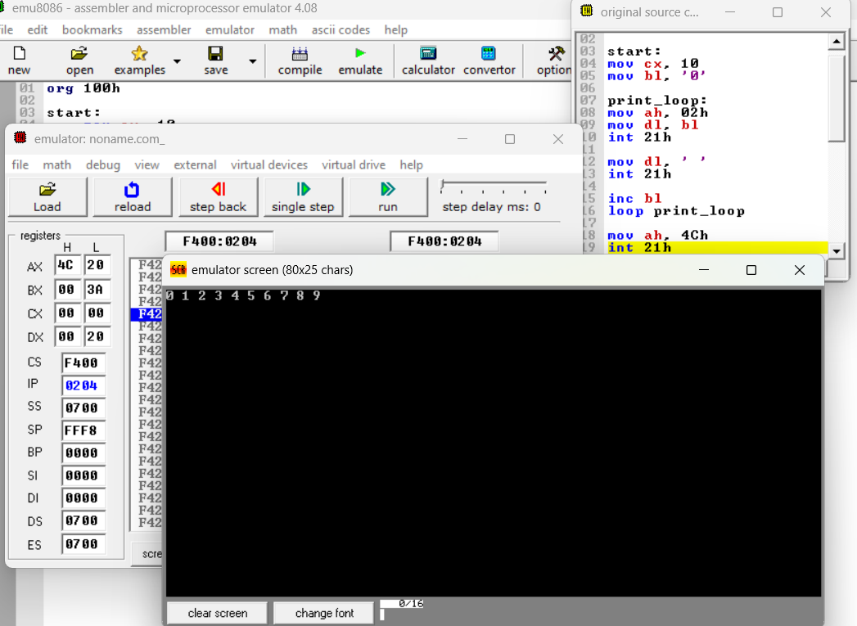

(b) Write an assembly language program to print the characters from A to Z in reverse order.

Code

org 100h

start:

mov cx, 26

mov bl, 'Z'

print_loop:

mov ah, 02h

mov dl, bl

int 21h

mov dl, ' '

int 21h

dec bl

loop print_loop

mov ah, 4Ch

int 21h

Output

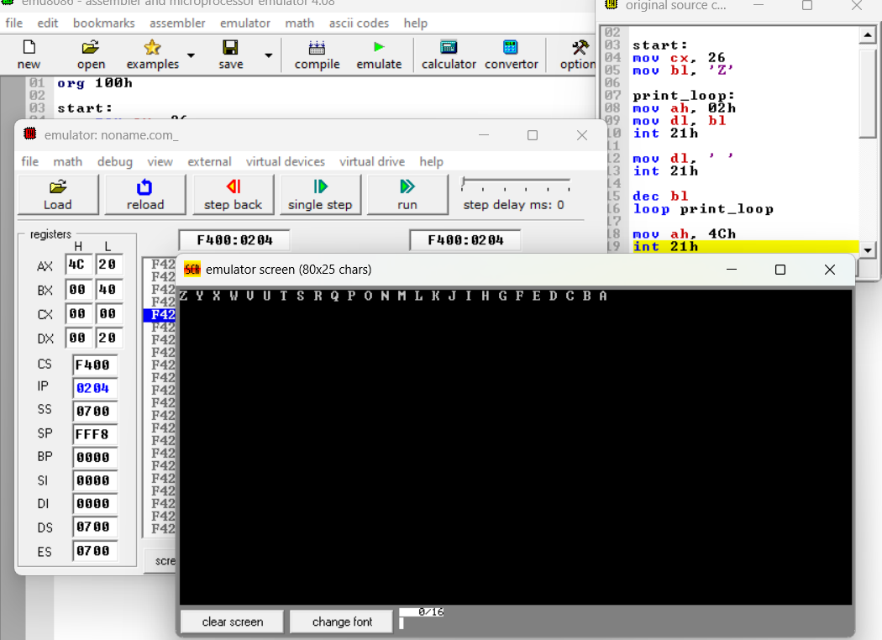

Practice set:

1. (a) Write a program in assembly language to print the numbers from 0 to 9 in reverse order.

Code

org 100h

start:

mov cx, 10

mov bl, '9'

print_loop:

mov ah, 02h

mov dl, bl

int 21h

mov dl, ' '

int 21h

dec bl

loop print_loop

mov ah, 4Ch

int 21h

Output:

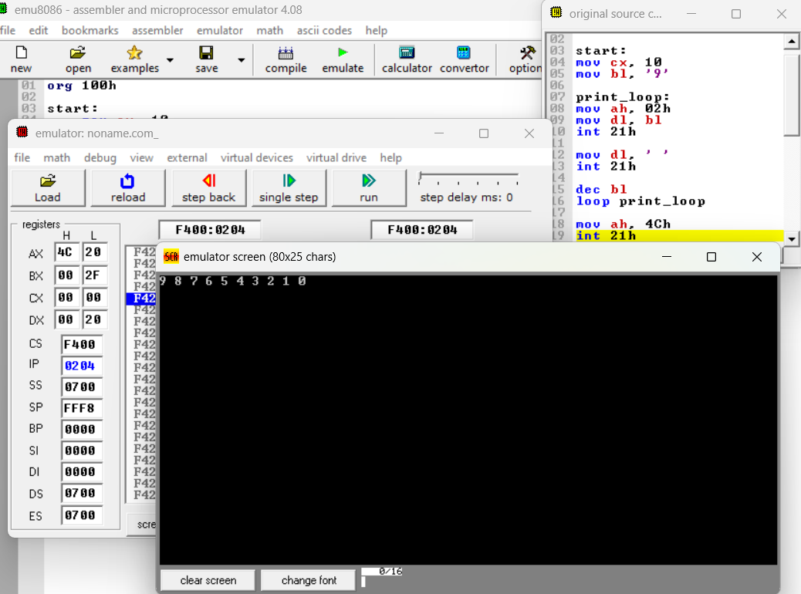

(b) Write an assembly language program to print the characters from A to Z.

Code

org 100h

start:

mov cx, 26

mov bl, 'A'

print_loop:

mov ah, 02h

mov dl, bl

int 21h

mov dl, ' '

int 21h

inc bl

loop print_loop

mov ah, 4Ch

int 21h

Output:

