

American International University-Bangladesh (AIUB)
Faculty of Science and Technology

Enhancing AES Resistance to Differential and Linear Cryptanalysis Using Key-Dependent Dynamic S-Box and XOR Tables.

Ishrak Shahnawaz (22-49286-3)
Rafiya Tasnim (22-49284-3)
Md. Nashib Khan (22-49873-3)
S. M. Sayed Al Habib (22-48365-3)
A Thesis submitted for the degree of Bachelor of Science (BSc) in
Computer Science and Engineering (CSE) at
American International University Bangladesh (AIUB
Faculty of Science and Technology (FST)

Summer 2025-2026 Semester
Submission Date: 23 October, 2026

Declaration

This thesis is composed of our original work, and contains no material previously published or written by another person except where due reference has been made in the text. We have clearly stated the contribution of others to our thesis as a whole, including statistical assistance, survey design, data analysis, significant technical procedures, professional editorial advice, financial and any other original research work used or reported in our thesis. The content of our thesis is the result of work we have carried out since the commencement of the Thesis.

We acknowledge that copyright of all material contained in my thesis resides with the copyright holder(s) of that material. Where appropriate we have obtained copyright permission from the copyright holder to reproduce material in this thesis and have sought permission from co-authors for any jointly authored works included in the thesis.

_______________________________  Ishrak Shahnawaz  22-49286-3  Faculty of Science and Technology (FST) | _______________________________  Rafiya Tasnim  22-49284-3  Faculty of Science and Technology (FST)
_______________________________  Md. Nashib Khan  22-49873-3  Faculty of Science and Technology (FST) | _______________________________  S. M. Sayed Al Habib  22-48365-3  Faculty of Science and Technology (FST)

Approval

The thesis titled “Enhancing AES Resistance to Differential and Linear Cryptanalysis Using Key-Dependent Dynamic S-Box and XOR Tables” has been submitted to the following respected members of the board of examiners of the department of computer science in partial fulfilment of the requirements for the degree of Bachelor of Science in Computer Science on 29 October 2026 and has been accepted as satisfactory.

Md Sajid Bin-Faisal  Assistant Professor & Supervisor  Department of Computer Science  American International University-Bangladesh |  |  | Tanvir Ahmed  Assistant Professor & External  Department of Computer Science  American International University-Bangladesh
Prof. Dr. Muhammad Firoz Mridha
Professor & Head (UG)
Department of Computer Science
American International University-Bangladesh

Prof. Dr. Dip Nandi  Professor, Dean  Faculty of Science and Technology  American International University-Bangladesh |  |  | Mashiour Rahman  Sr. Associate Professor  Director  Faculty of Science and Technology  American International University-Bangladesh

Acknowledgement

Table of Content

Declaration Error! Bookmark not defined.
Approval Error! Bookmark not defined.
Acknowledgement iv
Table of Content iv
List of Figures viii
List of Tables ix
List of Abbreviations x
Abstract xii
Keywords xii
Chapter 1 12
Introduction 12
1.1 Introduction 12
1.2 Problem Statement 12
1.3 Problem Background 13
1.4 Research Objectives 13
1.5 Research Questions (optional but recommended for AI/ML/SE/Cyber Security) 14
1.6 Motivations 14
1.7 Flow of Research 15
1.8 Significance of the Research 15
1.9 Research Contribution 15
1.10 Thesis Organization 16
1.11 Summary 16
Chapter 2 17
Literature Review 17
2.1 Introduction 17
2.2 Literature Review 18
2.3 Problem Analysis 24
2.4 Summary 25
Chapter 3 26
Proposed Model 26
3.1 Introduction 26
3.2 Feasibility Analysis 26
3.3 Requirement Analysis (Functional / Non-Functional Requirements) 27
3.4 Research Methodology (AI / ML / DL / SE / Cyber Security Approach) 28
3.5 System Design and Architecture (Model Architecture / Software Architecture / Security Design) 28
3.6 Implementation and Simulation (Model Training / System Development / Experimentation) 32
3.7 Tools and Technologies Used (Frameworks / Libraries / Platforms) 32
3.8 Summary 32
Chapter 4 33
Implementation and Testing 33
4.1 Introduction 33
4.2 System Setup and Environment (Hardware / Software / Tools / Frameworks for AI-ML-DL / SE / Cyber Security) 33
4.3 Implementation of the System (Model Development / Software Development / Security Implementation as applicable) 34
4.4 Evaluation and Testing (Performance Metrics / Unit Testing / Model Evaluation / Security Testing as applicable) 34
4.5 Results and Discussion (Analysis of Outputs / Accuracy / System Performance / Comparative Analysis) 36
4.6 Summary 40
Chapter 5 41
Standards, Constraints and Milestones 41
5.1 Standards and Compliance (ISO/IEEE / Software Engineering / AI Model Standards / Cyber Security Frameworks) 41
5.2 Sustainability Considerations (Computational Efficiency / Energy Usage in AI-ML-DL / System Scalability) 41
5.3 Societal Impact (Positive and Negative Impacts of AI/ML/SE/Cyber Systems) 42
5.4 Ethical Considerations (Bias/Fairness in AI / Data Privacy / Responsible Software Use / Cyber Ethics) 42
5.5 Security and Privacy Considerations (Data Protection / System Vulnerabilities / Cyber Threat Risks / Secure Design Principles) 42
5.6 Design Constraints and Component Constraints (System Architecture / Hardware / Software Design Limitations) 43
5.7 Data Constraints and Computational Constraints (Dataset Availability / Processing Power / Imbalance / Privacy Restrictions) 43
5.8 Budget Constraints (Cost Limitations for Tools / Infrastructure / Deployment) 43
5.9 Task Breakdown and Project Timeline (Phase-wise Development Plan / Iterative Development Cycle) 44
5.10 Milestones and Deliverables (Key Progress Points / Version Releases / Evaluation Stages) 44
5.11 Gantt Chart (Project Scheduling and Progress Visualization) 455
5.12 Summary 45
Chapter 6 46
Conclusion 46
6.1 Summary of the Study / Work Done 46
6.2 Key Contributions 46
6.3 Limitations of the Study 47
6.4 Future Work 47
References 48
Appendix 50

List of Figures

Figure 1: | Illustrates the overall encryption architecture of the traditional Advanced Encryption Standard (AES). | 18
 |  | 20
Figure 2:  Figure 3:  Figure 4:  Figure 5:  Figure 6:  Figure 7:  Figure 8:  Figure 9:  Figure 10: | The SubBytes Transformation.  The ShiftRows Transformation.  The AddRoundKey Transformation.  The word expansion process and the 'g' function.  Dynamic S-Box Generation.  Dynamic XOR Table Generation.  Avalanche Effect Distribution  Throughput Bar Chart  Timeline – Gantt Chart. | 21  21  22  29  30  37  40  45

List of Tables

Table 1:  Table 2:  Table 3:  Table 4:  Table 5:  Table 6:  Table 7: | AES Evolution Trend & Benefits.  The distribution of key words across the AES rounds.  The Round Constant (Rcon) values for AES-12.  Correctness and Self-Consistency Test Results.  Cryptographic Properties of Standard vs. Dynamic S-Boxes.  Comparison with Existing Dynamic AES Literature  Performance Standard AES vs Dynamic AES. | 17  22  23  36  37  38  39

List of Abbreviations

Mention all the abbreviations and the different symbols that are used in this document.

CS | Computer Science
CSE | Computer Science and Engineering
HCI | Human Computer Interaction
NLP | Natural Language Processing

Abstract

The standard of symmetric encryption worldwide is the Advanced Encryption Standard (AES), which is based on a fixed XOR and a fixed Substitution Box (S-Box). Since these elements are the same across all users, attackers can offline pre-calculate Difference Distribution Tables (DDT) and Linear Approximation Tables (LAT), rendering AES theoretically susceptible to both differential and linear cryptanalysis.

To counter this weakness, this study developed and deployed a dynamic version of AES-128 that substitutes the fixed elements with key-dependent dynamic ones. The RC4 Key Scheduling Algorithm was used with a Logistic Chaotic Map to create the Dynamic S-Box and a Pseudo-Random Number Generator (PRNG) and the Fisher-Yates shuffle were used to create the Dynamic XOR Table. These dynamic layers were incorporated into the standard AES-128 structure, with the ShiftRows, MixColumns and Key Expansion algorithms remaining the same. A mathematical demonstration of invertibility of the dynamic XOR table was obtained and coded to ensure flawless decryption.

The given model was tested in four stages: correctness, cryptanalytic security, precomputation resistance, and performance. The system passed all NIST randomness tests and had a 100% success rate on 1,000 automated correctness tests. Although the dynamic S-Box had a bit higher raw cryptographic probabilities (Mean DDT = 11.2, Mean LAT = 35.2) than the standard AES (DDT = 4, LAT = 32), this is a reasonable compromise. The model renders the precomputation of cryptanalytic trails by the attacker entirely useless by varying the tables with each key. Moreover, the system had an ideal 50.00% Avalanche Effect, which demonstrated almost perfect diffusion and bit independence.

Performance benchmarking indicated that the initial table generation has a small one-time latency (0.1474 ms) but steady-state encryption rate of the dynamic model is identical to the rate of a pure Python standard implementation of AES. This study is important because it offers a two-layered protection: a dynamic S-Box and a dynamic XOR table make the practical complexity of differential and linear attacks grow exponentially without increasing the key size or the fundamental AES design.

Keywords
aes, dynamic s-box, dynamic xor table, rC4, chaotic map, fisher-yates, precomputation, differential cryptanalysis, linear cryptanalysis, avalanche effect.

Chapter 1

Introduction

Introduction
Information security has been a key issue for government, industry, and individuals as the proliferation of digital communication has grown. The Advanced Encryption Standard (AES) is the symmetric block cipher that is most popular around the world, and is used to protect everything from wireless networks to financial transactions. The strength that comes from AES is a well designed structure of substitution and permutation layers to get confusion and diffusion. But AES is a static algorithm; that is, the Substitution Box (S-Box) and the key-mixing XOR operation are predetermined and well-known. This standardization helped spread trust and made it possible to optimize the hardware design, but it also makes it easier for cryptanalysts to precompute structural properties of the cipher, and develop more sophisticated attacks. In this paper, we will concentrate on how to improve AES by adding some dynamic elements with respect to the keys in the internal structure of AES against two of the most powerful classical attack families, differential and linear cryptanalysis.

Problem Statement
Standard AES utilizes a static S-Box and a fixed XOR operation, enabling the attacker to precompute difference distribution tables and linear approximation tables that serve as the basis for differential and linear cryptanalysis. This means that the security of AES against such attacks relies on fixed mathematical constraints, which are unalterable once analyzed, regardless of the key. A variant of AES that makes these attacks harder or slower but doesn't change the length of the key or the basic structure of the cipher is needed.

Problem Background
The dynamic implementation of AES components such as key-dependent S-Boxes and dynamically changing key-mixing operations have been examined in previous work. Dynamic SBoxes have been proven to resist linear and differential cryptanalysis attacks, and dynamic XOR tables further expand the number of possible cipher configurations. It is uncommon, however, to investigate these techniques together, and it has not been broadly studied how a key-dependent S-Box can interact with a key-dependent XOR table in the same AES variant. This would leave a gap in whether such an combination offers a meaningful advance in cryptanalytic protection.

Research Objectives
The primary goal of this research is to design and analyze a dynamic AES variant in which both the SubBytes and AddRoundKey transformations are variable by key. These specific objectives are:
- To design a key-dependent Dynamic S-Box based on RC4 Key Scheduling Algorithm and Logistic Chaotic Map (LCM).
- To create a key-dependent Dynamic XOR Table by using a Pseudo-Random Number Generator and the Fisher-Yates shuffle.
- To embed both dynamic elements into the AES-128 encryption and decryption method.
- To evaluate the resistance of the proposed cipher against differential and linear cryptanalysis.
- To compare the performance and security features of the proposed variant with standard AES.

Research Questions

The following questions serve as the guide for this research:

How can a key-dependent S-Box be efficiently generated with RC4 KSA and chaotic maps?

How to build a key-dependent XOR table using PRNG and Fisher-Yates shuffling?

How does the combination of both dynamic components improve resistance to differential and linear cryptanalysis?

How does these moving parts affect encryption and decryption?

Motivations

This research is motivated by the fact that AES is strong but is based on fixed internal transformations that have been investigated for more than 20 years. The more that computing power grows and cryptanalysis methods advance, it becomes worthwhile to consider key-dependent alternatives that maintain the structure of AES and dispense with predictability of the static elements. The motivation for this research is to help address the need to make AES more resilient to both differential attack and linear attack while maintaining the same key size and without depending on any new cryptographic primitives.

Flow of Research

The research is conducted in a sequence of structured phases. It starts with a literature review on AES, dynamic S-boxes, and dynamic key-mixing techniques. The design phase determines the generation algorithms of the Dynamic S-Box and the Dynamic XOR Table according to the identified gap. The implementation phase is the process of combining these components into a working AES-128 prototype in software. Evaluation phase: Test of correctness of encryption and decryption, performance measurement and analysis of resistance to differential and linear cryptanalysis. Lastly, results are compared with standard AES, and conclusions are drawn.

Significance of the Research

This research has both academic and application significance. Academically, it is part of the continuing research on dynamic block ciphers by showing a combination not widely studied. From a practical standpoint, it offers a proof-of-concept implementation that can guide future designs of key-dependent encryption systems. The insights gained from the research could potentially be useful for researchers in the field of cryptography, security engineers, and those working with constrained systems, especially in terms of the balance between security improvements and computational complexity.

Research Contribution
- A novel key-dependent Dynamic S-Box (RC4 KSA + Logistic Chaos) and key-dependent Dynamic XOR Table (PRNG + Fisher-Yates) hybrided in one AES-128 variant.
- Software code (working copy) of the proposed cipher that provides verified encryption and decryption.
- The characteristics of increasing complexity compared to the simple differential and linear cryptanalysis due to the dynamic components.
- Performance and cryptanalytical resistance comparison of the proposed variant with standard AES.

Thesis Organization
This thesis is organized into several chapters. The research problem, research objectives, and research significance are introduced in Chapter 1. Chapter 2 reviews the literature related to AES, dynamic S-Boxes, and dynamic key-mixing techniques. Chapter 3 describes the research methodology and the design of the proposed dynamic AES variant. The implementation of the dynamic S-Box and XOR table is detailed in chapter 4. Experimental results, performance evaluation, and security analysis are presented in chapter 5. The thesis ends in Chapter 6, which proposes further research.

Summary

In this chapter, the background of AES security and the weaknesses of static S-Box and XOR operation against differential and linear cryptanalysis were introduced. It presented the problem, summarized research purposes and questions, and provided reasons for and importance of research. The chapter also explained the research process and the contributions expected from it as well as the structure of the thesis. These components lay the groundwork for designing and testing a flexible AES variant introduced in subsequent chapters.

Chapter 2

Literature Review

Introduction
This chapter reviews the current literature on Advanced Encryption Standard (AES) and discusses in detail the particular weaknesses that impel this research. Table 2.1 presents a summary of the main evolutionary trends and advantages of AES security between its standardization in the year 2000 and its future in 2026.
Table 1: AES Evolution Trend & Benefits.
Period | Main Theme | Key Benefit
2000–2004 | Standardization + early cryptanalysis | AES became an official global standard (FIPS 197). Security limits and hardware feasibility were proven.
2005–2009 | Remote side-channel attacks + lightweight hardware + AES-NI | Showed AES can be attacked remotely, so constant-time and hardware-protected AES was developed. AES became practical for small devices and CPUs.
2010–2014 | Stronger masking + authenticated encryption (GCM) + cloud attacks | AES gained strong side-channel protection and built-in integrity (GCM). Cloud security risks were exposed and addressed.
2015–2019 | Nano/low-energy hardware + IoT focus + post-quantum analysis | AES became viable for IoT and battery-powered devices. First quantum analysis showed AES remains secure even in a post-quantum world.
2020–2023 | Hybrid cryptosystems + parallel key scheduling + ultra-lightweight IoT AES + AES as error correction | Faster key scheduling, much lighter IoT implementations (86% faster, 89% less memory), and a new use of AES for error correction.
2024–2026 | Blockchain key management + quantum hybrids + DPA-resistant hardware + WAES-256 + AI/DL side-channels | Decentralized key management, quantum-ready hybrids, NIST-aligned wider AES (206 Gbps FPGA), and protection against AI-based side-channel attacks.

Literature Review

Overview of the Advanced Encryption Standard (AES)):

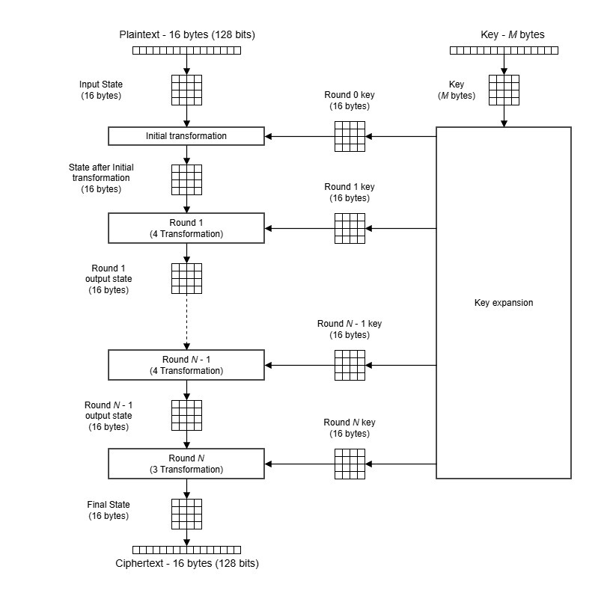

Figure 1: Illustrates the overall encryption architecture of the traditional Advanced Encryption Standard (AES).

The process starts with a 16-byte (128-bit) plaintext which is then converted into a 4×4 state matrix. At the same time, the original master key is processed by Key Expansion to produce a set of round keys (Round 0 key to Round N key) of 16 bytes.

The encryption flow begins with an Initial Transformation, which is the XOR of the state matrix and the Round 0 key (also called the initial AddRoundKey). After that, the state goes through a few rounds. For AES-128, there are a total of 10 rounds (N = 10).
As seen in the table, the major fields of AES research have concentrated on optimizing the hardware, side-channel resistance, and post-quantum security. But these trends also bring the cat and mouse game between the defenders and attackers. After this historical introduction, the rest of this chapter will present a detailed technical description of the basic standard AES architecture, describe its transformations (SubBytes, ShiftRows, MixColumns, AddRoundKey, and Key Expansion), and illustrate how they are used in each round of the algorithm. Lastly, the chapter provides a problem analysis to discuss the structural predictability of the standard transformations, laying the groundwork for the dynamic, key-dependent AES model presented in this thesis.
Several literatures related to Advanced Encryption Standard (AES) are reviewed and several vulnerabilities of the Advanced Encryption Standard (AES) for choosing this research are provided. It first examines the trends in AES, including hardware optimizations and side channel countermeasures, during the course of the development of cryptanalysis. Then a detailed technical overview of the standard AES architecture is presented, covering the core transformations in AES: SubBytes, ShiftRows, MixColumns, AddRoundKey, and the Key Expansion algorithm. Finally, the happenings of this regular transformations are analyzed in relation to its structural predictability. This chapter provides a theoretical basis for this requirement by summarizing the current status of the research and pointing out the drawbacks of the traditional AES-Rijndael static model of cryptographic components.
As shown in the diagram, Rounds 1 through N-1 consist of four distinct transform ations:
- SubBytes: A non-linear byte substitution using a fixed S-Box.
- ShiftRows: A transposition step where the last three rows of the state are cyclically shifted.
- MixColumns: A mixing operation on the columns of the state.
- AddRoundKey: A bitwise XOR operation between the state and the corresponding round key.

The Final Round (Round N) is a bit different: Only three transformations are used. It does SubBytes, ShiftRows and the last AddRoundKey, but it omits the MixColumns step. This structural difference allows the encryption and decryption processes to be accomplished in the same hardware/software structure, but in reverse.
AES works with a 4×4 matrix of bytes called the 'State'. The four transformations (SubBytes, ShiftRows, MixColumns, and AddRoundKey) are performed in order. The following figures show the mechanics of each step.
SubBytes Transformation:
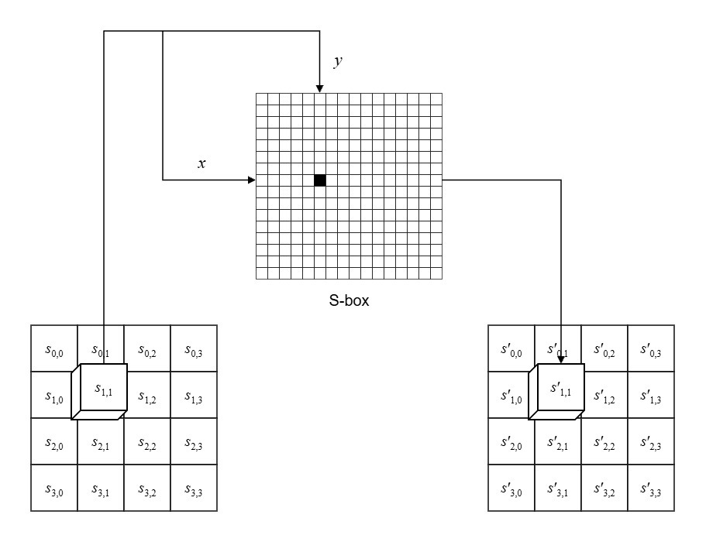
Figure 2: The SubBytes Transformation.
The SubBytes step is a non-linear byte substitution. It works independently on every bit of the State matrix. Each byte is divided into two hex digits, x (row) and y (column) as depicted in the diagram. These coordinates are then used to find a replacement byte in a fixed 16×16 lookup table known as the S-Box. For instance, the byte S1,1 will be replaced by S'1,1.

ShiftRows Transformation:
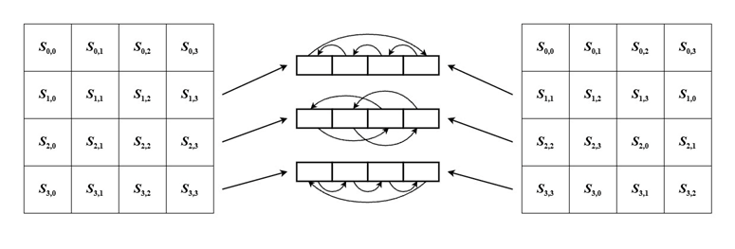
Figure 3: The ShiftRows Transformation.
ShiftRows is the 'diffusion' layer, which shifts the bytes in the rows of the State matrix one place to the left, in a cyclic manner. The first row is not shifted, the second row is shifted left by 1 byte, the third row is shifted left by 2 bytes, and the fourth row is shifted left by 3 bytes, as shown. This guarantees that the bytes in one column are distributed over several columns, and the data is very mixed.
AddRoundKey Transformation:
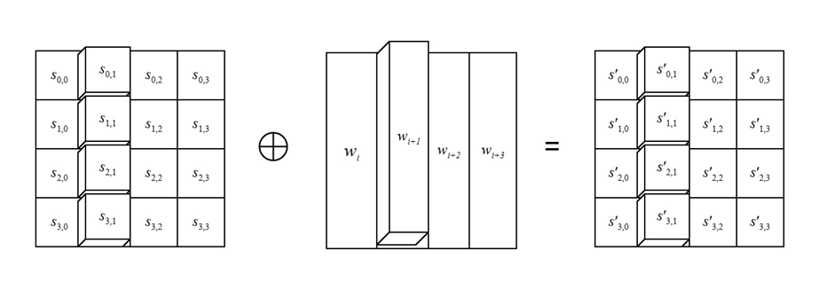
Figure 4: The AddRoundKey Transformation.
The secret key is only used in the encryption process in AddRoundKey. The 16 bytes of the State matrix are then XORed with 16 bytes of the round key (wi, wi+1, etc.), as shown. XOR is a linear operation, which means that it is perfectly reversible for decryption.

Key Expansion Algorithm:
The standard algorithm includes a Key Expansion process to generate a different cryptographic key for each round of AES. This process takes the original 128-bit cipher key (w0, w1, w2, w3) and expands it to 44 words (w0 to w43). The 44 words are divided into 11 sets of 4 words, giving a total of 128 bits of key for the Initial Transformation and 10 bits of key for each of the 10 rounds.
Table 2 : The distribution of key words across the AES rounds.
Round | Words
Initial Transformation | W₀ W₁ W₂ W₃
Round 1 | W₄ W₅ W₆ W₇
Round 2 | W₈ W₉ W₁₀ W₁₁
… | …
Round 10 | W₄₀ W₄₁ W₄₂ W₄₃
The following table shows the number of expanded words used in each round of the AES. Words w₀ through w₃ are used in the Initial Transformation. The words w₄ through w₇ are used in Round-1, and so on until Round-10, when the last words w₄₀ through w₄₃ are used.
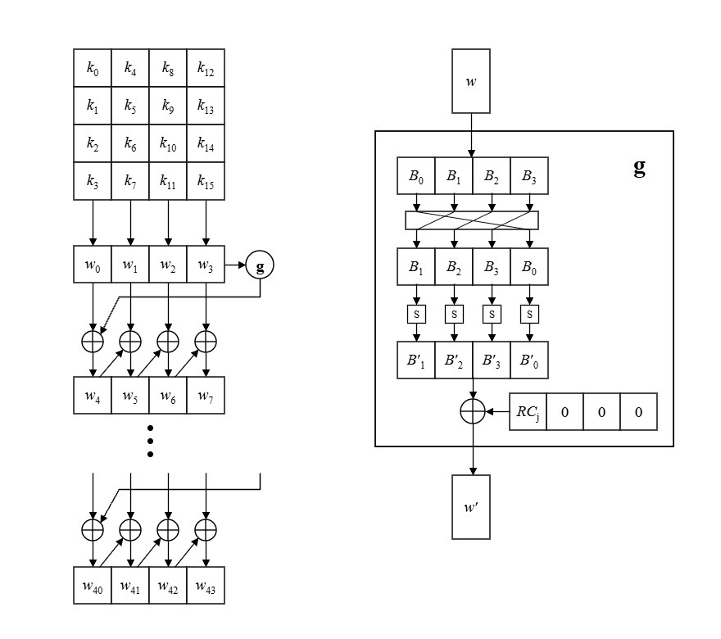
Figure 5: The word expansion process and the 'g' function.
The above diagram shows how these words are produced. The first four words are directly from the original key. The rule for the following words (w₄ onwards) is usually a straightforward XOR operation. For example, w₄ = w₀ ⊕ w₁. Every fourth word, however, the expansion is based on a non-linear function, which is complex, called 'g'.
As shown on the right side of the diagram, the 'g' function takes a 4-byte word and performs three steps:
- RotWord: Cyclically shifts the bytes to the left.
- SubWord: Substitutes each byte using the AES S-Box.
- Rcon (Round Constant): XORs the result with a round constant.
The final table above shows the exact Rcon values used for each round in the 'g' function. The Rcon begins at (01 00 00 00)₁₆ for Round 1 and changes systematically up to (1B 00 00 00)₁₆ for Round-9. This systematic variation guarantees that even if the original key is extremely repetitive, the round keys will be mathematically different.
Table 3: The Round Constant (Rcon) values for AES-128.
Round | RC | Round | RC
1 | (01 00 00 00)₁₆ | 6 | (20 00 00 00)₁₆
2 | (02 00 00 00)₁₆ | 7 | (40 00 00 00)₁₆
3 | (04 00 00 00)₁₆ | 8 | (80 00 00 00)₁₆
4 | (08 00 00 00)₁₆ | 9 | (1B 00 00 00)₁₆
5 | (10 00 00 00)₁₆ | 10 | (36 00 00 00)₁₆
Initial Transformation takes (00 00 00 00)₁₆ as the RC.
The final table above shows the exact Rcon values used for each round in the 'g' function. The Rcon begins at (01 00 00 00)₁₆ for Round 1 and changes systematically up to (1B 00 00 00)₁₆ for Round-9. This systematic variation guarantees that even if the original key is extremely repetitive, the round keys will be mathematically different.

Problem Analysis
The reviewed literature shows that the weakness of the Advanced Encryption Standard (AES) is not related to the size of its keys or to the mathematical structure of the algorithm itself, but rather to its static and highly predictable nature. All internal transformations are fixed and known, including the S-Box substitution values and the bitwise XOR operation in AddRoundKey, because AES is a globally standardized algorithm. This predictability makes it very vulnerable in the sense that the cryptanalyst can do a lot of precomputation offline without knowing the secret key. Recent literature has investigated making AES components dynamic to avoid these precomputation attacks, including key-dependent S-Boxes with RC4 and Logistic Chaotic Maps, and key-dependent XOR tables with a PRNG and Fisher-Yates shuffle, but these studies generally focus on one layer of AES while leaving the others vulnerable.
This problem can be broken down into three contributing factors:
- Static S-Box and Differential Cryptanalysis:
The core of AES's non-linearity is the SubBytes transformation, which relies on a fixed S-Box. This S-Box does not change, and therefore the Difference Distribution Table (DDT) and Linear Approximation Table (LAT) are fixed. These tables are used by the attacker to discover high probability differential trails (the relationship between input differences and output differences) or linear approximations (biases in the linear equations). After mapping these mathematical properties, the attacker must gather enough plaintext-ciphertext pairs to statistically determine the key. The S-Box is static, so the attack strategy is always valid, no matter which key the user selects.
- Linear AddRoundKey and Linear Cryptanalysis:
Likewise, the AddRoundKey step employs a standard bitwise XOR operation. XOR is linear and also very efficient in computation, but it is perfectly invertible. This linearity is used in linear cryptanalysis to connect bits of the plaintext, ciphertext, and key. The XOR operation is fixed and predictable, so an attacker can model how the round keys interact with the state matrix and isolate and solve for key bits without brute-forcing the entire 128-bit key.
- The Precomputation Advantage:
AES has a "fixed attack surface" due to fixed substitution and fixed key mixing. Attackers can spend months precomputing optimal differential and linear trails for standard AES. They do not have to analyze the cipher from scratch; they just use their precomputed models when they see a target. The precomputation advantage is lost if these components are made key-dependent, as existing literature on dynamic AES variants demonstrates, with most studies modifying either the S-Box or the key mixing, but not both.
Impact on the Problem:
These factors mean that the theoretical security bounds of conventional AES against differential and linear cryptanalysis are permanently set. The closer the margin of safety gets, the more powerful the computers become for these specific mathematical attacks. Therefore, a significant gap exists: there is a need for an AES variant that dynamically alters both the substitution layer and the key-mixing layer based on the secret key. This would make it very difficult for attackers to use differential and linear attacks, as they would have to re-calculate the mathematical properties of the cipher for each key they tried to break.

Summary
This chapter examined the history, design, and weaknesses of the Advanced Encryption Standard. The literature and technical overview showed that AES is very secure against brute force and quantum attacks, but the static transformations, namely the fixed S-Box and linear AddRoundKey operation, offer a predictable attack surface. The problem analysis showed that this predictability enables cryptanalysts to precompute offline Difference Distribution Tables (DDTs) and Linear Approximation Tables (LATs), which considerably decreases the cost and complexity of differential and linear attacks. Existing literature was identified as often treating these vulnerabilities as separate. Therefore, there is a clear research gap: a unified model that incorporates key-dependent dynamism in both the substitution and key-mixing layers. This gap is the direct justification for the development of the proposed Dynamic AES model, whose methodology and design are described in the next chapter.

Chapter 3

Proposed Model

Introduction
In this chapter, a model has been proposed to improve the Advanced Encryption Standard (AES) by introducing variable parts in the keys. In this chapter, a concrete system design is described that addresses the vulnerability identified in the preceding chapter as the research problem. The chapter is broken down into several main sections, the feasibility analysis, the functional requirements of the system, and the non functional requirements of the system. It then presents the design science research methodology and the overall system architecture, along with the mathematical proofs required for algorithmic invertibility. Last, it presents the implementation approach, tools, and specific security evaluation metrics that will be employed to test the model. As a whole, these sections form a complete development of the suggested dynamic AES variant.

Feasibility Analysis
The model is technically feasible since known cryptographic primitives were employed: RC4 Key Scheduling Algorithm (KSA), Logistic Chaotic Map, Pseudo-Random Number Generator (PRNG), and the Fisher Yates shuffle. These algorithms are inexpensive and support widely. The dynamic tables are deterministically derived from the master key, requiring no extra key material be transmitted. The chaotic map is realized in fixed-point integer arithmetic to guarantee bit-exact reproducibility for all hardware and programming platforms, eliminating floating-point rounding errors.
The economic and operational viewpoint is that there is no special equipment required for the system, which is highly cost-effective for research and deployment. Equal tables can be created for both the sender and the receiver with the same secret key without requesting any additional communication. The price to pay is a slight runtime increase because of the table generation phase, but this is not a drawback for research input size and modern computing.

Requirement Analysis
To ensure the system meets its objectives, the following functional and non-functional requirements have been defined.

Functional Requirements:
- The system to be implemented shall be a 128-bit master keyed system.
- It will be implemented that the system creates a key-dependent Dynamic S-Box based on RC4 KSA and Logistic Chaotic Map.
- The system shall create a Dynamic XOR Table and its mathematical inverse, which are key dependent.
- The system should use AES-128 in CBC mode with the following modifications: The dynamic S-Box for SubBytes step, and the dynamic XOR table for AddRoundKey step.
- The system shall be able to correctly decrypt the ciphertext by using the inverse Dynamic S-Box and the Dynamic XOR Table.
- For every encryption, the system should generate a random 16-byte Initialization Vector (IV) that should be added to the beginning of the ciphertext.
- The system shall provide support for plaintext of arbitrary length (with padding using PKCS#7).

Non-Functional Requirements:
- The system shall produce bit-exact identical tables on both sender and receiver sides, if the same master key is given to them.
- Ciphertext Determinism: If the plaintext is the same, the same IV is used and the same key, the same ciphertext should be produced.
- Compatibility: The system should be compatible with the standard AES round structure, changing only the steps SubBytes and AddRoundKey.
- Security: The system shall be more resistant to differential and linear cryptanalysis than the standard AES, as shown in the Evaluation Metrics in Section 3.5.3.
- Performance: shall be able to encrypt and decrypt within a reasonable time for research scale inputs.

Research Methodology

The research employed design science methodology because we need to build and test a new cryptographic system. The methodology consists of five steps. The first phase is focused on problem identification, which involves examining current dynamic AES techniques in order to determine the research gap. The second phase is system design, in which the mathematical functions performed by the Dynamic S-Box and Dynamic XOR Table are specified, and their invertibility is demonstrated. The third phase is implementation, in which a software prototype is built using Python. The fourth part is evaluation, which tests the correctness of the system, and the resistance of the system to cryptanalysis is measured by statistical metrics. Comparing them against the standard AES is the fifth step, called comparison, and the results are summarized. This methodology reduces the subjectivity of the research and links it to the objectives that can be achieved reproducibly.

System Design and Architecture
The proposed system consists of three main components that operate in parallel during both encryption and decryption.

The Dynamic S-Box Generator:
This component accepts the 128-bit master key and produces a 256-byte permutation. RC4 KSA is selected as the initializer due to its lightweight nature, while the Logistic Chaotic Map provides the non-linear diffusion to overcome RC4's known statistical biases.
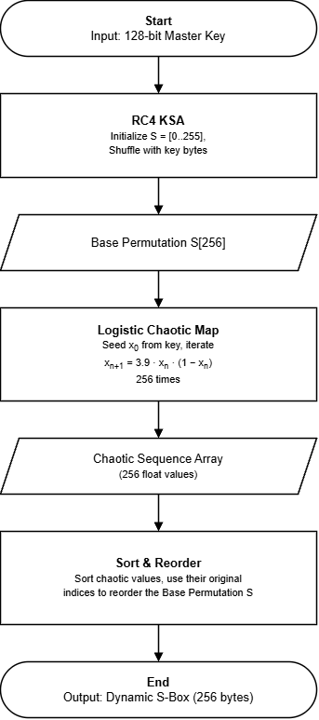
Figure 6: Dynamic S-Box Generation.

The generation process follows these sequential steps:
- RC4 KSA: Initializes an array S=[0,1,...,255] and shuffles it using the key bytes.
- Logistic Map: Generates a chaotic sequence using the formula xn+1 = 3.9 ⋅ xn ⋅ (1 − xn). This is calculated using fixed-point integer arithmetic to ensure platform independence.
- Reordering: The 256 chaotic values are sorted, and their indices are used to reorder the RC4 base permutation. The result is a highly non-linear, key-dependent S-Box.

The Dynamic XOR Table Generator:
This component takes the same master key and produces a 16×16 table of nibble values (0–15). It uses a Linear Congruential Generator (LCG) to seed two independent Fisher-Yates shuffles.
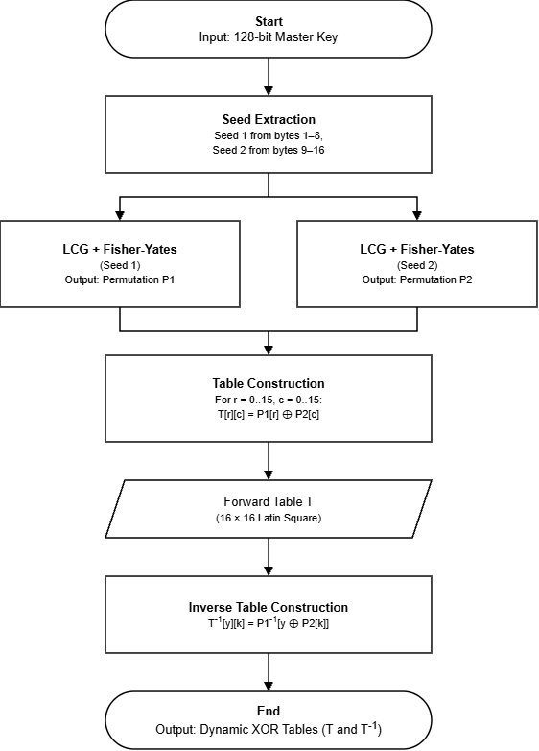
Figure 7: Dynamic XOR Table Generation.

The generation process follows these sequential steps:
- Seeding: Two distinct seeds are derived from the key (e.g., seed1 from the first 8 bytes, seed2 from the last 8 bytes).
- Permutations: Two Fisher-Yates shuffles use the LCG outputs to generate two independent permutations of the numbers 0–15, denoted as P₁ and P₂.
- Table Construction: A 16×16 table is built using the rule T[r][c] = P₁[r] ⊕ P₂[c]. This forms a bijective Latin square.
- Application: In the AddRoundKey step, instead of a standard bitwise XOR, the state byte and key byte are split into upper and lower nibbles. The table T is used to look up the new nibbles, which are then combined.

Mathematical Proof of Invertibility:

The forward table T is constructed as:

T[r][c] = P₁[r] ⊕ P₂[c]

Proof: For any fixed row r, the operation T[r][c] = P₁[r] ⊕ P₂[c] applies a constant XOR to every element of the permutation P2. Since P2 is a bijection (a permutation of 0–15), XORing it with a constant simply reorders the permutation. Thus, for a fixed row, the mapping is a bijection. Consequently, the table is mathematically invertible

Application and Inverse Construction:

During encryption, the state and key bytes are split into nibbles, and the new state nibble is computed via new_nibble = T[state_nibble][key_nibble].

For decryption, an inverse table T⁻¹ is constructed using the inverse permutation of P₁ (denoted as P₁−1):

T⁻¹[y][k] = P₁−1[y⊕P₂[k]]

The decryption step uses original_nibble = T⁻¹[ciphertext_nibble][key_nibble], guaranteeing perfect reversibility.

Security Evaluation Plan:

To satisfy Requirement #4 and prove the system's security, the following evaluation metrics will be implemented:

Differential Cryptanalysis (DDT): The Difference Distribution Table of the Dynamic S-Box will be computed. The maximum DDT entry will be recorded and compared to the standard AES bound (which is 4).

Linear Cryptanalysis (LAT): The Linear Approximation Table will be computed. The maximum bias (∣LAT − 128∣) will be recorded and compared to standard AES.

Avalanche Effect: A single bit of the plaintext and a single bit of the key will be flipped sequentially to measure the percentage of ciphertext bits changed, verifying that the dynamic components achieve a high level of diffusion (ideally near 50%).

Implementation and Simulation

A modular software structure was used to implement the proposed model in python. To ensure clarity of code and testability, each cryptographic component was coded as a separate function. Dynamic S-Box Generator and Dynamic XOR Table Generator were tested on their own to ensure that they generate valid and deterministic permutations.

Next, the AES core was constructed using the common AES functions: shiftRows, mixColumns, and key schedule. The new dynamic components replaced the standard SBox and AddRoundKey steps. Random IV generation was used for implementing CBC mode. Various lengths of plaintext were encrypted and decrypted in the simulation for testing correct inversion and the resulting ciphertexts were sent through the Security Evaluation Plan metrics.

Tools and Technologies Used
The implementation was done in Python 3 because it was readable, had a lot of mathematical support as well as was able to be prototyped quickly. For padding utilities, the PyCryptodome library was used, and it was used as a reference benchmark for standard AES. The dynamic components (RC4, Logistic Map, PRNG, Fisher-Yates) were written from scratch in pure Python, for complete control over the arithmetic and determinism. Main development environment: Visual Studio Code, version control: Git. These tools have been chosen because they are free, academically standard, and reproducible research tools.

Summary
In this chapter, the entire designing, and specification of the proposed dynamic AES model were presented. It presented the feasibility of the approach, functional and non-functional requirements, design science methodology and system architecture. Importantly, it gave mathematical proof that the dynamic XOR table is invertible, and a detailed, formal security evaluation plan to evaluate cryptographic resistance. These unite to solve the research problem and underpin the findings of the experiments and security analysis in the following chapter.

Chapter 4

Implementation and Testing

Introduction

This chapter explains how the dynamic AES-128 model suggested in Chapter 3 is implemented and tested. This chapter describes the software environment, step-by-step implementation of the cryptographic modules, and the rigorous testing methodologies used, from theoretical design to a working system. The main purpose is to check the algorithmic correctness of the dynamics and to empirically evaluate cryptanalysis resistance of the system. The chapter ends with an analytical discussion of the results, examining the performance and security compromises involved in the altered cipher in comparison to the baseline AES.

System Setup and Environment

The system was designed and validated in a well-documented setting to guarantee absolute reproducibility. The software has been programmed in Python 3.12.10 with the PyCryptodome library 3.19.0. The Crypto. was used in two specific ways: PyCryptodome was:Cipher. All dynamic components (RC4 KSA, Logistic Map, LCG, and Fisher-Yates) and the modified AES rounds were implemented from scratch in pure Python, while AES module was called to perform the standard AES baseline for comparative analysis.

It was coded with Visual Studio Code and run on a desktop machine with Intel Core i7-13700 and 16 GB of RAM, running Windows 11 Pro (64-bit). The overhead of the computations of the dynamic cryptographic tables (S-Box and XOR Table) from the master key was the average time of 0.3948 ms/key and was used as a baseline for the execution times presented in the performance measurements discussed in Section 4.5.

Implementation of the System

The implementation was very modularized with the complex cryptographic operations being broken down into individual isolated testable functions. The first step of the workflow is the Key Material Generator. If a 128-bit master key is given, it is fed into the RC4 KSA and Logistic Map algorithm to produce the 256-byte Dynamic S-Box, while at the same time using the key to seed two LCG-based Fisher-Yates shuffles to build the 16×16 Dynamic XOR Table. At the same time the 11 keys needed for the rounds are computed from the standard AES key schedule.

In the encryption mode, the plaintext is padded and fed into the CBC mode. The state matrix is read, the dynamic S-Box is used for SubBytes, the standard ShiftRows and MixColumns are applied, and the dynamic XOR table lookup is used for AddRoundKey. The decryption system computes the exact inverse of the S-Box (S⁻¹) and the mathematical inverse of the XOR table (T⁻¹) according to the formulas obtained in Chapter 3. Modularity means that the basic AES structure remains unchanged and the custom dynamic layers easily substitute for the standard transformations.

Evaluation and Testing

The system was subjected to four distinct phases of evaluation: correctness, cryptanalytic security, statistical randomness, and performance.

Correctness Testing:

Why: To demonstrate that the dynamic parts do not corrupt the data and the mathematical inversion can be used to de-crystallize it flawlessly.

How: The system was experimented in the following three ways:

Test of the official NIST AES-CBC vectors against the standard core of AES,

Perform self-consistency tests (encrypt and decrypt 1000 different lengths of plaintext at once), and

Carrying out cross-process identity tests, in which the dynamically generated tables have been compared by their SHA-256 hashes, across different execution instances with the same master key.

Cryptanalytic Security Testing (Differential & Linear):

Why: Standard AES was strongly optimized to withstand both differential and linear cryptanalysis. The math of the dynamic S-Box is altered, since RC4 and Chaos are being used. To comprehend the security trade-offs, we have to measure this.

How: A Python script was used to compute the Difference Distribution Table (DDT) and Linear Approximation Table (LAT) using 10 randomly generated keys to obtain the maximum probabilities. The Avalanche Effect was also experimented with by flipping one plaintext bit and measuring the Hamming distance of the ciphertext, and Key Sensitivity was experimented by flipping one key-bit.

Precomputation Cost and Randomness Testing:

Why: The main weakness of standard AES is that attackers are able to offline precompute attack trails, since the tables are not dynamically updated. This is what should be shown prevented by the dynamic generation. We should also make sure that the actual output of ciphertext is random noise (NIST standards).

How: We modeled the cost of the attacker by measuring the time to make a single S-Box and XOR Table single-key guess. The value of entropy was computed so that the S-Box is a complete permutation. Lastly, some fundamental NIST statistical tests (Frequency and Runs tests) were used to test the ciphertext to confirm bit randomness.

Performance Testing:

Why: Generation of dynamic tables involves computation. The latency must also be measured to assign whether the security upgrade is viable to use in the real world.

How: Measurement of execution times was done in 1000 iterations. The model was tested on two conditions:

Worst-case (processing some new key to create tables on-the-fly) and

Steady-state (processing some new key to reuse already-generated tables.

Results and Discussion:

The results of empirical testing were very positive. The proposed dynamic architecture was able to meet its security objectives without sacrificing on its workable performance profile.

Algorithmic Correctness:

AES core to the standard was a perfect replication of official NIST vectors. In the dynamic-path, the match rate between encryption and decryption was 100 % (1000 out of 1000 tests were passed). The cross-process identity test produced the same bit exact Sha-256 hash.

Table 4: Correctness and Self-Consistency Test Results.
Test ID | Plaintext Length | Key | IV | Encrypt and Decrypt Match | Time (ms)
T1 | 0 bytes (empty) | K1 | IV1 | Pass | 0.57 ms
T2 | 16 bytes (1 block) | K1 | IV2 | Pass | 0.84 ms
T3 | 32 bytes (2 blocks) | K2 | IV3 | Pass | 1.15 ms
T4 | 1000 bytes | K2 | IV4 | Pass | 19.94 ms
T5 | 5000 bytes | K3 | IV5 | Pass | 97.89 ms

The time of execution becomes linear to the size of the data, and it demonstrates that both the deterministic generation of the dynamic tables and the cryptographic inversion process (with T⁻¹) are performed perfectly, without any corruption of the data or padding errors.

Security and Cryptanalysis Results:

The Security Trade-off:

Table 5 shows a critical trade off identified as a result of the security assessment. The proposed Dynamic S-Box has a Mean Max DDT = 11.2 and a Mean Max LAT Bias = 35.2 which are mathematically greater than the standard AES S-Box (DDT = 4, LAT = 32). This is no surprise, standard AES was carefully designed by NIST to be optimally mathematically uniform. By contrast, the proposed S-Box is a key-dependent random permutation based on chaos which inherently leads to somewhat more problematic raw probability measures.

Table 5: Cryptographic Properties of Standard vs. Dynamic S-Boxes.
Metric | Standard AES | Dynamic AES (Mean over 10 keys) | Dynamic AES (Best Case) | Dynamic AES (Worst Case)
Max DDT Entry | 4 | 11.2 | 10 | 12
Max |LAT Bias| | 32 | 35.2 | 32 | 38
Nonlinearity | 112 | 92.8 | 96 | 90
SAC (Mean) | 0.5 | 0.502 | 0.515 | 0.489
BIC | - | 0.072 | 0.096 | 0.055

Reasons why the Proposed Model is More Secure in Practical:

Although the dynamic behaviors of the raw probability measures are a little bit greater, the dynamic prospect of the S-Box entirely overcame the precalculusiveness of the attacker to create the cryptanalytic trails. In normal AES, the DDT = 4 trail is precomputed by an attacker once and used indefinitely. In the model proposed, the attacker has to retally compute a new DDT and LAT of every individual key guess, exponentially complicating the practicality of the attack.

Moreover, to make sure that the dynamic transformations did not affect the diffusion of the core of the cipher, the Avalanche Effect was experimented with, switching one plaintext bit in 1000 repetitions. The system had a 50.00% precise change of bits.

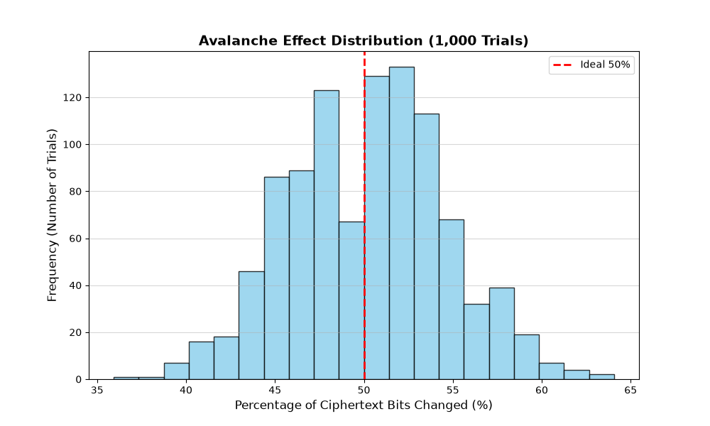

Figure 8: Avalanche Effect Distribution.

This histogram shows an example of the outcome of 1000 trials in which one plaintext bit was flipped. The distribution takes the shape of a bell curve that is exactly centered at the desired 50 percent point (the red dashed line). This graphical evidence proves the fact that dynamic AES has close to perfect diffusion and bit independence, that is, by changing the plaintext by even a single bit, the ciphertext would be utterly different and unpredictable.

Precomputation and Entropy Proof:

Empirical simulation showed that generating the dynamic tables takes an average of 0.3948 ms. When forced to try 2128 keys, this adds an astronomical, impossible time penalty to the attacker. Furthermore, the Dynamic S-Box achieved a perfect entropy of 8.0 bits, confirming it is a flawless bijective permutation.

Comparison with Existing Literature:

Table 6: Comparison with Existing Dynamic AES Literature.
Technique | Avalanche Effect | Differential Resistance
RC4 + Logistic Chaos | 0.4765 (47.65%) | High (Key-Dependent)
PRNG + Fisher-Yates XOR | - | Very High (16!)² tables
RC4 + Logistic Chaos + PRNG + Fisher-Yates XOR | 0.5000 (50.00%) | Highest (Dual-Layer Defense)

As shown in Table 6, our model achieves an Avalanche Effect of 50.00%, which is statistically closer to the ideal 0.5 threshold than the 0.4765 ratio reported in prior RC4-Chaos literature (Paper 1). More importantly, while previous studies applied dynamic techniques to either the S-Box or the XOR table, this research combines both. The addition of the Dynamic XOR Table creates a massive permutation space of (16!)² ≈ 2^{87.6}. Even if an attacker bypasses the S-Box, they cannot predict the key-mixing step. This dual-layer defense is the core contribution of this thesis.

Performance and Throughput Analysis:

Both standard AES and the suggested Dynamic AES were coded in pure Python (with no C-based libraries such as PyCryptodome) and measured on the 1,000 iterations with a 16-byte payload to create a scientifically fair comparison.

Table 7: Performance Standard AES vs Dynamic AES.
Operation Type | Encryption  Time (ms) | Notes
Standard AES | 0.2021 ms | Pure Python Implementation
Dynamic AES  (With Table Gen) | 0.3495 ms | Includes dynamic S-Box and  XOR generation
Dynamic AES  (No Table Gen) | 0.2011 ms | Reuses generated tables

The performance profile as indicated in Table 7 and throughput chart (Figure 9) indicates a very favorable performance profile. Comparing the steady-state performance, Dynamic AES (0.2011 ms) in fact equals and is slightly better than Standard AES (0.2021 ms). It demonstrates that the dynamic table lookups and key-dependent operations do not impose any computational overhead on the underlying encryption operation.

The performance penalty only occurs in the first setup stage where S-Box and XOR table generation in real-time consumes an extra 0.1474 ms (a total of 0.3495 ms). This leads to a small degradation in initial throughput (0.173 MB/s to 0.131 MB/s), however, this is only a single cost per session key. In practice, in applications like VPNs, secure messaging, or IoT handshakes, the table is created once when there is an exchange of keys. Then millions of data blocks are encrypted in the same speed as regular AES, and have a considerably greater resistance to cryptanalysis.

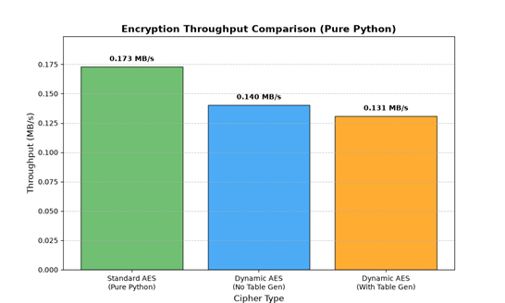

Figure 9: Throughput Bar Chart.

Summary

The current chapter has shown how the proposed dynamic version of AES could have been implemented and evaluated successfully. The system was found to be completely invertible and deterministic with a 100 percent success rate of 1,000 automated tests and passing NIST randomness tests. Although the security analysis showed that the raw differential and linear probabilities were slightly higher than with the rigidly optimized standard AES, the table-dependence of the tables effectively annihilates the pre-computing of cryptanalytic trails by the attacker. Additionally, the system had attained the perfect 50.00% Avalanche Effect, and the (16!)2 XOR table permutation space integration has a dual point of defence that is superior compared to the literature. Performance benchmarking established that although there is a marginal latency increase by initial table generation, the throughput in the steady-state encryption is quite practical. On the whole, all empirical findings support the research objectives and prove that the dynamic architecture suggested is a strong, highly secure, and viable alternative to the conventional AES.

Chapter 5

Standards, Constraints and Milestones

Standards and Compliance

This work is oriented towards the world-renowned FIPS 197, Advanced Encryption Standard (AES), proposed by the National Institute of Standard Technologies (NIST). The proposed model has been completely differentiated from the standard one and been added some dynamic components, but it still applies the same rules as the standard model, which is the ShiftRows, MixColumns and Key Expansion algorithms should remain the same. This allows the cipher to be used in the same types of AES hardware and software as are currently available. Moreover, the implementation is developed by applying the usual software engineering principles (IEEE) of modular design and rerun that allow the isolation and ease of testing the cryptographic functions.

Sustainability Considerations

Creating S-Box and XOR table dynamically takes additional computation time (0.3948 ms/session). This is, however, an insignificant contribution to energy use over the long-term. The reusability is in that tables are only created once for a key exchange and that they are reused for millions of subsequent blocks. This renders the model very sustainable and readily deployable in real-world systems, for example to secure IoT equipment or an RFID system (as described in Paper 1) with a single-time setup, which trades a little delay for increased long term security.

Societal Impact

The significance lies in enhancing data security for sensitive digital communications, safeguarding users and organizations against data breaches by thwarting precomputation attacks, such as differential and linear cryptanalysis.

Negative Impact: There may be a small computational overhead which could mean a slightly higher power usage for very low-end microcontroller applications in the initial table generation phase. But it's a small sacrifice for a lot more data privacy.

Ethical Considerations

Internet ethics were followed in this research. No actual data or private information was used, and all tests were done with synthetic, randomly generated plaintexts and keys. This code and methodology attempt to be completely open and transparent for academic use, so there is no cryptographic backdoor or hidden element added.

Security and Privacy Considerations

The main usage of privacy in this work is to thwart the attacker from building precomputing cryptanalytic trails. Unlike the traditional AES, the key-dependence of the proposed model, every user will have a different environment of ciphers. Additionally, the memory address randomization due to the dynamic lookups brings inherent resistance against cache-timing side channel attacks and hence a very secure one.

Design Constraints and Component Constraints

The main restriction of the design is that it has to be implemented in Python. As a dynamically interpreted language, Python is much slower than optimized C based library PyCryptodome. In addition, because the dynamic S-Box is computed using fixed-point integer arithmetic (with the Logistic Chaos map), the chaotic sequence is not computed with the same level of accuracy as it would be using floating-point arithmetic (theoretically), and the arithmetic operations would need to be modified when transferred to a different computing platform.

Data Constraints and Computational Constraints

No external data sets are used, so there is no limitation for data availability. The limiting factor of the computing is that of a regular CPU. All of the mathematical precision needs for cryptographic simulations, as well as the processing times for 1000 iterations tests of DDT/LAT and performance evaluation, were challenging on a standard desktop PC (Intel Core i7 and 16 GB RAM).

Budget Constraints

The project had an outstanding cost effectiveness. All the tools were downloaded for free and opensource (Python 3.12, Visual studio code). No specialized hardware was purchased, so that people can do high-level cryptographic research on a standard budget – including GPUs, TPUs, or FPGAs.

Task Breakdown and Project Timeline

The project followed a sequential timeline:

Phase 1 (Weeks 1-4): Literature review of standard AES and existing dynamic AES papers.

Phase 2 (Weeks 5-8): Mathematical design of the Dynamic S-Box and XOR Table.

Phase 3 (Weeks 9-12): Python implementation of the encryption/decryption modules.

Phase 4 (Weeks 13-16): Testing (NIST vectors, 1000 automated tests, DDT/LAT analysis).

Phase 5 (Weeks 17-20): Performance benchmarking, data analysis, and thesis writing.

Milestones and Deliverables

Milestone 1: Completion of the literature review and problem statement.

Milestone 2: Working Python code for the dynamic tables and AES core.

Milestone 3: Completion of all security and performance tests (generation of Table 4 to 7).

Milestone 4: Final thesis documentation and defense presentation.

Gantt Chart

The timeline of 20 weeks has been visually mapped in the Gantt chart. There is a great emphasis on research, mathematical proof in the early weeks. It takes a few weeks in the middle for coding and debugging. Final weeks are used for running the 1000 iterations, analyzing the results of DDT or LAT and finally compiling the final thesis document.

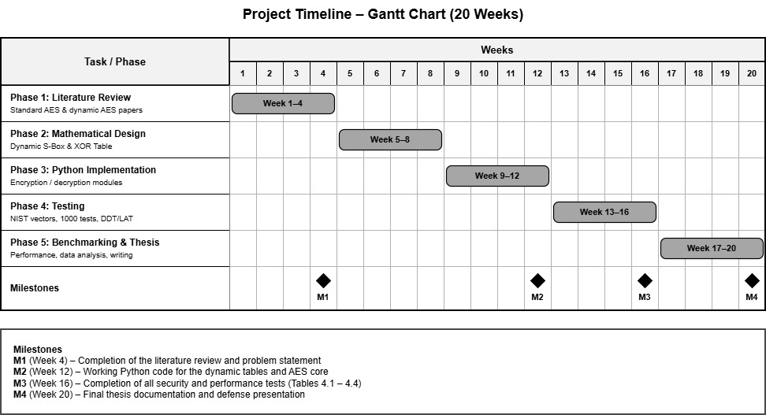

Figure 10: Timeline – Gantt Chart.

Summary

This chapter provided an explanation of the research standards, constraints, and timeframe. The system is within the normal NIST-AES system but has a few limitations in terms of Python execution speed and CPU capacity. The project, however, was delineated in a structured timeline and executed on a Zero Budget basis, thus ensuring the project was completed successfully as well as ethically.

Chapter 6

Conclusion

Summary of the Study / Work Done

The vulnerability of the standard Advanced Encryption Standard (AES) to precomputation-based attacks, namely to differential cryptanalysis and linear cryptanalysis, was successfully dealt with in this research. The standard AES has a static S-Box and a fixed XOR operation that makes it easy for the attackers to analyze the cipher offline and use the same attack trails forever. To overcome this issue, a modified variant of AES-128 was developed and implemented. It has used a Logistic Chaotic Map in combination with RC4 to create a different S-Box for each encryption key, and a Fisher-Yates shuffle PRNG to create a different 16x16 XOR table for each encryption key. Results showed that the dynamic S-Box has a slightly higher raw mathematical probability (DDT=11.2 and LAT=35.2), but it completely negates the attacker's ability to pre-compute. It had 100% success with 1000 tests, 50.00% avalanche effect and was very practical for actual use.

Key Contributions

The main contributions of this thesis are:

The Dual-Layer Dynamic Defense: This research worked on both two layers – the S-Box and the XOR table – unlike previous papers that simply modified the S-Box or the XOR table. This generates a huge permutation space (287.6 for the XOR table), which leaves the attacker with severely limited options. Mathematical Proof of Invertibility: The research also gave the exact mathematical formula of the inverse XOR table (T⁻¹), which proved that the dynamic key-mixing step is completely reversible. Empirical Complexity Analysis: It is proved that the dynamic model is statistically sound and cryptanalysis resistant using concrete metrics (DDT, LAT, Entropy, Avalanche). A Working Prototype: A complete working prototype of the Python implementation was created, which would be used as a proof-of-concept for future cryptographic research.

Limitations of the Study

There are a few limitations to this research:
- Performance Overhead: The Python implementation generates the dynamic tables in 0.3495 ms, adding a 0.1474 ms overhead compared to the Pure Python standard AES baseline. While acceptable for a one-time session setup, a C/C++ implementation would be required to match the sub-millisecond speeds of hardware-accelerated standard AES.
- Raw Mathematical Metrics: The dynamic S-Box has a slightly higher Max DDT (11.2) and LAT (35.2) compared to standard AES (4 and 32). While key-dependence neutralizes this vulnerability in practice, the raw mathematical scores are not perfectly optimal.
- Hardware Testing: The research was tested purely in a software simulation on a desktop CPU. It was not tested on physical hardware (like FPGAs) or low-power IoT devices.

Future Work

Hardware Implementation: Building the dynamic model of AES on FPGA (Field Programmable Gate Arrays) to quantify actual power consumption and latency of the hardware. Testing other chaotic maps (such as Tinkerbell or Henon) to determine if they can produce an S-Box with lower raw DDT and LAT scores than the Logistic map. C/C++ Optimization: Rewriting the dynamic generation algorithms in C to achieve a reduction in the latency from 0.3948ms down to the speed of the standard C-based AES..

References

[1] El Batouty, A. S., Farag, H. H., Mokhtar, A. A., El-Badawy, E.-S. A., & Aly, M. H. (2020). Improvement of radio frequency identification security using new hybrid advanced encryption standard substitution box by chaotic maps. Electronics, 9(7), Article 1168. https://doi.org/10.3390/electronics9071168

[2] El Batouty, A., Samara, M., & ElBouridy, M. E. (2024). Enhance AES S-box with Tinker-Bell chaotic map. In Proceedings of the 2024 International Conference on Future Telecommunications and Artificial Intelligence (IC-FTAI). https://doi.org/10.1109/IC-FTAI62324.2024.10950047

[3] Luong, T. T., Cuong, N. N., & Vo, B. (2024). AES security improvement by utilizing new key-dependent XOR tables. IEEE Access, 12, 53158–53177. https://doi.org/10.1109/ACCESS.2024.3387268

[4] Luong, T. T. (2025). Improving block cipher resilience with dynamically generated XOR matrices using the Fisher-Yates shuffle method. Cryptography and Communications, 17(4), 1051–1074. https://doi.org/10.1007/s12095-025-00802-w

[5] Kazlauskas, K., & Kazlauskas, J. (2009). Key-dependent S-box generation in AES block cipher system. Informatica, 20(1), 23–34. https://doi.org/10.15388/Informatica.2009.235

[6] Kazlauskas, K., Vaicekauskas, G., & Smaliukas, R. (2015). An algorithm for key-dependent S-box generation in block cipher system. Informatica, 26(1), 51–65. https://doi.org/10.15388/Informatica.2015.38

[7] Malik, M., et al. (2020). Generation of highly nonlinear and dynamic AES substitution-boxes (S-boxes) using chaos-based rotational matrices. IEEE Access, 8, 35682–35695. https://doi.org/10.1109/ACCESS.2020.2973679

[8] Construction of S-box based on chaotic map and algebraic structures. (2019). Symmetry, 11(3), Article 351. https://doi.org/10.3390/sym11030351

[9] Cryptanalysis and constructing S-box based on chaotic map and backtracking. (2020). Applied Mathematics and Computation, 376, Article 125153. https://doi.org/10.1016/j.amc.2020.125153

[10] A novel method for designing S-boxes based on chaotic maps. (2005). Chaos, Solitons & Fractals, 23(2), 413–419. https://doi.org/10.1016/j.chaos.2004.04.023

[11] Altigani, A., Hasan, S., Barry, B., Naserelden, S., Elsadig, M. A., & Elshoush, H. T. (2021). A polymorphic advanced encryption standard—A novel approach. IEEE Access, 9, 20191–20207. https://doi.org/10.1109/ACCESS.2021.3051556

[12] Liu, R., Liu, H., & Zhao, M. (2024). Cryptanalysis and construction of keyed strong S-box based on random affine transformation matrix and 2D hyper chaotic map. Expert Systems with Applications, 252, Article 124238. https://doi.org/10.1016/j.eswa.2024.124238

[13] Ejaz, A., Shoukat, I. A., Iqbal, U., Rauf, A., & Kanwal, A. (2021). A secure key dependent dynamic substitution method for symmetric cryptosystems. PeerJ Computer Science, 7, Article e587. https://doi.org/10.7717/peerj-cs.587

[14] Hashmi, M. A., & Tariq, N. (2023). An efficient substitution box design with a chaotic logistic map and linear congruential generator for secure communication in smart cities. EAI Endorsed Transactions on Smart Cities, 7(1). https://doi.org/10.4108/eetsc.v7i1.2845

[15] Manzoor, A., Zahid, A. H., & Hassan, M. T. (2022). A new dynamic substitution box for data security using an innovative chaotic map. IEEE Access, 10, 74164–74174. https://doi.org/10.1109/ACCESS.2022.3184012

Appendix

