
American International University-Bangladesh (AIUB)

Faculty of Science & Technology (FST)
Department of Computer Science

Introduction to Data Science
Mid-Term Project Report
Spring 2025-2026

Section: B
Group: 4

Project Contributions

SL  # | Student Name & ID | Contributions (mention every part of the project where you contributed)
1. | Name: Rafiya Tasnim  ID: 22-49284-3 | Load and inspect dataset  Missing values handle  Outliers handle  Report Writting
2. | Name:Ishrak Shahnawaz  ID:22-49286-3 | Duplicate rows  Convert data  Normalization
3. | Name:Md. Sifti Al Mahmud  ID:23-50099-1 | Handle invalid data  Filter data  Balance dataset  Train/Test split
4. | Name:Rajbir Acharjee  ID:22-48080-2 | Descriptive statistics  Compare averages  Compare variability

Dataset Description

This dataset contains 5000 records of climate related data across 16 variables for various countries in 2026. It includes many environment indicators like average temperature, temperature change, CO₂ emissions and sea level rise. It also covers extreme weather events like heatwaves, wildfires, floods and droughts. Additional metrics include rainfall changes, air quality, climate risk scores and population affected. The data is useful for analyzing climate patterns, risk assessment and environmental impact in different regions of the world.
Project Implementation Detail

Load the Dataset:

The dataset exists as a CSV file on computer but R cannot directly access it. So the dataset neede to be loaded in R.

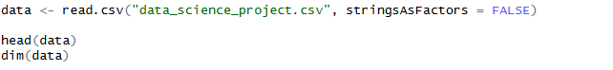

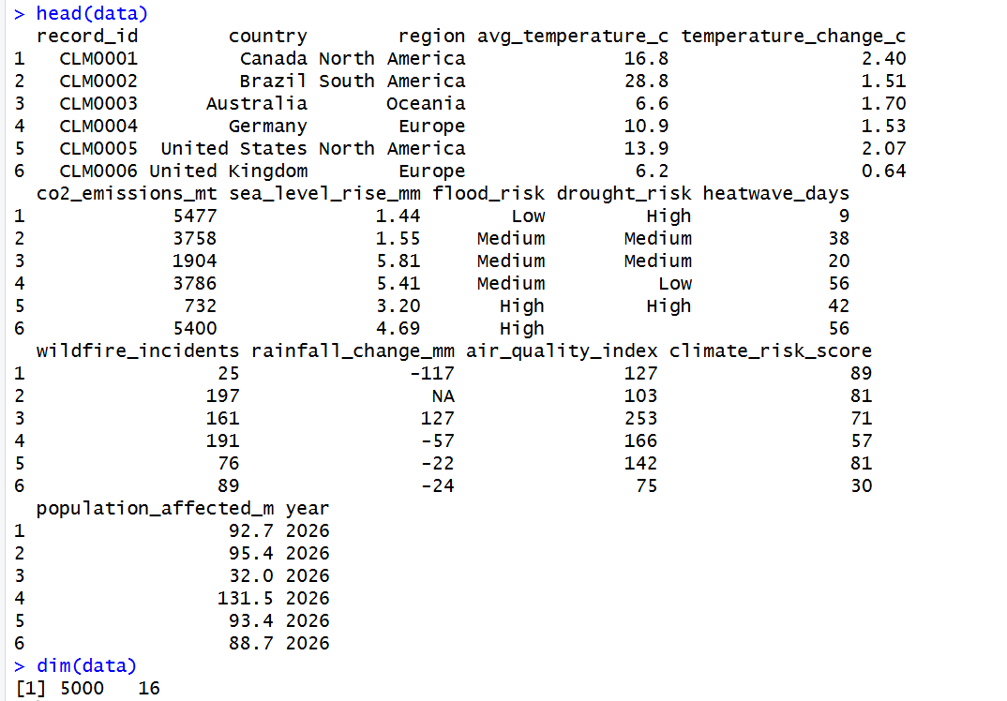

The read.csv() command loads dataset into R. head(data) shows the first 6 rows and dim(data) shows the dataset has 5,000 rows and 16 columns.

Handel Missing Value:

Firstly replace blank cells with ‘NA’. Then count missing values per column. Lastly handel the missing value by fiilling numeric columns with mean and categorical columns with mode.

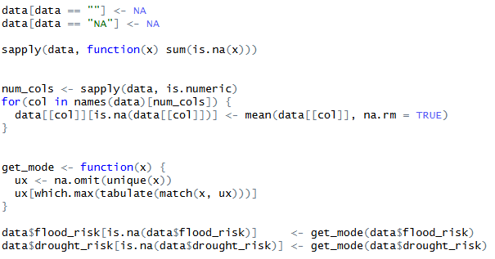

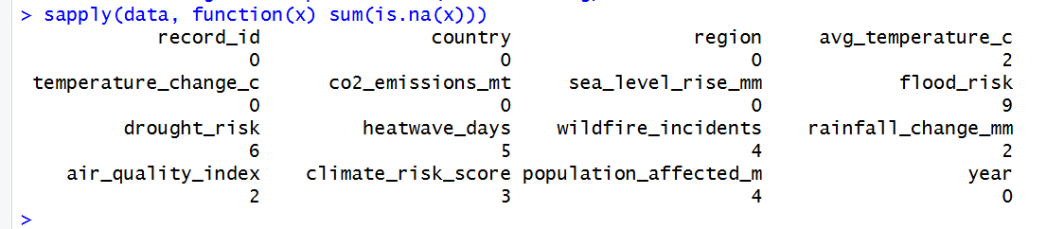
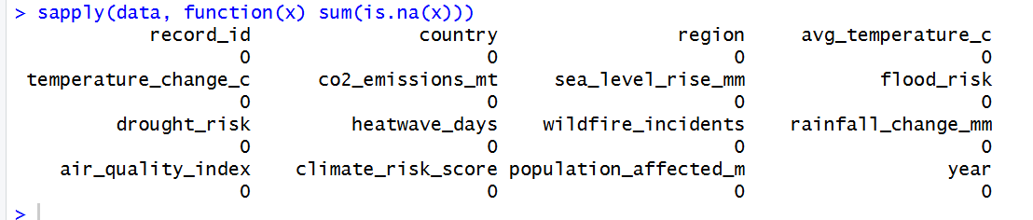

First output there are lots of missing values both in catagorical data and numeric data. So for catagorical data, missing values recoverd by using mode and for numeric data, missing values recoverd by average. Lastly in second output, there are no missing value left.

Detect & Handle Outliers:

Outliers are extreme values that deviate significantly from other observations in a dataset. Remove outliers using IQR method. Using the formula IQR = Q3 - Q1.

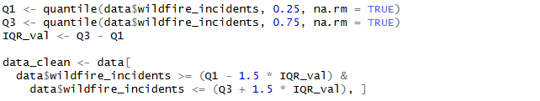

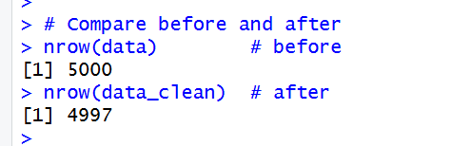

The code removed 3 outlier rows from the wildfire_incidents column. It reducing the dataset from 5000 to 4997 observations while preserving the integrity of the remaining data.

Remove Duplicate Rows:

There are some duplicate rows in the dataset. This need to count rows and remove them.

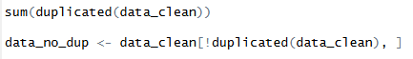

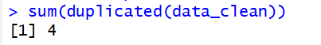

There are 4 duplicate rows counted and remove them from dataset.

Handle Invalid Data:

This dataset has some invalid data. It will remove the rows.

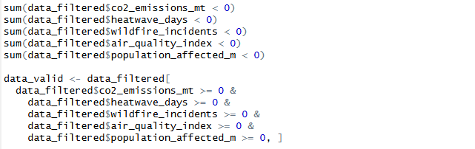

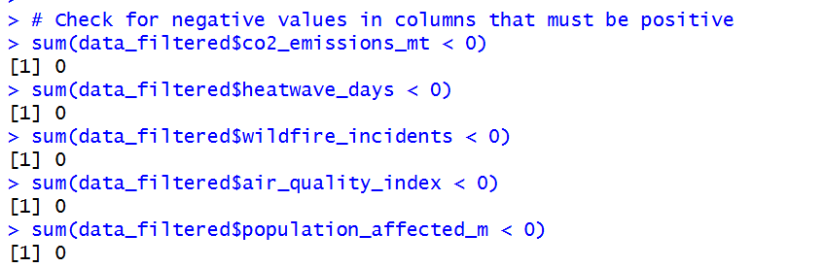

No data cleaning was required because all values in these columns are already valid. The dataset remains unchanged with all rows retained.

Convert Data Types:

Categorical variables contain text based labels "High", "Medium", "Low" that need to be converted to factor type for proper statistical analysis in R Convert categorical columns to numaric.

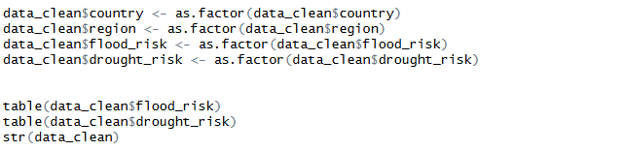

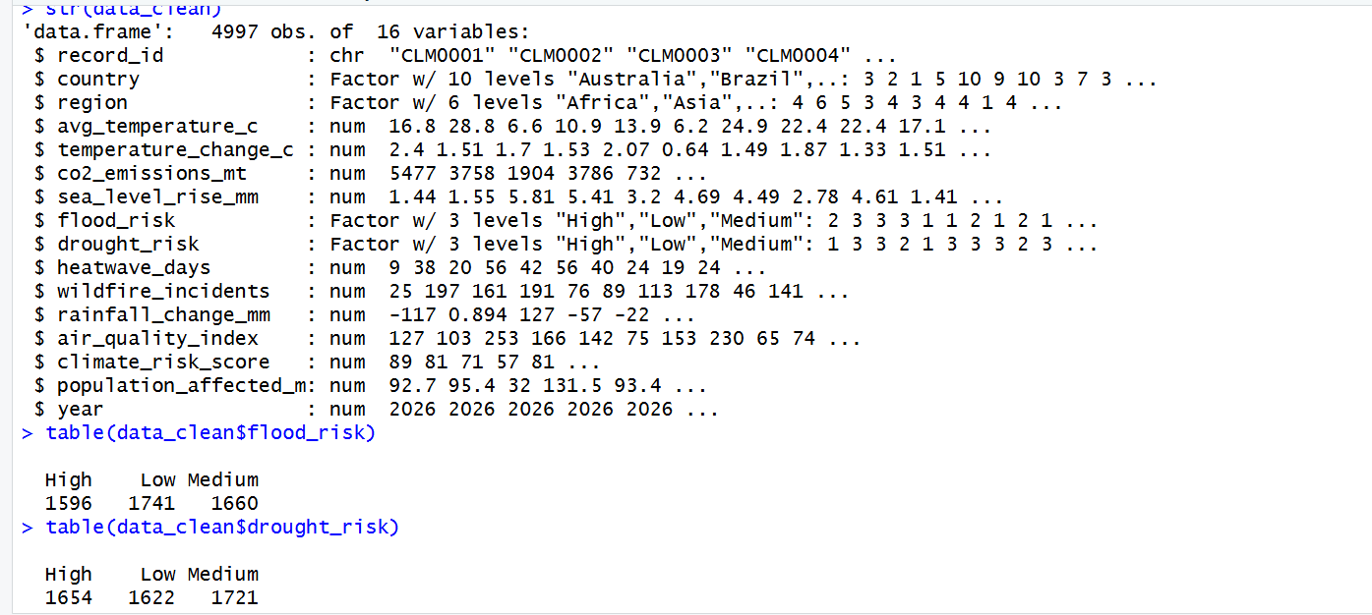

After conversion, flood_risk has 1596 High, 1741 Low and 1660 Medium values then drought_risk shows 1654 High, 1622 Low and 1721 Medium values. Now the dataset contains 4997 observations.

Normalization:

Normalization convert numerical data to a range (0 to 1) using the formula:
(x - min) / (max - min). Apply it to continuous columns.

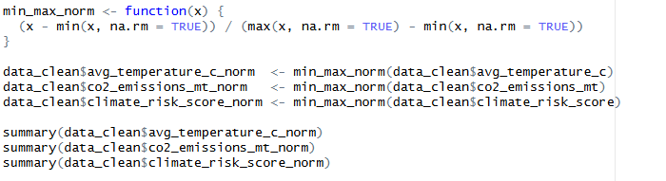

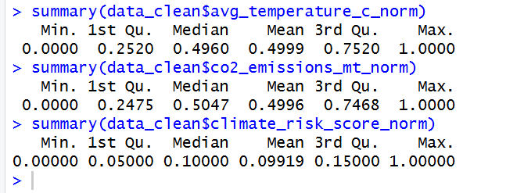

All 3 normalized columns have minimum value = 0 and maximum value = 1. All values has between 0 and 1.

Filter Data:

In the flood risk column there are 3 outputs low, medium and high. So for filteration it keep only high and medium flood risk.

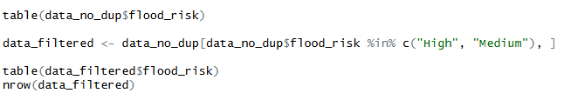

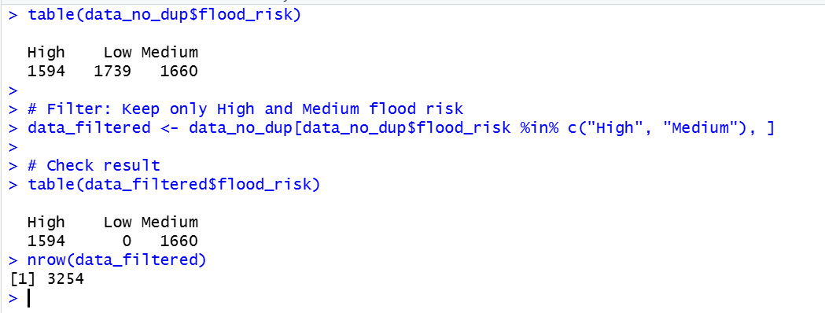


After filtering, the dataset contains 1594 High and 1660 Medium risk observations, totaling 3254 rows. All 1739 Low risk rows have been removed from the dataset.

Balance the Dataset:

Balancing ensures each categorical variable has an equal number of observations and it preventing bias in machine learning models.

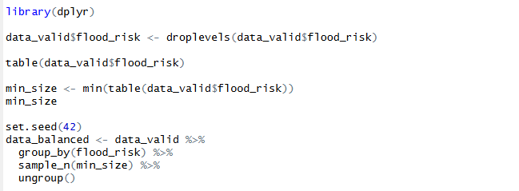



After balancing, all three flood risk categories (High, Low, Medium) will have exactly 1594 observations each, creating a perfectly balanced dataset with equal.

Train/Test Split (70/30):

Splitting data into training and testing sets is essential for evaluating machine learning models. The training set builds the model and the testing set validates its performance.
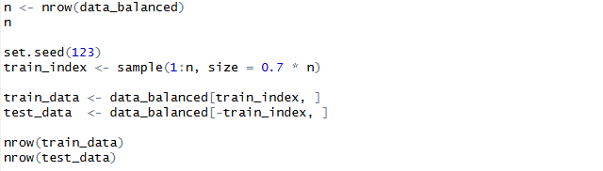

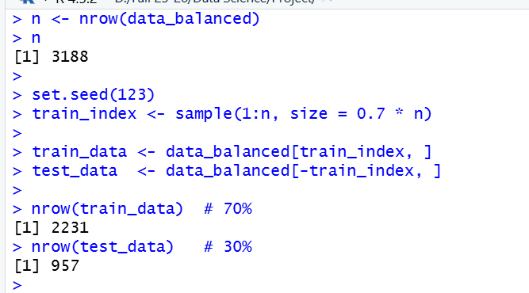

The dataset is successfully split into 2231 training observations (70%) and 957 testing observations (30%), maintaining the original data distribution across both subsets.

Descriptive Statistics by Target Class:

Descriptive statistics summarize and compare the distribution of numeric variables across different categories of a target variable.

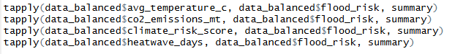

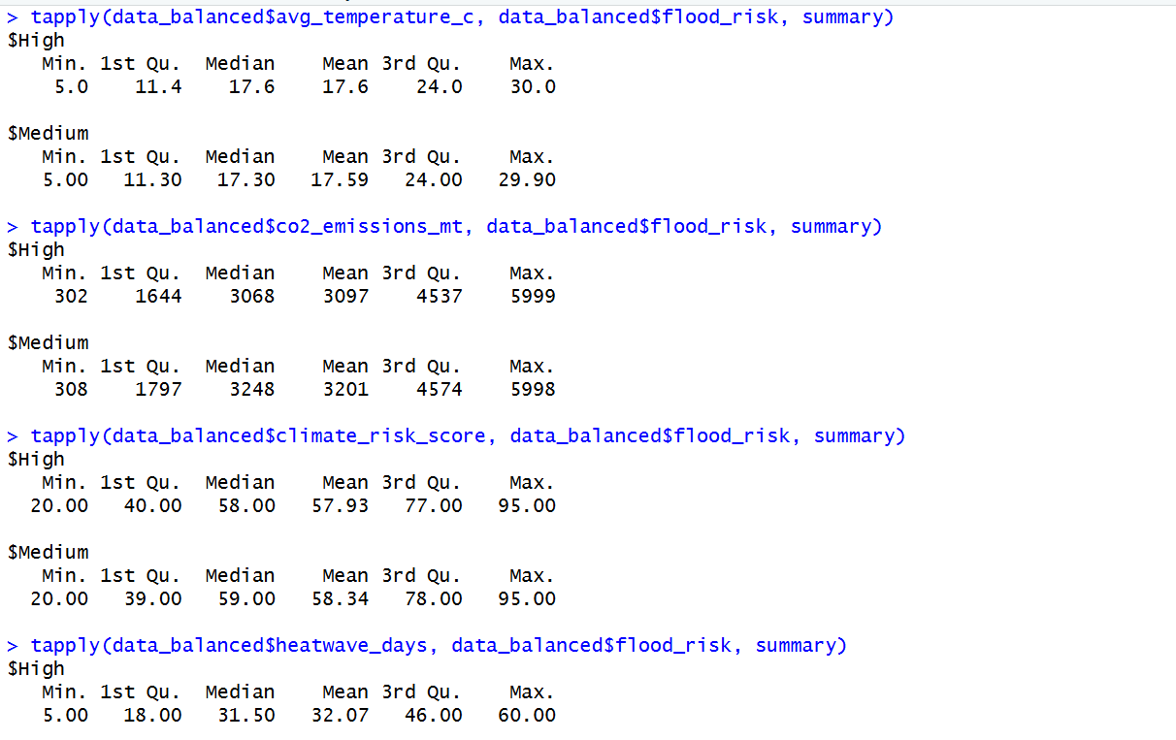

The summary outputs show that High and Medium flood risk categories have remarkably similar statistical profiles.

Compare Average Values Across Two Categories:

This analysis calculates the mean (average) of key numeric variables for each drought risk category (High, Low, Medium).

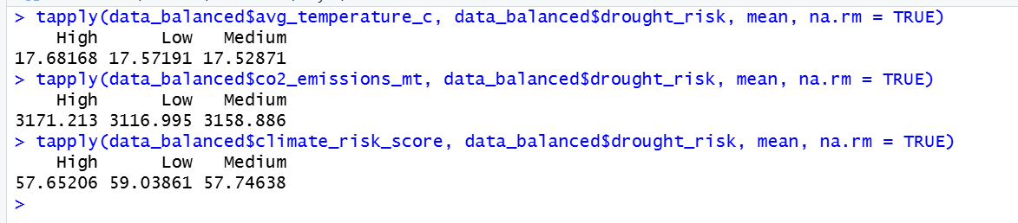

Compare Variability Across Categories:

Variability metrics (Standard Deviation, Variance, IQR, and Range) measure how spread out CO2 emissions values are within each region.

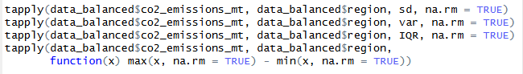

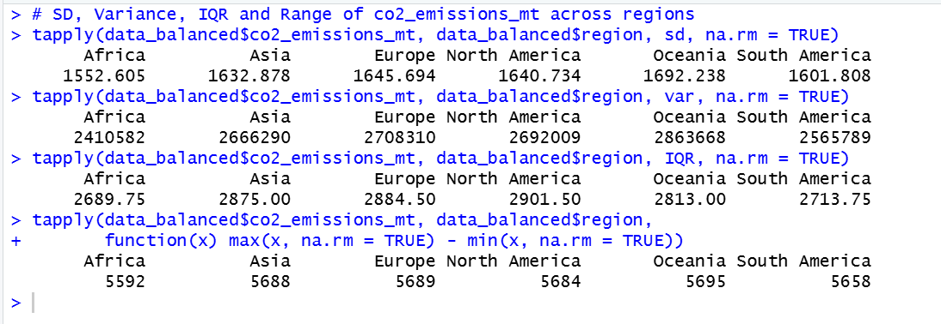

Project Code

