**Bangladesh University of Engineering and Technology**

**Department of Electrical and Electronic Engineering**

**Project Report**

**Project Title : Optimal Placement and Size of Distributed Generator for Voltage and Power Improvement**

**Course No :** EEE 412

**Course Name :** Power System II Sessional

**Course Instructors :** Asikur Rahman Jowel

Md. Obaidur Rahman

**Group Members:**

1706009 Jahid Hasan Tushar

1706015 Mir Jubaier Hassan

1706033 Azazul Islam

1706056 S. M. Monzurul Hoque Chowdhury

1706077 Kazi Ishrak Ahmed

1706089 Istiak Hasan Arnab

1706130 Abu Bakar Mohammad Abdullah

**Lab Group: G1**

**Level :** 04

**Term :** 02

**Introduction**

The demand for electrical power is growing at a rapid pace and the gap between generation and load is increasing. The difference between demand and load leads to several problems like outages, poor power quality and even sometimes to black out. These problems can be solved by the introduction of Distributed Generation (DG) in the system. For maximum reliability, technical and economic advantages, proper sizing or capacity of distributed generators, its proper allocation in the power systems, types of generating unit, number of units etc. are very important. Among these factors, the problem of installation of DG units with optimal location and size is of great importance. Improper allocation of DG resources in power system would lead to increase in power losses. Genetic algorithm is used as a solving tool for tackling this optimization problem.

The impact of DG size and location on system losses is studied using load flow. Improper allocation of DG leads to increase in system losses. Hence, Genetic algorithm (GA) is implemented to find the optimal size and location of distributed generation unit in a radial distribution system. The total active power losses are minimized, and voltage profile is improved by the proper allocation of DG. Multi objective function is introduced which includes the active power losses, the voltage deviation and DG cost with appropriate weight of each variable. Minimization of objective function is subjected to voltage constraints, active power losses constraints and DG size constraints. This method is implemented on IEEE 15 bus,33 bus and 69 bus radial distribution system.

**Objective**

* Optimal Placement of Distributed Generators (DGs)
* Finding out optimized size of DG
* Improving the voltage profile of the system
* Reducing the real power loss
* Reducing the reactive power loss

**Load Flow Method**

Load flow of the radial distribution system is performed in forward-backward sweep power flow method. The forward-backward method is a numerical technique that is commonly in radial bus systems.

**Reasons of using Forward-Backward Method**

Radial bus systems are characterized by having a single source or generator connected to multiple load buses through a series of transmission lines. In such systems, the power flow is unidirectional, meaning that the power flows from the source towards the load buses. The forward-backward method takes advantage of this unidirectional power flow to solve the power flow equations efficiently. Also presence of high R/X ratio, poor convergence of typical method like Gauss-Seidel and Newton-Raphson method influences the use of forward backward sweep method.

The power flow equations for a radial bus system are a set of non-linear equations that relate the voltages and phase angles at each bus to the active and reactive power flows in the system. The forward-backward method works by iterating through the system, updating the voltage and phase angle at each bus based on the known values at the neighbouring buses. The method starts at the source bus and moves forward along the transmission lines to the load buses. Once the load buses have been solved, the method moves backward from the load buses to the source bus, updating the voltage and phase angle at each bus based on the new values obtained from the load buses.

The forward-backward method converges quickly in radial systems since it exploits the unidirectional power flow. However, it may not converge in more complex systems with loops or multiple sources.

**Simulation Test System**

For this project, IEEE 33 bus test system is considered. The system is a radial distribution system with source at the slack bus 1. Base power and voltage of the system is 1 MVA and 12.66 kV.

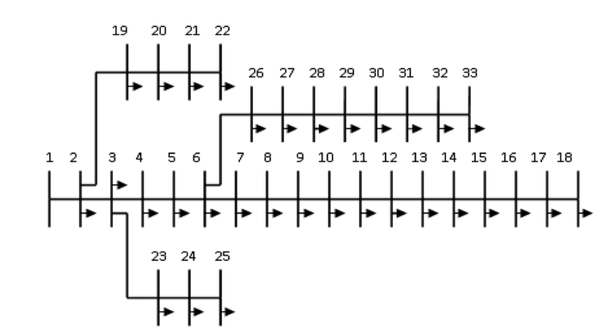

**Figure:** SLD of IEEE 33 Bus Test System

The system has a total 3.715 MW load distributed in the rest 32 buses apart from slack bus. Total reactive load of the system is 2.3 MVAR. Line data and load data in different bus are given in the following chart.

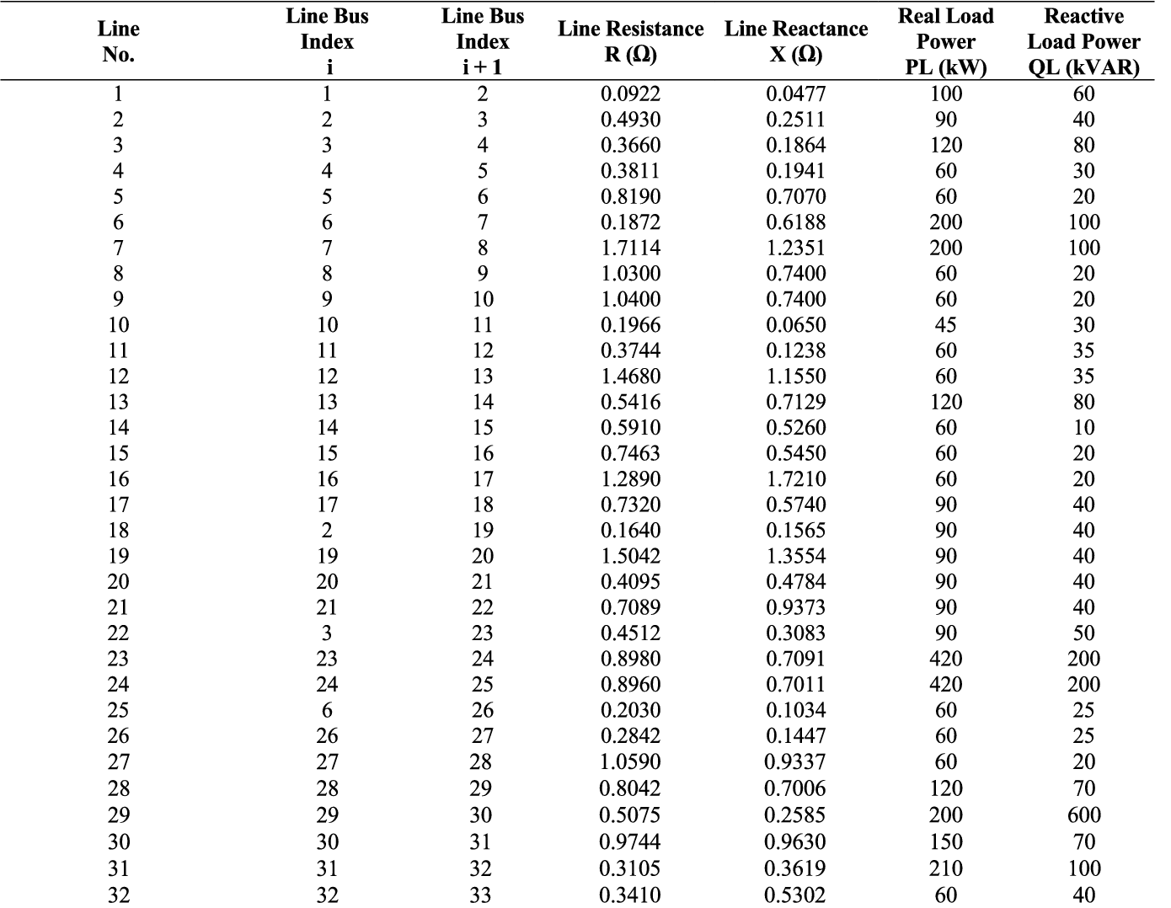

After doing forward-backward sweep power flow on this system, obtained power loss is 211 kW and 143 kVar. If the summation of the absolute voltage difference from the rated per unit value is calculated, it will be almost 1.8045. The voltage profile after load flow is demonstrated bleow:



**DG Types and Modelling**

Distributed generators are small-scale power generation systems that can be located near or at the point of electricity consumption. These generators are connected to the distribution network and can provide backup power or help meet local demand during peak periods. There are different types of distributed generators are available. Common types are:​

* **P type DG**: A DG that can only provide active power (P) to the grid, also known as real power. This type of DG is typically used to reduce peak demand and improve reliability.
* **Q type DG:** A DG that can only provide reactive power (Q) to the grid, also known as imaginary power. Reactive power is required to maintain voltage levels and stabilize the grid. Q type DGs are used to regulate voltage and improve power quality​
* **Delivering both P and Q**: A DG that can provide both active and reactive power to the grid in a balanced manner. This type DGs are used to improve the overall power quality and help maintain grid stability.
* **Delivering P, consuming Q:** A DG that can provide both active and reactive power to the grid in an unbalanced manner, which means it can either generate or absorb reactive power. P-jQ type DGs are typically used for local voltage control and to reduce grid losses.

The DG that is used for this project can supply both P and Q. It is modelled as a negative load for the respective bus.

**Objective function:**

The main goal of the proposed algorithm is to determine the best locations for new

distributed generation resources by minimizing distinct functions. The following

objectives are considered:

1. Real Power Loss Reduction.

2. Voltage profile Improvement.

3. Reactive Power Loss Reduction.

Here the objective function F is defined as:

F = w1*f1 +w2*f2 +w3*f3

Where,

f1 = $\sum_{1}^{33}{I_{i}^{2}*R_{i}}$;

f2 = $\sum_{2}^{33}{\frac{{|V}_{i }-V_{rated}|}{V_{rated}}}$;

f3 = $\sum_{1}^{33}{I_{i}^{2}*X_{i}}$

are the normalized power losses, normalized cumulative voltage deviation (CVD) and normalized cost of DG respectively while w1, w2, and w3 are the weighting factors for each of the objective respectively and w1+w2+w3=1.

These parameters should be within constraints to obtain the proper result. The main

constraints in the optimization process in the proposed methodology are:

1. Real Power loss constraint:

Pl w/DG ≤ Pl wo/DG

Where, Pl w/DG is power loss before installing DG and

Pl wo/DG is power loss after installing DG.

1. Voltage constraint: The bus voltage (Vi) at bus i is restricted by its lower and upper limits (Vmin and Vmax) as:
   1. ≤Vi ≤1.05
2. Reactive Power loss constraint:

Ql w/DG ≤ Ql wo/DG

Where, Ql w/DG is power loss before installing DG and Ql wo/DG is power loss after installing DG.

Assumptions: Weights are linearly distributed between the objective functions. So w1=w2=w3=0.33. After future works, an objective weight optimization will be applied.

**Flow Diagram:**

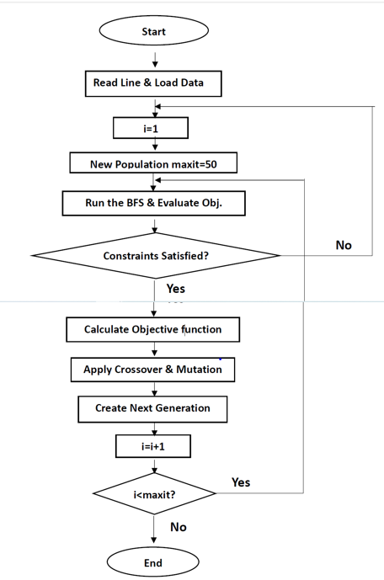

**Results after placing 1 dg:**

|  |  |
| --- | --- |
| Dg Placement | Bus 8 |
| Dg Size | 2 MW |
| Percentage of the total load | 53.835% |
| Power Factor | 0.85 |
| Real power loss | 83.9411 kW |
| Reactive power loss | 64.2178 kVAR |
| Real power loss improvement | 60.217% |
| Reactive power loss improvement | 55.092% |

We instantly notice a significant amount of improvement in real and reactive power losses, which gives an indication of the genetic algorithm’s effective way of finding the optimal location and size of the dg.

**Voltage Profile**

* The summation of all the 33 absolute bus voltages deviations from the 1pu voltage was found to be 0.4535pu averaging 0.0137pu for a single bus. where initially the value of absolute deviation was 1.8045pu averaging .0546pu. So, we can notice nearly 4 times before the pre-optimized condition in terms of average deviation.
* The lowest voltage was found in bus 33 and the value was 0.957579pu. So, the lowest voltage was found in the range of 0.95pu-1.05pu. Previously, it was the 18th bus which had the lowest voltage, and the value of the voltage was 0.9037772pu which was way less than the lowest value of the optimum voltage range.

Here’s a look at the voltage profile after the 1st dg placement:

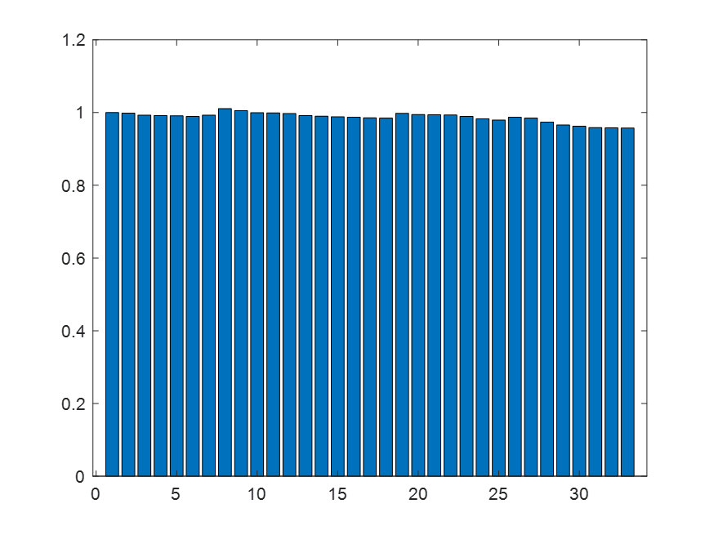

**IEEE 15-bus Radial distribution System Behaviour**

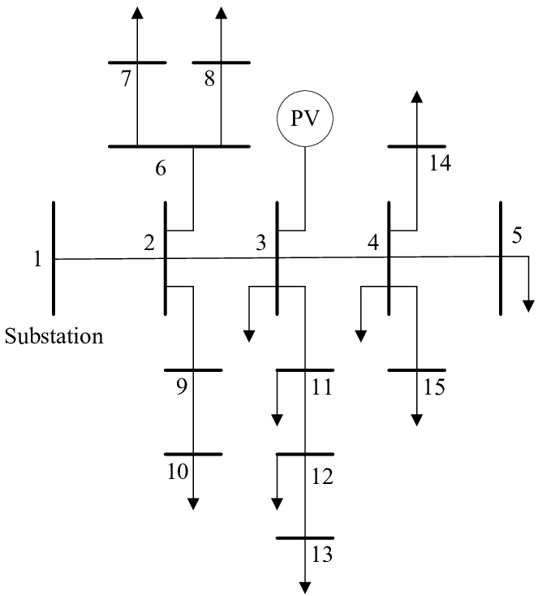

**Figure**: Single Line Diagram of 15-bus Radial System

The IEEE 15-bus radial system is a well-known test system used in power system analysis and simulation studies. The behavior of the system is determined by a number of factors, including the topology of the system, the loading conditions, the type of components used, and the control strategies employed. In general, the IEEE 15-bus radial system exhibits a number of characteristic behaviors, including voltage regulation, load flow control, and fault management.

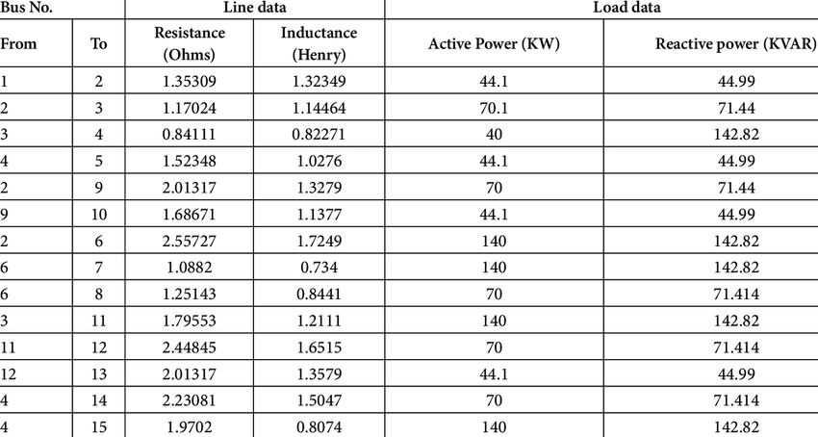

Fig: Line data of the 15-bus Radial system

**Summary of this system**

Total Real Power Load (P) of this radial bus system is 1.1265 MW and reactive power load (Q) is 1.251182 MVar. Base Operating Voltage is 12.66 kV. Base power is 1 MVA.

After Running Load-flow on this system, we got the following voltage profile:



**Figure:** Voltage Profile

We know that healthy voltage limit is 0.95pu to 1.05pu. But from the figure, we can see that most of the buses contain this voltage profile. In worst case, bus 13 has lowest voltage 0.960348 pu. Here,

Total real power loss = 42 kW

Total reactive power loss = 38.57 kVar

Summation of the absolute voltage difference from the rated per unit value = 0.4476

Bus 13 has lowest voltage 0.960348 pu

**IEEE 69-bus Radial Distribution System**

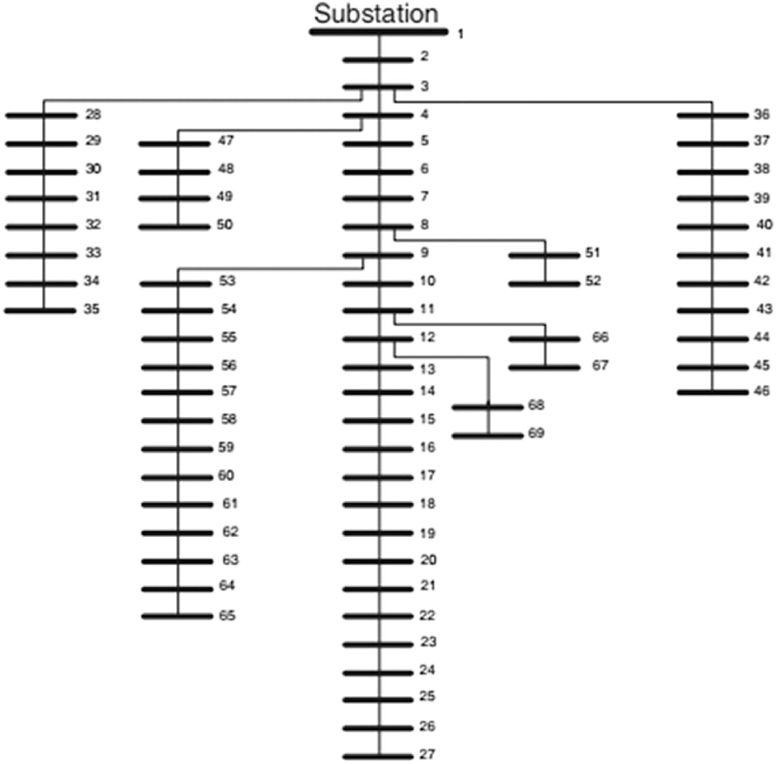

**Figure:** Single Line Diagram

The IEEE 69-bus radial system is another well-known benchmark system in power system analysis, which is often used to test load flow algorithms and techniques. Like the IEEE 15-bus radial system, the IEEE 69-bus radial system is a simplified representation of a distribution feeder, consisting of 69 buses and 68 branches.

System configurations of this distribution are:

Total Real Power Load (P) = 3.802 MW

Total Reactive Power Load (Q) = 2.694 MVar

Base kV = 12.66 kV

Base power = 1 MVA

Line data of the system is given below:

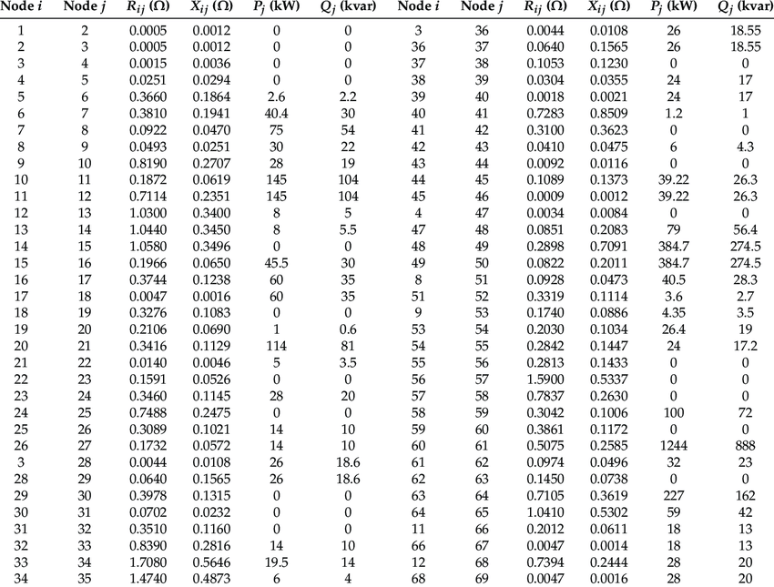

**Load-flow analysis Using forward-backward method**



**Figure:** Voltage Profile

**Load-flow analysis results:**

Total Real Power Loss = 42 kW

Total Reactive Power Loss = 38.57 kVar

Summation of the absolute voltage difference from the rated per unit value = 0.9761

Bus 27 has lowest voltage 0.967458 pu

**Results (After one DG placement) for IEEE 15 Bus Radial System**

After adding a distributed generator in the existing network, the voltage profile of the system gets better as well as the real power loss and the reactive power loss gets minimized. Using the algorithm, we get the following voltage profile:

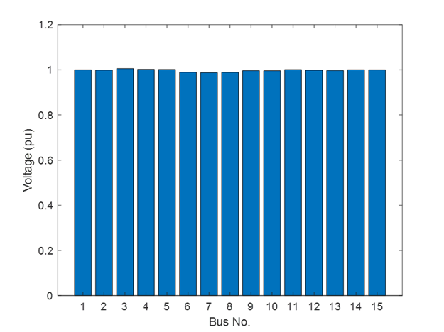

**Figure**: Voltage Profile of the 15 buses system after dg implementation

The value of the different parameters like the losses, DG’s position and value are given below:

|  |  |
| --- | --- |
| Optimal position of DG​ | Bus 3​ |
| Value of DG​ | 1.4218 MW​ |
| Power factor​ | 0.85​ |
| Total Real Power Loss​ | 15.38kW​ |
| Total Reactive Power Loss​ | 12.6565kVar​ |
| Sum of Voltage Deviation of all buses​ | 0.0581pu​ |
| Lowest voltage profile​ | Bus 7​ (0.988059pu)​ |

Here, we can see that the real power loss is reduced by 63.38% and reactive power loss is reduced by 67.19%. These values are huge in numbers. The sum of voltage deviation of the buses from the rated value is improved by 87%. So, the improvement of the system is great.

**Results (After one DG placement) for IEEE 69 Bus Radial System**

Similarly, after adding a DG the improvement of the voltage profile and reduction of losses are also seen in this network.

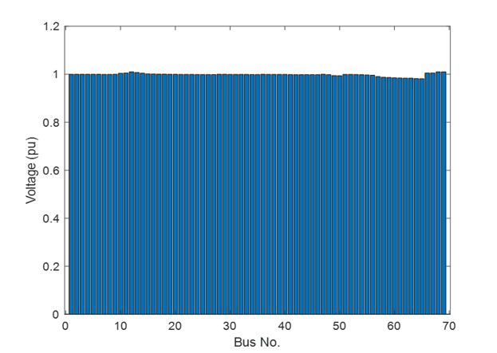

**Figure**: Voltage Profile of the 69 buses system after dg implementation

The value of the different parameters like the losses, DG’s position and value are given below:

|  |  |
| --- | --- |
| Optimal position of DG​ | Bus 12​ |
| Value of DG​ | 1.5131 MW​ |
| Power factor​ | 0.85​ |
| Total Real Power Loss​ | 25.7675kW​ |
| Total Reactive Power Loss​ | 14.3269kVar​ |
| Sum of Voltage Deviation of all buses​ | 0.2430pu​ |
| Lowest voltage profile​ | Bus 65​ (0.9814pu)​ |

In this case the real power loss is reduced from 42kW to 25.7675kW and the reactive power loss is reduced from 38.57kVar to 14.3269kVar. Thus, the improvements of the losses are 38.65% and 62.85% respectively. The sum of the voltage deviation from the rated value is from 0.9761pu to 0.2430pu. Thus, the improvement is 75%.

**Maximum Effective DG Number Estimation**

Deploying DG to certain location or busbar improves voltage profile and reduces loss. If number of such optimally located and sized DG is increasing, then after a number of DG such improvement slows down possibly for voltage variations or intervention on voltage control processes. To find out this effective number of DG in a radial distributed system, optimally located DG is increased gradually and the effect on voltage, real power and reactive power is observed. For the considered three IEEE test systems:

**1. IEEE 15 Bus Test System**

With the increment in the number of DG, initially system total real power loss decreases. But according to the following figure when DG number gets higher than 3, improvement rate drastically falls and instead of getting improved, it starts to fluctuate.



**Figure:** Total Active Power Loss vs Total DG Number (15 Bus System)

Similar behaviour can be observed from the curves of total reactive power loss and total absolute difference of voltage from rated value with respect to DG number.

As significant improvement can’t be instilled into this 15 bus network after 3 optimally placed DG, recommended maximum effective DG number for this test system will be 3.



**Figure:** Total Reactive Power Loss vs Total DG Number (15 Bus System)



**Figure:** Total Absolute Voltage Difference vs Total DG Number (15 Bus System)

**2. IEEE 33 Bus Test System**

Same as before increment in DG number initially brings positive output, but after an effective number, observed curves of real, reactive power loss and improvement in voltage deviates from being improved and starts to fluctuate.



**Figure:** Total Active Power Loss vs Total DG Number (33 Bus System)



**Figure:** Total Reactive Power Loss vs Total DG Number (33 Bus System)



**Figure:** Total Absolute Voltage Difference vs Total DG Number (33 Bus System)

For this 33 bus system, up to 4 DG, presented figures indicate significant improvement. On the other hand, after 9 DG, instead of getting improvement, fluctuation starts. Thus maximum effective number of DG for this system is 4.

**3. IEEE 69 Bus Test System**

For the last case, number of buses is increased up to 69. But this IEEE test system has total active power and reactive power load similar to IEEE 33 Bus Test System. This hints that similar number of DG as the previous case should be achieved here.

Following the previous two cases, number of DGs are increased and behaviour of loss of active, reactive power and improvement of voltage is recorded. Respective curves suggest 4 maximum effective optimally placed DG number for this 69 bus system as we can see from the following figures that up to that DG number, noteworthy amelioration occurs. Also when DG number gets higher than 6, irregular rising and falling appears instead of improvement.



**Figure:** Total Active Power Loss vs Total DG Number (33 Bus System)



**Figure:** Total Active Power Loss vs Total DG Number (33 Bus System)



**Figure:** Total Absolute Voltage Difference vs Total DG Number (33 Bus System)

A summary of the findings is given below:

|  |  |  |
| --- | --- | --- |
| **Test System** | **Effective DG number**  **(Significant Improvement)** | **Effective DG number**  **(Before Fluctuation)** |
| IEEE 15 Bus System | 3 | 3 |
| IEEE 33 Bus System | 4 | 9 |
| IEEE 69 Bus System | 4 | 6 |

**Conclusion**

This project provides a thorough investigation on finding out the effects of optimally placed and sized DG on three different radially distributed system. Genetic Algorithm is used for the optimization process and forward backward sweep power flow method is utilized for the load flow of the system. Inclusion of such optimal DG enhances respective power loss and voltage profile. But gradual increment in their number eventually reaches an effective number after which this improvement rate falls and fluctuation starts. This maximum effective number of optimally placed DG is also analysed for these systems. Thus, this project can help to find out not only optimally placed and sized DG based on power loss and voltage profile but also can provide a guideline about maximum DG that should be installed in the system. For future development, transmission system network, comparison between different DG source like fossil fuel, renewable energy etc, cost analysis will be included.

**References**

1. Abou El-Ela, A.A., El-Sehiemy, R.A., Kinawy, A.-M. and Mouwafi, M.T. (2016), Optimal capacitor placement in distribution systems for power loss reduction and voltage profile improvement. IET Gener. Transm. Distrib., 10: 1209-1221.
2. S. H. Lee and J. -W. Park, "Optimal Placement and Sizing of Multiple DGs in a Practical Distribution System by Considering Power Loss," in IEEE Transactions on Industry Applications, vol. 49, no. 5, pp. 2262-2270, Sept.-Oct. 2013, doi: 10.1109/TIA.2013.2260117.
3. Babaei, Ebrahim et al. “Optimal Placement of DG Units Considering Power Losses Minimization and Voltage Stability Enhancement in Power System.” Journal of Automation and Control Engineering 3 (2014)
4. Hamidan, Mohammad-Ali, and Farzaneh Borousan. "Optimal planning of distributed generation and battery energy storage systems simultaneously in distribution networks for loss reduction and reliability improvement." *Journal of Energy Storage* 46 (2022): 103844.
5. Hamidan, Mohammad-Ali, and Farzaneh Borousan. "Optimal planning of distributed generation and battery energy storage systems simultaneously in distribution networks for loss reduction and reliability improvement." *Journal of Energy Storage* 46 (2022): 103844.
6. Hossain, Shah Mohazzem, and Abdul Hasib Chowdhury. "Multi-objective optimal placement of distributed generations for dynamic loads." *International Journal of Electrical & Computer Engineering (2088-8708)* 9, no. 4 (2019).