**BANGLADESH UNIVERSITY OF ENGINEERING AND TECHNOLOGY**



**Department of Electrical and Electronic Engineering**

**Course No. :**  EEE 310 **Group No. :** 3

**Course Title:** Communication Laboratory

**Project Report:** Study of Different Multiplexing Techniques and Comparison Among Them

**Group members:**

1. Md. Sabbir Hossen Bijoy; Id:1706074

2. Ahadur Rahman; Id:1706075

3. Khandaker Khairuzzaman; Id: 1706076

4. Kazi Ishrak Ahmed; Id:1706077

**Level/ Term :** 3/1

**Section:** B

**Title: Study of different multiplexing techniques and comparison among them**

**Objectives:**

* To examine signal sampling, aliasing, and signal reconstruction.
* To implement time division, frequency division, and code division multiplexing systems using MATLAB Simulink.
* To understand fundamental concepts of spread spectrum communication systems.

**Abstract:**

In telecommunications and computer networks, multiplexing (sometimes contracted to muxing) is a method by which multiple analog or digital signals are combined into one signal over a shared medium. The multiplexed signal is transmitted over a communication channel such as a cable. The multiplexing divides the capacity of the communication channel into several logical channels, one for each message signal or data stream to be transferred. A reverse process, known as demultiplexing, extracts the original channels on the receiver end. A device that performs the multiplexing is called a multiplexer (MUX), and a device that performs the reverse process is called a demultiplexer (DEMUX or DMX).

We have implemented 3 multiplexing techniques: FDM, TDM, CDM

* **Frequency Division Multiplexing:** Frequency division multiplexing (FDM) is a technique of multiplexing that means combining more than one signal over a shared medium. In FDM, signals of different frequencies are combined for concurrent transmission. It allows sharing of a single transmission medium like a copper cable or a fiber optic cable, among multiple independent signals generated by multiple users. FDM has been popularly used to multiplex calls in telephone networks. It can also be used in cellular networks, wireless networks, and satellite communications.
* **Time Division Multiplexing:** Time-division multiplexing (TDM) is a method of transmitting and receiving independent signals over a common signal path through synchronized switches at each end of the transmission line so that each signal appears on the line only a fraction of time in an alternating pattern. This method transmits two or more digital signals or analog signals over a common channel. It can be used when the bit rate of the transmission medium exceeds that of the signal to be transmitted. TDM is used in the GSM telephone system, the plesiochronous digital hierarchy (PDH) system, also known as the PCM system, for digital transmission of several telephone calls over the same four-wire copper cable (T-carrier or E-carrier) or fiber cable in the circuit-switched digital telephone network, the synchronous digital hierarchy (SDH)/synchronous optical networking (SONET) network transmission standards, the Basic Rate Interface and Primary Rate Interface for the Integrated Services Digital Network (ISDN), the RIFF (WAV) audio standard interleaves left and right stereo signals.
* **Code Division Multiplexing:**  Code division multiplexing (CDM) is a multiplexing technique that uses spread spectrum communication. In spread spectrum communications, a narrowband signal is spread over a larger band of frequency or across multiple channels via division. It does not constrict bandwidth’s digital signals or frequencies. It is less susceptible to interference, thus providing better data communication capability and a more secure private line.

**Frequency Division Multiplexing**

**Methodology:**

* **Concept & Process**

In FDM, the total bandwidth is divided into a set of frequency bands that do not overlap. Each of these bands is a carrier of a different signal that is generated and modulated by one of the sending devices. The frequency bands are separated from one another by strips of unused frequencies called the guard bands, to prevent overlapping of signals.

The modulated signals are combined using a multiplexer (MUX) in the sending end. The combined signal is transmitted over the communication channel, thus allowing multiple independent data streams to be transmitted simultaneously. At the receiving end, the individual signals are extracted from the combined signal by the process of demultiplexing (DEMUX).

* **Example**

The following diagram conceptually represents multiplexing using FDM. It has 4 frequency bands, each of which can carry a signal from 1 sender to 1 receiver. Each of the 4 senders is allocated a frequency band. The four frequency bands are multiplexed and sent via the communication channel. At the receiving end, a demultiplexer regenerates the original four signals as outputs.

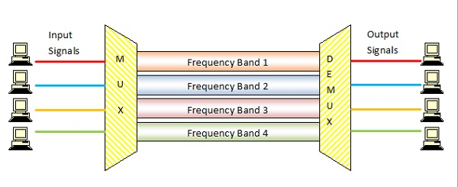

Here, if the frequency bands are of 150 kHz bandwidth separated by 10KHz guard bands, then the capacity of the communication channel should be at least 630 kHz (channels: 150 × 4 + guard bands: 10 × 3).

**Simulation Process**

* **FDM Transmitter:** The below figure shows the block diagram of an FDM transmitter.

[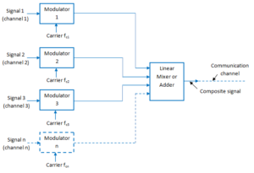](https://electronicspost.com/wp-content/uploads/2016/04/FDM-transmitter.png)

Fig: FDM Transmitter

The signals which are to be multiplexed will each modulate a separate carrier. The type of modulation can be AM, SSB, FM, or PM. The modulated signals are then added together to form a complex signal which is transmitted over a single channel.

* **Working Operation of the FDM Transmitter:** Each signal modulates a separate

carrier. The modulator outputs will contain the sidebands of the corresponding signals. The modulator outputs are added together in a linear mixer or adder. The linear mixer is different from the normal mixers. Here the sum and difference frequency components are not produced. But only the algebraic addition of the modulated outputs will take place. Different signals are thus added together in the time domain but they have a separate identity in the frequency domain. The composite signal at the output of the mixer is transmitted over the single communication channel as shown in the figure. This signal can be used to modulate a radio transmitter if the FDM signal is to be transmitted through the air.

* **FDM Receiver:** The block diagram of an FDM receiver is shown in the following figure.

[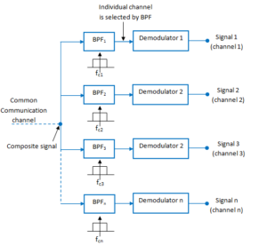](https://electronicspost.com/wp-content/uploads/2016/04/FDM-receiver.png)

Fig.3: FDM Receiver

The composite signal is applied to a group of bandpass filters (BPF). Each BPF has a center frequency corresponding to one of the carriers. The BPFs have an adequate bandwidth to pass all the channel information without any distortion. Each filter will pass only its channel and rejects all the other channels. The channel demodulator then removes the carrier and recovers the original signal back.

**Simulink Model Diagram:**

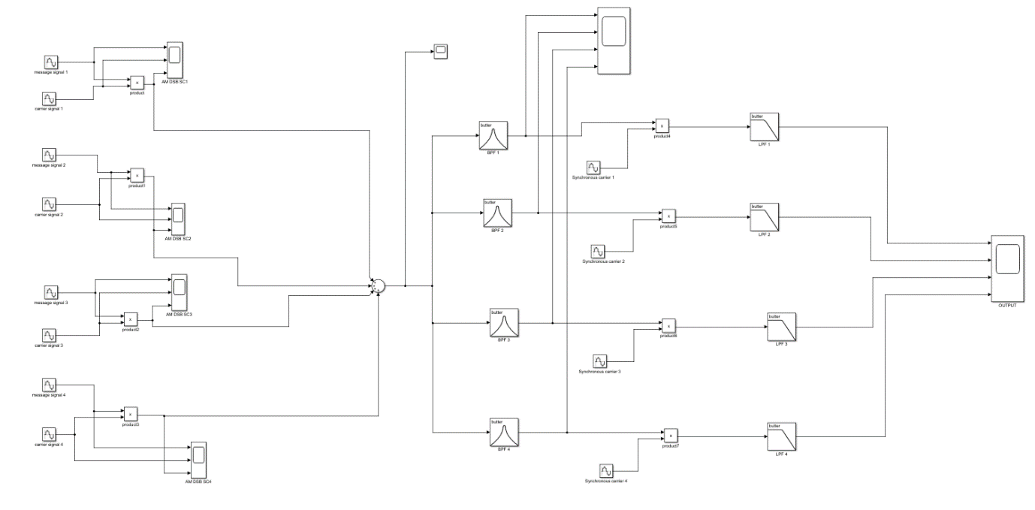

**Result:**

We have chosen four single tone sinusoid message signals of 2V p-p amplitude & modulating frequency were respectively from 5 to 20 Hz equally spaced.

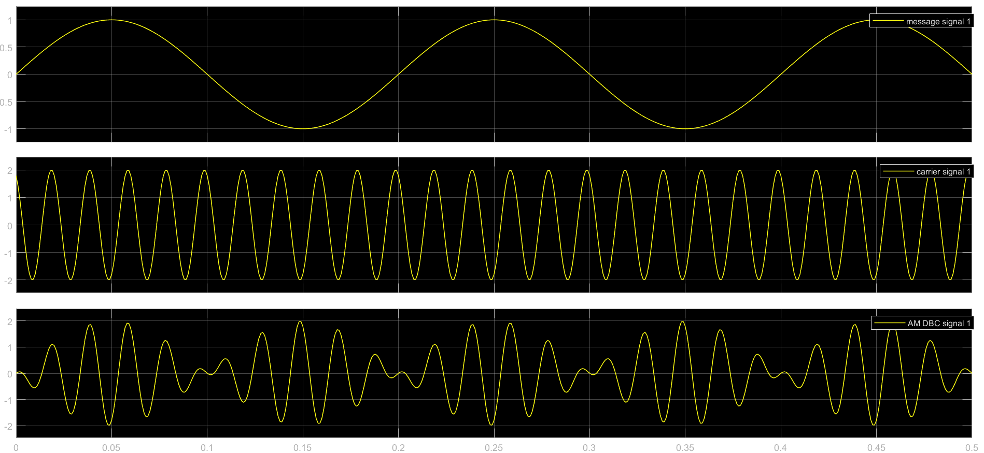

We performed DSB + C modulation & for that carrier waves of 2V p-p & fc were chosen from 50 Hz to 200 Hz equally spaced.

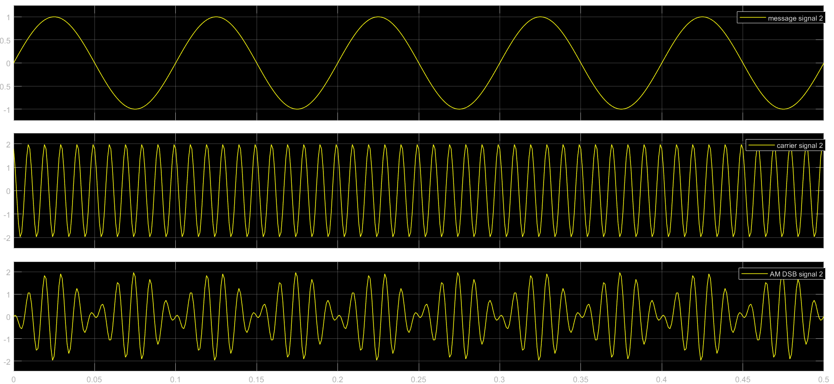

It should be noted that the carrier amplitude & wave were chosen such that no phase reversal can occur.

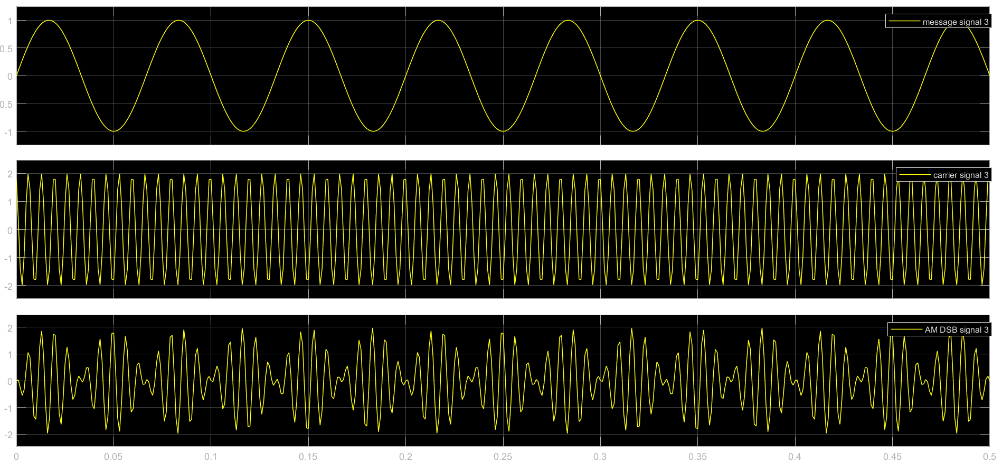

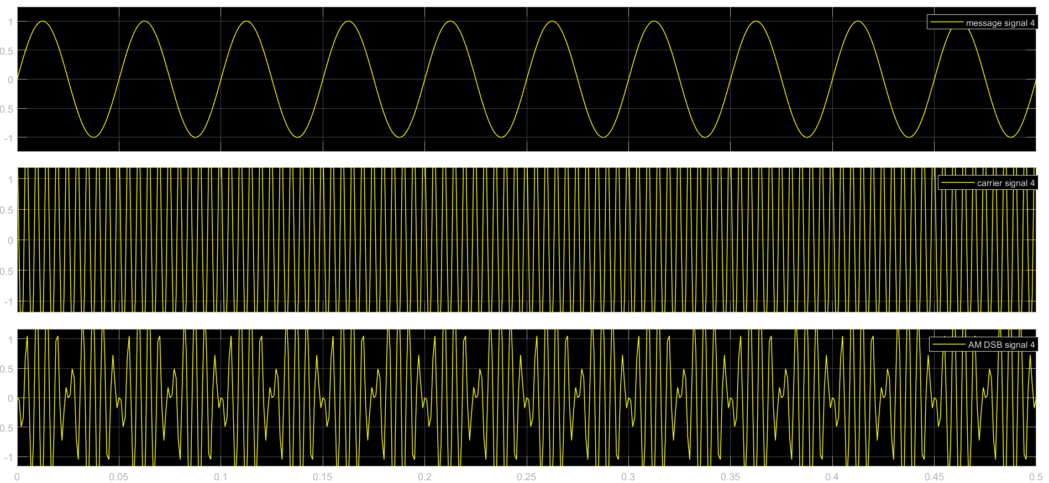

Followed that, the modulated signal has been multiplexed & passed through the channel.

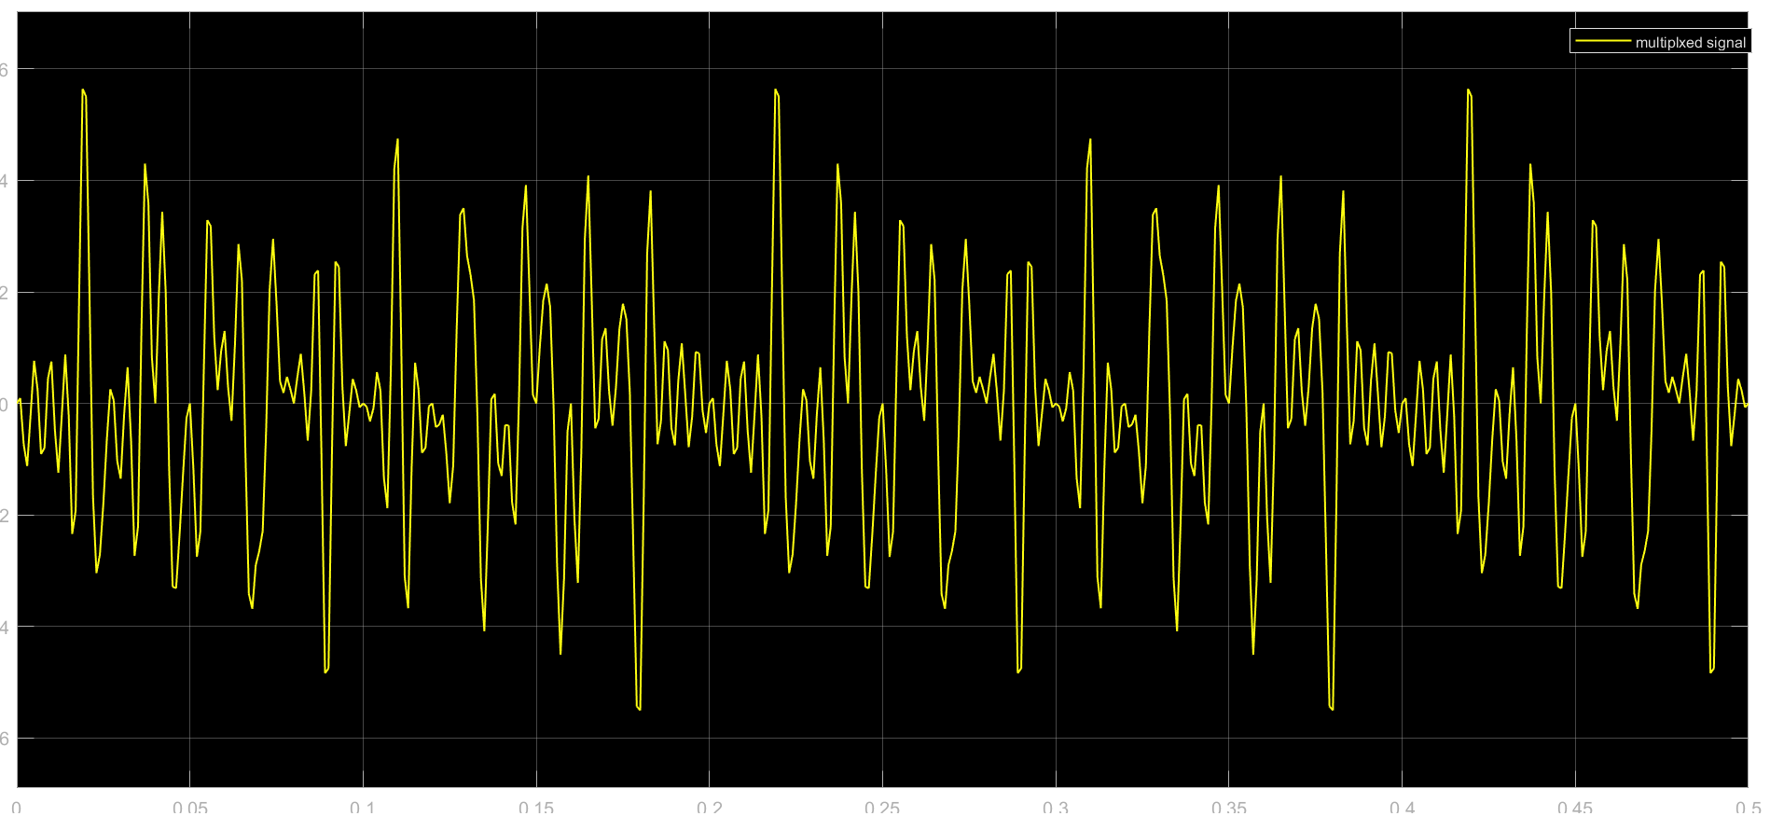

On the receiver side, the signal has been demultiplexed using a bandpass filter. The bandpass filter has been designed following the carrier frequencies of the message signals and symmetry concerning them.

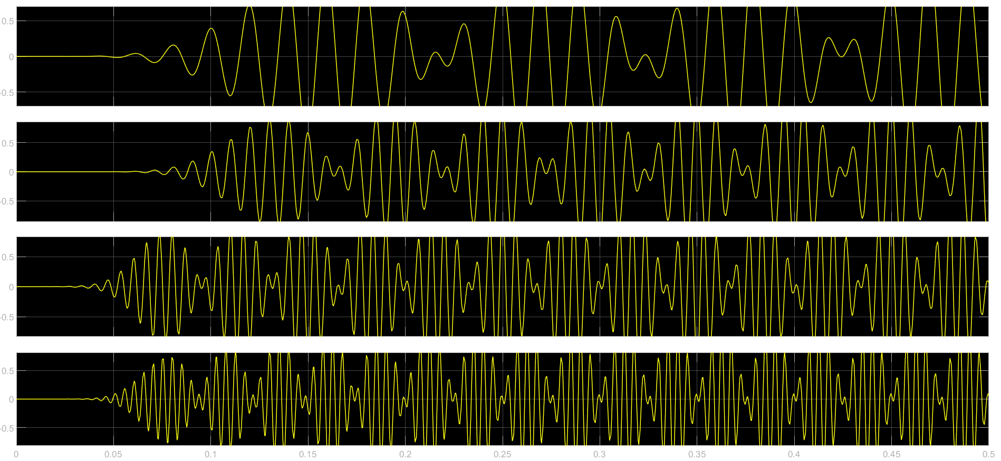

We chose the carrier frequency and message signal bandwidth such that no aliasing could happen.

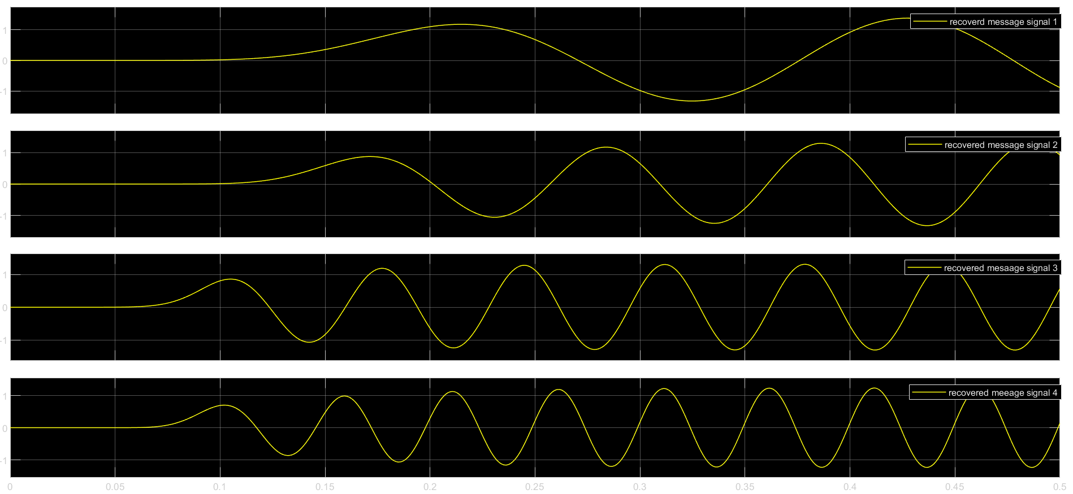

Finally, the signals have been demodulated through respective synchronized carriers & passed through the low pass filters to get rid of the unnecessary high-frequency components & thus the message signals have been redeemed.

**Time Division Multiplexing**

**Methodology:**

* **Concept and Process:**

In TDM, the data flow of each input stream is divided into units. One unit maybe 1 bit, 1 byte, or a block of few bytes. Each input unit is allotted an input time slot. One input unit corresponds to one output unit and is allotted an output time slot. During transmission, one unit of each of the input streams is allotted a one-time slot, periodically, in a sequence, on a rotational basis. This system is popularly called the round-robin system.

The modulated signals are combined using a multiplexer (MUX) in the sending end. The combined signal is transmitted over the communication channel, thus allowing multiple independent data streams to be transmitted simultaneously. At the receiving end, the individual signals are extracted from the combined signal by the process of demultiplexing (DEMUX).

* **Example:**

A system having four input streams, A, B, C, and D. Each of the data streams is divided into units that are allocated time slots in a round-robin manner. Hence, the time slot 1 is allotted to A, slot 2 is allotted to B, slot 3 is allotted to C, slot 4 is allotted to D, slot 5 is allocated to A again, and this goes on till the data in all the streams are transmitted.

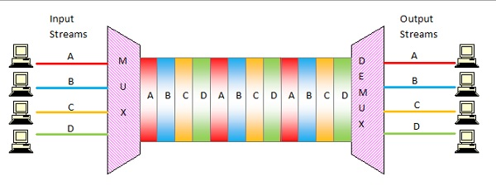

**Simulation Process:**

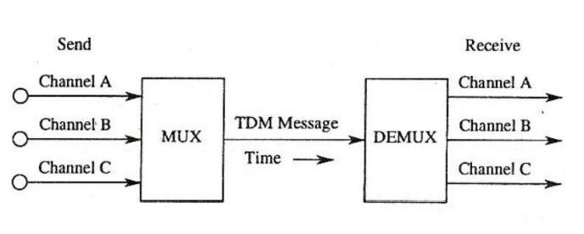

**Figure:** Illustration of TDM MUX and DEMUX

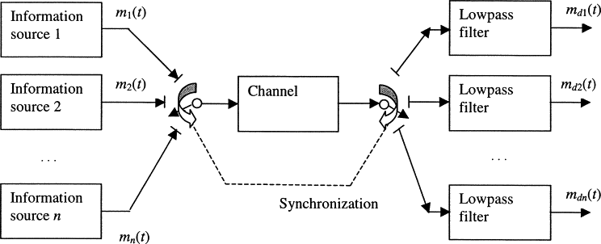

Time-division multiplexing can be applied in instances where the messages are represented in pulse modulation format. Here pulse amplitude modulation is used to represent the messages m1(t), m2(t),…, mn(t), which are now assumed to all be of bandwidth W Hz. A commutator samples each message in turn, which according to the sampling theorem must be at a minimum rate of 2W samples per second per message. At the receiving end, a second commutator, which is synchronized with the one at the transmitting end, deinterleaves the samples corresponding to the respective messages. A low-pass filter then allows the recovery of each message from its sample values. Using the sampling theorem in reverse, it can be shown that the theoretical minimum transmission bandwidth requirement for TDM is the same as that for FDM.

**Simulink Model Diagram:**

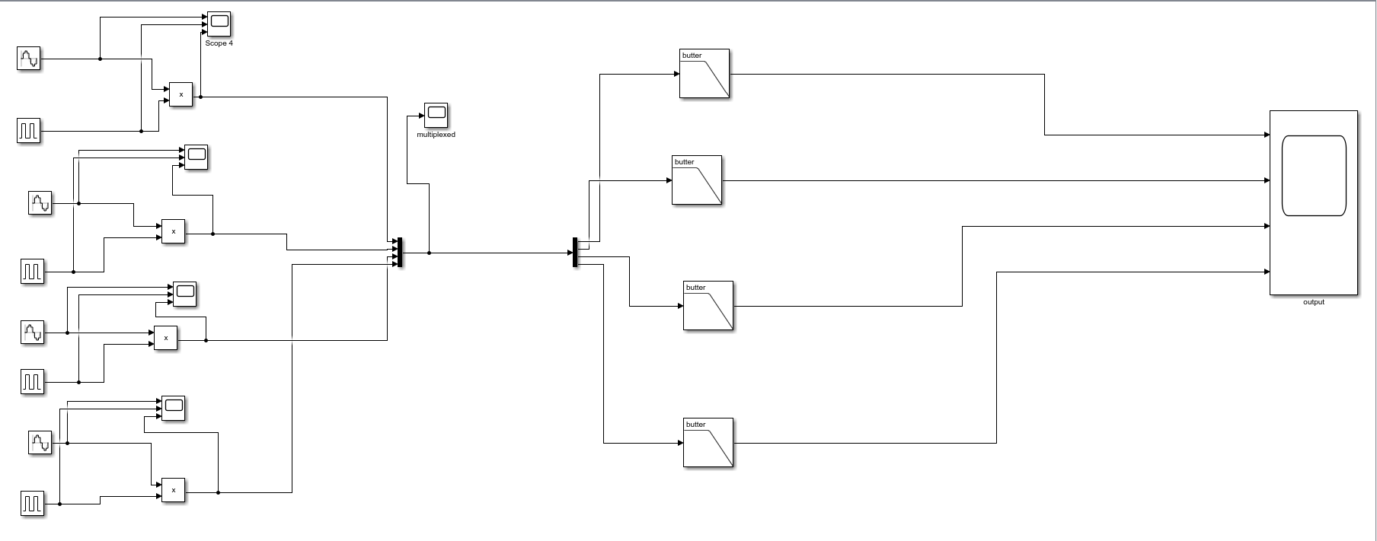

**Result:**

We have chosen four single-tone sinusoidal signals of amplitude 1V and period 10s, 5s, 2s, and 1s respectively. Each signal is sampled with a pulse train of amplitude 1V.

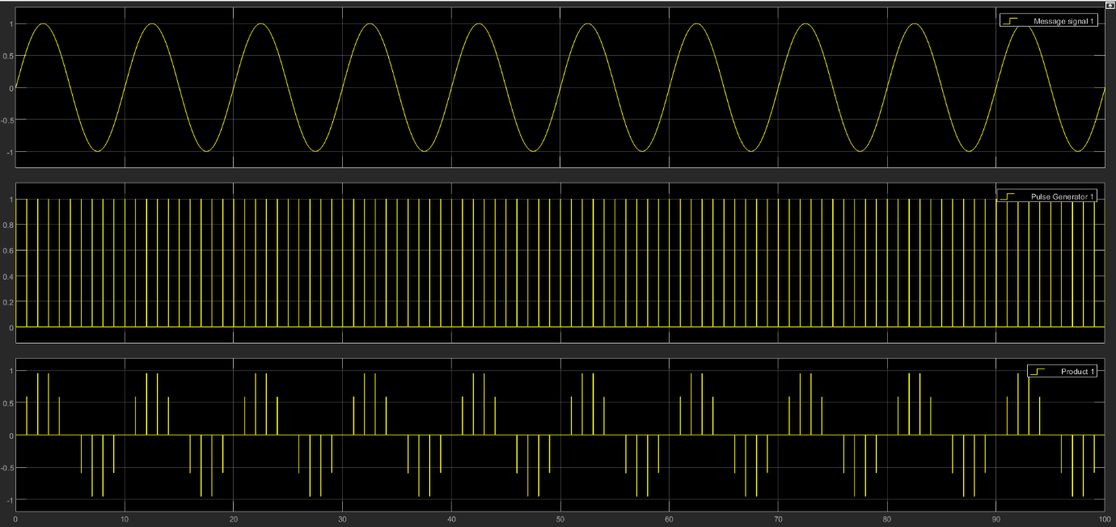

**Figure:** Message signal 1 and sampled signal

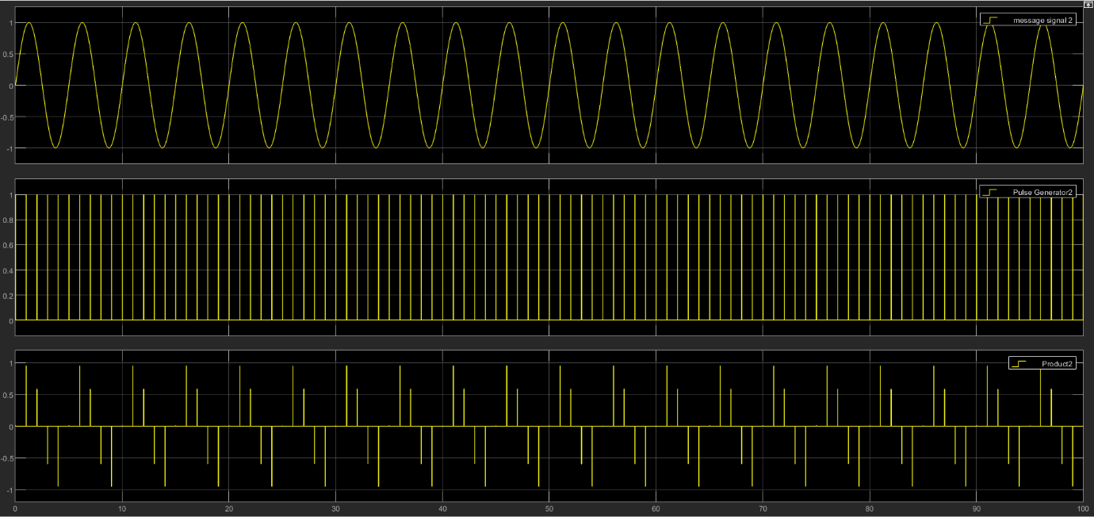

**Figure:** Message signal 2 and sampled signal

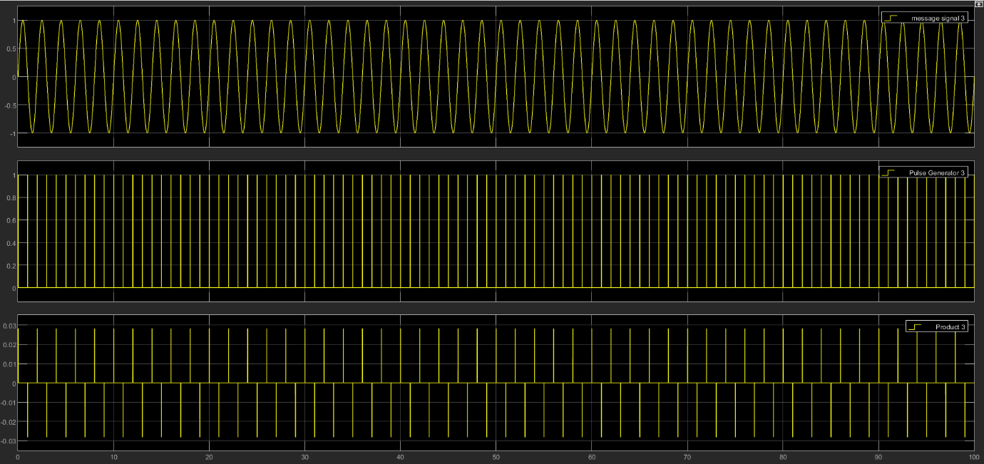

**Figure:** Message signal 3 and sampled signal

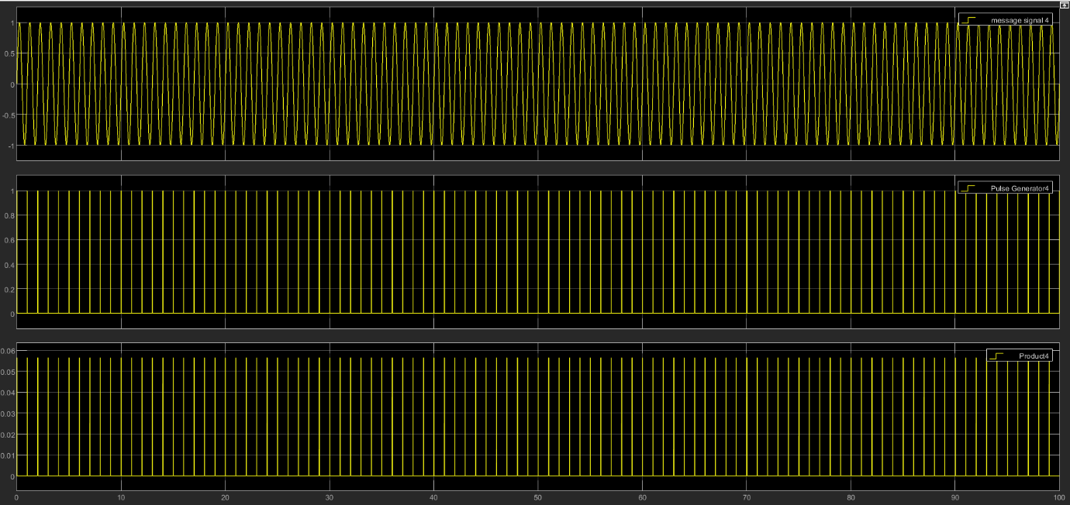

**Figure:** Message signal 4 and sampled signal

Followed that, the sampled signals have been multiplexed & passed through the channel. The MUX block combines its 4 inputs into a single output.

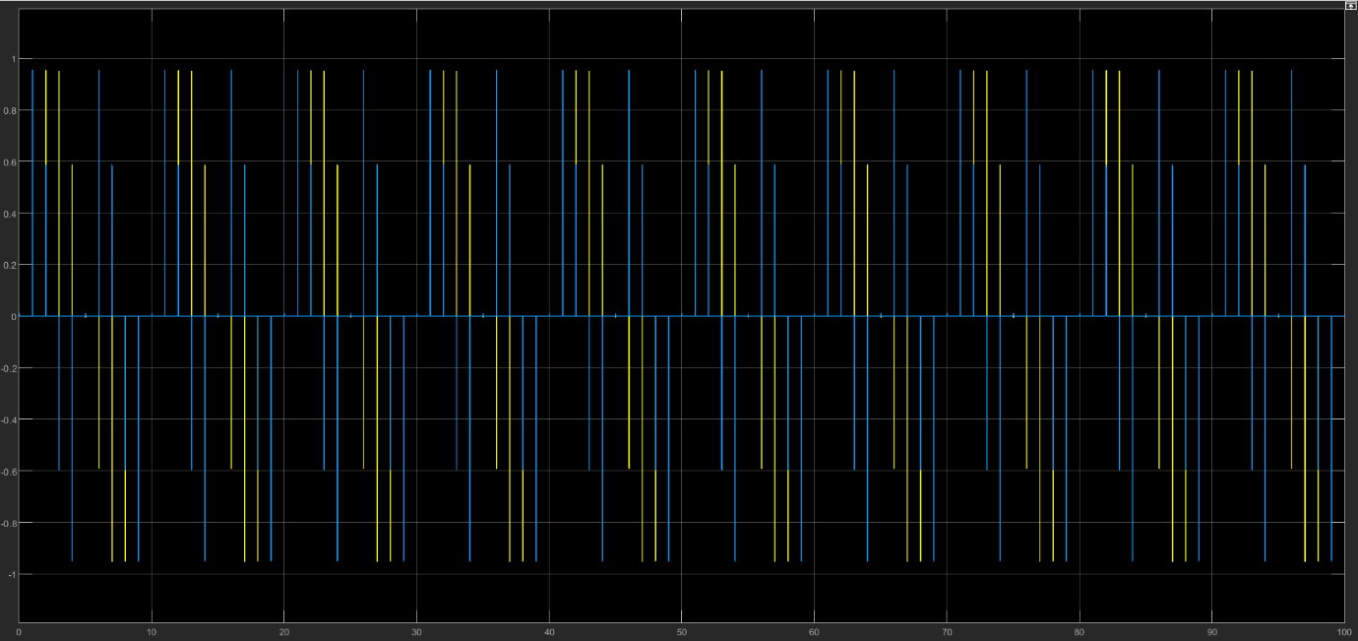

**Figure:** Multiplexed output

Then the multiplexed output is passed through the channel and goes into the DEMUX block that extracts the components of an input signal and outputs the components as separate signals. On the receiver side, the signal has been demultiplexed and message signals have been reconstructed using Butterworth lowpass filters. The lowpass filters have been designed following the carrier frequencies of the message signals and symmetry concerning them.

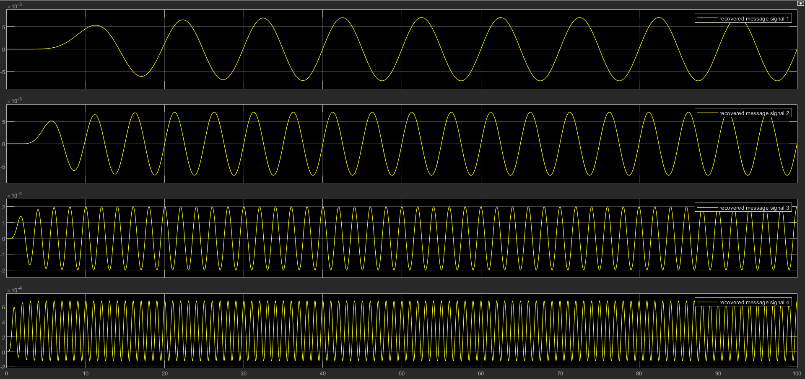

**Figure:** Demultiplexed recovered output

Thus all of our 4 message signals have been recovered.

**Code Division Multiplexing**

**Methodology**

* **Concept & Process**

Each communicating station is assigned a unique code. The codes stations have the following properties −

* If the code of one station is multiplied by the code of another station, it yields 0.
* If the code of one station is multiplied by itself, it yields a positive number equal to the number of stations.

The communication technique can be explained by the following example −

Consider that there are four stations w, x, y and z that have been assigned the codes cw , cx, cy and cz and need to transmit data dw , dx, dy and dz respectively. Each station multiplies its code with its data and the sum of all the terms is transmitted in the communication channel.

Thus, the data in the communication channel is dw . cw+ dx . cx+ dy . cy+ dz . cz

Suppose that at the receiving end, station z wants to receive data sent by station y. In order to retrieve the data, it will multiply the received data by the code of station y which is dy.

data = (dw . cw+ dx . cx+ dy . cy+ dz . cz ) . cy

= dw . cw . cy + dx . cx . cy+ dy . cy . cy+ dz . cz .

cy

=0 + 0 + dy . 4 + 0 = 4dy

Thus, it can be seen that station z has received data from only station y while neglecting the other codes.

* **Orthogonal Sequences**

The codes assigned to the stations are carefully generated codes called chip sequences or more popularly orthogonal sequences. The sequences are comprised of +1 or –1. They hold certain properties to enable communication.

* The properties are −
* A sequence has *m* elements, where *m* is the number of stations.
* If a sequence is multiplied by a number, all elements are multiplied by that number.
* For multiplying two sequences, the corresponding positional elements are multiplied and summed to give the result.
* If a sequence is multiplied by itself, the result is *m*, i.e. the number of stations.
* If a sequence is multiplied by another sequence, the result is 0.
* For adding two sequences, we add the corresponding positional elements.

Let us ascertain the above properties through an example.

Consider the following chip sequences for the four stations w, x, y and z −

[+1 -1 -1 +1], [+1 +1 -1 -1], [+1 -1 +1 -1] and [+1 +1 +1 +1]

* Each sequence has four elements.
* If [+1 -1 -1 +1] is multiplied by 6, we get [+6 -6 -6 +6].
* If [+1 -1 -1 +1] is multiplied by itself, i.e. [+1 -1 -1 +1]. [+1 -1 -1 +1], we get +1+1+1+1 = 4, which is equal to the number of stations.
* If [+1 -1 -1 +1] is multiplied by [+1 +1 -1 -1], we get +1-1+1-1 = 0
* If [+1 -1 -1 +1] is added to [+1 +1 -1 -1], we get [+2 0 -2 0].

The commonly used orthogonal codes are **Walsh codes**.

**Simulation Process:**

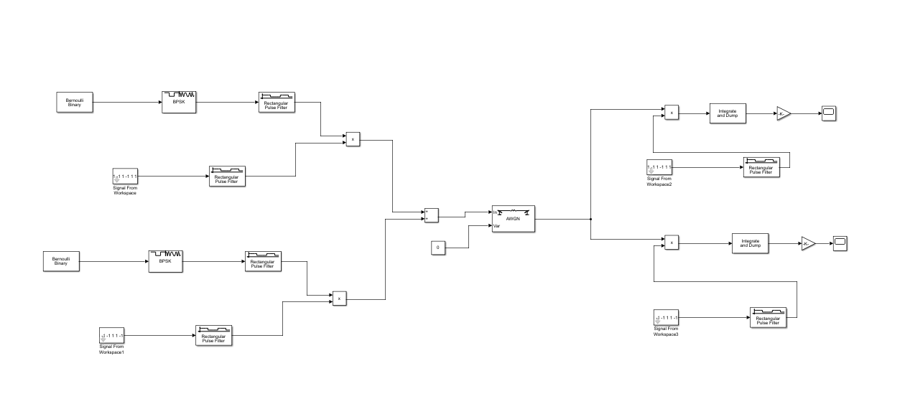

**Figure:** Simulink block diagram

In the transmitter portion of the model, the Bernoulli Binary Generator block generates random binary numbers using a Bernoulli distribution. This block acts as our message source in the simulation. The BPSK Baseband Modulation block applies BSPK modulation to the message bits. The output of this block connects to an Ideal Rectangular Filter block, which translates the BPSK symbols into rectangular pulses. The sequences [1 -1 -1 1 -1 1 1 -1] and [1 1 -1 -1 1 1 -1 -1] are the spreading codes for User 1 and User 2, respectively. The Add block is used to sum the User 1 and User 2 coded messages into a single transmission.

The AWGN Channel block has been added to see the effects of the noise on the system.

In the receiver portion of the model, The Delay block allows you to delay the receiver spreading sequence used relative to the one used in the transmitter. The Product block performs the despreading operation in the receiver. The Integrate and Dump block integrates the received pulses, which can be thought of as part of the ideal correlation receiver (or the matched filtering process).

**Result:**

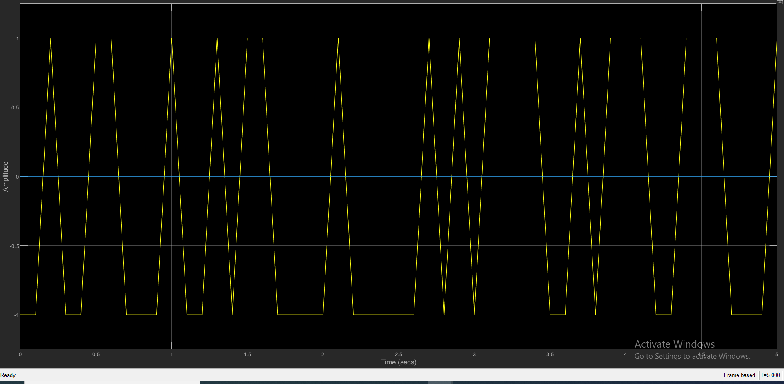

In this time scope, we can see that the message signal has been encoded and passed through the transmission channel.

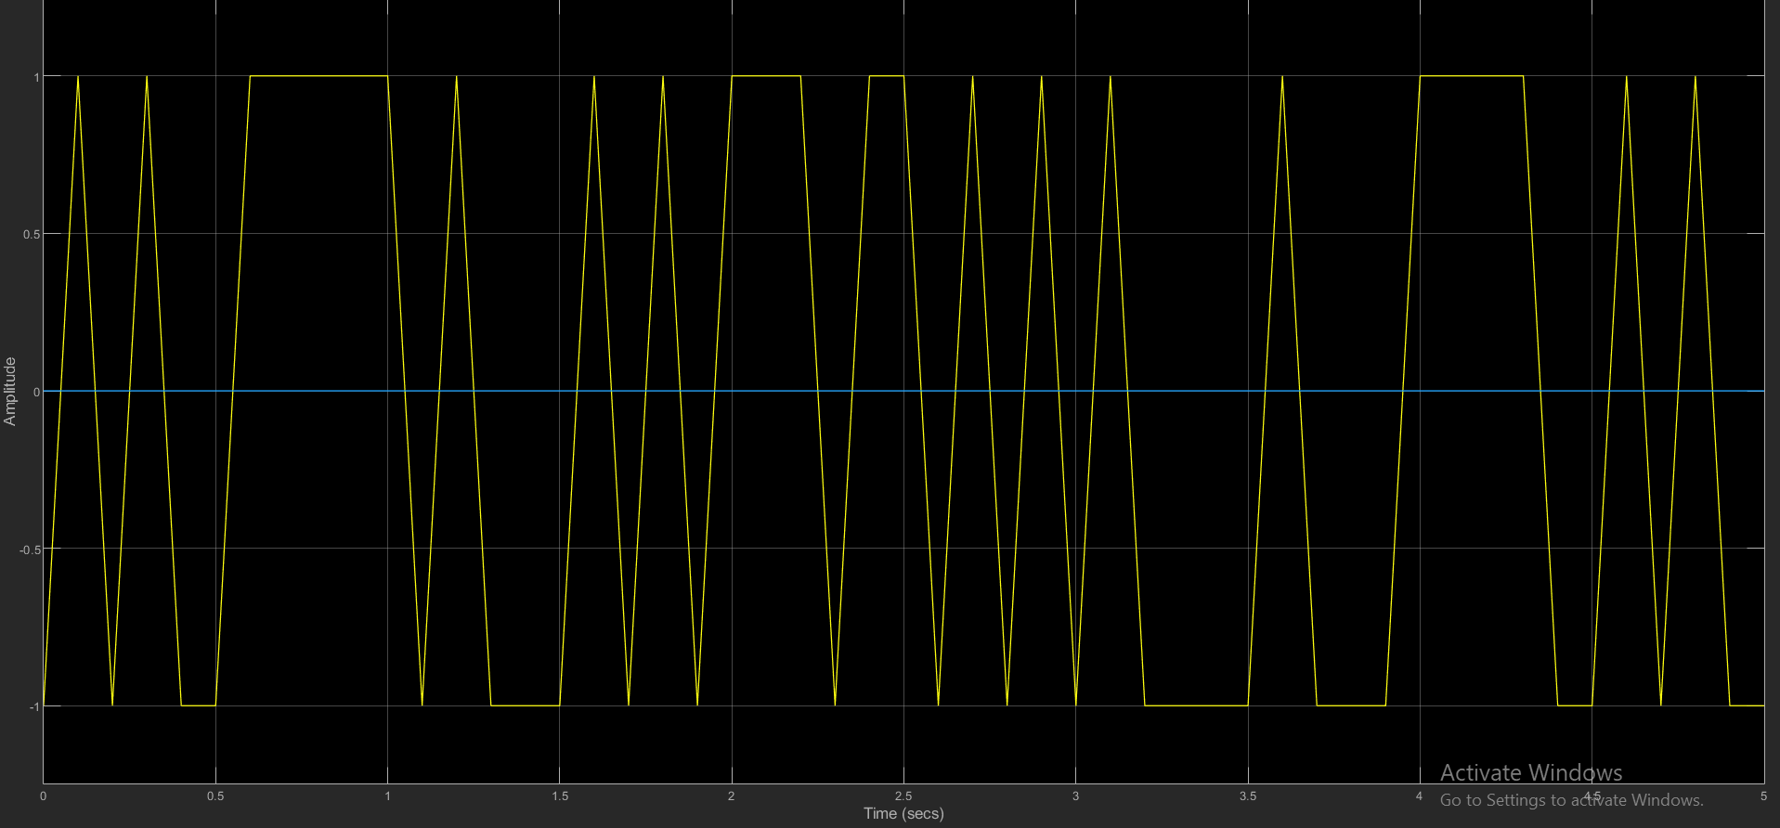

Here in this time scope, we can see that the signal has been retrieved.

**Future improvements**

Instead of sinusoidal signals, we want to pass our speech signals to see the output. OFDM is a technique where the channel bandwidth is split into many closely packed sub-carriers or narrowband channels each of which transmits signals independently using techniques like QAM (Quadrature Amplitude Modulation). Consequently, they do not need any guard bands and thus have better utilization of available bandwidth. STDM is often used for managing data being transmitted via a local area network (LAN) or a wide area network (WAN). We want to implement this in our system in the future. Applications of optical [code division multiplexing](https://www.sciencedirect.com/topics/computer-science/code-division-multiplexing) (OCDM) to multi-tera bit/s [photonic](https://www.sciencedirect.com/topics/engineering/photonics) network are introduced. A high spectrum efficiency OCDM/WDM transmission as a link technology, and a transparent virtual optical code/wavelength path (VOCP/VWP) network as a node technology are highly used.

**Comparison:**

|  |  |  |
| --- | --- | --- |
| **FDM** | **TDM** | **CDM** |
| In this, sharing of bandwidth among different stations takes place | In this, only the sharing of time of satellite transponder takes place | In this, there is sharing of both i.e. bandwidth and time among different stations takes place |
| There is no need of any codeword. | There is no need of any codeword | Codeword is necessary |
| In this, there is only a need for guard bands between the adjacent channels are necessary | In this, a guard time of the adjacent slots is necessary | In this, both guard bands and guard time are necessary |
| Synchronization is not required. | Synchronization is required. | Synchronization is not required. |
| The rate of data is low | The rate of data is medium | The rate of data is high |
| It is a little flexible | It is moderate flexible | It is highly flexible |

**Conclusion:**

In this project, we have implemented the simulation of multiplexing techniques of several signals and reconstruction of our signals. Both TDM & CDM are digital modulation whereas FDM is analog modulation. Though CDM is somewhat costly, it provides with better security.