Notes
Components: For the flight computer, there are some critical parts we need, we need to compare with the reference project, cross check its availability in turkiye and see the replacements.

Component | Ref. component | Replacement(if needed) | Better | Link(if any)
MCU | STM32F405RGT6 | STM32F446RET6 | STM32F407VET6 (100 pin version of ref) | Trendyol link
IMU/GYRO | MPU6000 | MPU9350

MCU:
As the reference component cannot be found easily, which is STM32F405RGT6, we need to work with STM32F446RET6. They are both from the F4 family, so we need to check the pin-outs and other requirements for operation. we need to keep looking at their physical specs.

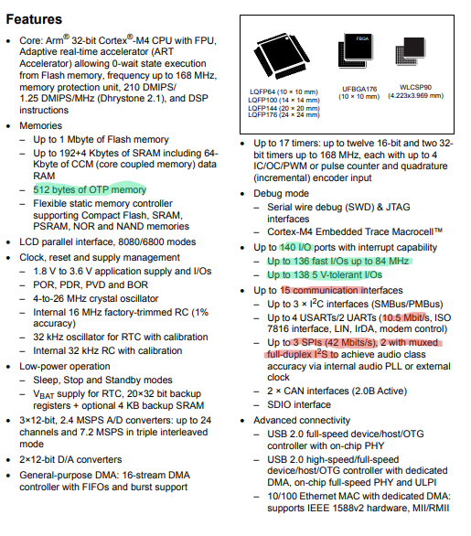
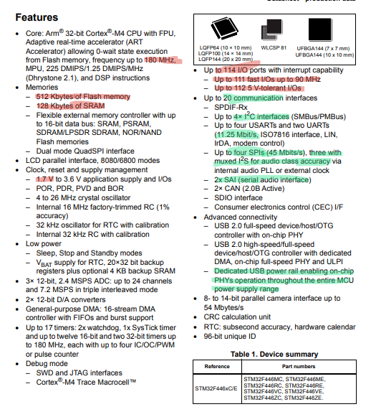
STM32F405RGT6 STM32F446RET6
The chips are very close to each other but the core differences are:

Feature | STM32F405RGT6 | STM32F446RET6
Core Speed | 168 MHz (210 DMIPS) | 180 MHz (225 DMIPS)
Flash Memory | 1 MB (1024 KB) | 512 KB
SRAM | 192+4 KB (incl. 64KB CCM) | 128 KB
SPI Interfaces | Up to 3 | Up to 4
I2C Interfaces | Up to 3 | Up to 4
UART/USART | 6 total (4 USART, 2 UART) | 6 total (4 USART, 2 UART)
USB | OTG FS/HS | OTG FS/HS (with dedicated power rail)
Package | LQFP64 (10x10 mm) | LQFP64 (10x10 mm)

Pin layouts:
STM32F405RGT6 STM32F446RET6

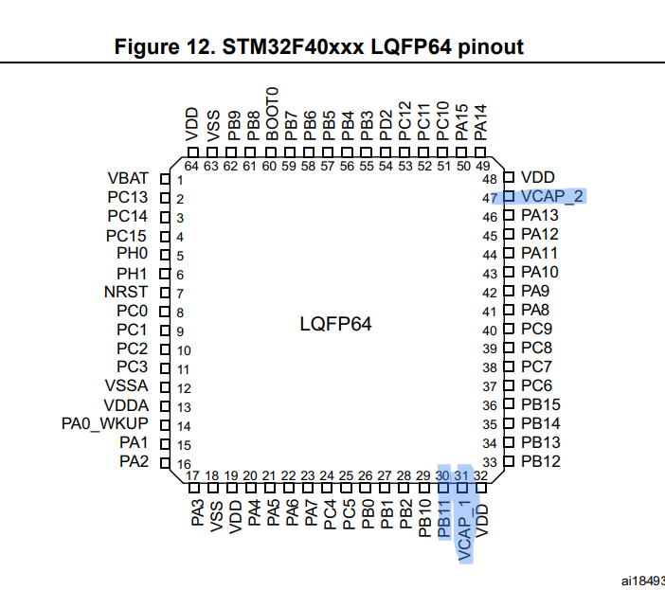
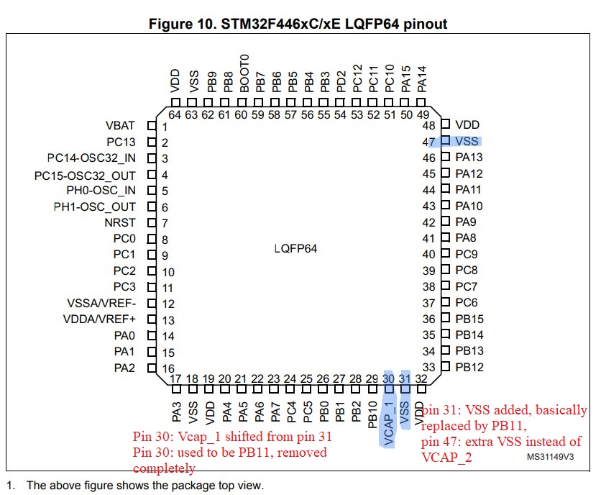

For the replacement in pin 47, where the VCAP_2 is replaced by VSS, we should remove the 100nF capacitor and directly connect it to the ground.

We will compare the Alternate function table next:

I found a great alternative, I will use STM32F407VET6
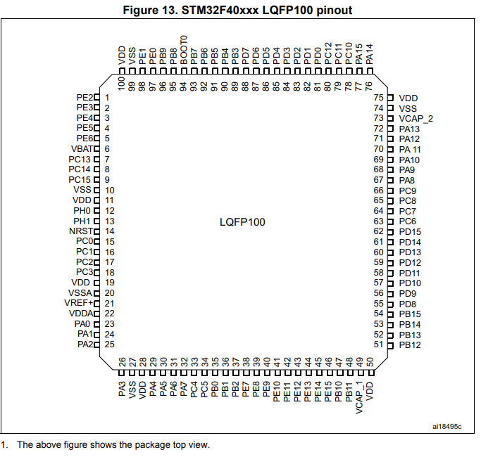
The only difference of this die compared to the reference is that it has a larger footprint, with 100 pins, mostly GPIO that can be later used for other things in later upgrades.

This is a game changer as this has exabtly same spec as the reference chip and thus requires minimal rewiring as far the main MCU is concerned.
MPU:
we will be using the MPU-9250 extracted from an old navio2 instead of a MPU-6000. The 9250 IC is much powerful and actually has more features such as magnetometer for compass and more(ref to datasheet). We need to check the pins with 6000 to make sure we understand the differences and connect them accordingly.

MPU-6000 MPU-9250
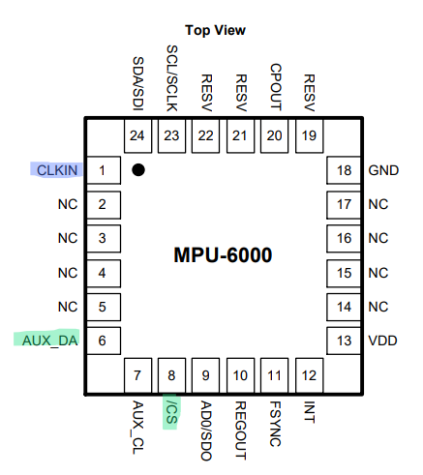
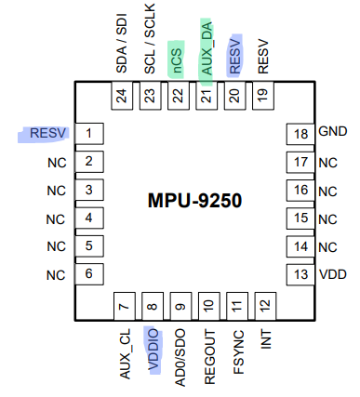

Pin in 6000 | Pin in 9250 | What to do in 9250 schematic
Pin-1 CLKIN | Pin-1 RESV | As pin 1 clkin in 6000 ref is connected to GND, its not used.  In 9250 → pin 1(RESV) → VDDIO
Pin -8 /CS | Pin - 22 | Shifted from 8→22 in 9250
Pin -20 CPOUT | Pin- 20 | In 9250, pin 20 → GND(no 2.2nF)
Pin 6, 7 I2C com | Pin 7, 21 I2C | Not connected, not using Magnetometer for compass
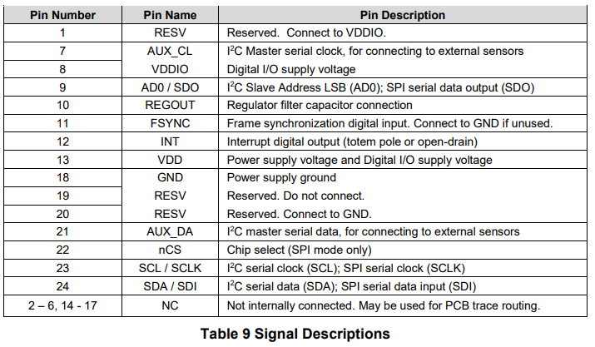

STMCUBEMX pining:

1. Go to STMcubeMX and enable the RCC-crystal timer from system core.
2. from connectivity section, we need to enable USB_OTG_FS to Device only,
3. for the gyro, we need to set pa4-7
Pin,Function,CubeMX Setting
PA4,Chip Select (CS),GPIO_Output -> GYRO_CS
PA5,Clock (SCK),SPI1_SCK (Auto-set)-> GYRO_SCL
PA6,Master In Slave Out (MISO),SPI1_MISO (Auto-set)->GYRO_SDO
PA7,Master Out Slave In (MOSI),SPI1_MOSI (Auto-set)->GYRO_SDA
PC4 - GPIO_EXTI - GYRO_INT

4. The analogue inputs:
pc1 - VBAT_PAD(for battery pct check) - ADC_IN11
pc2 - RSSI_PAD(for radio signal) - ADC_IN12
pc3 - CURRENT_PAD(from current sensor) - ADC_IN13
pc5 - 5C_USB(detect usb with 2 10k resistor, one grounded) - ADC_IN15

5. radio reciever input - PPM_IN - TIM3_CH3/TIM8_CH3, if software based decoder(GPIO_EXTI)7

6. I2C com -
PB6 - SCL_PAD(serial clock with 10k resis) - I2C1_SCL
PB7 - SDA_PAD(serial data with 10k resis) - I2C1_SDA

7. (optional) if we want to communicate telem via UART, we can enable
USART,
the UART we enable under connectivity are
1. USART1
2. USART3
3. USART6
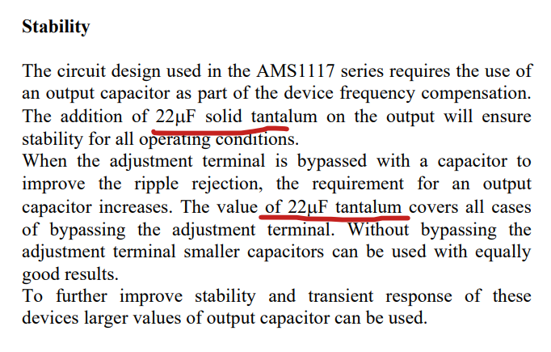
Linear regulators (LDOs) – AMS1117 – 3.3v
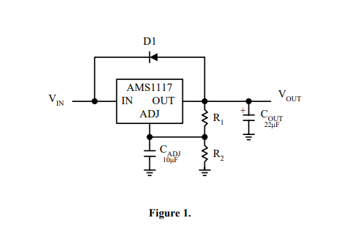
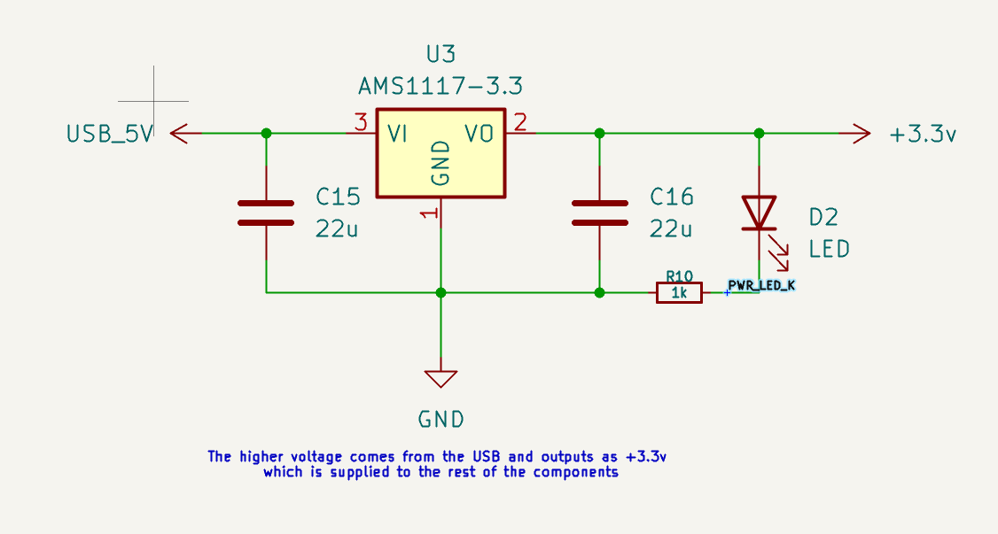
The Vin in out case comes from the USB-5V from the USB port. Both the Vin and Vout needs to have 22uF capacitors for stability as per the datasheet of AMS1117 on page 4.
csdf

