**PROJECT**

**Election System Database Management System**

**SCENARIO**

1. Election commission manages election, count votes and also gives permission to election candidates.
2. Election commission has name, address and unique id.
3. Election has unique id, specific city of election and date.
4. Each voter has unique id, name, address and age.
5. Voter will attend election and gives vote.
6. Each vote has unique number and these votes are from the voters for their favorite candidate.
7. Each candidate has unique id, address, name and total vote.
8. Each candidate has permission for participate in election.
9. Each permission has permission number and unique id.

**ER- DIAGRAM**

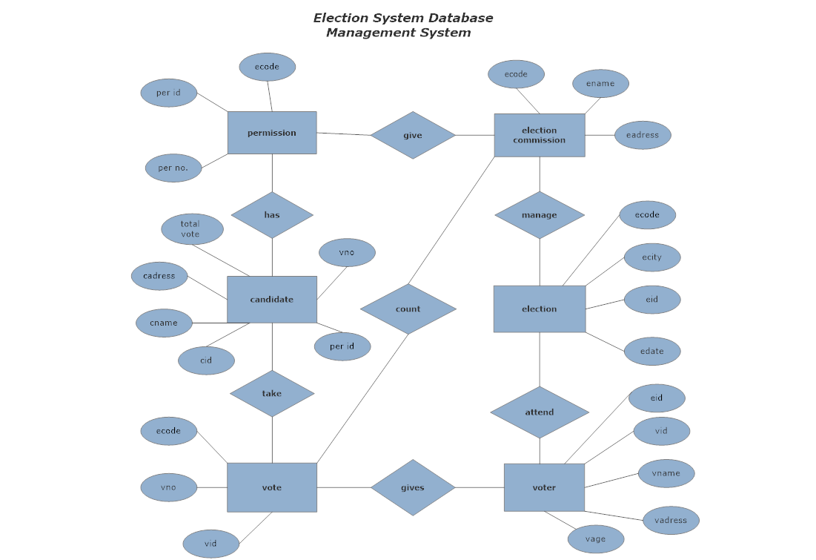

**NORMALIZATION**

**For relationship manage:** (ecode, ename , eadress, ecity, eid, edate,ecode)

1NF: No Multivalued Attribute

2NF: (ecode, ename, eadress).

(ecity,eid,edate).

3NF: election commission (ecode,ename,eadress).

Election (ecity,eid,edate,ecode).

**For relationship attend:** (ecity, eid, edate,ecode, vid, vname, vadress, vage,eid)

1NF: No Multivalued Attribute

2NF: (ecity, eid, edate,ecode).

(vid, vname, vadress, vage)

3NF: election (eid,edate,ecity,ecode)

voter (vid, vname, vadress, vage, eid)

**For relationship gives:** (vid,vname,vadress,vage,eid,vno,vid,ecode)

1NF: No Multivalued Attribute

2NF: (vid,vname,vadress,eid)

(vno,ecode,vno)

3NF: voter(vid,vname,vadress,vage,eid)

Vote(vno, vid)

**For relationship count:** (ecode,ename,eadress,vno,vid,ecode)

1NF: No Multivalued Attribute

2NF: (ecode, ename, eadress)

(vno,vid)

3NF: election commission (ecode, ename,eadress,vno,vid)

Vote (vno,vid,ecode)

**For relationship take :** (vno, vid, ecode, cid, cname, cadress,total vote,perid,vno)

1NF: No Multivalued Attribute

2NF: (vno,vid,ecode).

(cid, cname, cadress,total vote,per. id).

3NF: vote (vno,vid,ecode).

Candidate (cid, cname, cadress,total vote,vno,per.id).

**For relationship has :** (cid, cname, cadress,total vote,vno,per no.,per. id,per. Id,ecode)

1NF: No Multivalued Attribute

2NF: (cid, cname, cadress,total vote,vno)

(per no.,per. Id,ecode)

3NF: candidate (cid, cname, cadress,total vote,vno,perid)

Permission (per no.,per. Id,ecode)

**For relationship give : (**per no., per. Id, ecode, ename, eadress,ecode)

1NF: No Multivalued Attribute

2NF: (per no.,per. Id)

(ecode, ename, eadress)

3NF: permission(per no.,per. id,ecode)

Election commission(ecode, ename, eadress)

So after normalization tables are given below,

Election commission(ecode, ename, eadress)

election (eid,edate,ecity,ecode)

voter(vid,vname,vadress,vage,eid)

vote (vno,vid,ecode).

candidate (cid, cname, cadress,total vote,vno,perid)

permission(per no.,per. id,ecode)

**Table Creation**

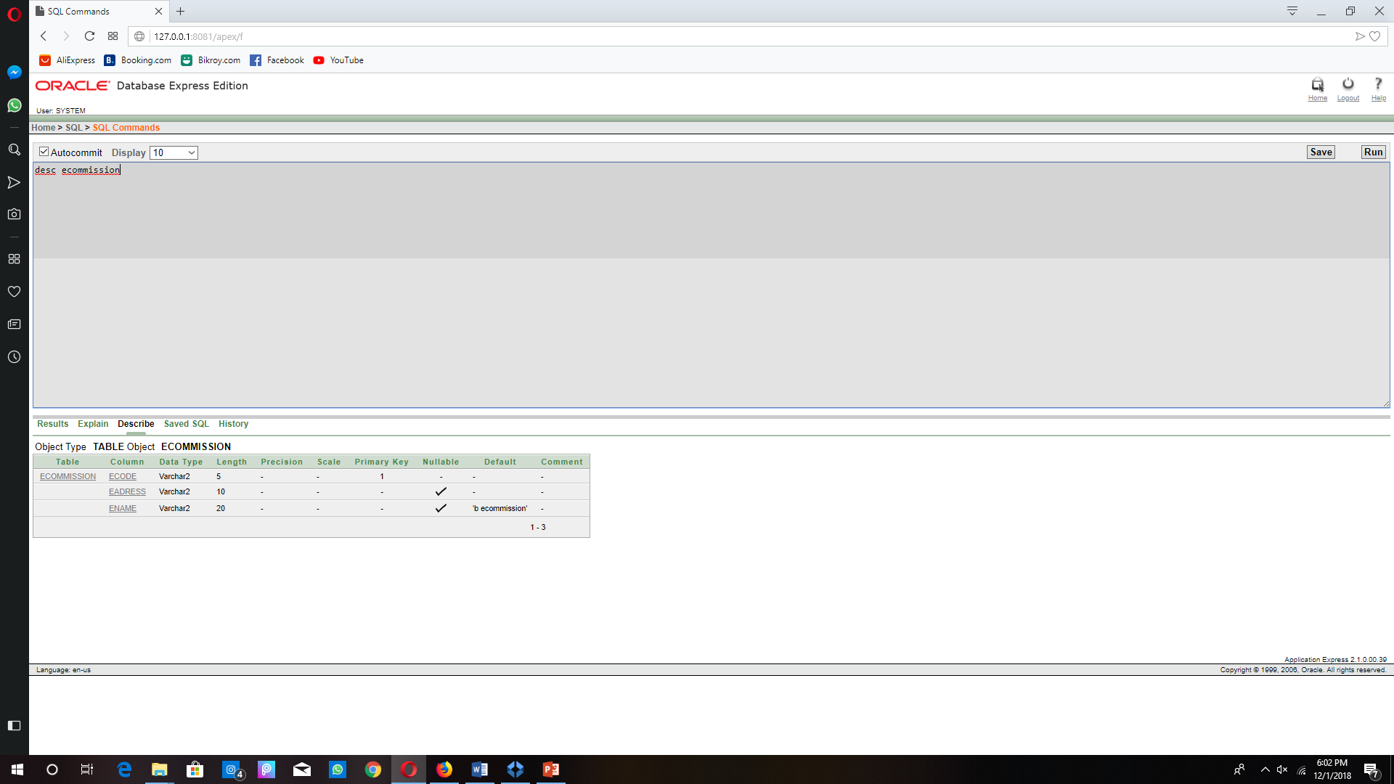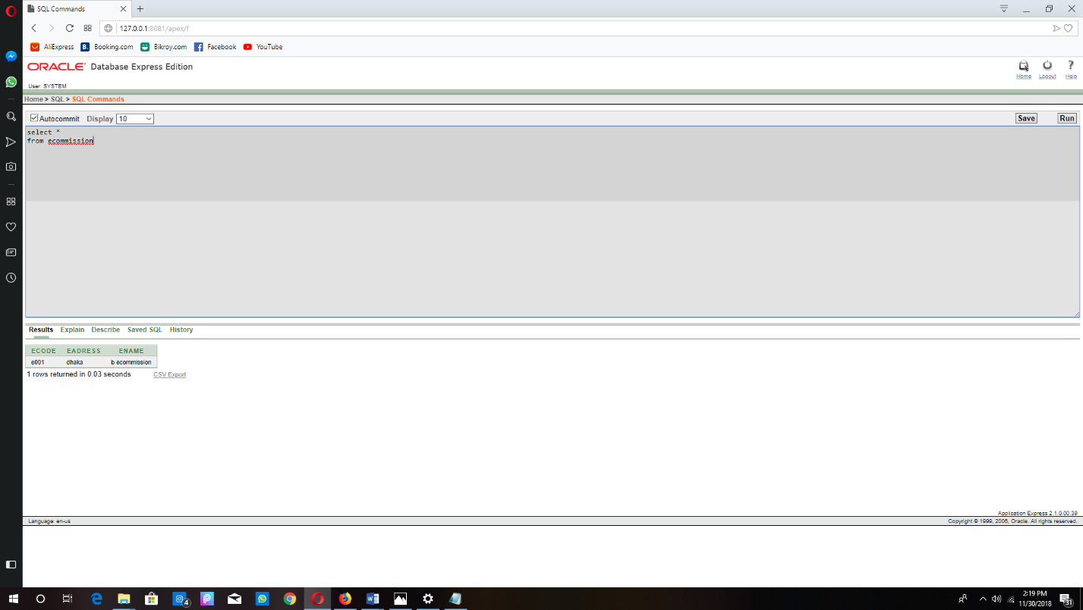**Election commission table:**

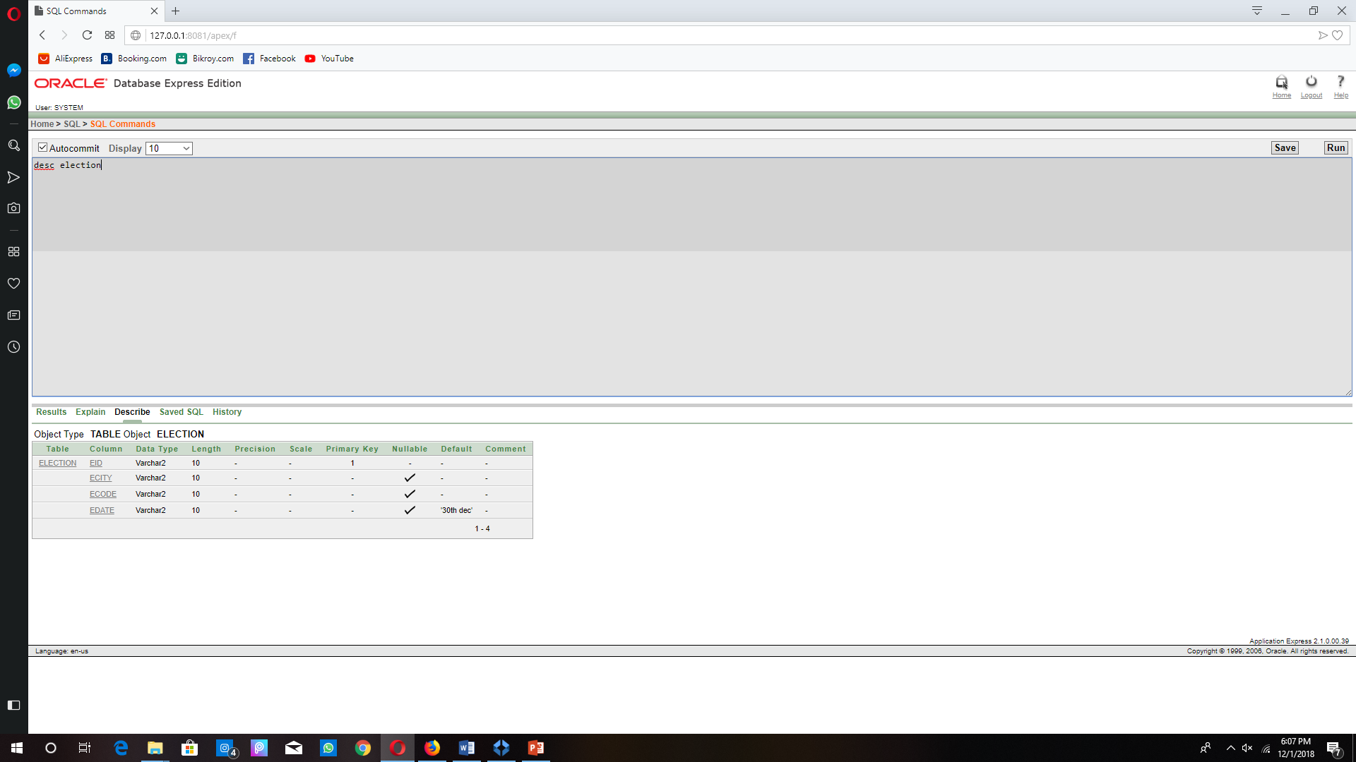**Election table:**

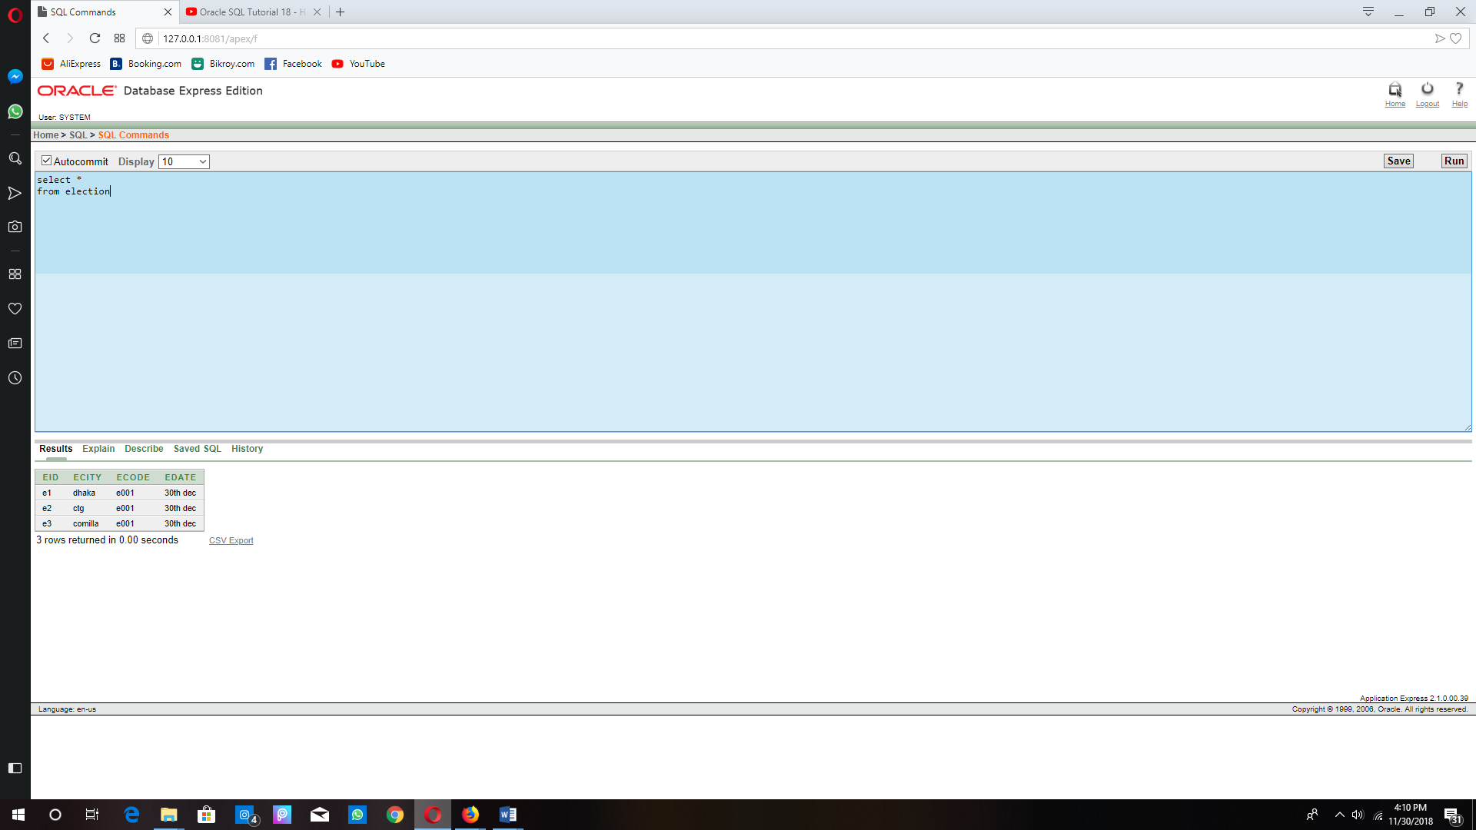

**Voter table:**

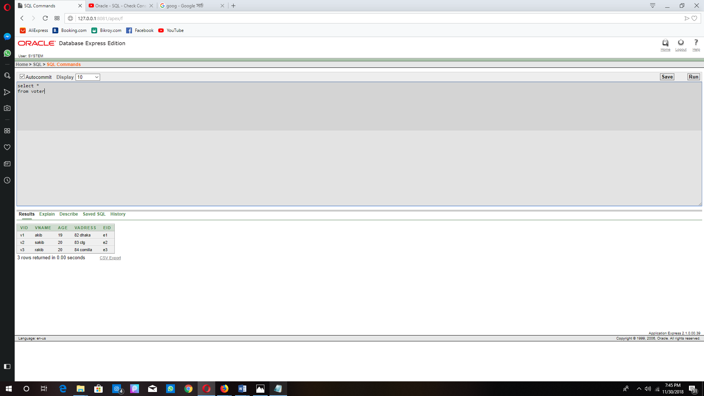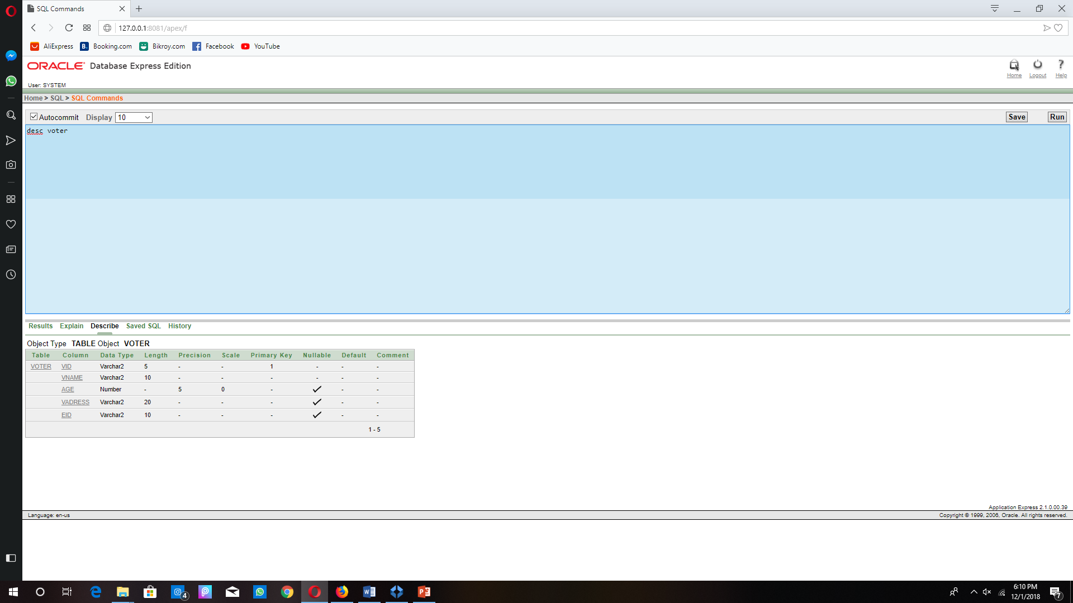

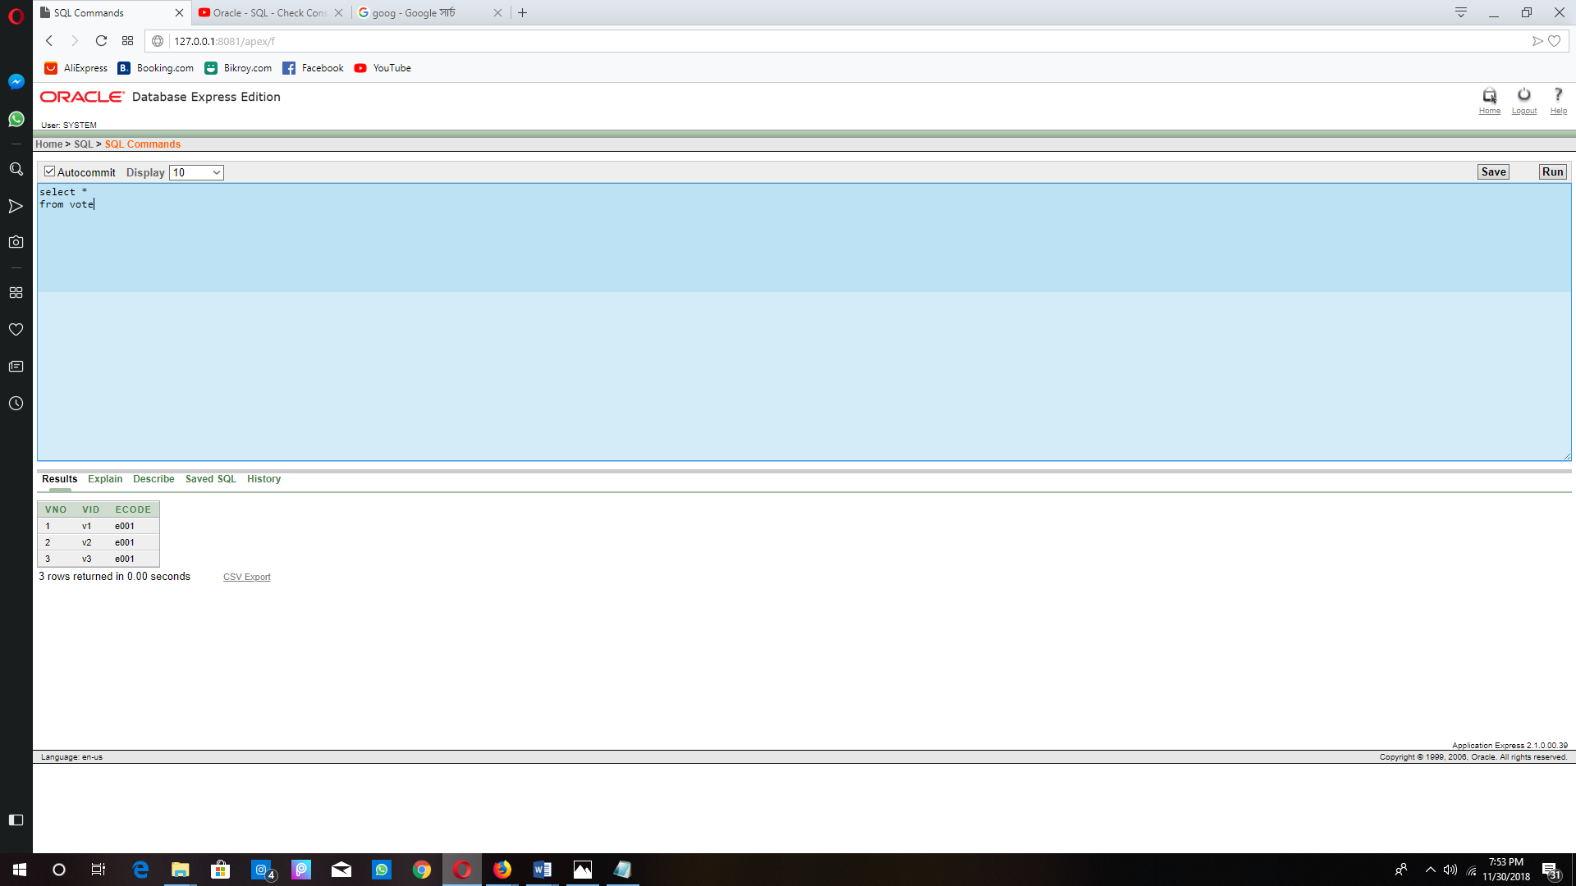

**Vote table:**

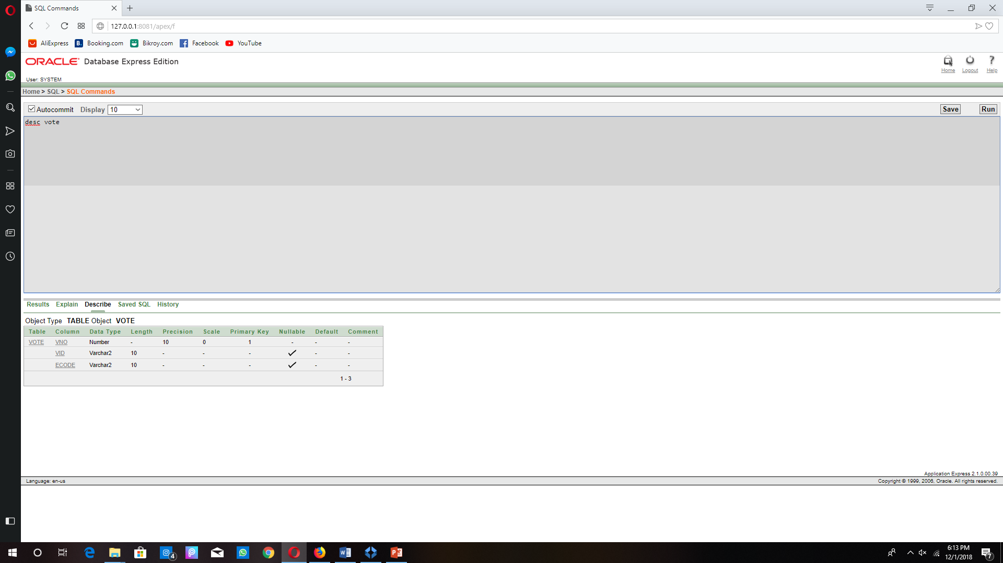

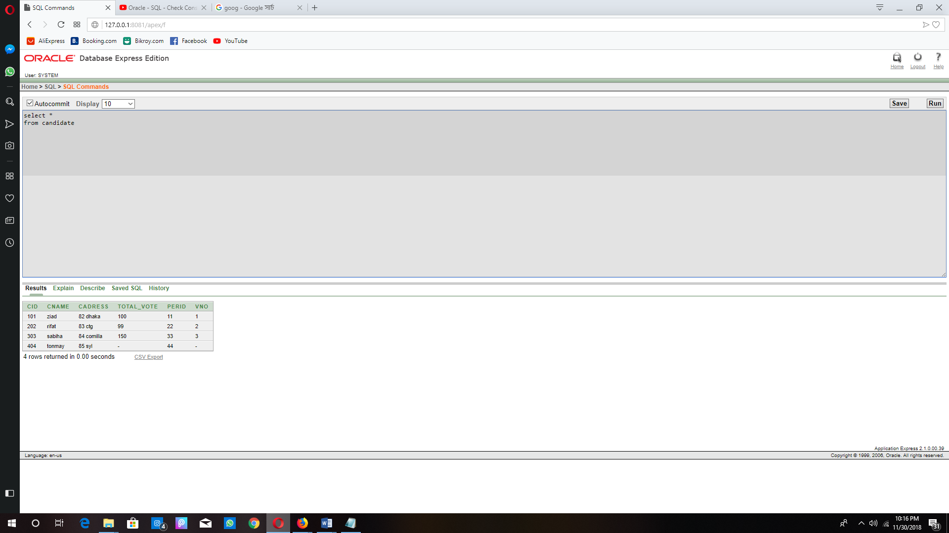**Candidate table:**

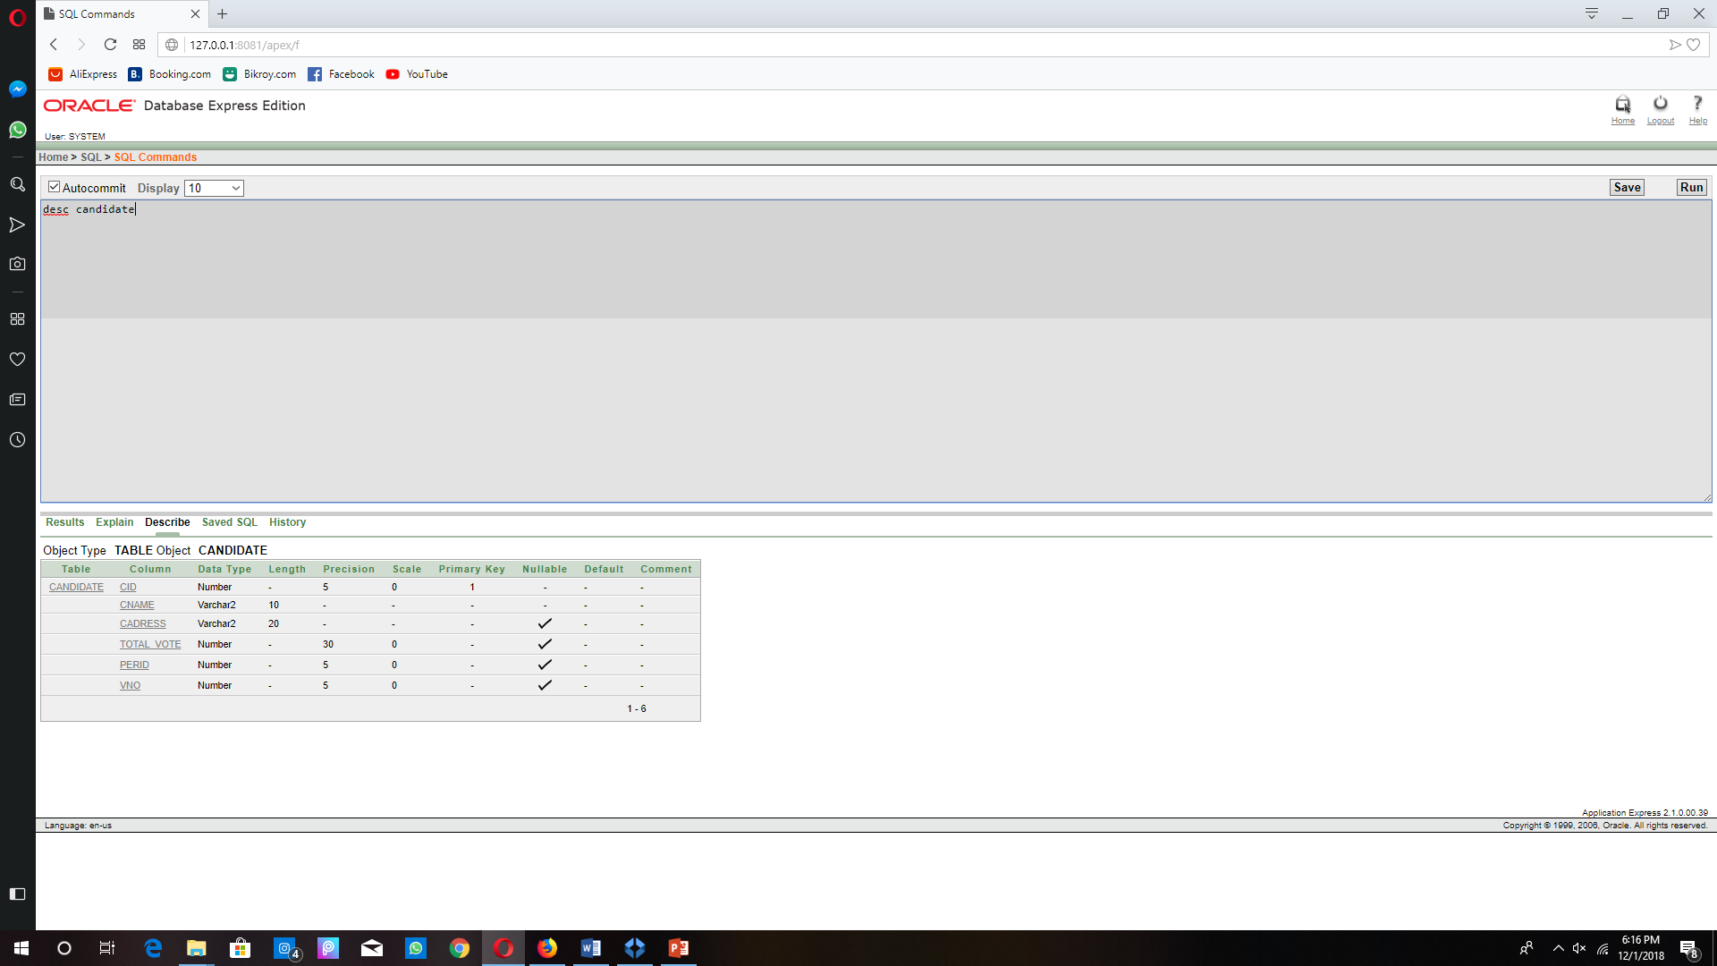

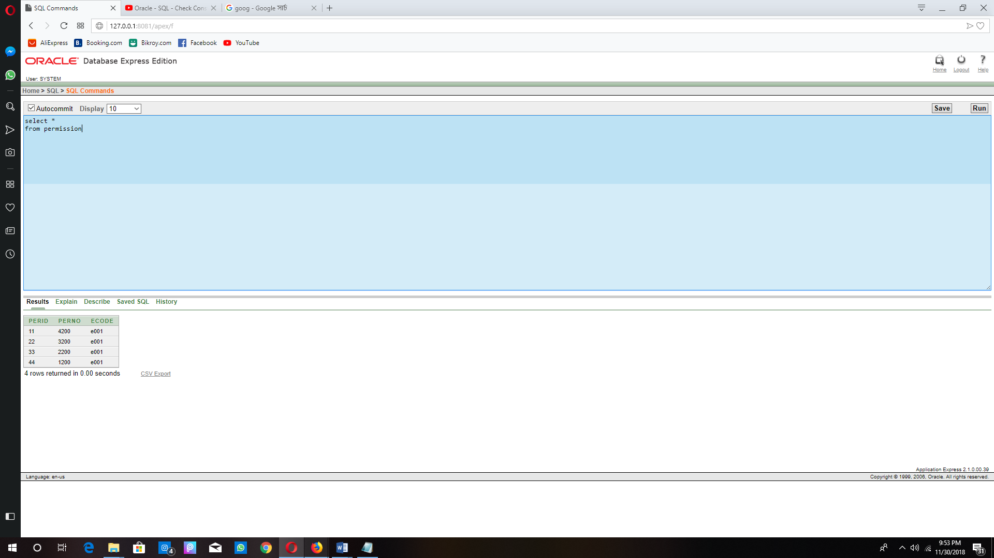**Permission table:**

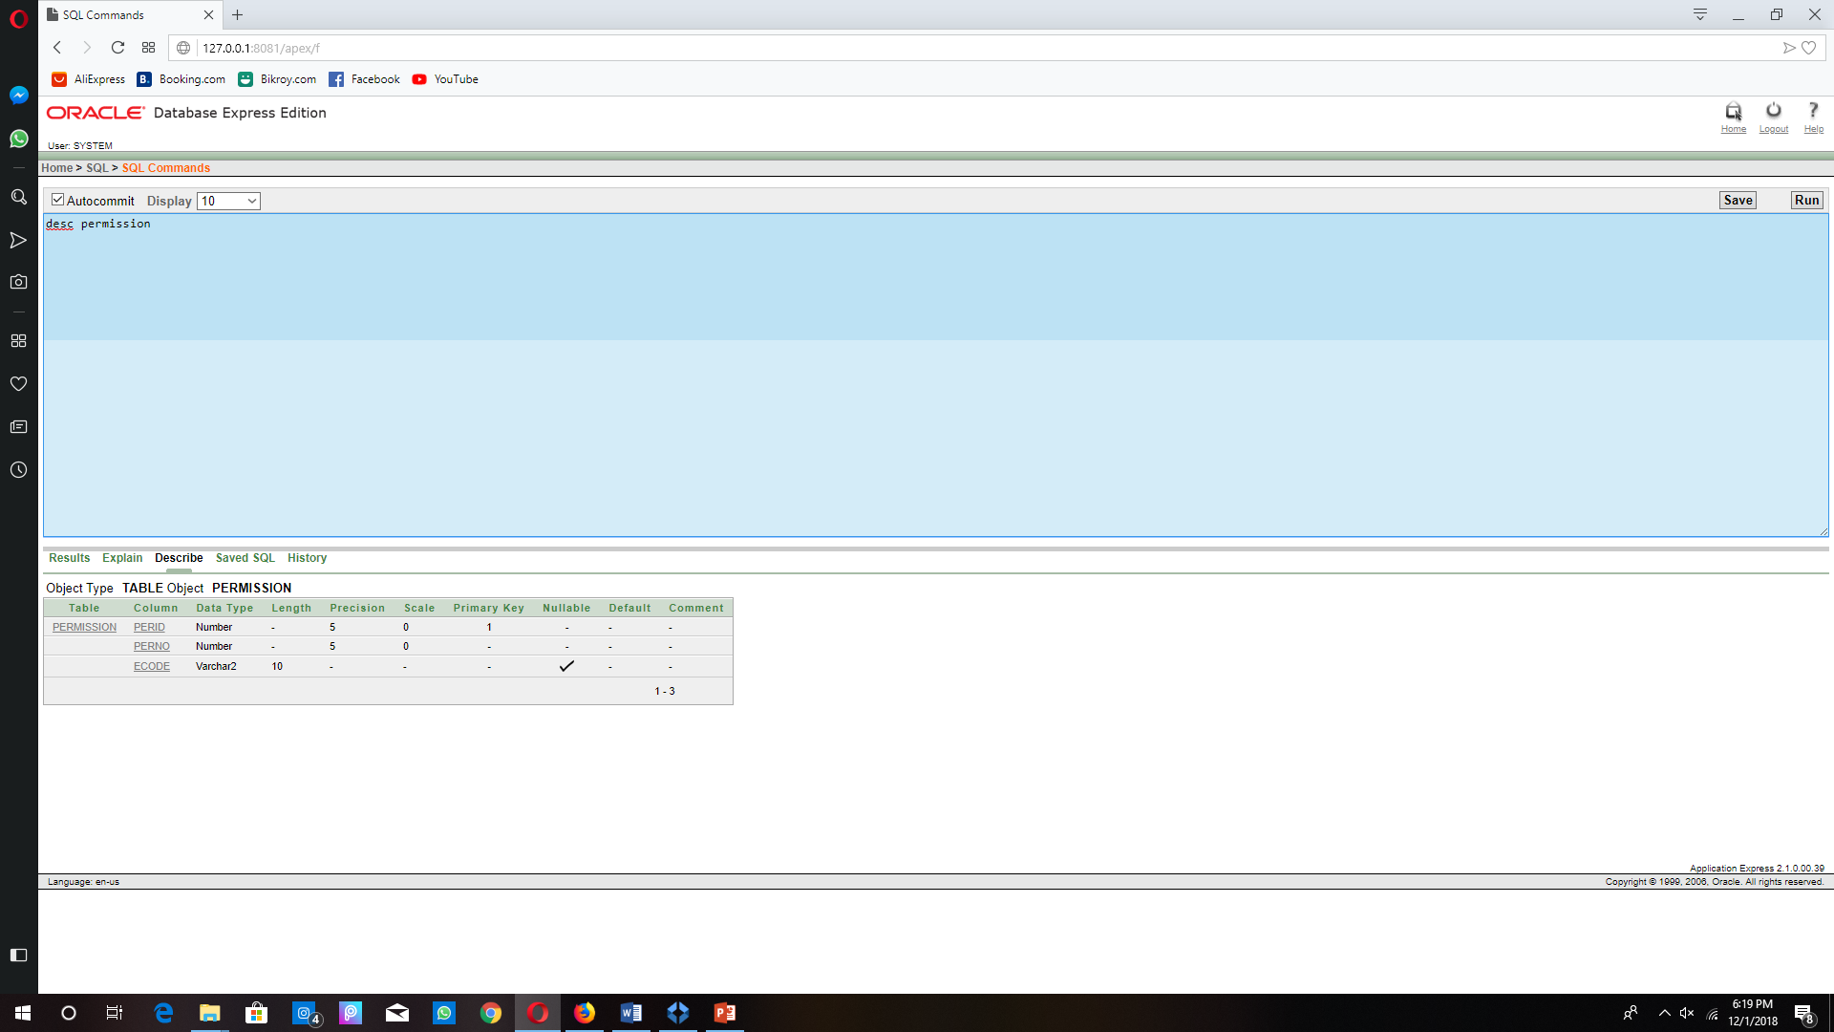

**Sub Query:**

1. Information of those voters, who are older than akib

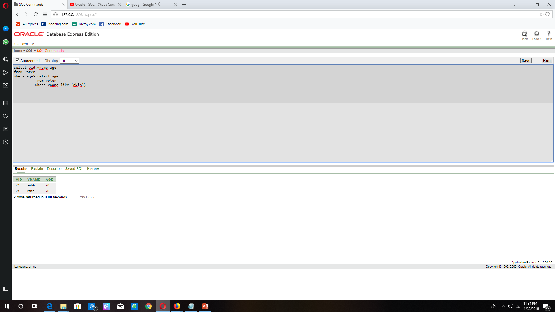

1. Name of the candidate who got more vote than Ziad.

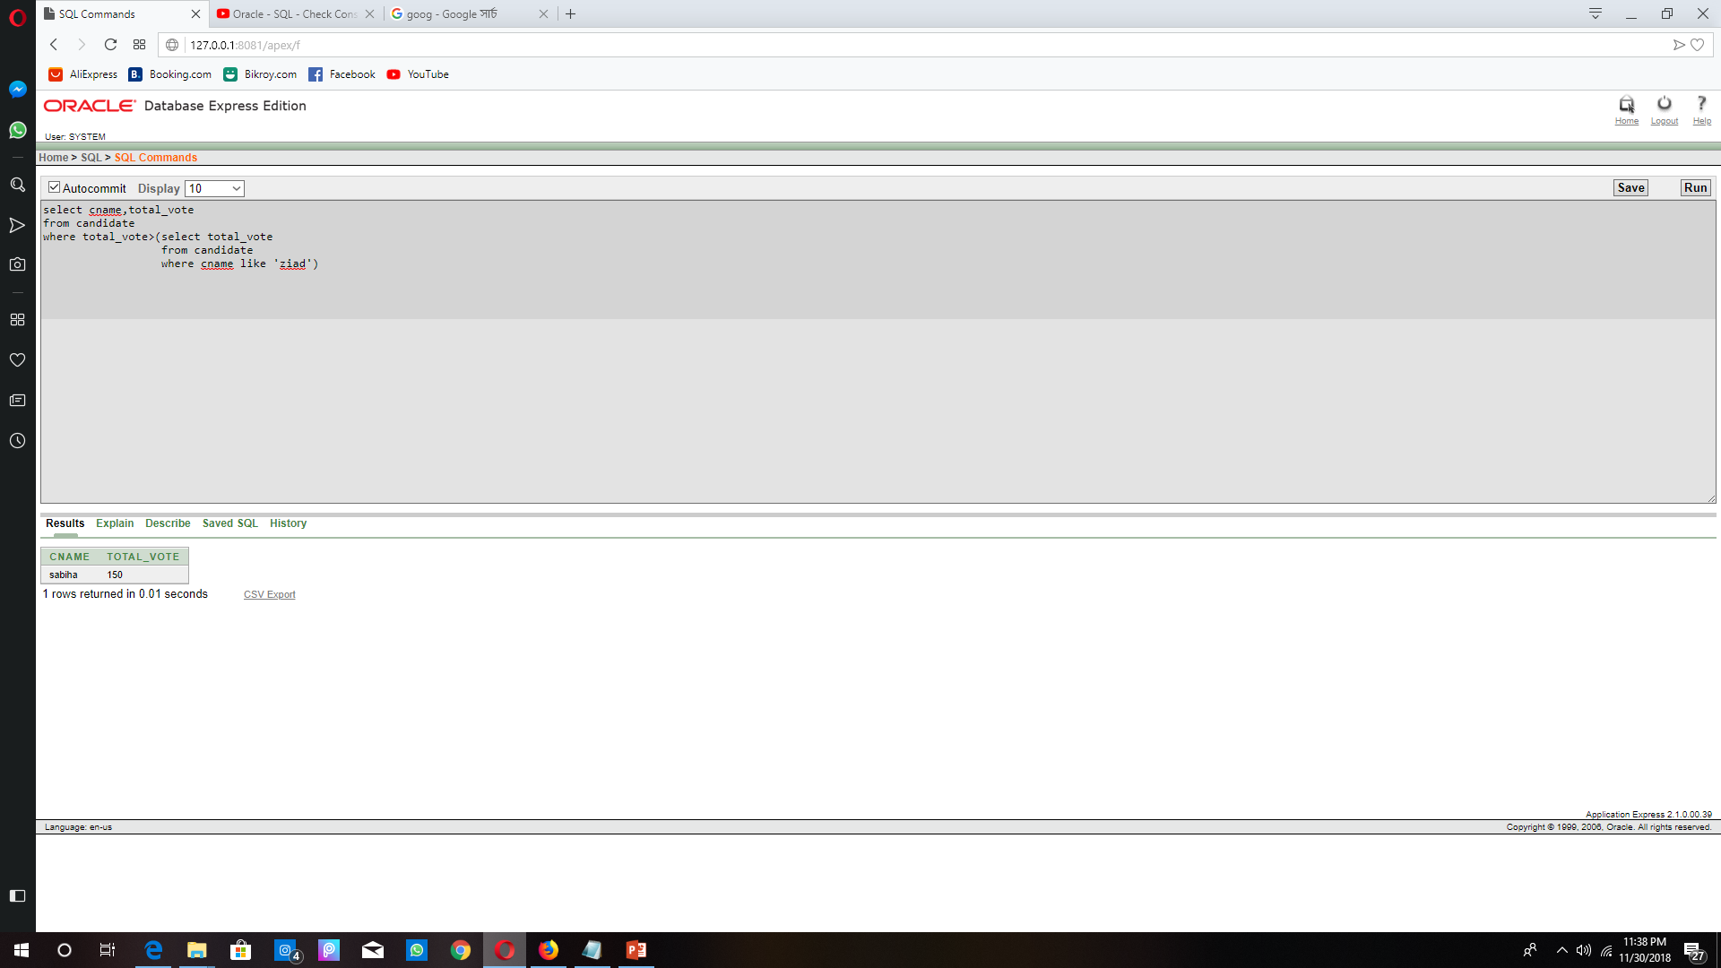

1. Nonelected candidates by using sub query.

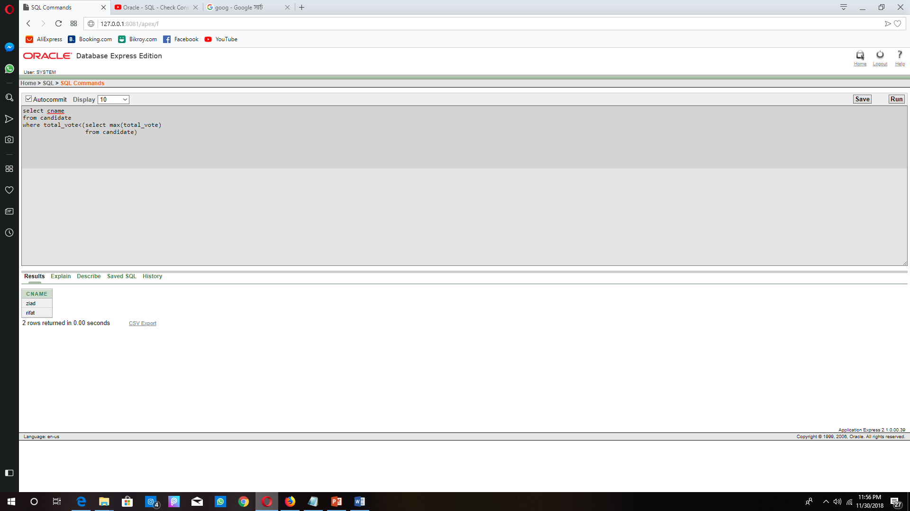

**Joining:**

**Equi join:**

The election id date and city which elections are handling by Bangladesh election commission.

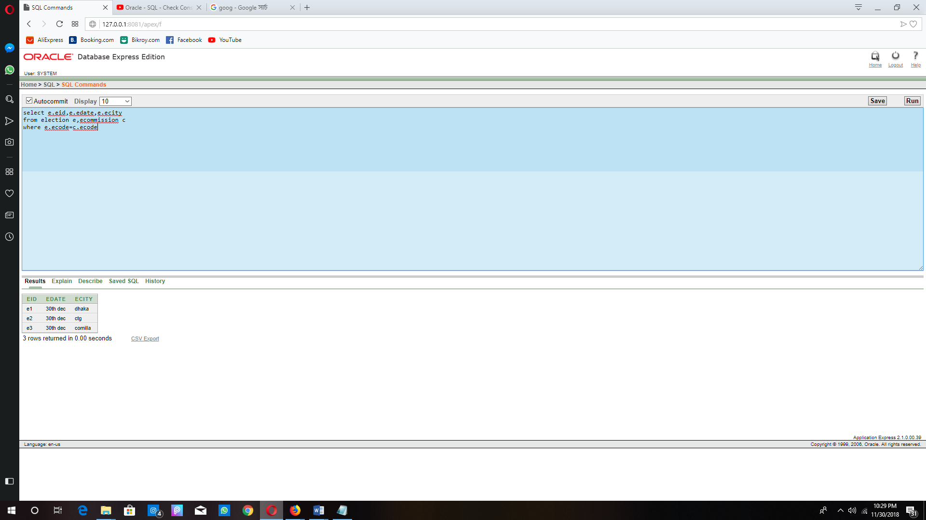

The information of voters with their election city.

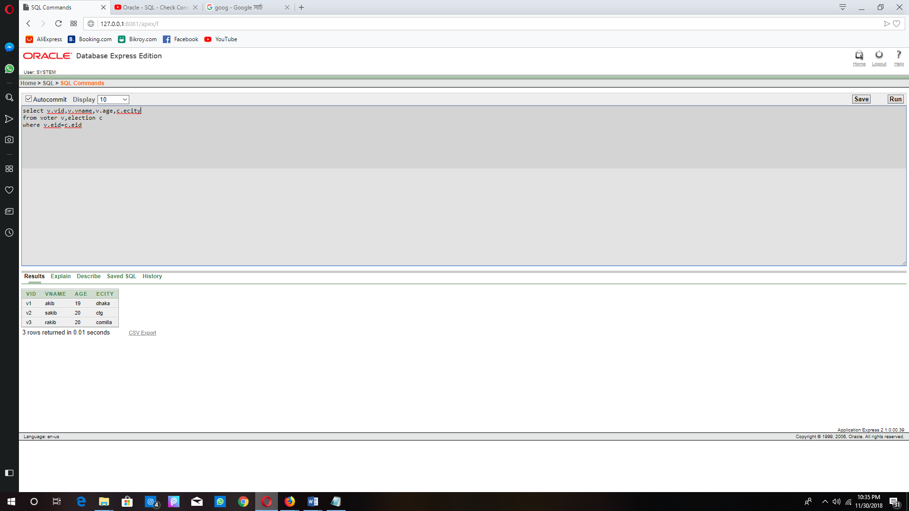

**Non-equi:**

Voters name who got more vote than who.

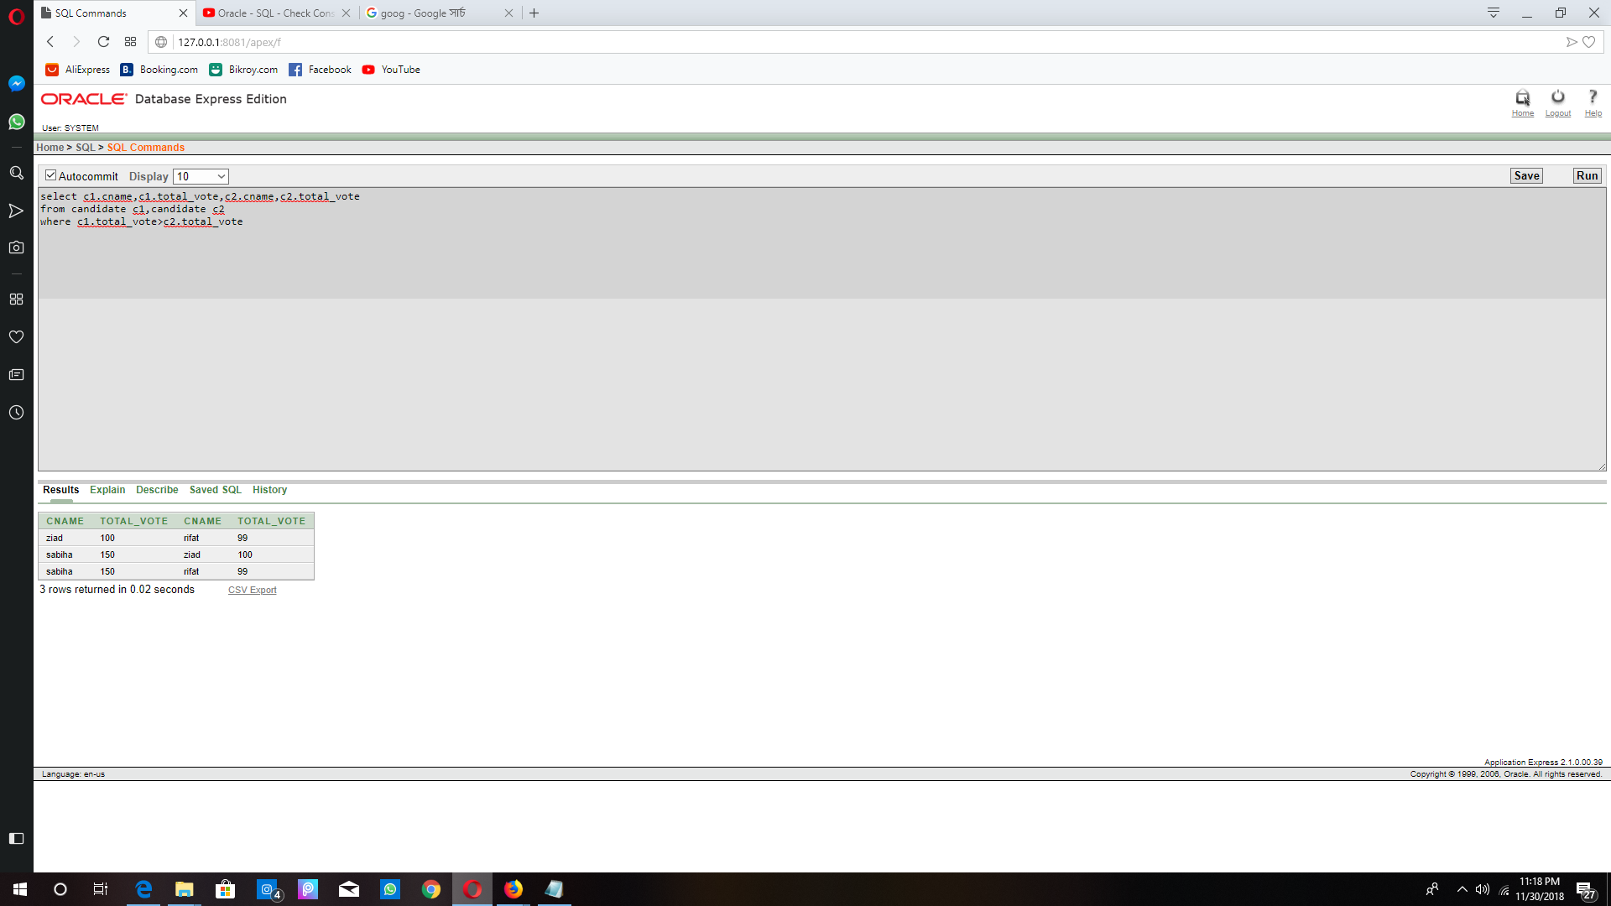

**Natural join:**

Vote information of same election commission and the candidates with their permission number.

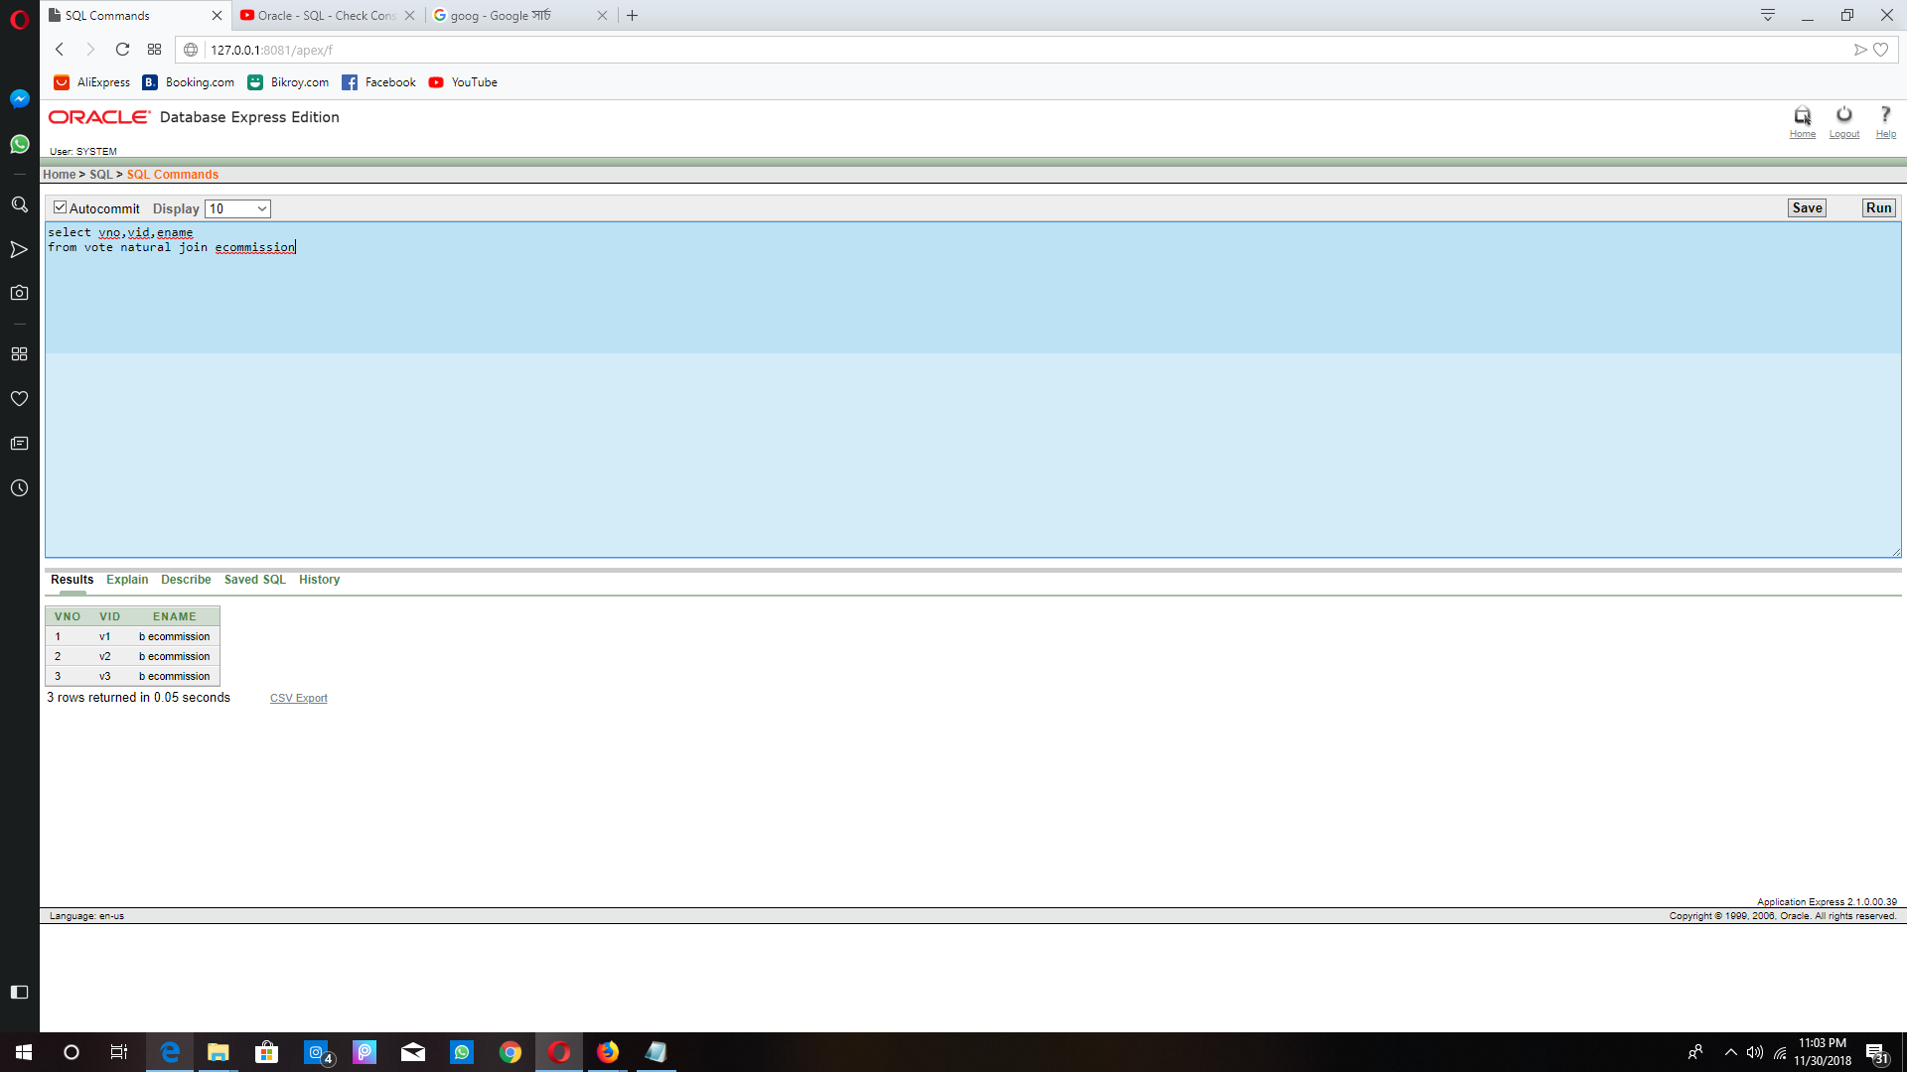 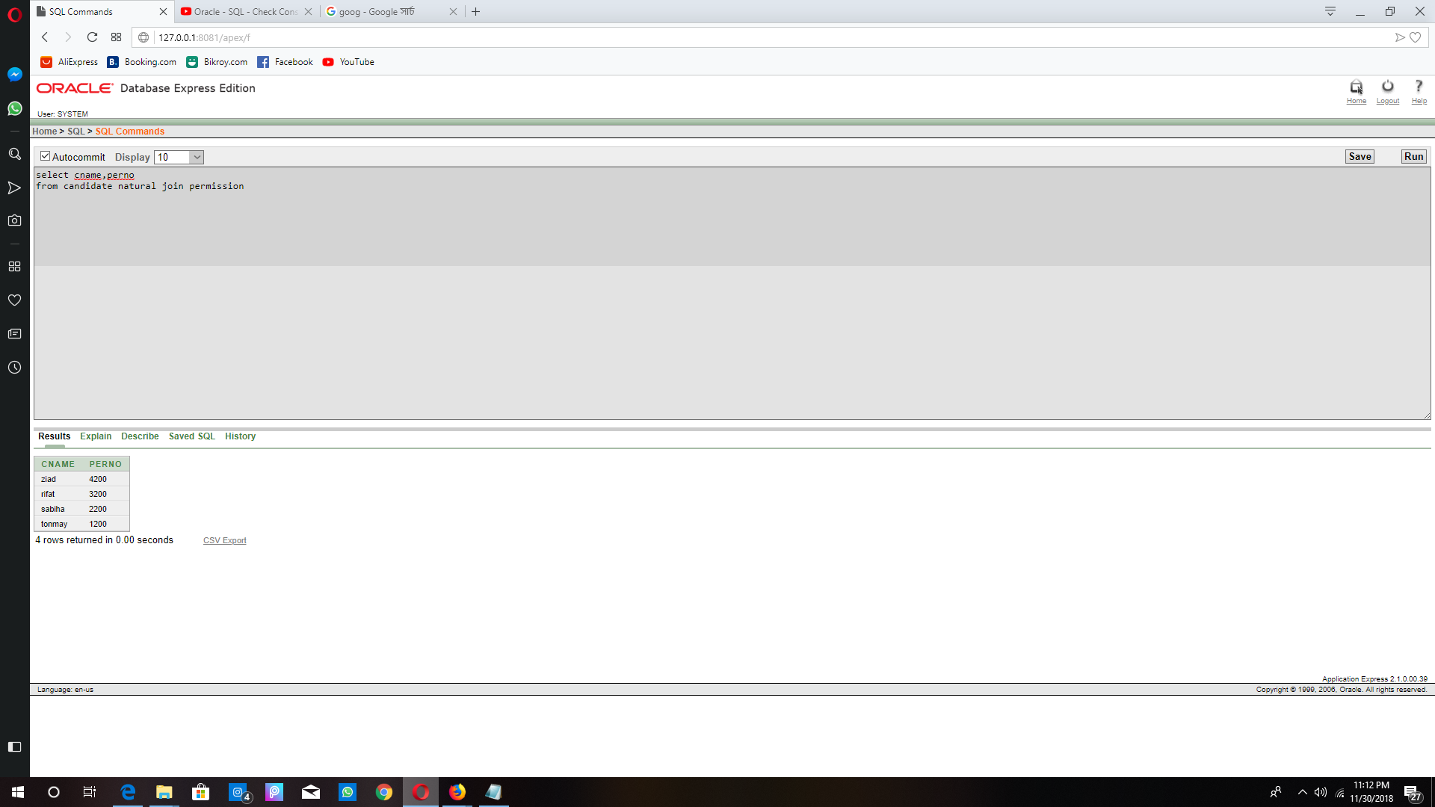

**Self join:**

Information of voter according to their age

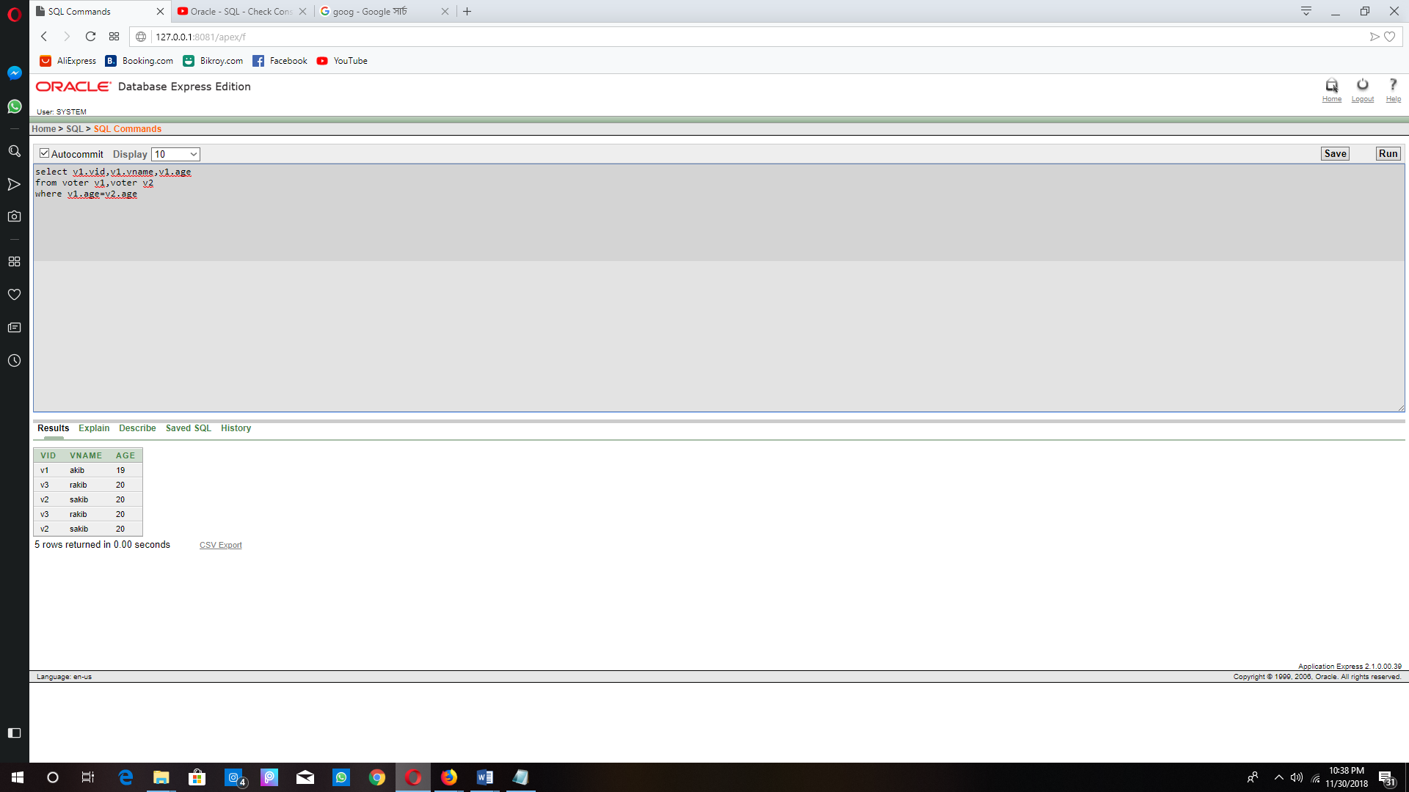

**Outer join:**

Candidate information with their vote number and also those candidates who didn’t get any vote.

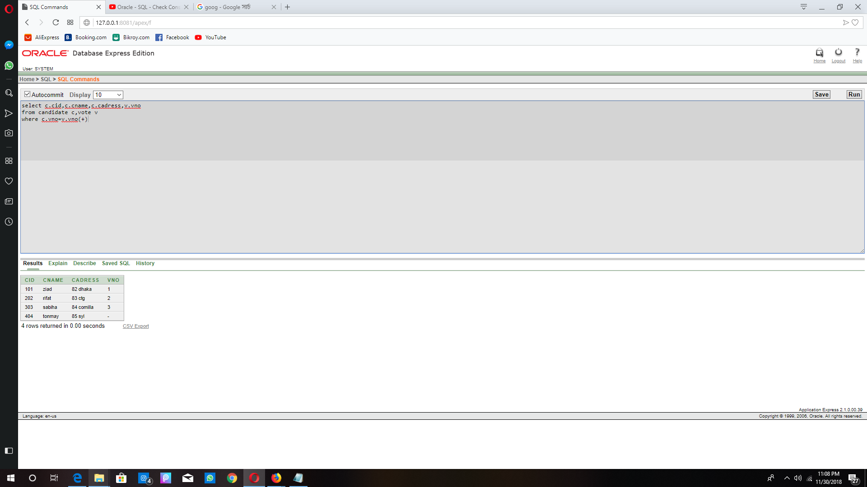

**Constraint:**

According to the rules of constraint we use primary key, NOT NULL and Foreign key.

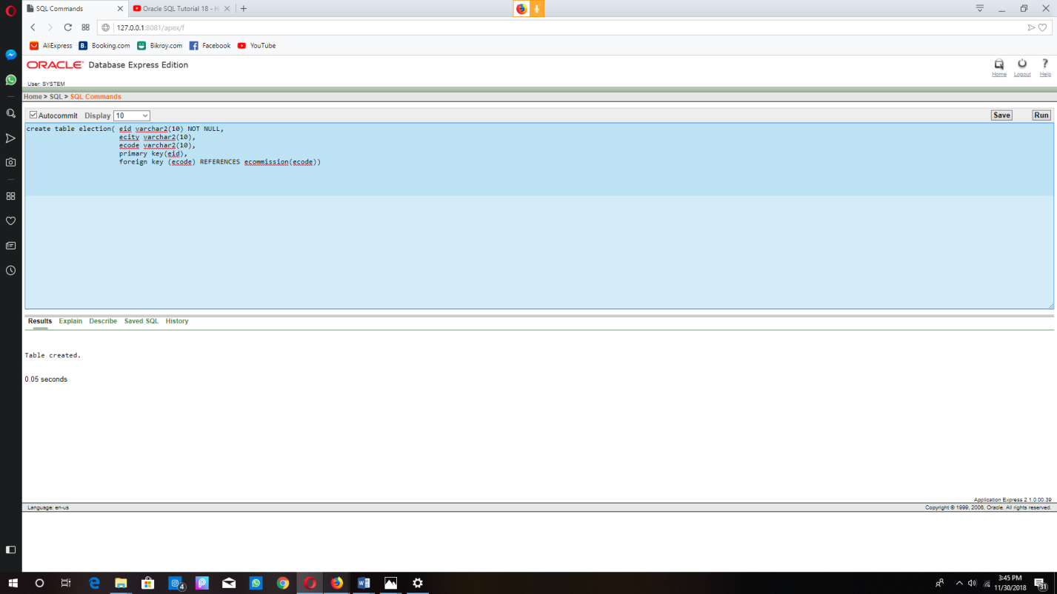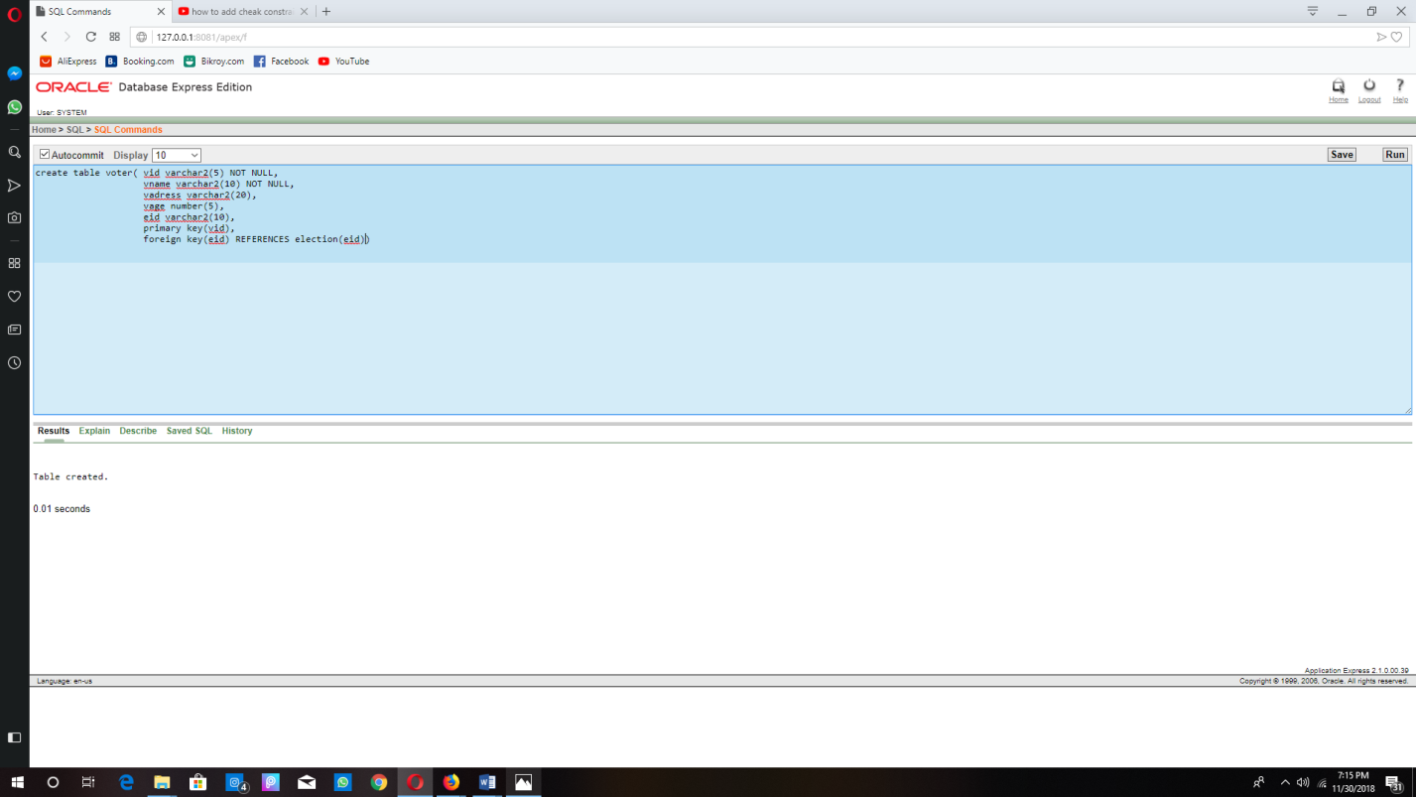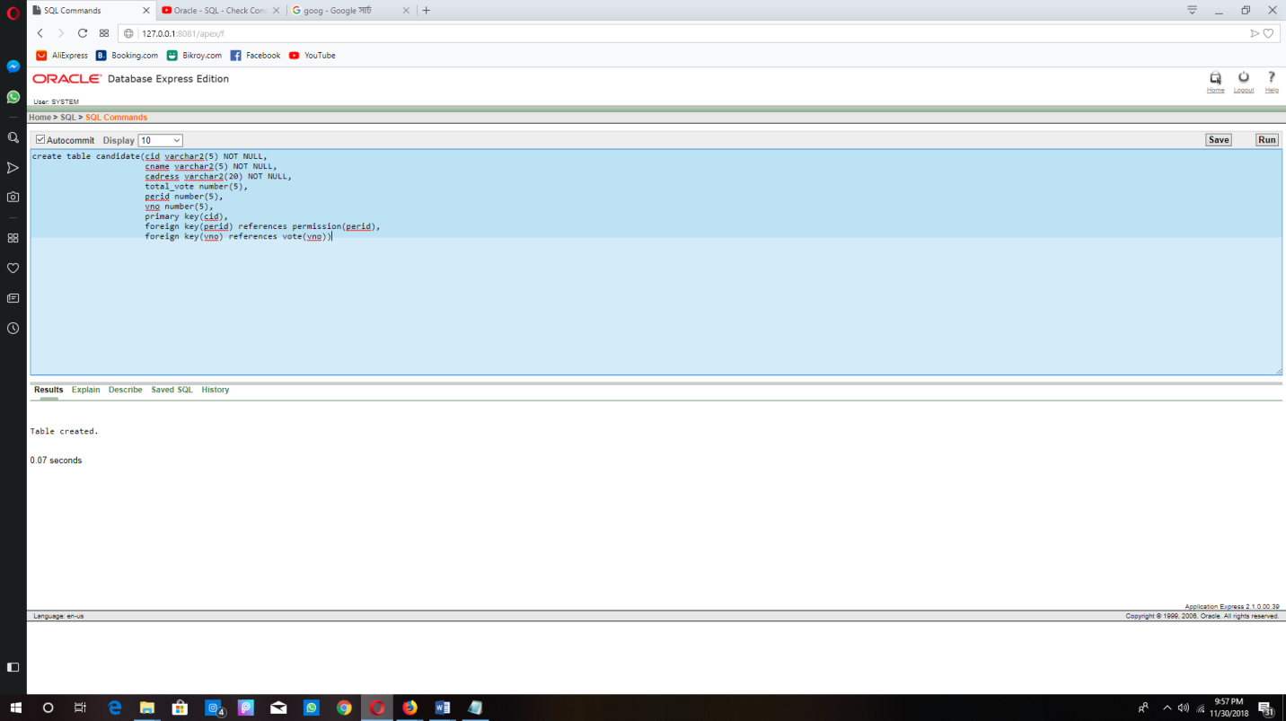

We usedefault constraint for same value:

As our project is only for Bangladesh election so we use Bangladesh commission for every column and we also set the election date fix for every city which is 30th December.

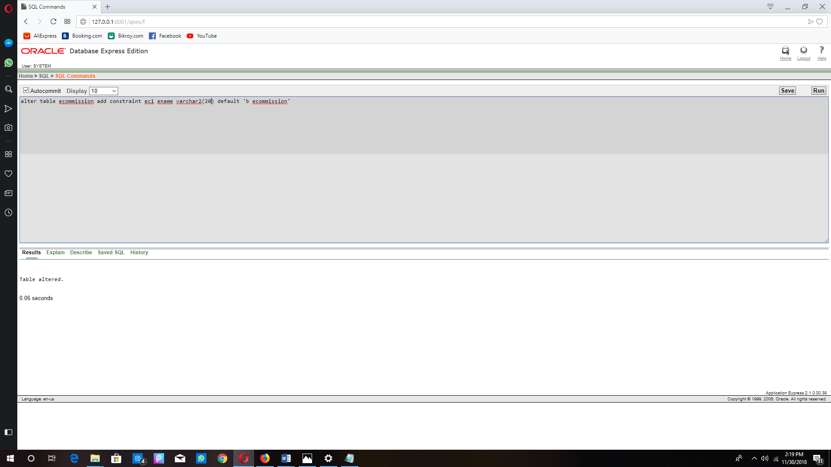

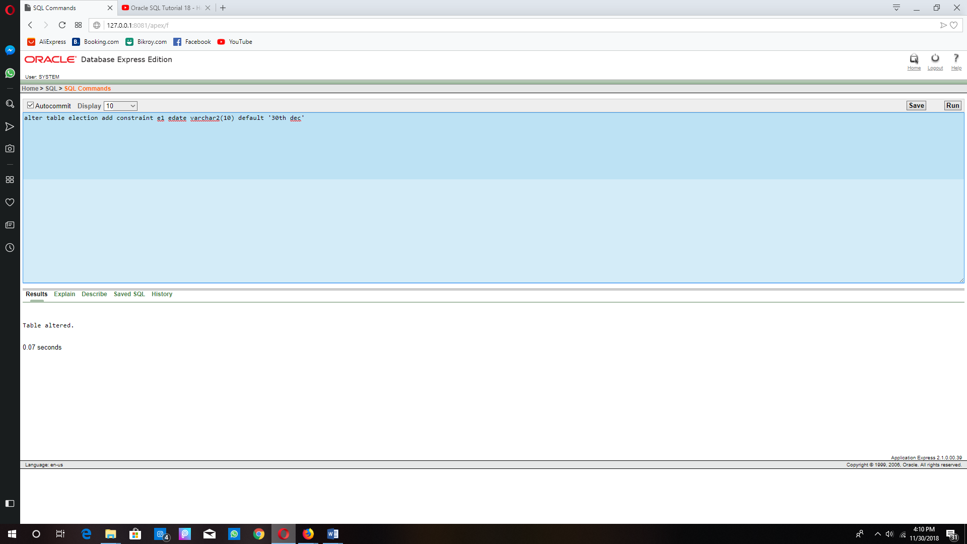

We also use check constraint:

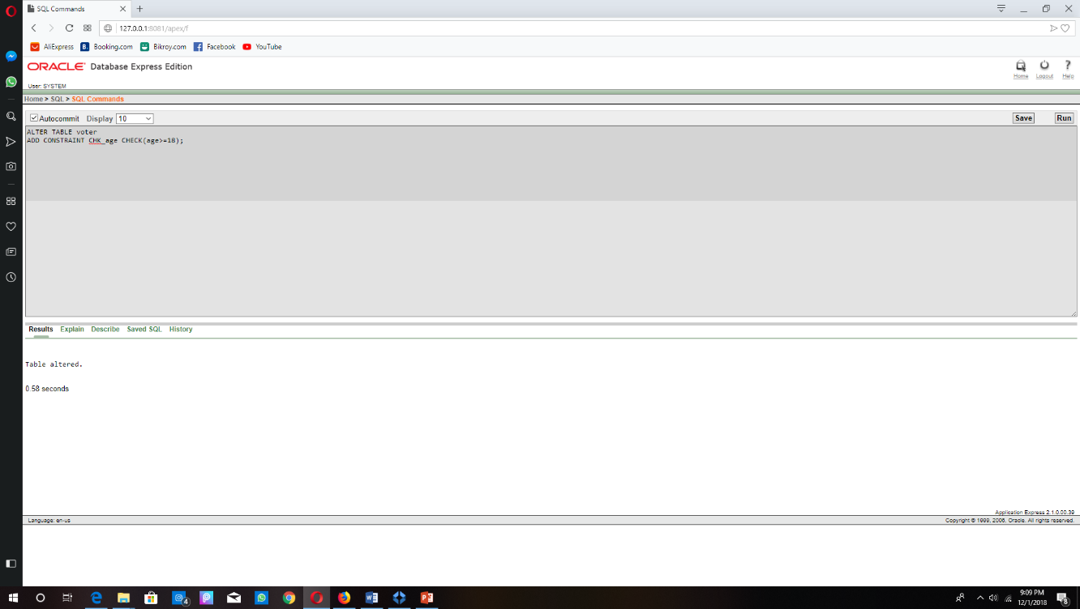As we know that in our country the minimum age limit for a voter is 18. So we use check constraint to set it