**Problem-2: Problem solving**

package students;

import java.util.*;

class StudentInfo{

private int id;

private String fname;

private float cgpa;

public StudentInfo(int id, String fname, float cgpa) {

super();

this.id = id;

this.fname = fname;

this.cgpa = cgpa;

}

public int getId() {

return id;

}

public String getFname() {

return fname;

}

public float getCgpa() {

return cgpa;

}

}

public class Students {

public static void main(String[] args) {

Scanner in = new Scanner(System.in);

int testCases = Integer.parseInt(in.nextLine());

List<StudentInfo> studentList = new ArrayList<>();

while(testCases>0){

int id = in.nextInt();

String fname = in.next();

float cgpa = in.nextFloat();

StudentInfo st = new StudentInfo(id, fname, cgpa);

studentList.add(st);

testCases--;

}

Collections.sort(studentList, (StudentInfo s1, StudentInfo s2) -> {

if(s2.getCgpa()>s1.getCgpa()){

return 1;

}else if(s2.getCgpa()<s1.getCgpa()){

return -1;

}

return s1.getFname().compareTo(s2.getFname());

});

System.out.println("Output:");

for(StudentInfo st: studentList){

System.out.println(st.getFname());

}

}

}

Input:

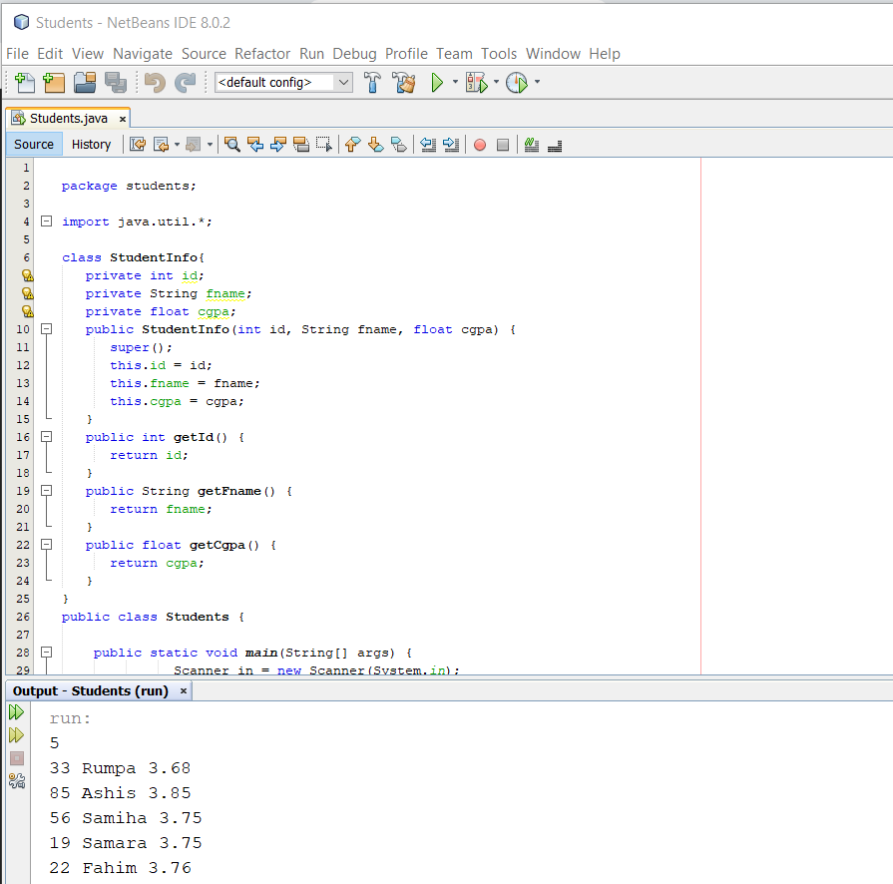

Output:

