**Problem-3: SQL Problem**

**Solution:** Select NAME from STUDENTS where MARKS>75 order by substr(NAME, -3), ID ASC;

**Input:**

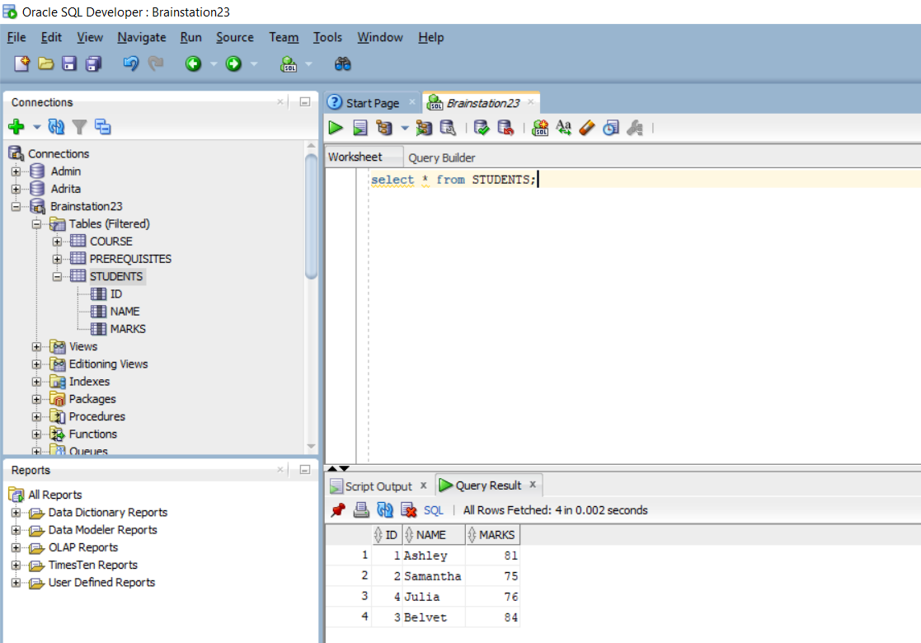

**Output:**

