Problem Statement 3: Decompose the returns of Apple Inc (AAPL) using Fama-French 3 factor model and present the results.

**Python Code: aapl.py**

Answer:

1. Data Collection:
   * Apple Stock Data: Daily adjusted close prices for past 10 years using yfinance.
   * Fama-French 3-Factor Data: Daily factor data was downloaded from Kenneth French's library, covering the same period.

Factors include: Mkt-RF: Market risk premium.

SMB: Size factor (small-minus-big).

HML: Value factor (high-minus-low).

RF: Risk-free rate.

1. Regression Analysis:

We applied Ordinary Least Squares (OLS) regression to model Apple’s excess returns as a function of the Fama-French factors:



* Ri,t​−Rf​: Apple’s excess returns.
* Mkt-RF, SMB, HML: Fama-French factors.
* α: Intercept (unexplained component of returns).
* β1,β2,β3: Factor loadings (coefficients).

1. Regression Results: The OLS regression summary provides the following key metrics:

* Intercept (α): Represents the unexplained component of Apple’s returns, independent of the three factors. A statistically significant positive value indicates that Apple generated excess returns not explained by the model.
* Market Risk Premium (β1​): A high and significant coefficient for Mkt-RF indicates Apple’s returns are strongly influenced by market movements.
* Size Factor (β2​): A small or insignificant coefficient for SMB suggests that Apple, being a large-cap company, has little exposure to the size premium.
* Value Factor (β3​): A small or negative coefficient for HML implies that Apple does not exhibit strong value stock characteristics and aligns more with growth stocks.
* Model Fit (R2): The R2 value measures the proportion of variance in Apple’s returns explained by the model. A high R2 indicates a good fit.

1. Key Findings

* Quantitative Insights:

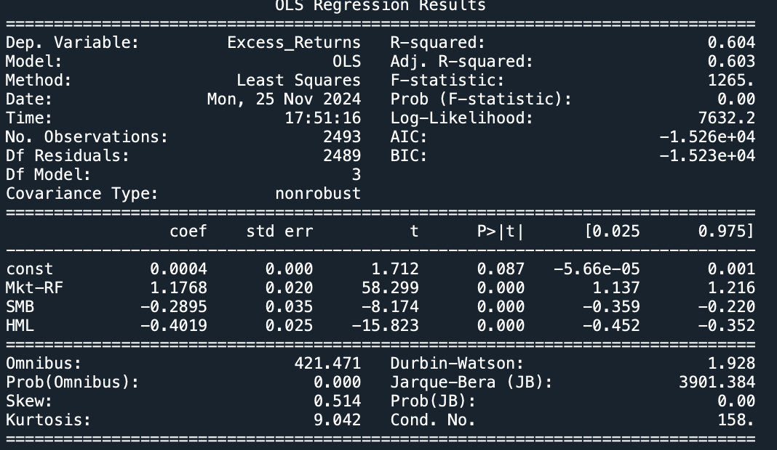

* Model statistics:
  + - R-squared: 0.604: The model explains 60.4% of the variance in Apple’s excess returns, indicating a reasonable fit. The remaining 39.6% may be attributed to other factors (e.g., momentum, profitability, or company-specific events).
    - Adjusted R-squared: 0.6030.
    - F-statistic: 1265.0, with a p-value of <0.001, indicating the model as a whole is highly significant.
    - Intercept (α): The intercept, α=0.0004, is not statistically significant (p=0.087). This suggests that Apple’s excess returns are largely explained by the Fama-French factors, with little contribution from other unexplained sources.
    - Market Risk Premium (β1​): Coefficient: 1.17681, highly significant (p<0.001). Apple’s returns are positively and strongly correlated with the market premium. For every 1% increase in the market risk premium, Apple’s excess returns increase by approximately 1.18%.
    - Size Factor (SMB, β2​): Coefficient: −0.2895, highly significant (p<0.001). The negative coefficient indicates Apple behaves more like a large-cap stock, inversely related to small-cap performance. This aligns with Apple’s status as one of the largest companies globally.
    - Value Factor (HML, β3​): Coefficient: −0.4019, highly significant (p<0.001). Apple has a strong growth-stock profile, with a negative loading on the value factor. This reflects its reinvestment-driven growth strategy over traditional value characteristics like high dividends.

Plot Fit:

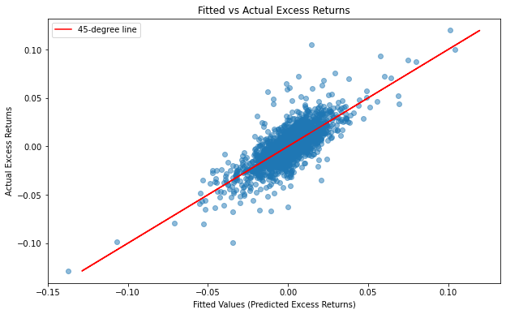

The scatterplot of actual vs. fitted values shows that most of the points cluster near the 45-degree line, indicating the model effectively predicts Apple’s excess returns.

1. Conclusion:

Factor Contributions: Apple’s returns are primarily driven by the market risk premium (β1=1.1768). The negative coefficients for SMB (−0.2895) and HML (−0.4019) indicate Apple’s large-cap and growth-stock characteristics, consistent with its profile as a global tech giant.

Alpha (α): The insignificant intercept suggests that most of Apple’s returns can be attributed to systematic factors, implying limited unexplained returns.

Stock Profile: Apple’s high sensitivity to the market (β1>1) implies that it may amplify portfolio exposure to market movements. Its growth profile and large-cap nature may make it less suitable for diversification if the portfolio is already weighted toward growth stocks.