Problem Statement 1: Analyze the sentiment of FOMC minutes (programmatically) from 2019-2023 and evaluate its impact on S&P500 performance.

**Python Code: fomc.py**

Methodology:

1. Data Collection:

* leverage the FedTools package to systematically gather the FOMC meeting minutes spans over 2019 to 2023.
* Retrieved S&P 500 daily closing prices from Yahoo Finance for the same period.

1. Sentiment Analysis:

* Each document is meticulously broken down into individual sentences to prepare for fine-grained sentiment analysis.
* Used FinBERT model specifically trained on financial texts, offering nuanced understanding beyond general-purpose language models.
* Each sentence is classified into one of three categories: positive, neutral, or negative.
* Quantify the overall sentiment of each meeting's minutes, we calculate a sentiment score: (Number of Positive Sentences - Number of Negative Sentences) / Total Number of Sentences.

1. Event Window Analysis:

* Defined a 5-day pre-event window (5 business days including the FOMC event) and a 5-day post-event window (5 business days after the FOMC event).
* Calculated cumulative returns for the S&P 500 index in both windows.
* Grouped events by sentiment score (positive or negative) and compared average cumulative returns.

1. Key Findings

* Quantitative Insights:

Positive Sentiment Events:

* + - * Pre-event cumulative return: +0.05%
      * Post-event cumulative return: -0.32%

Negative Sentiment Events:

* + - * Pre-event cumulative return: +0.48%
      * Post-event cumulative return: -0.67%
* Market Behaviour: Positive sentiment meetings were followed by slightly negative returns. This could possibly be because we had very few events (6 out of total 40) of positive sentiments of FOMC minutes, which is not enough to capture the impact of positive sentiments. Whereas Negative sentiment meetings showed even more significant post-event declines, reflecting heightened uncertainty or fear in the market.
* Volatility: Negative sentiment meetings were associated with more pronounced volatility, as seen in the larger absolute differences between pre- and post-event returns.
* Correlation:

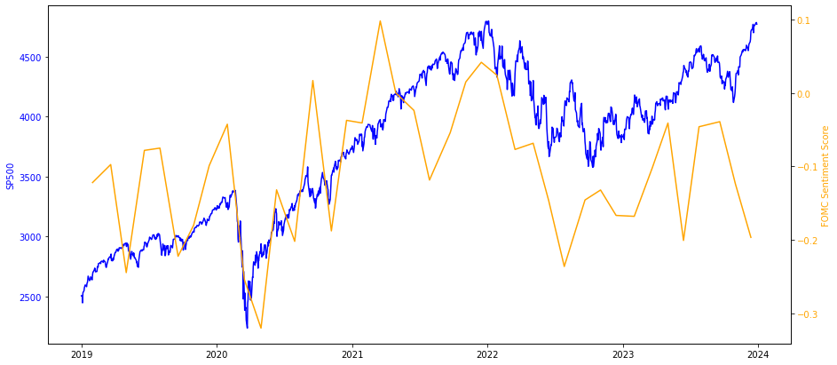

Synchronized Movements: During certain periods, such as 2020 to mid-2021 and 2022 to mid-2023, the sentiment score and the S&P 500 Index appear to move in sync. Peaks in the stock market often align with higher positive sentiment scores, while dips correspond to more negative sentiment. This pattern suggests that in bullish markets, FOMC minutes tend to reflect a more optimistic outlook, whereas in bearish phases, the tone becomes more cautious or reserved.

Divergences: However, this relationship is not always consistent. Instances of divergence between the sentiment score and the S&P 500 Index indicate that other external influences, beyond the tone of FOMC minutes, may have played a significant role in shaping market movements. These factors could include broader economic data, geopolitical events, or unexpected shifts in monetary policy.

General Reflection: Although this analysis does not establish a direct cause-and-effect relationship, the trends observed suggest that the sentiment in FOMC minutes could potentially act as a leading or concurrent indicator of market performance. Investors might use this information as part of a broader strategy to anticipate market behavior..

1. Conclusion:

* Sentiment and Market Reactions: Sentiment derived from FOMC minutes has a noticeable correlation with market returns. Negative sentiment events tend to drive stronger pre-event returns but result in sharper post-event declines.
* Implications for Investors: Positive sentiment does not guarantee positive market reactions (but that could be because of less data around positive sentiment in last 5 years), highlighting the complexity of interpreting FOMC communications. Conversely, negative sentiment often aligns with increased market caution and volatility.
* Periods marked by negative sentiment in FOMC meetings tend to offer lower-than-expected returns and come with higher-than-usual risks, as indicated by increased volatility. This suggests that investors should exercise caution during such times, as these periods are associated with both reduced return potential and elevated uncertainty.